**Replies to referee 1**

[Authors] We thank the referee for the provided feedback. Please find below the point-by-point replies to the raised questions and comments. A list of references is provided at the end of this document

The authors present a comparison between local (LPC) and global (GPC) current-free boundary conditions applied to an axisymmetric, hybrid simulation of a Hall effect thruster. They apply these boundary conditions to three separate system configurations: one with an external cathode (EC) inside the magnetic field separatrix (MS), one an EC outside the MS, and one with an internally mounted cathode, using four separate domain sizes, i.e., 12 different cases. There are several issues noted for this manuscript to be considered for PSST in its current form:

Major Points:

1) The authors should address how the simulations are validated against experimental data. It is indeed an interesting study from the perspective of Hall thruster simulations, but the paper reads more like a “sensitivity study,” without detailed discussions of the physics. So, what is the novelty in the physics that the authors discovered or investigated with this new computational model? There are some mentions of experimental measurements which agree with the cathode location study, but there are no direct numerical comparisons to any experimental results (e.g., thruster performance, oscillation amplitude or frequency, etc.).

The referee is totally right: we do not present a direct comparison of our numerical results with experimental ones, and this is an important backstep that limits the validation of our simulation results. This is due to the fact that we lack experimental data to perform a quantitative comparison against our simulation results. In our research group, we are currently doing our best to obtain data from real prototypes to advance on this aspect. As the referee may know, this is not straightforward, and we hope the referee can understand this situation.

Nonetheless, while an exhaustive validation of our simulation results is pending for experimental data availability, we believe that this study presents a valuable investigation on key aspects for the modelling of the magnetized near plume of a Hall effect thruster (HET). The main novelty is the global plume condition model (GPC), which is shown to provide a more robust current solution in the plume against plume truncation, especially when the externally-mounted cathode is outside the magnetic separatrix (a configuration commonly encountered in HETs). Indeed, in this situation, the local plume condition (LPC), that sets a local zero current condition at the plume, and that is most commonly used in HET plume modelling, is shown to be intrinsically and strongly dependent on the plume size, making it unreliable. This is a central point that precludes the validation of the numerical results against data from plume diagnostics. In contrast, the GPC model presented overcomes this limitation, and thus stands as a step forward enabling a more reliable validation of simulation results against experimental data from plume diagnostics to be conducted in the near future.

We would also like to highlight that, as discussed in the manuscript, there are a number of results in our study that show a good qualitative agreement with previous studies in the literature, as follows. First, with the LPC model the lateral plume boundary is found to perturbe the electron transport leading to a higher electron current collected at that boundary. This effect has also been reported in Ref. [1]. In our study, the GPC model is shown to avoid this issue. Second, unlike the LPC, the GPC model can estimate the final potential reached in the far plume , and, for all cathode locations considered, it yields values for the total electric potential fall in this off-simulation region, close to those found with a kinetic paraxial model of a collisionless plasma stationary expansion in a convergent-divergent magnetic nozzle (MN), reported in Ref. [2]. Third, our results show that downstream of the magnetic separatrix (MS), where the magnetic topology features a MN shape, the near-unmagnetized ions detach inwardly from the magnetic lines for all cases. This result agrees with those reported in Ref. [3] based on a two-fluid, 2D model of the supersonic plasma expansion in a divergent MN. Finally, as mentioned by the referee, qualitative trends with cathode location of several key performance parameters such as cathode-beam coupling voltage, , the thrust, , the thrust efficiency, the plume divergence, and of the solution in the near plume of the electric potential, , the electron temperature, , and the plasma density, , are well aligned with previous experimental and numerical results reported in the literature, as it is detailed in Sec. 4.

2) The authors do not discuss the details of the hybrid code, HYPHEN. It can be understood that the authors did not want to make the paper any longer (already 16 pages), but it is critical to explain the basics of the code. The major comments include the following. (i) The E-module is perhaps the most important. Please add some detailed explanation for readers who are not familiar with hybrid models in Hall thrusters, e.g., what kinds of equations are solved and how are the equations solved? In particular, the quasineutral drift diffusion model solves an elliptic PDE for the potential, so how one can “force” the current condition via the electron equations is of great interest and importance (e.g., eq (1) perhaps determines the balance between the electric field and pressure gradient). (ii) The sheath (S) module might also play an important role in the investigation. Please elaborate on “The local sheath potential fall is also determined” and “retains non-Maxwellian features of the electron velocity distribution function (VDF)”. (iii) Please include particle statistics in the report or demonstrate particle convergence. How many macroparticles per cell were used in this study? Are the presented results instantaneous or time-averaged? (iv) Can you include any comments about the computational cost of the model?

(i) We need to decide if we include E-module equations (similar to the original version). I would restrict it to the cont+mom equations (not the energy equation). Maybe it is easier to include it in an Appendix?

I would include all model equations (cont+mom and energy) in Sec. 2 (as in the first version of the text). Then, I would include in the appendix the details of the numerical discretization and solution of the cont+mom equations only, in a similar fashion as in zhou22a and zhou19a.

(ii) We need to describe a bit the S-module that is applied at the anode and dielectric walls (also commented by referee 2). Maybe we can summarize it as a second section of the appendix (I would take the info from JAP paper HT5k).

(iii) HYPHEN incorporates a dedicated population control algorithm based on particle generation processes (collisions, both ionization and CEX and ion recombination at the walls) that controls, for each ion and neutral species, the number of particles per cell and limits dispersion on the macroparticle weights (number of elementary particles represented by each macroparticle). Details on the algorithm can be found in Ref. [4,domi18c]. For the simulations reported in this study, and as a reasonable compromise solution between accuracy and computational burden of the simulations, we use 500 parts per cell with a 10% tolerance. The simulation or ion-moving timestep is set to 15 ns, so that a typical fast doubly-charged ion takes at least two timesteps to cross the smallest PIC cell. The total simulation time is 900 s, so that the discharge current undergoes a sufficiently large number (about 10-15) of low-frequency (i.e., breathing mode) oscillation cycles, and the results shown in the manuscript are time-averaged over those cycles.

(iv) We shall include data on the computational cost of the model

3) The anomalous scattering frequency is assumed to be a function of axial position only. Are the same values used in the same magnetic field lines or radial direction? Past studies (cf, Hall2De) have shown that an anomalous scattering frequency is also needed for the cathode-to-plume coupling. It would seem to me that in a paper investigating the cathode boundary condition these details would be important and should at the very least be mentioned. [Page 3, Paragraph 4]

Thank you for pointing out this aspect: we use the same value of alpha along each magnetic line, and we have clarified this point in the revised version of the manuscript.

We agree with the referee on the fact that anomalous transport mechanisms can play a role in the cathode-plume coupling. In our study, we do apply an anomalous scattering frequency in the cathode plume region. However, (1) this parameter is uncertain and unfortunately, we lack experimental data to evaluate it more accurately; and (2) in our study we analyze only the effect of the cathode position while keeping constant the electron turbulence level. Nonetheless, in the revised version of the manuscript we acknowledge this aspect and we cite Ref. [1], which presents a more elaborated study with Hall2De on these matters.

4) Figure 2 is interesting, but what is the meaning of showing all four cases? There are only 2 paragraphs explaining the results. It seems like P1 is different when the domain is truncated but P2-P4 looks pretty similar, i.e., the near-field plume is not affected, and the far-field plume shows a circulation of electrons at far field. The paper could be significantly shortened by modifying this discussion. [Page 3, Section B, Paragraph 2]

Aquí quizás le haría caso al revisor y eliminaría los casos P4, por ejemplo.

Sin embargo, el revisor dice aquí que la figura 2 es interesante, aunque luego en el punto 6) se contradice porque pide cambiarla totalmente incluyendo los resultados P3C2 y P3C3 de las figuras 6 y 7. Por tanto, no le haría caso en el punto 6.

Maybe we can remove P2, P3 or P4? The results for P4 confirm that LPC is a good approximation only for large plumes, as expected. Since now we report the location of the stagnation point for P4, and we say that it is the same for LPC and GPC, maybe we can simply omit the figure. (REMOVE P4)

We agree with you on this point. We have now better quantified the differences on the electric current solution downstream the cathode magnetic line (CML) by reporting the location of the electric current stagnation point. Since the solution is similar for P4 cases, we have omitted the results for size P4 on Fig. 2 so that the paper is shortened, as suggested by the referee.

5) It is hard to see “The main differences among cases are found in the outwards flow of electrons, especially in the lateral part of the plume.” Also, I am confused by this sentence: “the surface-averaged values over P of B and the effective Hall parameter, for plume sizes P1 to P4, decrease from 7.4 to 1.8 G, and from 212.2 to 68.1 G, respectively.” What is the significance of this statement? This just comes from the smaller domain? [p. 6]

The first sentence has been rephrased and clarified in the revised version of the manuscript. Our aim with the second sentence is to highlight the fact that the electron population in the plume is well-magnetized even for the largest domain considered. Along with the effective Hall parameter, ranging from 212.2 to 68.1 for plume sizes P1 to P4, we report the average B value for completeness.

6) Figure 4 seems to be a very busy figure but is least effective in addressing the scientific messages. It is perhaps more effective to just show the comparison of the 2D figures of C1, C2, and C3 with GP3 and LP3, which are shown in Figs. 6 and 7. To make the paper more concise, the authors may make a figure comparing LP3/GP3C1, C2, and C3 as one figure. Comparing LP3/GP3 vs LP4/GP4 seems less scientifically interesting. If the authors feel otherwise, then the recommendation would be to add more scientific discussions about what “physics” is captured and is important to be captured with the larger domain. The scientific messages of Fig 4 can be done without it and what the authors want to talk about in Fig 5 can be better captured.

Figure 4 has been improved in the revised version of the manuscript to better address the corresponding scientific messages. First, we have simplified it by omitting the ion and electron current profiles and energy profiles without losing the associated scientific messages in the text. Second, we highlight the differences in the electric potential and the electron temperature at the lateral part of the plume boundary P induced by the plume condition. These differences are now better quantified in the manuscript. In particular, the LPC yields a larger electron flow at the lateral P boundary. As a consequence, in case LP3C1 is up to approximately 30% higher than in case GP3C1, with differences on the order of the local electron temperature, and thus relevant for near-plume diagnostics. Finally, these differences in have been found to affect the dynamics of slow ions generated in the plume through charge exchange collisions (CEX). The current density of singly charged CEX ions is now shown in Figure 4(c), and the distinct behavior of this ion population under both the GPC and LPC models is discussed and quantified in the revised manuscript.

La figura 4 enseña muchos resultados importantes en la discusión, como la distinta corriente de electrones, la distinta Te y la distinta phi. Creo que la alternativa es intentar clarificarla, como además sugiere el revisor 2, pero no eliminarla.

Además:

“The scientific messages of Fig 4 can be done without it and what the authors want to talk about in Fig 5 can be better captured.”

no veo cómo se pueden discutir los aspectos sobre Te y phi sin enseñar la figura 4.

Tampoco creo que los mensajes de la figura 4 se puedan discutir con la figura 5, pues la figura 4 enseña magnitudes en todo el borde P, mientras que la 5 enseña perfiles a lo largo de la línea media. Por ejemplo, la figura 5 puede servir para ilustrar el coupling voltage, pero no dice nada de phi o Te en la región lateral de la pluma.

Propuesta para la figura 4 (que va en línea también con lo que nos indica el revisor 2):

En todas las figuras, poner “Axial P boundary ” “Lateral P boundary”. Estos tags pueden indicarse también la figura 1(b) o 1(c) y mencionarse en la sección II.A y/o II.B.

Fig 4(a): Eliminar los casos L, pues la jni de los casos G es igual a la jni de los casos L (y a su vez en estos casos jni = jne). Una alternativa más drástica sería eliminar por completo la figura 4(a) y no enseñar las corrientes, pues ya se han enseñado en las figuras anteriores. Esto afecta a los comentarios sobre el caso C2 en la sección 4 (se comenta sobre el maximo local de je en la intersección con la CML).

Fig. 4(b): Esta figura creo que es la más clara, y quizá únicamente añadiría una anotación con flecha al final indicando el mayor potencial en los casos L en el lateral P boundary.

Fig. 4(c): Voy a intentar añadir una subfigura insertada que haga zoom en la zona lateral únicamente para los casos C1, con la intención de resaltar que la condición en P afecta significativamente a Te, tal y como ahora resalto en el texto, los cambios en Te son del orden del 50% de los valores locales. Esto es importante para diagnósticos en pluma.

Fig. 4(d) Diría que quizá puede directamente eliminarse. En el artículo puede darse simplemente los comentarios sobre los valores promedios de las energías en P. Posteriormente, en la sección 4 también se hace referencia a ella acerca del mayor eta_ene de los casos C2 (mayor potencia de los electrones, que tienen mayor Te), pero basta referirse a Te para hablar de ello.

Lo que propone el revisor, entiendo que es cambiar la figura 2 por una figura que solo enseña la comparación LP3/GP3 para los tres casos de cátodo C1, C2 y C3. Sin embargo, veo una incoherencia con su anterior comentario, donde dice que la figura 2 es interesante, y simplemente plantea reducirla eliminando algunos casos de los que se enseñan. Además, la propuesta del revisor plantea dos problemas principales:

1. No se enseña el mal resultado de LP1C1 comparado con GP1C1, que se comenta en el texto actualmente y creo que es relevante
2. Al no comparar P3 y P4 para los casos C2, no puede ilustrarse el hecho de que el punto j=0 se mueve con el boundary en los casos LPC. Esto es central para desechar el modelo LPC frente al GPC en ese escenario. En cuanto a la física que dice que hay que capturar, diría que es precisamente este escenario el que demuestra que la solución de corriente para LPC está afectada por la BC y no responde a la física real de la expansión.
3. No veo cómo incluir en una misma figura los resultados de j y je, pues no hay espacio

Creo que aquí podemos decir que la figura 4 nos parece importante y que da mensajes distintos de la 5, tal y como se argumenta en el paper. Además, se han completado algunos de los mensajes de la figura 4 y se ha mejorado la figura 4.

Otro cambio en el que se puede ceder: añadir la figura 6(f) (je para GP3C2) en la figura 3 [sería la figura 3(d)]. Se eliminarían las figuras de je en la figura 6. De esta manera, cuando se comenta je en la sección 4 para los casos C2, se hace referencia únicamente a la figura 3(d), pues la comparación LPC/GPC para je aquí es similar a la ya realizada para C1 (basta simplemente mencionarlo en el texto), y tan solo hay que comentar el distinto reparto de electrones desde el cátodo siguiendo la nueva línea magnética.

Por otro lado, cedería quizá en reducir la figura 7 enseñando únicamente el caso C3, pues el C4 sale muy parecido en este caso y no añade nada nuevo. Hay que ver si incluir je en la figura 7 o pasarla también a la figura 3.

Propuesta:

Eliminar las figuras de je de la figura 6 y poner en su lugar solo las figuras de j de la figura 7 para los casos LP3C3/GP3C3

Alternativa para je de los casos C2 y C3: Hacer una nueva figura en una columna solo con je de los casos GP3C2 y GP3C3

De este modo la nueva figura 6 sería:

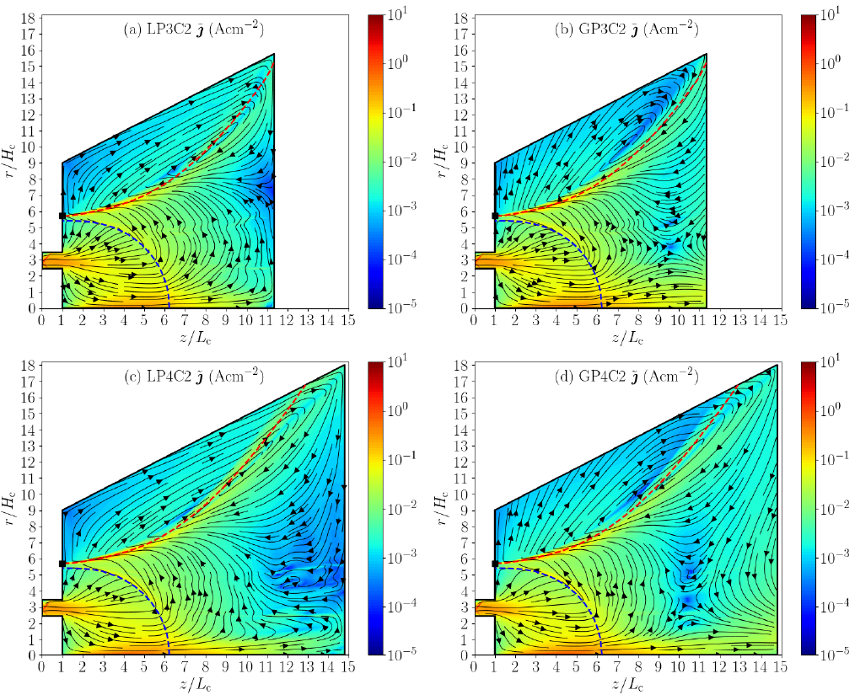

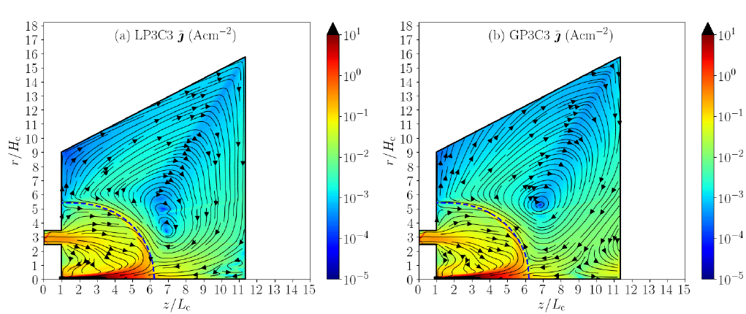

Y la nueva figura 7 sería, a una columna (lo ideal sería unirla a la figura 3, pero no tengo claro que hay espacio en una columna para 5 figuras de este tipo):

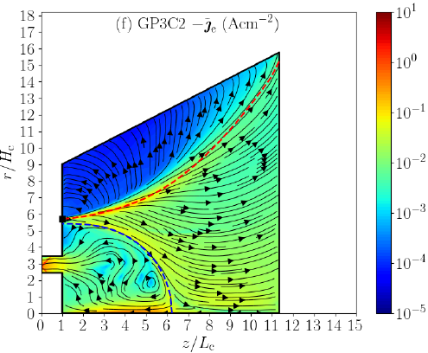

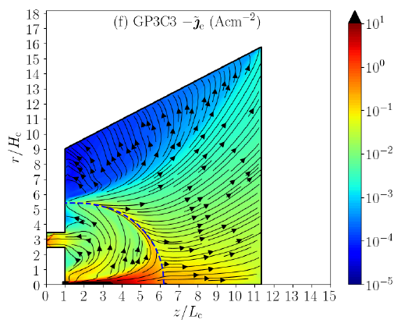

7) Figure 5 seems interesting, but it should be clearly mentioned that all results assume the same anomalous mobility profile. The cathode location may significantly change the near-field electron transport profile.

OK

8) The calculation of the thrust is non-trivial. Please elaborate on whether the thrust was found to be constant beyond a certain control volume and on how the control volume / surface to evaluate the thrust is chosen.

Aquí puedo calcular F en secciones intermedias para los casos P4. En todo caso, el thrust se calcula en el boundary final, y va aumentando ligeramente al aumentar el tamaño de pluma debido a la pequeña fuerza magnética (la pluma sigue magnetizada, como se comenta en el paper)

DAR LA FÓRMULA PARA EL THRUST MAGNÉTICO. Citar zhou22a.

9) Table II is interesting (especially, ϕ_∞) but more details are needed. (i) Why do we not see the convergence of results? For instance, LP2C1 = 13.22 V; LP3C2 = 14.15 V; LP4C1 = 10.97 V. (ii) The small thrust with smaller domain is attributed to magnetic force. (iii) Please provide more clarification and physics discussions. The authors mention that the results are “converging”, but the main interesting physics is what is the correct value of ϕ_∞? For instance, if the cathode potential is 0 V, the far-field potential should be Vcc, which is a positive value with respect to the cathode potential? (v) Finally, while it is appreciated that the authors provide all values thoroughly, many of the values seem to be less interesting. For instance, all discharge power, current, efficiencies are not that sensitive to the far-field boundaries.

**(i)** We thank the reviewer for pointing out this important aspect, which highlights a difficulty associated with the use of a Magnetic Field Aligned Mesh (MFAM) for solving the electron fluid equations. We have included a corresponding remark in the revised version of the manuscript to clarify this point, as detailed below.

The variations in the coupling voltage reported in Table II for C1 cases are not due to fundamental changes in the plasma solution with plume size, but rather stem from numerical differences in the construction of the MFAM. The MFAM is generated from the applied magnetic field. The cells of the mesh are defined by the intersection of the magnetic field streamlines and equipotential lines, which are obtained through the integration of the magnetic field. For each plume size, the MFAM is built to balance accuracy and computational cost, ensuring a controlled cell skewness and resolution. Since the applied magnetic field is highly non-uniform in the near-plume region, the resulting distribution of magnetic field lines is also highly non-uniform (refer to Fig. 1(a) below). Thus, the optimal selection of magnetic isolines that define the MFAM cells becomes a nontrivial task, which typically results in variations in the cell layout across different plume sizes. Consequently, the cathode magnetic line (CML), defined within each MFAM by the field line passing through the cathode injection center, may differ slightly between plume sizes. This leads to small differences in the intersection between the CML and the thruster channel midline used to estimate , as illustrated in Fig. 1(b). These geometric differences explain the variations in among the C1 cases (maximum of about 1% of for plume sizes P2-P4), and do not reflect significant physical changes in the cathode-beam coupling process. In fact, compared to C1 cases, variations in among C3 cases reported in Tab. IV are lower (maximum of about 0.3% of ). This is because the CML is the symmetry axis for C3 cases (cathode at the axis), and the magnetic line that connects it to the thruster channel midline is the magnetic separatrix (MS), which is the same for every MFAM regardless of the plume size (refer to Fig. 1).

We would also like to point out that the aforementioned variations in are not connected to those in among cases. Values of are related to far field plume dynamics, and exhibit a monotonic decrease with the plume size.

Siguiente cara (P4G_Fz_C1fcat2533_Tcath_new):

V. Average for two P4 cases is 2.65 V. Thus, say that variations due to MFAM construction are approximately of V.

V. Average for two P4 cases is Say that variations due to MFAM construction are approximately of V.

| (a) |
| --- |
| (b) |
| Fig. 1. (a) MFAM streamlines comparison for P2 (blue), P3 (green) and P4 (red). (b) Detail of the CML (dashed lines) and corresponding magnetic tube between two consecutive MFAM magnetic streamlines. The horizontal thick black line corresponds to the thruster channel midline. The MS is the same for the three MFAMs and it is depicted with a thicker blue line in (a). |

(i) We acknowledge that Vcc does not exhibit a clear trend for C1 cases. Variations among P2 and P3 are low, but with respect to P4 are of about 30% regardless of the GPC or LPC model, similar to those in other quantities among cases. The use of an MFAM introduces non trivial difficulties in the numerical treatment. Increasing the plume size implies the generation of a new MFAM, whose quality and resolution deteriorate quickly with the plume size. Taking into account that errors introduced by the required interpolation between the PIC mesh and the MFAM are present. Enseña que el uso de MFAM limita el tamaño máximo de pluma a simular (mencionarlo en la intro y conclusiones). Nonetheless, we mention this fact in the revised version of the manuscript.

Izquierda P4. Derecha P3 (parece que la P4 es más fina)

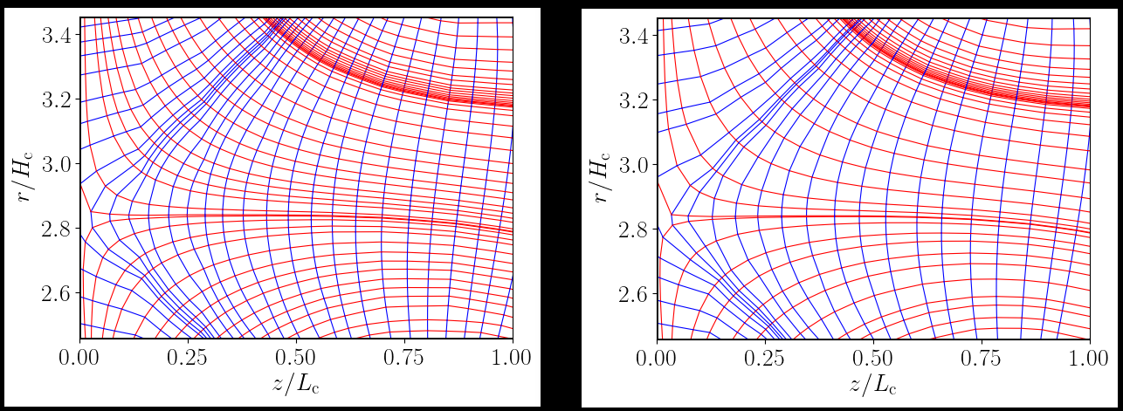

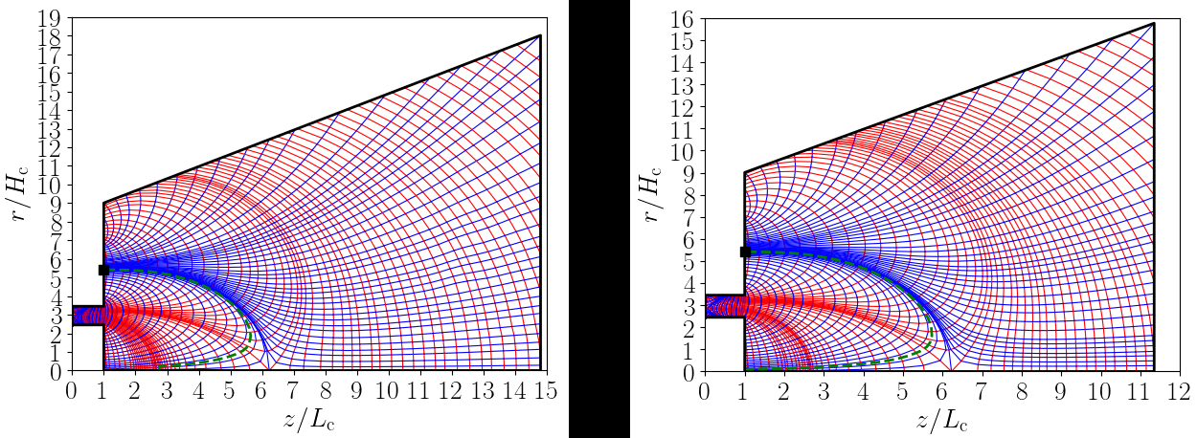

He probado a obtener Vcc en posiciones más exactas del cruce entre la CML y la midline, pero los cambios no son importantes. Creo que debemos decir que las variaciones en Vcc son razonables. En el caso C3 tampoco hay una tendencia clara y las variaciones son menores, como ocurre con el resto de performances.

Also: compute average phi among several nodes in the surroundings of the magnetic line cross with the midline to see if we can smooth trends.

(ii) This is a direct consequence of the fact that the near plume is magnetized (values of both the magnetic field magnitude and the Hall parameter at P are provided in the manuscript), and can be seen from the plasma momentum equation.

(iii) We do not use the word “converging” for nor for . Vcc is a value in the very near field plume, but the current free expanding plume very far downstream is expected to reach a lower potential value, as results indeed indicate. As we indicate in the manuscript, our results for plume sizes P2-P4 suggest that simulating a plume size larger than P4 would be necessary for a more precise estimation of , which requires the use of optimal MFAMs to limit numerical errors or the use of cylindrical meshes for the electron model instead, and is left for future work.

(iv) We have omitted some of the performance values in the tables, and are now just reported in the text for simplicity. (Quitar P, Id? eficiencias? quizas conviene dejarlas porque luego se localizan mejor para la comparación con los casos C2 y C3)

10) It is perhaps important to mention the difference between ϕ_P vs ϕ_∞. The sheath theory in Eq 4 should only be applicable for ion-attracting electron-repelling sheath. Do the authors apply Eq 4 for ion-repelling ion-attracting sheath as well?

We agree with the referee. The difference between and has been clarified in the revised version of the manuscript (see Sec. II.C).

Eq. (4) is not applied for electron attracting sheath (i.e. reverse sheath). In all the cases simulated in the paper and in all locations, phi_P > phi_infty, so all sheaths are electron repelling (INCLUIR EN EL TEXTO DEL PAPER ESTA FRASE).

11) Section IV mainly discusses the observations in Tables III and IV. In the text, the decrease and increase of certain values are shown, but it seems to lack a concrete scientific discussion. If there is no scientific discussion, one could consider moving this to the appendix or significantly shortening the discussions. Specifically, the increase in ϕ_∞ in Table III (when increasing the domain size) is counterintuitive.

I need to reduce the comments in sec 4. Maybe just focus on those results that are relevant for the comparison with other studies.

La estructura actual de la sección 4 es la siguiente:

1. Efecto del tamaño de pluma en performance para C2 y C3 y comparación con C1:

1.a) Se comienza haciendo referencia a las tablas III y IV y hablando sobre el efecto del tamaño de pluma para los casos C2 y para los casos C3 en Vcc, F y phi_inf.

1.b) Se habla de IiP y Id, y por tanto Pd y eta.

1.c) Se habla de las eficiencias parciales

1. Se comparan las tendencias encontradas en Vcc, F, eta y divergencia con resultados experimentales y numéricos en la literatura.
2. Se analiza la solución de phi, Te y ne y se comparan con resultados en la literatura
3. Se analizan las corrientes y se dice que LPC no vale para C2

Propuesta:

Comenzar por las corrientes, ya que permite enfatizar que LPC no es aplicable en un escenario como C2, de manera que remarcamos la importancia del nuevo modelo GPC. Además ya en lo que sigue puede evitarse LPC, con lo que quizá podemos reducir las tablas III y IV a una sola tabla que enseñe solo los resultados GPC para C2 y C3.

Tras esto, guiaría al lector diciendo que se van a comentar los aspectos más importantes en comparación con otros estudios. Reduciría el texto comentando únicamente los aspectos de la solución que permiten extraer tendencias como las encontradas en los estudios experimentales y numéricos citados:

1. Centrarse en Vcc , F, eta y divergencia.
2. Se analiza la solución de phi, Te y ne y se comparan con resultados en la literatura

Minor points:

12) The authors mention “zero current condition at the plume downstream”. It would be better to briefly explain that current-free plasma at the far field plume or the assumption that the accelerated ion beam is neutralized at the far field plume.

Únicamente mencionamos “zero current condition at the plume downstream” una sola vez en el abstract. La verdad es que no entiendo bien lo que nos pide el revisor. Quizá debemos escribir algo como:

“A new model assuming a non-local neutralization of the ejected ion beam at the far field plume and yielding a global zero current condition at the plume downstream boundary is presented.”

13) The explanation of the electron energy flux should be made more carefully (cf. eq (2)). If one considers a half-Maxwellian, it can be considered that c = 2. 5/2 comes from the 3/2 p + p in the energy equation (but without any q). So, mathematically where do 9/2 and 13/2 come from?

Previous simulations of an electrodeless plasma thruster in Ref. [5] investigated the effect of c using the LPC. Values of c = 5/2 (qe = 0), 9/2 (qe = 2neTeue) and 13/2 (qe = 4neTeue) were simulated. The results revealed a significant impact of c on the electron temperature, with c = 9/2 providing the best agreement for two plume domain sizes. Since in our present study we have a MN-like topology downstream the CML, similar to that of an EPT, we set c = 9/2 when the LPC is applied.

EL VALOR 4.5 INTENTA REPRODUCIR edeltaphi/Te en P obtenido con GPC (ver paper).

14) More discussion is needed on the modeling details. (i) In the introduction, there is no mention about whether ions = kinetic and electrons = fluid. Also, state-of-the-art models use mainly drift diffusion approximation but it is not specified that the authors use QDD until later. The use of QDD is important in how the local vs global current-free conditions are applied. (ii) The model is described as an axisymmetric r-z simulation but the drift-diffusion model will only work in Cartesian (i.e., Coriolis/centrifugal forces will not be captured)? Please elaborate.

(i) OK, we can specify that hybrid models set ions = kinetic and electrons = fluid, apply quasineutrality and consider a drift diffusion model (what does QDD refer to? Is it quasineutral drift diffusion?

(ii) I do not get the point. Centrifugal/coriolis forces appear or not depending on the motion physics/reference frame used to refer the motion, and not on the coordinate system (cartesian/cylindrical coordinates) used to describe this motion (to specify position, velocity and accelerations as vector quantities). In drift diffusion models, electron inertia is neglected, so that electron acceleration (including, in general, centrifugal forces, are not captured). If an inertial reference frame is used to describe the motion, Coriolis force is not present.

15) This sentence is appreciated: “Eq. (3) is an implicit equation for ϕ_∞ which is solved iteratively [by linearizing Eq. (4)].” However, this is why the equations for the electron fluid model are recommended. It would be much clearer that ϕ is solved at the “n-th” timestep, but ion current density comes from n-1 th timestep. Then, the interior cells can use the drift-diffusion formulation to solve for ϕ at n-th time step but the boundary condition requires the evaluation of j_neP at the n-th timestep, which may (or may not) need the implicitness for ϕ. The model for ϕ_∞ is very interesting (i.e., novel), but it is recommended to be more specific about the meaning of this, i.e., the global potential value, ϕ_∞, is chosen such that the global current is maintained to be zero.

Referir a artículos anteriores. j_neP y phi_infy se calculan a la vez.

16) “[T]urbulent cross-field transport due to high-frequency electron instabilities” should more precisely be “turbulent cross-field transport due to high-frequency plasma waves driven by kinetic and fluid instabilities.”

Ok, thank you. We have corrected the sentence in the revised version of the manuscript as indicated by the referee.

17) Figure 5 appears to have some stray red dots.

The referee is right. These dots are not in the original figure and only appear in the submitted proof document generated by the PSST website.

18) What was the justification of choosing GP3 as the reference case for comparison between cathode placement results? Wouldn’t it be better to use the larger domain case? Could this be elaborated upon in the text?

The impact of plume size is higher for cathode location C2 than for C1 and C3. This is why results for both GP3 and GP4 are shown and discussed in the document in Figs, 6 and 7. While Figs. 3 and 4 show results for size P3, results for P4 can be depicted instead without changing the scientific message. As indicated in the text of the manuscript, with respect to size P3, size P4 yields only incremental variations in plasma properties in the near plume, and thus the effect on discharge performance is minimal. Moreover, the quality of the MFAM tends to deteriorate significantly for very large plumes.

Habría que cuantificar/ilustrar la peor calidad de la malla MFAM para P4.

No decir nada de la calidad de la MFAM. P4 no se enseña para C1 ni C3 porque no hay cambios importantes. Para C2 se enseña P4 para ilustrar que la solución dada por LPC no es fiable y depende inherentemente del tamaño de la pluma.

19) Could the authors elaborate on the selection of locations for estimating Vcc (i.e., plume boundary at channel mid-radius vs crossing point between the channel midline and the CML vs crossing point between the channel midline and the MS).

We agree that the definition of Vcc is not unique. This is connected to our reply to point 9 above.

LPC1 cases computation of Vcc through interpolation from MFAM to crossing point between CML

Cambio: Tomar MS para C2.

20) There seems to be consistently a red “radial” line near the anode (e.g., Fig 2). Does this mean that there is a strip of very large current ? This isn’t the focus of the paper but seems strange. Is this a meshing artifact (see Fig 1b)? [Page 5, Figure 2]

The referee is right and this is due to the magnetic topology in the near anode region, which mimics that of the Safran’s PPS500 prototype. We have checked that this is not an artifact of the meshing, but has a physical foundation. However, as the referee indicates, this study does not focus on the solution inside the thruster channel.

21) Figures 5(e) and 5(f) are never discussed or references in text.

En la sección 3 es cierto que no se habla prácticamente de ne. Sin embargo, en la sección 4 se cita a la figura 5 y se habla de la densidad de plasma para los casos C2 y C3. Casos C2 tienen una ne similar en la pluma, y casos C3 una ne media mayor, en consonancia con estudios experimentales.

Podemos, o bien eliminar las figuras 5(e) y 5(f) y simplemente dar los datos de ne en el texto, o bien citar explícitamente a las figuras 5(e) y 5(f). Quizá optaría por lo primero para contentar al revisor y acortar el artículo.

OK. We have eliminated them in the revised version of the manuscript for simplicity, trying to shorten the paper and make it more concise, as suggested by the referee.

QUITAR FIGURAS 5 DE LA DENSIDAD

22) What is meant by “electron momentum flux is transferred to ion momentum flux”? Are the authors trying to imply collisional momentum transfer or referring to the decrease in electron contribution to the net thrust with increasing domain size? Is this just meant to be a description of the magnitude of the ion vs electron current? [Page 7, paragraph 4]

We thank the referee for this comment. We are not meaning collisional momentum transfer. Instead, we refer to the decrease in the electron contribution to the net thrust with increasing domain size, as noted by the referee. We have clarified this aspect in the revised version of the manuscript.

La transferencia se debe al campo eléctrico ambipolar. Esto no conlleva un aumento de F neto. El aumento de F se debe al thrust magnético.

23) The net zero-current condition implies that the cathode current equals the anode current at steady state. This means that there is no leakage current. If this is the case, it would be interesting to explicitly mention that.

Thank you for noting this aspect. In our simulations, the cathode current equals the anode current in both models, the LPC and the GPC, since the net current leaving the plume boundary is zero. We have clarified this point in the revised version of the manuscript.

Aguas abajo del cátodo, tenemos corriente nula en cualquier superficie.

**REFERENCES**

[1] Lopez Ortega, A. and Mikellides, I. G., “The importance of the cathode plume and its interactions with the ion beam in numerical simulations of Hall thrusters”, Physics of Plasmas, Vol. 23, No. 4, 2016, pp. 043515.

[2] Ahedo, E., Correyero, S., Navarro, J., and Merino, M., “Macroscopic and parametric study of a kinetic plasma expansion in a paraxial magnetic nozzle,” Plasma Sources Science and Technology, Vol. 29, No. 4, 2020, pp. 045017.

[3] Merino, M. and Ahedo, E., “Plasma detachment in a propulsive magnetic nozzle via ion demagnetization,” Plasma Sources Science and Technology, Vol. 23, No. 3, 2014, pp. 032001.

[4] Domínguez-Vázquez, “Axisymmetric simulation codes for Hall effect thrusters and plasma plumes”, PhD thesis, Universidad Carlos III de Madrid, Leganés, Spain, 2019.

[5] Zhou, J., Domínguez-V´azquez, A., Fajardo, P., and Ahedo, E., “Magnetized fluid electron model within a two-dimensional hybrid simulation code for electrodeless plasma thrusters”, Plasma Sources Science and Technology, Vol. 31, No. 4, 2022, pp. 045021.