**Replies to referee 2**

[Authors] We thank the referee for the provided feedback. Please find below the point-by-point replies to the raised questions and comments. A list of references is provided at the end of this document

In this paper, the authors present a two-dimensional radial-axial hybrid particle-in-cell (PIC) simulation of a Hall thruster. The hybrid model is a well-established approach for simulating Hall thruster discharges, and the presented simulation results appear credible. While the simulation outcomes are of interest, the authors' discussion regarding the newly introduced plume boundary condition remains unclear. My comments primarily concern the impact of the proposed boundary condition model, which the authors claim to be a significant contribution.

We thank the referee for the valuable comments. We would like to emphasize the main reasons why we consider the newly introduced Global Plume Condition (GPC) a significant contribution to the numerical modelling of Hall thruster (HET) plumes. As discussed in the manuscript, the GPC yields a much more robust and physically grounded solution for the electron current in the plume region, which is essential for meaningful comparison with experimental plasma diagnostics, most of which are performed in the near plume.

In particular, our results for cathode location C2, which corresponds to a laterally-mounted cathode positioned off-axis and outside the magnetic separatrix (a configuration commonly encountered in HETs), demonstrate that the widely used Local Plume Condition (LPC) fails to provide reliable current solutions in the near plume. In this configuration, the LPC produces artificial features such as stagnation points and nonphysical current loops, and the solution becomes strongly dependent on the size of the simulated domain. This behavior reveals a fundamental limitation in the applicability of the LPC for such configurations.

The GPC overcomes this limitation by enforcing a net zero-current condition over the entire plume boundary, thereby limiting the effect of the plume size on the current solution in the near plume. Crucially, by enabling reliable current maps in reduced, computationally efficient simulation domains, the GPC establishes a solid foundation for future validation of hybrid models against experimental measurements, particularly in plume diagnostics where accurate representation of electron transport is essential. Additionally, the GPC enables the estimation of key physical quantities, such as the final potential reached in the far plume, $ϕ_{∞}$, which are not accessible under the LPC framework.

For these reasons, we believe the introduction of the GPC model represents a substantial step forward in enabling accurate and scalable numerical predictions of HET plume behavior and in paving the way for future validation of simulations against experimental plume diagnostics.

Major Comment:

1) The effect of the new boundary condition model—referred to as the Global Plume Condition (GPC)—is not demonstrated quantitatively. The authors state that the GPC minimizes the truncation effects of the plume boundary. Although differences between the results using the LPC and the GPC are illustrated in Figures 2 and 3, it is not convincingly shown that the results obtained using the GPC are more accurate. The manuscript claims that the GPC yields solutions “much closer” to those obtained with a larger simulation domain and provides a “significantly more robust solution,” yet these assertions lack quantitative discussion. While Table II presents a comparison of thruster performance parameters (e.g., discharge current), the data do not clearly support the claimed advantages of the GPC. A quantitative assessment—such as the convergence behavior of key physical parameters with respect to simulation domain size—would strengthen the argument and clarify the benefit of the proposed boundary model.

“much closer”: appears in Sec 3, when discussing C1 cases (page 6, line 10-11, first column)

Here we can report the relative change in the location of the electric current stagnation point in the plume, which was originally in the manuscript.

GP2C1:

z_null_j2D_point in plume (z/Lc) = 6.39655158e+00

r_null_j2D_point in plume (r/Hc) = 6.28548364e+00

GP3C1:

z_null_j2D_point in plume (z/Lc) = 6.99999980e+00

r_null_j2D_point in plume (r/Hc) = 5.77126269e+00

Results for scans of j are not satisfactory and I would not include them. The following are scans of j, j_z and j_r. Radius of the scan extends from the thruster exit plane point at the axis to the location of the j=0 point for P4 cases (same for GPC and LPC). With respect to P4 cases, GP3C1 shows larger differences than LP3C1…

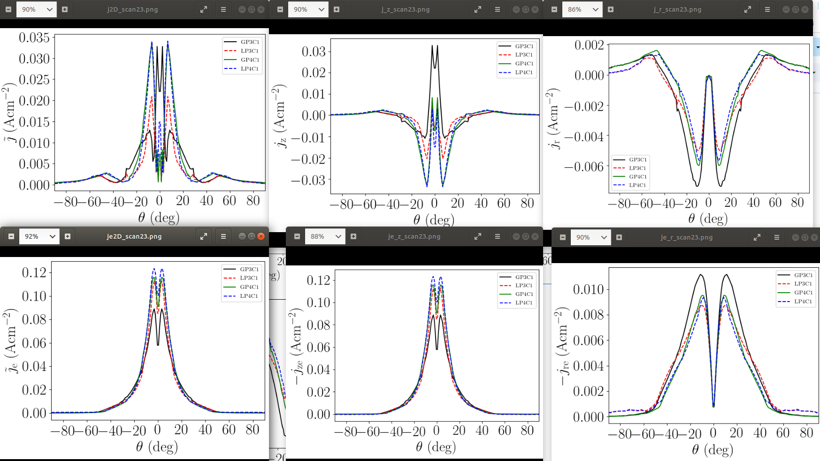

“significantly more robust solution”: appears in section 5,conclusions referring to C2 cases (page 14, line 51, first column).

In this case, the 2D maps of j are more convincing, since it is explained that the electric current stagnation point moves with the boundary in LPC cases.

An important asset of the GPC is the determination of the potential at infinity, $ϕ_{∞}$, which cannot be obtained by the LPC. This is a key parameter characterizing the current-free expansion of the plasma plume into free space (or into a large vacuum chamber with low background pressure). This value is reported in Tab. II for the four plume sizes and the trends with the plume size are discussed in the manuscript. Also, as discussed at the end of Sec. 3, the surface-averaged values of ${eϕ}_{∞P}/T_{e}$ obtained in our study agree very well with those reported in Ref. [2].

Minor Comments:

2) Is it possible to implement a nonlinear sheath model at the anode boundary alongside the new nonlinear plume boundary condition? In conventional electron fluid models for Hall thrusters, the anode sheath is often modeled using a nonlinear approach, whereas the plume boundary typically employs a linearized model—likely due to an issue of numerical stability. In the current study, the anode boundary is modeled with a Dirichlet condition on potential, whereas the plume employs a nonlinear condition. It would be beneficial for the authors to discuss whether a nonlinear sheath model could also be applied to the anode boundary in combination with the nonlinear plume model.

We thank the referee for the comment. Indeed, the current model does apply a nonlinear sheath model at the anode, which is a boundary metallic wall at known potential. The nonlinear sheath model is linearized and solved iteratively if required together with the electron momentum and continuity equations. As we comment on the manuscript, the details on the implementation at the anode can be found in Ref. [1].

We have included more details about the model equations in the revised version of the manuscript, along with a new appendix

3) In Figure 3, the authors discuss differences in electron flow near the lateral plume boundary. While the directional vectors highlight these differences, the electron current density in that region is relatively small (on the order of 10^-5 to 10^-3), suggesting that the impact may be limited. Could you provide a more quantitative assessment of this difference? For instance, does the altered electron flow significantly influence the trajectories of high-divergence fast ions or charge-exchange (CEX) ions?

Thank you for pointing out this aspect. In Sec. 3, when discussing the values of the ion beam current $I_{iP}$ listed in Tab. II, we quantify the fraction $I_{eP}$ (= $I_{iP}$) that is collected at the lateral boundary for the cases LP3C1 and GP3C1 (whose 2D solution for the in-plane electron current density are shown in Fig. 3). These fractions are 14% for LP3C1 and 10% for GP3C1, illustrating the physical relevance of the difference in this lateral electron flow.

Moreover, differences are observed not only on the electron current density, but also on the electron temperature and electric potential. These differences are shown in Figure 4 and have been better quantified in the new version of the manuscript. Relative to the case GP3C1, the case LP3C1 exhibits differences on Te and phi in the lateral part of the plume that amount up to about 50%.

Maybe we can plot quantities of CEX ions, since these could be affected by the differences in the potential.

4) Figure 4 may be difficult for readers to interpret. It is recommended that the authors highlight selected lines or regions in the figure to better emphasize the key differences being discussed.

Thank you for the comment. Figure 4 has been upgraded according to your recommendations.

**REFERENCES**

[1] Perales-Díaz, J., Domínguez-Vázquez, A., Fajardo, P., Ahedo, E., Faraji, F., Reza, M., and Andreussi, T., “Hybrid plasma simulations of a magnetically shielded Hall thruster”, Journal of Applied Physics, Vol. 131, No. 10, 2022, pp. 103302.

[2] Ahedo, E., Correyero, S., Navarro, J., and Merino, M., “Macroscopic and parametric study of a kinetic plasma expansion in a paraxial magnetic nozzle”, Plasma Sources Science and Technology, Vol. 29, No. 4, 2020, pp. 045017.