**HOW TO MAKE BROWNIES**

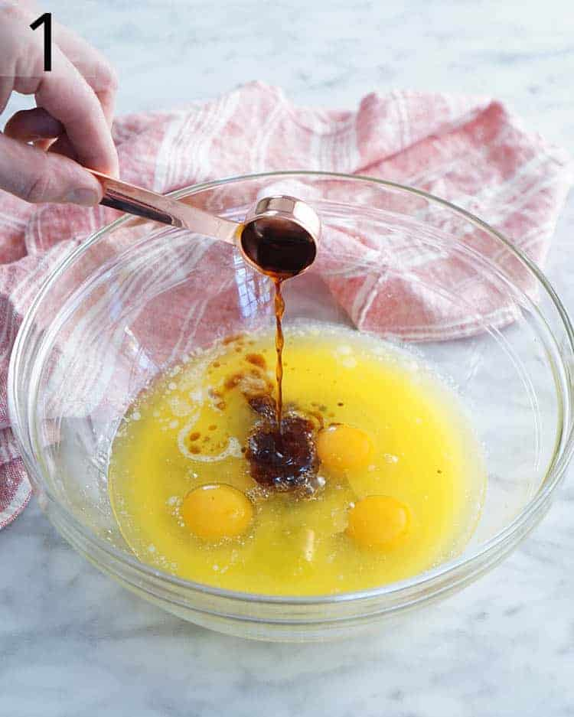

[](https://www.mediavine.com/)

1. Add your melted butter, room temperature eggs, coffee and vanilla to a large bowl then whisk together. The coffee is optional but I find that it helps to bring out the chocolate flavor. If you don’t want to use any just skip or add a drop more of vanilla.

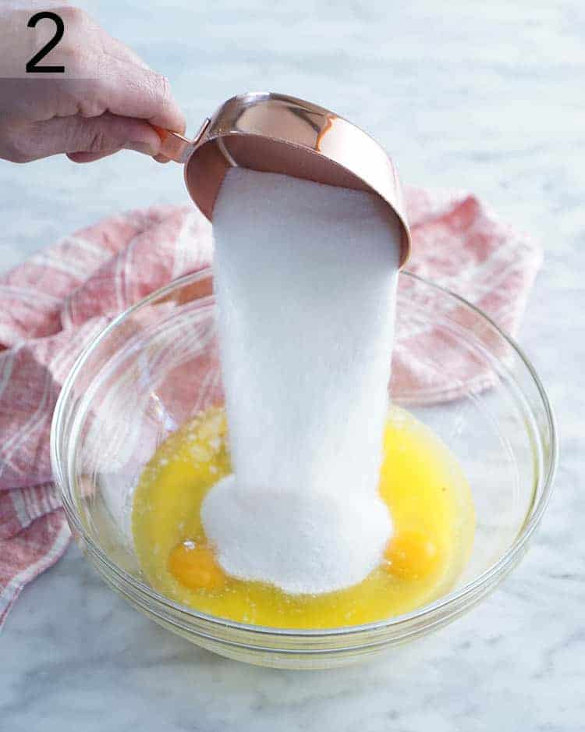

1. Add the white sugar and lightly packed brown sugar to the mixture.

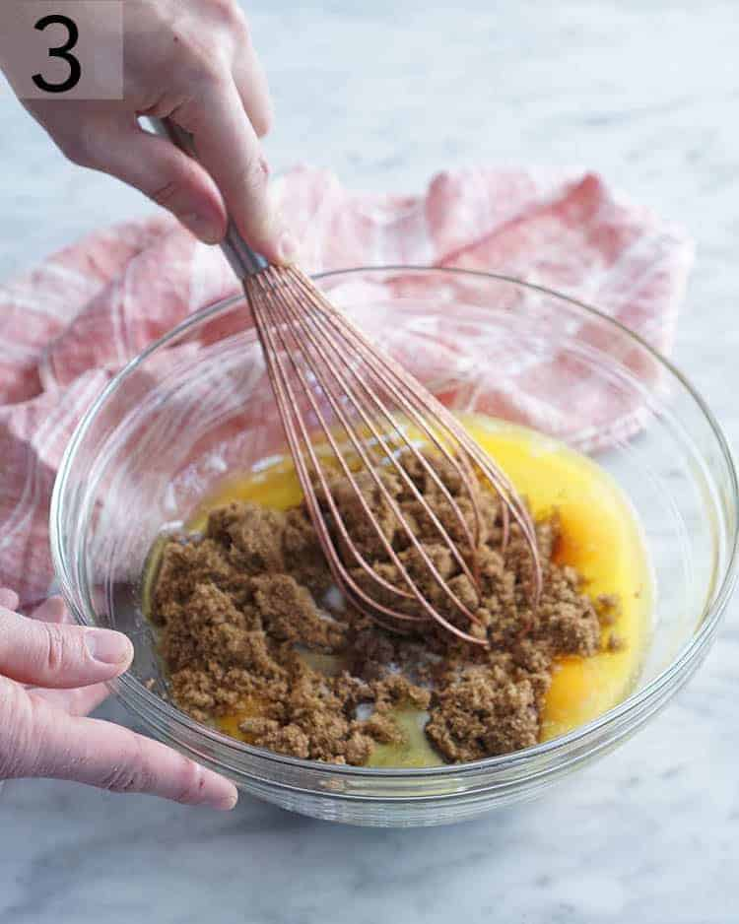

3. Whisk the mixture together until it’s nice and smooth.

4.Sift in the flour, salt and cocoa powder. It is important to sift as the cocoa is often pretty lumpy.

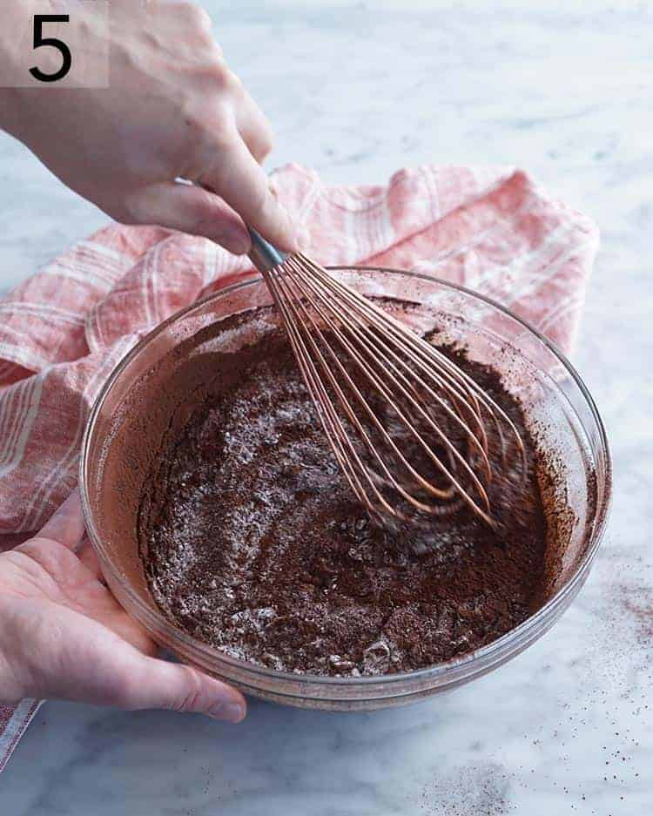

[](https://www.mediavine.com/)

5. Stir the mixture together until just incorporated.

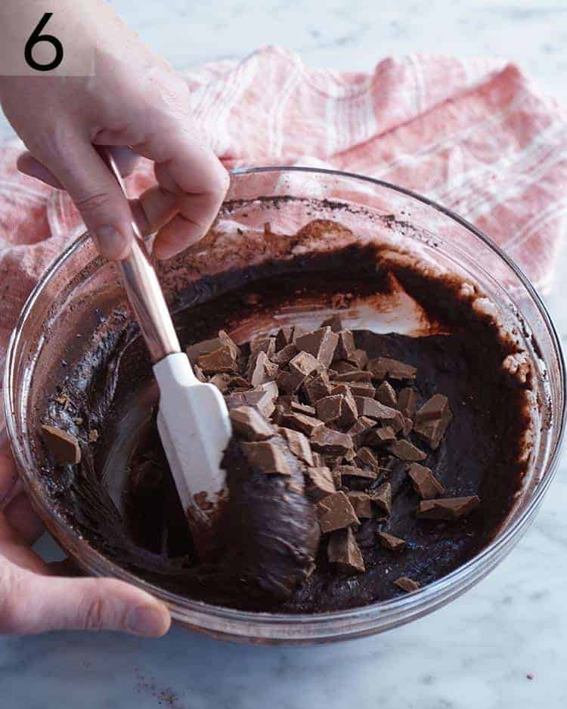

[](https://www.mediavine.com/)

6. Fold in the chocolate chips or chunks. While you have the spatula out it’s a good time to scrape the bottom of the bowl and really make sure there are no pockets of unmixed ingredients hanging out.

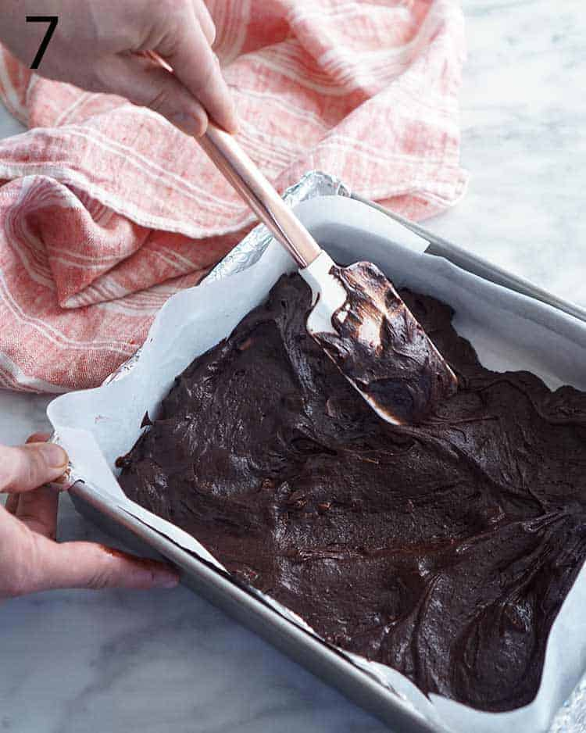

[](https://www.mediavine.com/)

7. Transfer the batter to a parchment-lined baking dish and smooth it to the corners. Bake at 350F for about 30 minutes. The center will continue to bake and set after you remove the brownies from the oven so don’t worry if they seem a bit fudgy.

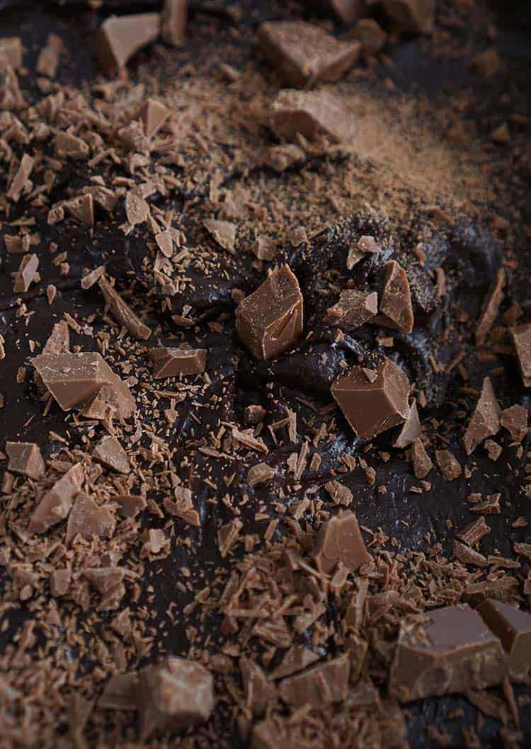

[](https://www.mediavine.com/)

You can add either chopped chocolate or chocolate chips to the top of your brownies but this is totally optional. I’ve made the recipe both ways but found the brownies to be a bit more photogenic without the additional chocolate on top.