Assignment 1: Stock Analysis Streamlit App
Analysis and reflection: adding a second moving average to 06-streamlit-demo.py and to the Stock-based app (assignment_1.py / stock.py).

1. What had to change, and where
In the demo, every change went into one file. I added two sidebar sliders, computed two rolling-mean columns right after the data is downloaded, and switched the price chart from a single y column to a list of three columns. The demo had no moving average at all, so both averages were new there.
demo_modified.py — sidebar, calculation, and chart
short_window = st.sidebar.slider("Short moving average (days)", 5, 200, 20)
long_window = st.sidebar.slider("Long moving average (days)", 5, 200, 50)
...
df["MA_short"] = df["Close"].rolling(window=short_window).mean()
df["MA_long"] = df["Close"].rolling(window=long_window).mean()
...
fig = px.line(
df,
x=df.index,
y=["Close", "MA_short", "MA_long"],
labels={"x": "Date", "value": "Price ($)", "variable": "Series"},
)
In my version the change was spread across two files. The calculation went into the Stock class: __init__ takes a new optional ma_long_window argument, get_data() calls _calc_ma() a second time, and _calc_ma() gained a column parameter so it can write either MA or MA_long. The app then needed a second slider, the new argument passed through the cached load_stock() function and the saved settings tuple, and one more trace in plot_price_ma().
stock.py
def __init__(self, symbol, start=None, end=None, ma_window: int = 10,
ma_long_window: int = None):
...
self.ma_long_window = ma_long_window

# in get_data()
data = self._calc_ma(data, self.ma_window)
if self.ma_long_window is not None:
data = self._calc_ma(data, self.ma_long_window, column='MA_long')

def _calc_ma(self, df : {__setitem__,__getitem__},window, column='MA'):
df[column] = df['Close'].rolling(window=window).mean()
assignment_1.py
def load_stock(symbol, start, end, ma_window, ma_long_window=None):
return Stock(symbol, start=start, end=end, ma_window=ma_window,
ma_long_window=ma_long_window)

ma_long_window = st.sidebar.slider('Long moving average window (days)',
min_value=5, max_value=200, value=50)
if ma_window >= ma_long_window:
st.sidebar.warning('Short window should be smaller than the long window.')

st.session_state['single_args'] = (symbol, start, end, ma_window, ma_long_window)

if 'MA_long' in stock.data:
fig.add_trace(go.Scatter(x=stock.data.index, y=stock.data['MA_long'],
mode='lines', name=f'{stock.ma_long_window}-day MA'))

2. Which version was easier to change without breaking something?
The demo was faster to change: three edits in one file. But it was also easier to break, because the data, the calculation and the chart all live inside the same if run_button: block. One thing that needed care there was the chart label. The original code used labels={"x": "Date", "Close": "Price ($)"}. Once y becomes a list, Plotly melts the columns into "value" and "variable", so a "Close" key no longer matches anything and the axis title falls back to "value". I changed the labels to key on "value" and "variable" instead.
The class version touched more places, but nothing that already worked broke. Because ma_long_window defaults to None, the Portfolio tab's existing call load_stock(ticker, p_start, p_end, p_ma) still ran unchanged and does not compute an extra column it never uses. The easiest mistake to make was updating load_stock() but forgetting the saved settings tuple in st.session_state['single_args'], which would make the new slider do nothing without any error. In both versions, setting the long window to 200 days on a 6-month range leaves MA_long entirely NaN, so that line silently disappears from the chart instead of crashing.

3. Where the class made the change harder or forced a design decision
In the demo I could simply write another df[...] = ...rolling(...) line. With the class I had to decide what the public interface of Stock should be. The options were to add a second window argument, to accept a list of windows, or to leave the class alone and create two Stock objects with different ma_window values. Creating two objects would download the same data twice. Computing the MA in the app would put calculation back in the interface, which is exactly what the class is meant to prevent.
I chose an optional ma_long_window=None argument and a column parameter on _calc_ma(). That keeps every existing call working, keeps the original MA column name that the rest of the app relies on, and reuses one calculation method instead of copying it. The class also forced a caching decision the demo never needed: the new window had to become an argument of the @st.cache_data function so that different long windows are cached separately.
def load_stock(symbol, start, end, ma_window, ma_long_window=None):

4. Which version would I rather start from in six months?
I would start from the class-based version. Each piece has one clear place: data and calculations are in Stock, and the app only builds interface pieces such as plot_price_ma(stock) and zero_based_performance(stock). A new metric such as volatility would become one method on Stock, and both tabs could use it immediately through load_stock(). Error handling is also already consistent: every tab checks stock.data is None and shows stock.message.
if stock.data is None:
st.error(f'{ticker}: {stock.message}')
continue
In the demo, downloading, calculating and plotting are mixed together in one long if run_button: block. Any new feature means reading the whole block to see which DataFrame columns exist at that point. The cost of the class version is that you need to know its column names (change, return, MA, MA_long) and read two files. For anything beyond a quick one-off chart, that cost is worth paying.

Portfolio comparison: MSFT vs. GOOG (last 6 months)
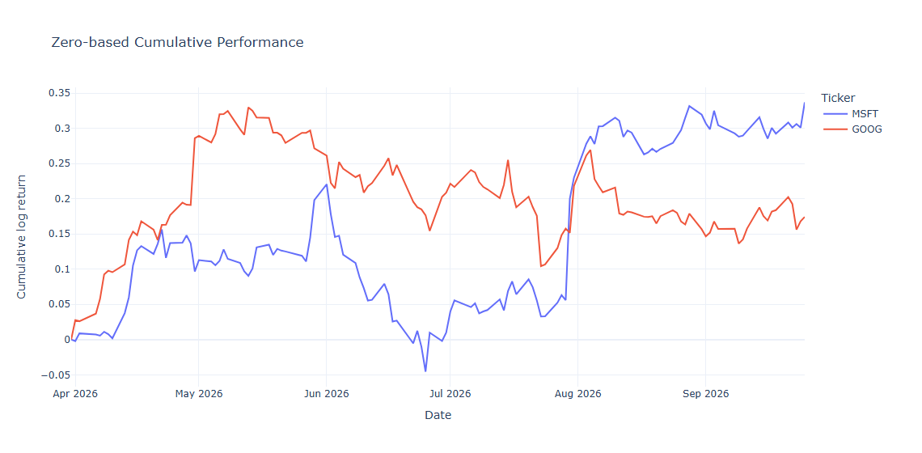
Zero-based cumulative log return from the Portfolio tab, 2026-03-28 to 2026-09-28.
I compared Microsoft (MSFT) and Alphabet (GOOG) from 2026-03-28 to 2026-09-28. GOOG led for most of the period, peaking near 0.33 cumulative log return in mid-May, while MSFT dipped slightly below zero in late June. The gap narrowed on 2026-07-23, when GOOG's daily return was -0.0714 against MSFT's -0.0227. The lines crossed on 2026-07-30: MSFT's daily return that day was +0.1442 (close $389.81 to $450.25), while GOOG's was -0.0062, taking MSFT from 0.056 to 0.200 and past GOOG at 0.152. GOOG rebounded +0.0666 the next day, but MSFT stayed ahead and finished the period at 0.337 against GOOG's 0.174.

