ASTEROID HUNTER
The whole project, start to end
Group report: how we built it, how it works, and how well it works
Course: Machine Learning (702DB0C015) · B.Tech CSE (Data Science), Semester V · MPSTME, NMIMS · 2026-27
Team: Advik (lead), Aaryan, Paras, Satvik
Data: public ZTF images from the IRSA archive
Date: October 2026

Contents
- The project in one page
- The problem
- The data
- The pipeline, step by step
- Our ML model: the CNN
- The second model: scoring tracks
- How we tested it
- Results (evaluation metrics)
- How it got better: the story v1 to v5
- The deep search
- What did not work, limits, and what we do not claim
- Who did what
- Tools, code, and how to run it
- References
- Use of AI (declaration)
- Glossary

1. The project in one page
About this document. It was drafted with the help of an AI assistant (Claude, by Anthropic) from the project's own files, as the course's GenAI policy allows for planning and learning. Before you submit it, read it fully, change anything that is not true for you, and rewrite the parts you present in your own words (see 00_Start_Here/07_AI_Use_and_Integrity.md).
In one sentence: we built a machine-learning pipeline that looks through old, public telescope images from the Zwicky Transient Facility (ZTF) for small moving dots, which are asteroids, and we measured honestly how well it works.
Telescopes photograph the same patch of sky again and again. Stars stay in the same place; asteroids move a little between photos. If we subtract an old photo from tonight's, the stars cancel out and only things that changed are left. The problem is that almost everything left over is junk. On our test night, five photos of one patch of sky gave 41,522 blobs, and only about 3% of them were real. So we:
- find every blob in the difference images,
- use a neural network (CNN) to decide which blobs look like a real object and which are junk,
- link blobs from different photos into straight-line tracks,
- use a second model (XGBoost, made of decision trees) to score each track,
- compare the tracks with the catalogue of known asteroids, and keep anything unknown for a person to check,
- measure everything on nights the models never saw, using fake asteroids we planted ourselves so we know the right answer.

Headline results
What we measured | Result | Where the number comes from
CNN vs simple model (validation nights, 67,041 blobs, 3.2% real) | average precision 0.899 vs 0.780 | 00_Start_Here/01_Project_Overview.md
False alarms per photo when 90% of real blobs are found | 176 (CNN) vs 813 (simple model): 4.6x fewer | project/docs/realbogus_cnn.md
CNN on the untouched test night | average precision 0.938 | project/docs/realbogus_cnn.md
CNN at the deployed stage-1 cut (test night, one quadrant) | recall 99.1% but precision 6.1%: tuned to miss nothing; junk is removed later | web/public/data/night.json
Track classifier (4 models, cross-validated by night) | about 0.999 AP for 3 of 4 models: saturated (96% of tracks are easy fakes), so not used to judge | project/docs/tracklet_classifier.md
Depth: magnitude where half the planted fakes are found (test night) | v1 20.5 → v4 21.4 → deep search 22.1 | reports/scoreboard.csv, docs/deep_search.md
Real search of the test night (no fakes) | 31 known asteroids recovered (16.2 to 21.8 mag) | 00_Start_Here/01_Project_Overview.md
Fast (trailed) objects | 97% of planted trails recovered (93% on a later night) | project/docs/fast_movers.md
3x more training data (v5) | did not help at equal false alarms | project/docs/more_data.md

What we do not claim: no new asteroid has been discovered or reported. The pipeline reliably finds known asteroids down to about magnitude 21, and one faint object in a related two-night study passes every check we have, but it still needs a human review and the Minor Planet Center's process.
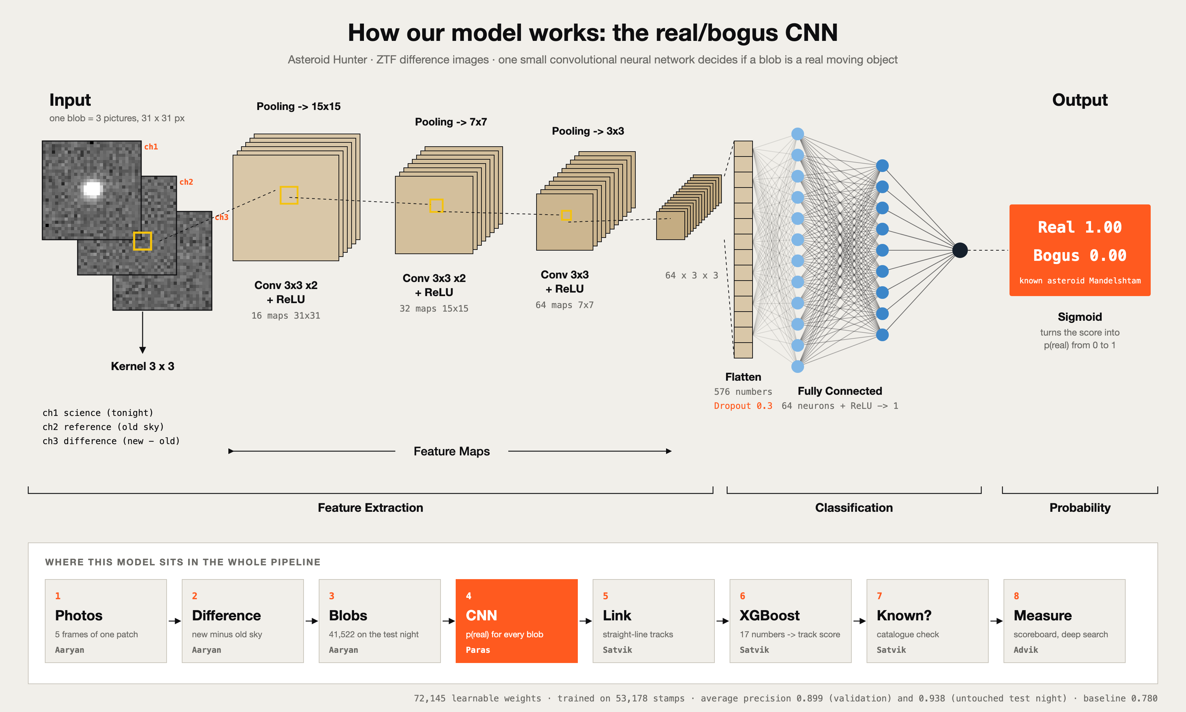
Figure 1. The one ML architecture of the project: the real/bogus CNN, and where it sits in the pipeline (00_Start_Here/00_How_Our_Model_Works.svg).

2. The problem

What we are solving
Input: a few 30-second photos of the same patch of sky, taken over one night. Output: a ranked list of moving objects (tracks), each with a score and a flag saying whether it is a known asteroid.

Why it is hard
- Most blobs are junk. About 97% of blobs are noise, leftovers of bright stars, cosmic-ray hits or edges of bad pixels.
- The interesting asteroids are faint, barely brighter than the noise.
- Nobody labels the sky. There is no list of 'every asteroid in this picture', so we had to create our own labels.
- The telescope moves a little between photos, so the same star is not on the same pixel each time.
- Catalogues have errors too; one of them was about 2.9 arcseconds off, which we only found because our model disagreed with it.

Why machine learning is needed (and where it is not)
Junk comes in many shapes, and writing a hand-made rule for each one fails. A CNN can learn what real and junk look like from labelled examples. A tree model can combine many weak clues about a track better than any single threshold. But some steps are not learning at all: finding blobs, joining them along straight lines and adding photos together are physics and statistics. Knowing which part needs learning and which does not is part of good ML design.

How we measure success
Not with accuracy: a model that always says 'junk' would be 96.8% accurate and find nothing. Instead we use precision, recall and average precision, the number of false alarms per photo at a fixed recall, the depth (how faint we can go), the number of known asteroids recovered, and unexplained alarms per night. A simple baseline (logistic regression on six numbers per blob, AP 0.780) is the bar every model must beat.
The idea came from an online post where someone found a planet candidate in old Kepler data with AI-written code. We checked that post first: the signal belongs to an already confirmed planet (Kepler-169 e). That taught us the first lesson of the project: check before you claim.

3. The data
All data is public: ZTF images served by NASA/IPAC's IRSA archive. For every exposure there are four files: the science image (38 MB), the mask of bad pixels (19 MB), the difference image (7 MB) and the PSF, the shape a point of light makes in that photo (6 KB). The reference image is not downloaded separately: reference = science − difference.
Fact | Value
Exposures of our patch of sky in the archive | 1,552 (898 r-band, 478 g-band, 176 i-band)
Exposures with quality warnings (removed) | 16.4%
Nights with at least 4 good photos | 40
Downloaded for the first 11 nights | 220 files, 3.55 GB, nothing missing
One photo (one CCD quadrant) | 3072 x 3080 pixels, 1.01 arcsec per pixel, 30 seconds
Raw data on disk by the end | about 50 GB (not in the project folder)

Split by night, decided before any modelling
We split the data by night, never by random rows, and wrote the split into a configuration file (configs/acquire.yaml) before training anything, so it could not quietly change after a disappointing result.
Split | Nights | Used for
Train | 8 | learning the models
Validation | 2 | choosing settings and thresholds
Test | 1 (2019-02-08) | the honest final check; the sharpest, deepest night
Holdout | 1 (2022-06-17) | opened only by the scoreboard
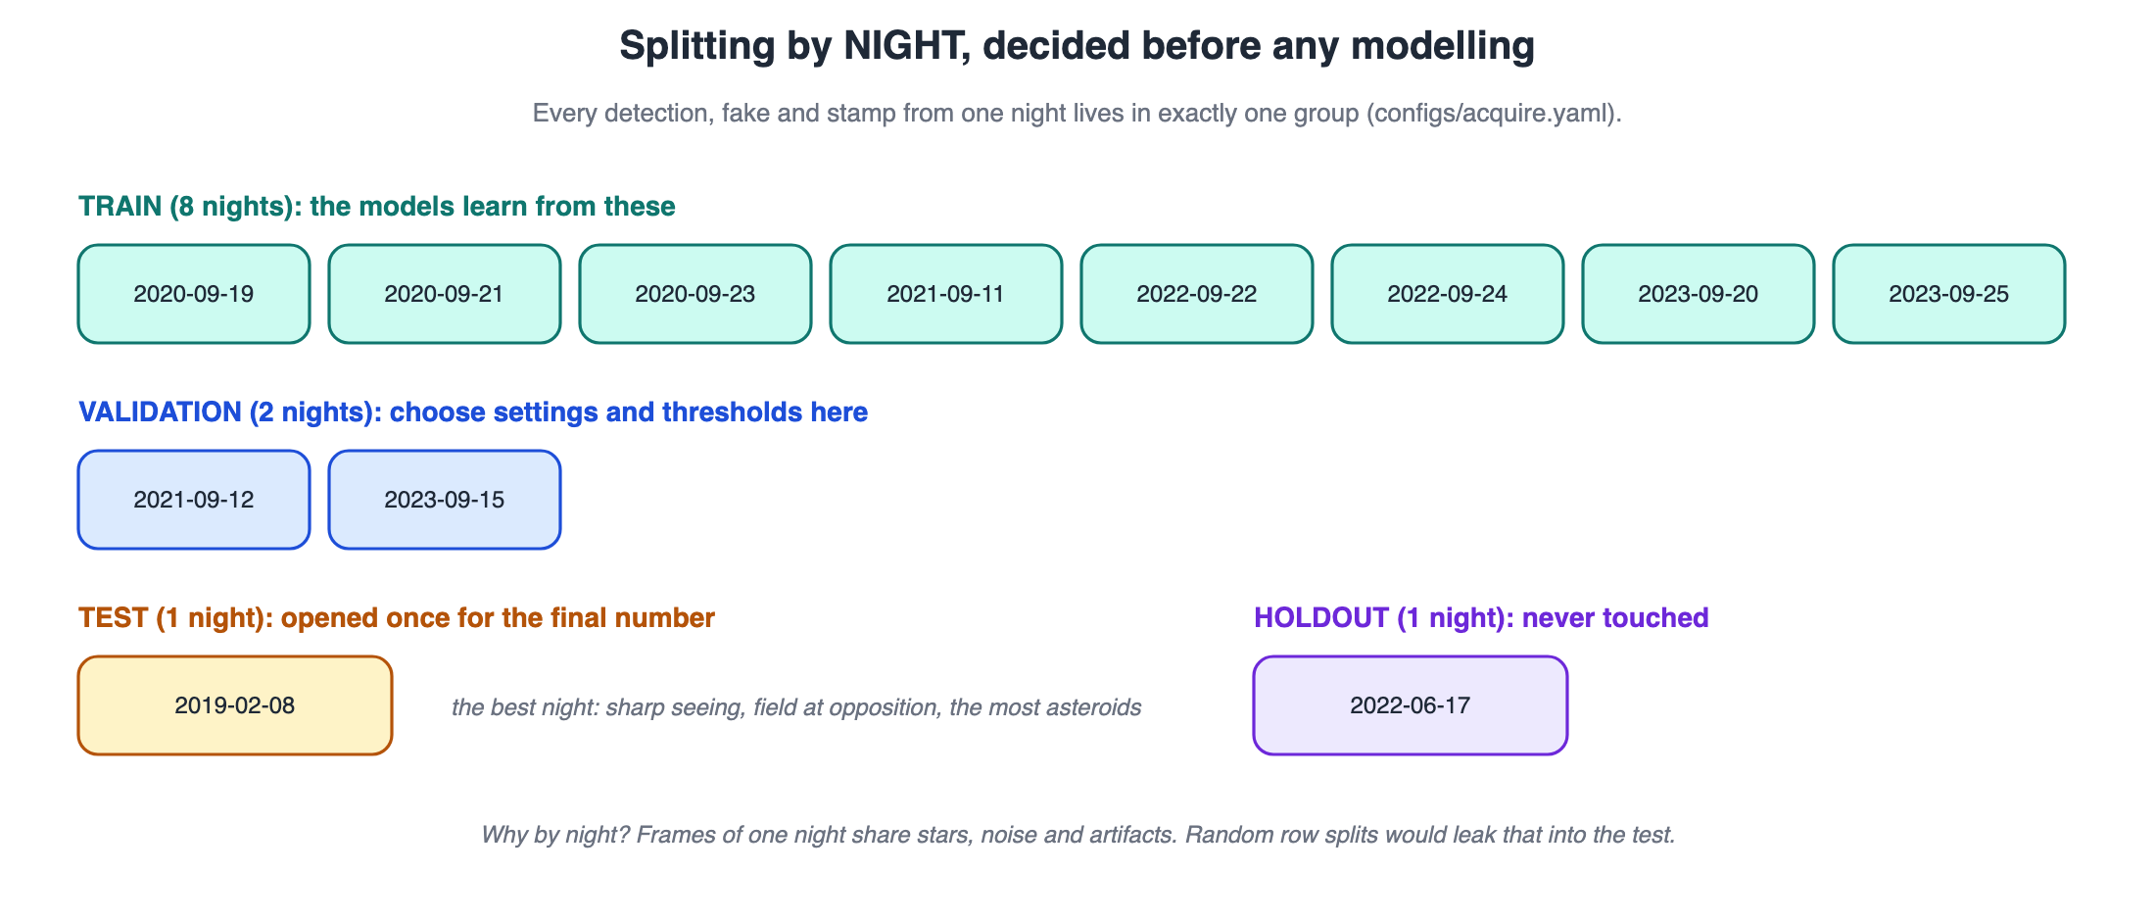
Figure 2. Splitting by night (00_Start_Here/11_Diagrams/02_split_by_night.svg).

Cleaning
- Bad pixels (saturated, dead, noisy, satellite trails, empty areas) are masked; about 6-12% of a difference image is empty (NaN).
- The noise level is measured robustly: 1.4826 x the median absolute deviation, so bright stars do not inflate it.
- Pixel positions are turned into sky coordinates, because the telescope points slightly differently each time.

4. The pipeline, step by step
The same code path is used to evaluate the system (with planted fakes) and to run the real search (without). What we test is exactly what we deploy.
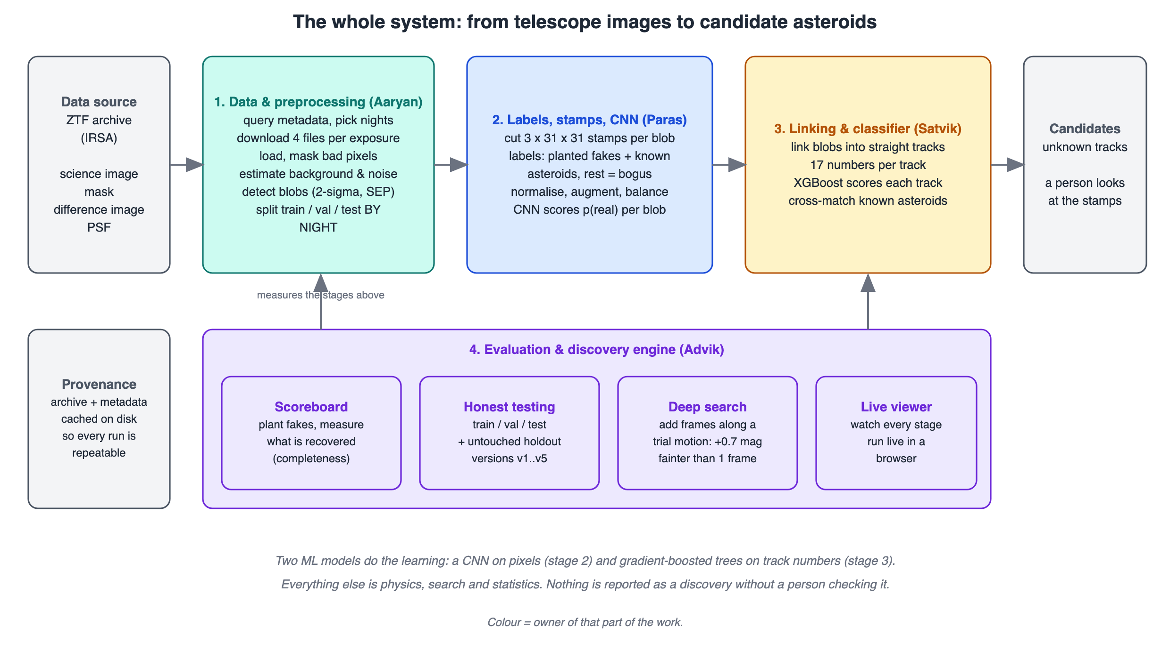
Figure 3. The whole system (00_Start_Here/11_Diagrams/01_system_overview.svg).
# | Step | What happens, in plain words | Owner
1 | Pick the photos | Take 5 photos of one patch of sky from one night, in time order. | Aaryan
2 | Open and clean | Read the four files, build the bad-pixel mask, compute the reference, measure the noise. | Aaryan
3 | Plant fakes (test mode) | Paint 300 fake asteroids into the photos with ZTF's own blur shape, so we know the right answer. | Paras
4 | Find blobs | Circle every spot at least 2x brighter than the noise and at least 5 pixels big: about 7,800 per photo. | Aaryan
5 | Cut stamps | Cut a 31 x 31 pixel square around each blob from science, reference and difference. | Paras
6 | CNN score | The neural network gives every blob a score from 0 (junk) to 1 (real). Low scores are dropped. | Paras
7 | Link | Join kept blobs from different photos that lie on a straight line at a steady speed. | Satvik
8 | Describe tracks | Give every track 17 numbers: speed, straightness, steady brightness, CNN opinion and more. | Satvik
9 | Score tracks | XGBoost turns the 17 numbers into one track score. | Satvik
10 | Known or unknown? | Compare with the catalogue of known asteroids (positions from JPL Horizons). | Satvik
11 | Measure | Count planted fakes found by brightness, known asteroids found, and unexplained alarms. | Advik
12 | Show it | The live viewer and the web app show every stage on real images. | Advik

5. Our ML model: the CNN
We use one neural network architecture: a small convolutional neural network (CNN) that looks at the three stamps of a blob and outputs one number, p(real). Small was a deliberate choice: the stamps are only 31 x 31 pixels and the patterns are local, so 72,145 weights are enough, train fast on a laptop, and are hard to overfit.

Why three pictures
A real new object shows up in the science and difference images but not in the reference. A badly subtracted star shows up in science and reference, with a messy pattern in the difference. A cosmic ray is a sharp spike, narrower than a star. Seeing all three at once lets the filters learn these differences directly.
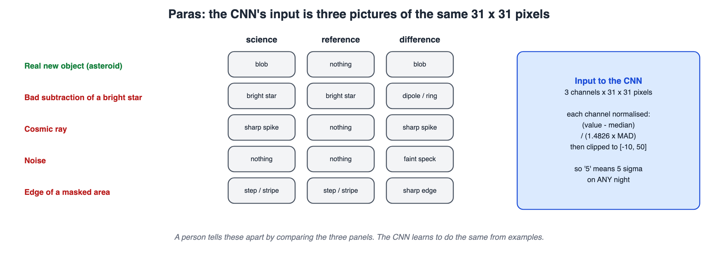
Figure 4. What the three channels look like for real objects and junk (03_Paras/07_Diagrams/02_triplet_stamp.svg).

The layers
Layer | Output size | What it does | Weights
Input | 3 x 31 x 31 | science, reference, difference | 0
2 x Conv 3x3 (16 filters) + ReLU | 16 x 31 x 31 | finds small shapes: dots, edges, rings | 2,768
Max-pool 2x2 | 16 x 15 x 15 | keeps the strongest value; halves the size | 0
2 x Conv 3x3 (32 filters) + ReLU | 32 x 15 x 15 | combines shapes into bigger patterns | 13,888
Max-pool 2x2 | 32 x 7 x 7 |  | 0
Conv 3x3 (64 filters) + ReLU | 64 x 7 x 7 | patterns over the whole blob | 18,496
Max-pool 2x2 | 64 x 3 x 3 |  | 0
Flatten + Dropout 0.3 | 576 | one long list; dropout switches off 30% while training | 0
Fully connected + ReLU | 64 | weighs all the evidence | 36,928
Fully connected + Sigmoid | 1 | p(real) from 0 to 1 | 65
Total |  |  | 72,145

How it was trained
- Labels: planted fakes and known asteroids within 2 pixels of a blob are 'real'; everything else is 'bogus'.
- Normalising: every stamp is put on the same scale ((value − median) / noise), so the model compares shapes, not brightness.
- Augmenting: random 90° rotations and mirror images (the sky has no 'up'); training data only.
- Balancing: all 8,863 real stamps plus 5 bogus per real = 53,178 training stamps (16.7% real). Validation keeps the true mix: 67,041 stamps, 3.2% real.
- Settings: Adam optimiser, learning rate 0.001, batch 256, up to 25 epochs, early stopping after 4 epochs without improvement; binary cross-entropy loss. Best validation AP 0.899 at epoch 21.
- Cross-fitting: the scores passed to the next model come from CNNs that never saw that night, so the next model does not learn from over-confident scores.
The web app (web/) runs this exact network, with the trained weights, inside the browser; its scores match PyTorch to within 0.00001 on 48 real stamps.

6. The second model: scoring tracks
After linking, each track is described by 17 numbers. Each has a physical reason: an asteroid moves at a steady speed in a straight line, keeps nearly the same brightness for half an hour, stays a round point, leaves nothing behind at its old positions, and is faintly visible at its predicted position even in photos where no blob was found.
Group | Numbers | Idea
Motion | photos it appears in, speed, distance off a straight line | steady straight motion
Brightness | mean and spread of magnitude | asteroids keep their brightness; noise does not
Strength | mean and lowest SNR | one weak point makes a weak track
CNN opinion | mean and lowest CNN score | what the network thought of each blob
Shape | size spread, elongation | a point source stays the same shape
Static neighbours (v4) | blobs left behind at the track's positions | a mover leaves none; an artifact leaves many
Forced photometry (v4) | signal at the predicted spot in every photo | real objects leave a weak signal even when missed
We compared four models, always cross-validated by night (GroupKFold): logistic regression (0.999 AP), a single decision tree (0.983), a random forest (0.999) and XGBoost (0.999; 300 trees, depth 3, learning rate 0.05). Three of them tie. We use XGBoost because it handles missing values and interactions without extra work, but we say openly that logistic regression would be a defensible simpler choice.
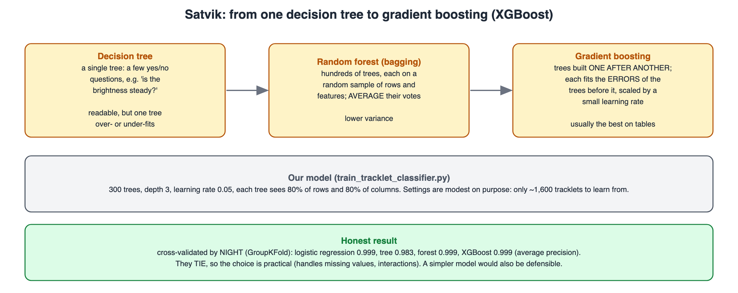
Figure 5. From one decision tree to a forest to boosting (04_Satvik/07_Diagrams/02_boosting.svg).

7. How we tested it
- Planted fakes (injection-recovery). We cannot know every real asteroid in an image, so we plant 300 fakes per night (magnitude 17 to 22, speed 5 to 100 arcsec/hour, any direction), run the normal pipeline and count how many come out.
- Are the fakes realistic? A classifier asked to tell fakes from real known asteroids could not (AUC 0.46-0.48, where 0.5 means 'cannot tell').
- Held-out nights. Numbers only count when they come from nights nobody tuned on.
- One scoreboard. A single function computes every headline number for every model version and writes reports/scoreboard.csv.
- Fair comparisons. Models are compared at the same false-alarm level, not each at its own threshold.
- Statistics. When we try thousands of possibilities (the deep search), chance alone produces strong-looking signals, so the thresholds are set from pure-noise tests.
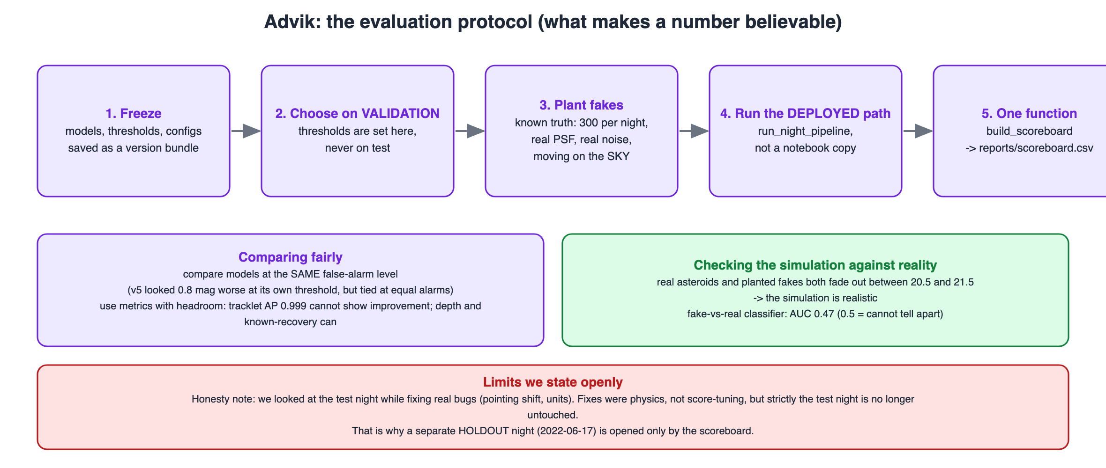
Figure 6. The evaluation protocol (01_Advik/07_Diagrams/02_evaluation_protocol.svg).

The metrics in plain words
Metric | Question it answers
Recall | Of all the real objects, how many did we find?
Precision | Of everything we flagged, how much was real?
Average precision (AP) | How good is the model across all thresholds, for a rare class? (1.0 = perfect)
False alarms per photo at 90% recall | If we insist on finding 90% of real objects, how much junk do we have to look at?
Depth (magnitude at 50% completeness) | How faint can an asteroid be and still be found half the time?
Known asteroids recovered | Does it find real asteroids on its own, without our fakes?
Unexplained alarms per night | How many high-scoring tracks are neither fakes nor known asteroids?

8. Results (evaluation metrics)

The CNN against the simple baseline
Model (validation nights) | Average precision | Precision at 90% recall | False alarms per photo at 90% recall
Logistic regression on 6 numbers (baseline) | 0.780 | 0.191 | 813
Our CNN | 0.899 | 0.522 | 176
At the same recall the CNN lets through 4.6x fewer false alarms. On the untouched test night its average precision is 0.938.
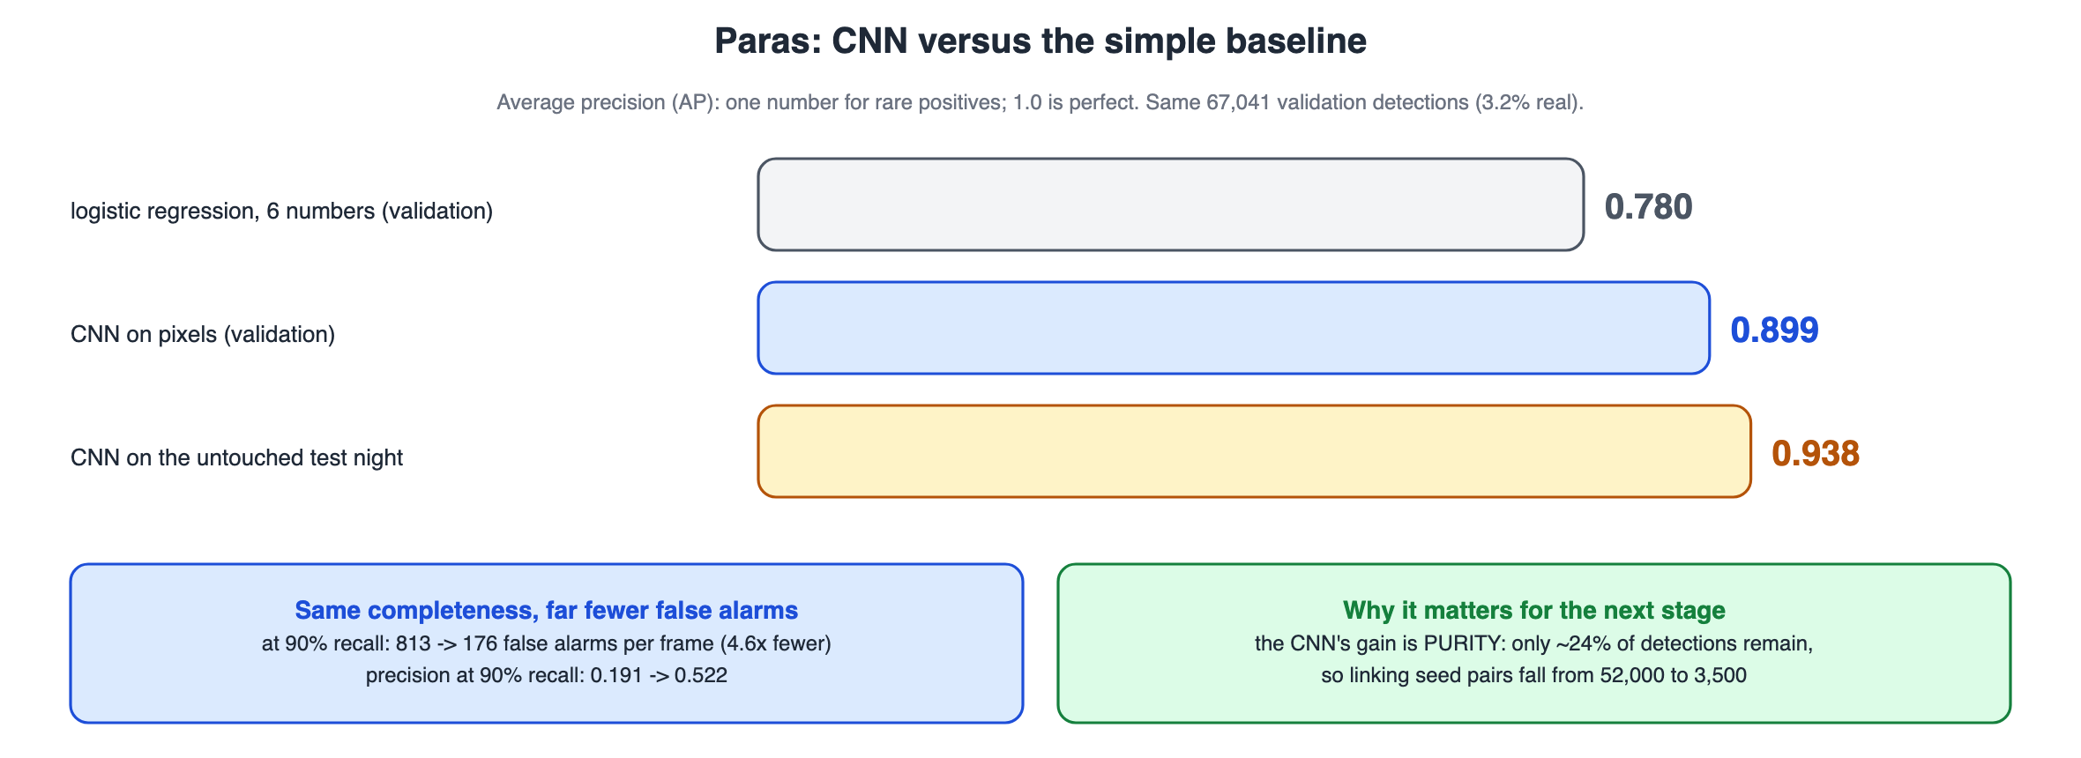
Figure 7. CNN results (03_Paras/07_Diagrams/04_cnn_results.svg).

The CNN on the whole test night
Cut | Recall | Precision | F1 | False alarms per photo
Stage-1 cut (deployed) | 99.1% | 6.1% | 0.11 | 4,144
Cut for 95% recall | 95.0% | 55.0% | 0.70 | 210
Cut for 90% recall | 90.1% | 90.5% | 0.90 | 26
Recall alone can look too good: the deployed stage-1 cut keeps 99.1% of real blobs, but only 6.1% of the blobs it keeps are real (4,144 junk blobs per photo). That is a deliberate choice: an asteroid dropped here is lost for good, while junk is removed later by linking and the track model. Asking for 90% recall instead gives 90.5% precision. Average precision over all cuts is 0.944 (random guessing would score 0.032). The whole pipeline is judged at the end by depth, known asteroids recovered and unexplained alarms per night.
At the deployed cut | Kept (predicted real) | Dropped (predicted junk)
Really real | 1,336 true positives | 12 missed
Really junk | 20,722 false alarms | 19,452 true negatives

Why accuracy is the wrong number
 | Predicted real | Predicted junk
Really real (2,129) | 1,547 true positives | 582 missed
Really junk (64,912) | 493 false alarms | 64,419 true negatives
This is the baseline at threshold 0.5 on the validation nights. Accuracy is 98.4%, but a model that always says 'junk' scores 96.8% and finds nothing. ROC AUC looked excellent (0.95) while average precision was only 0.78. For rare positives, precision and recall tell the truth.

The scoreboard: every version, measured the same way
nights | version | blob AP | stage-1 recall | junk kept per photo | track AP (saturated) | depth (mag) | known found | unexplained per night
test | v1 | 0.942 | 97.4% | 1,245 | 0.998 | 20.53 | 39/44 | 0.0
test | v2 | 0.942 | 99.2% | 4,293 | 0.992 | 21.39 | 40/44 | 13.3
test | v4 | 0.942 | 99.2% | 4,293 | 0.993 | 21.34 | 40/44 | 5.0
test | v5 | 0.940 | 99.2% | 3,857 | 0.993 | 20.56 | 38/44 | 0.3
validation | v1 | 0.919 | 96.0% | 1,184 | 1.000 | 20.18 | 21/28 | 0.0
validation | v4 | 0.919 | 99.2% | 3,901 | 0.998 | 20.49 | 24/28 | 0.0
holdout | v1 | 0.905 | 95.4% | 1,468 | 1.000 | 20.14 | 16/18 | 0.0
holdout | v4 | 0.905 | 98.5% | 4,716 | 0.998 | 20.47 | 17/18 | 0.3
From project/reports/scoreboard.csv. Planted-fake runs over 3 quadrant-nights for test and holdout and 6 for validation. On the single test-night quadrant the summary numbers are 20.5 (v1) and 21.4 (v4); with the deep search, 22.1.
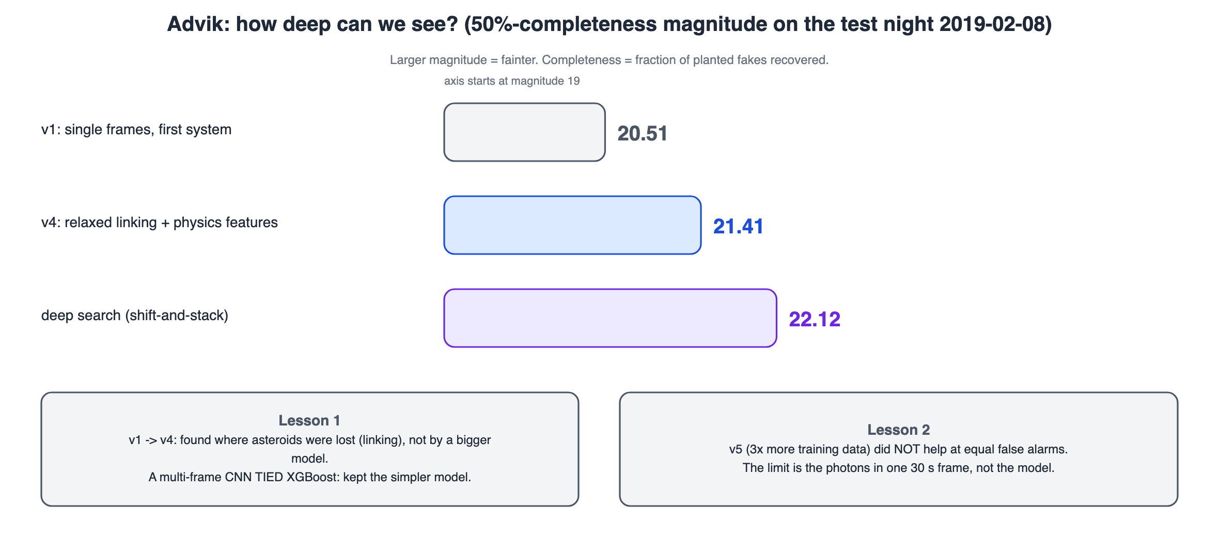
Figure 8. How the versions compare (01_Advik/07_Diagrams/03_scoreboard_versions.svg).

The real search
Without any fakes, the pipeline found 31 known asteroids on the test night by itself, from magnitude 16.2 to 21.8, with no unexplained candidates above the threshold. On the test night, all 9 tracks that our labels called 'false positives' turned out to be real known asteroids that the labels had missed.

9. How it got better: the story v1 to v5
- v1: CNN + XGBoost on single photos. Track AP 0.999 looked perfect, but the scoreboard showed depth only about 20.5. The right metrics were depth and known asteroids, not AP.
- We measured where asteroids were lost: at linking, not at the classifier. Relaxing linking (3 of 5 photos instead of 4) found more asteroids but created about 1,500 chance tracks per night, which became useful hard examples (v2).
- Looking at false alarms by eye showed two kinds (artifacts that 'walk' and noise that happens to line up). One new feature group for each gave v4 with 17 features.
- A bigger multi-frame CNN tied the simple XGBoost (AP 0.9933 vs 0.9924), so we kept the simple one.
- Three times more training data (v5) did not help at equal false alarms: one 30-second photo only holds so much light.
- So we added photos together (the deep search): +0.7 magnitude, to 22.1.

Real bugs found by checking against reality
- Telescope pointing shifts (up to 12 pixels between photos): real asteroids failed to link while fakes linked perfectly. Fixed by linking on one shared sky grid; leftover error fell from about 2.5 to 0.05-0.47 pixels.
- Catalogue offset: the CNN's most confident 'mistakes' were known asteroids; the SkyBoT positions were about 2.9 arcsec off. Switching to JPL Horizons cut the median error from 2.72 to 0.26 pixels.
- Leakage in the first dataset: 100% accuracy was a warning sign. A test showed 100% → 50% (a coin flip) on realistic data; after rebuilding, 99%. (These are accuracies on a 50/50 balanced set, the one case where accuracy is fair; on real data, 3% positive, we never use it.)
- A bug in one of our own features flagged 22% of real tracks; after the fix, 0.4%. A test was written for each fix.

10. The deep search
A faint asteroid is hidden in the noise of any single photo. If we knew its motion, we could shift each photo so the asteroid stays on the same pixel and add them up: the signal grows N times but the noise only √N times. We do not know the motion, so we try 4,888 of them (every direction up to 120 arcsec/hour) on the laptop's GPU.
- The catch: trying 4,888 motions at every pixel makes chance peaks common. On pure noise there were 6,179 false peaks per stack at 5σ but only 44 at 6σ, so we use 6σ.
- Real data are messier than noise: the first version still gave about 47,550 peaks per stack; after clipping, background removal and masking it was 94.
- Null test: shuffling the photo times (so real movers no longer line up) gave 16 false tracks per night before a velocity-consistency cut and 0 after, while all 20 known asteroids were kept.
- Result: half the planted fakes found at 22.1 magnitude, vs 21.4 for the best single-photo system on the same night (+0.7).
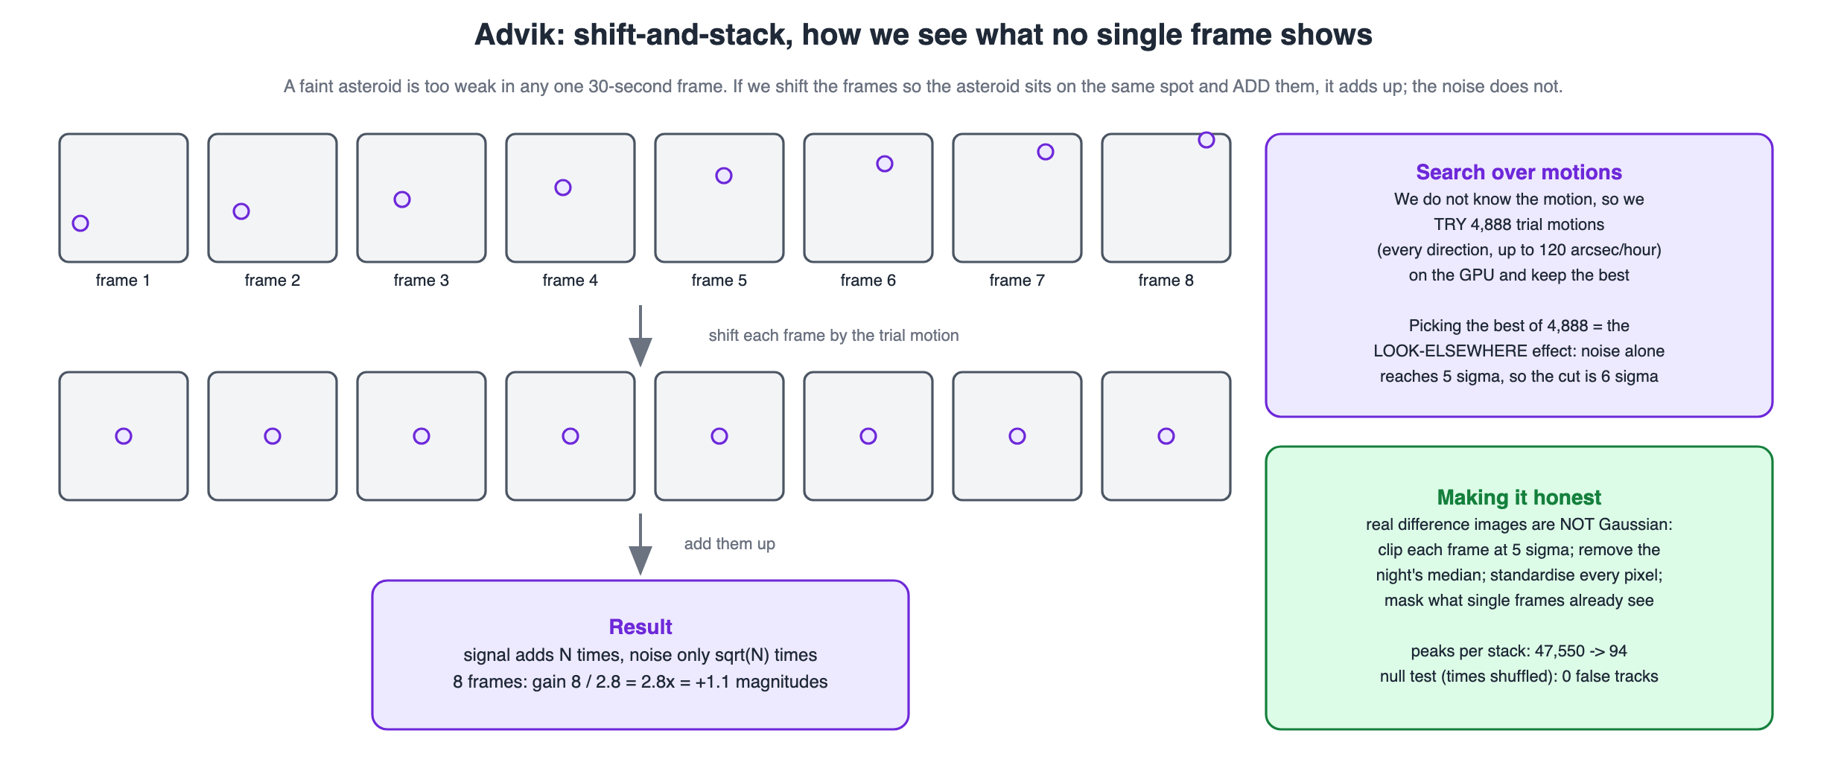
Figure 9. Shift-and-stack (01_Advik/07_Diagrams/04_shift_and_stack.svg).

11. What did not work, limits, and what we do not claim
- No discovery is claimed. Nothing has been reported to the Minor Planet Center.
- One night, one patch: the best depth (22.1) is for one night and one CCD quadrant.
- Labels are partly simulated: the realism test says fakes look like real asteroids on the features we checked, which is a check, not a proof.
- The test night was looked at while fixing real bugs; that is why a separate holdout night exists.
- Probabilities are inflated because training was balanced (16.7% real vs about 3% in reality); we correct for the base rate when we need real probabilities.
- A fancier model and more data did not help. We report these negative results because they explain where the real limit is.
- The deep search needs at least 20 photos in a night; a night with 18 photos silently found nothing until we added a check.

12. Who did what
Member | Part | Main results | Course marks it covers
Aaryan | Problem, data, preprocessing, exploration, leakage audit | 1,552 exposures checked; split by night; leakage proved and fixed (100% → 50% → 99%) | Problem understanding (3), preprocessing and exploration (3, shared)
Paras | Labels, dataset, the CNN | AP 0.899 vs 0.780; 4.6x fewer false alarms; test AP 0.938; catalogue bug found | Model development (4, shared), data preparation
Satvik | Linking, track classifier, metrics, cross-match | pointing-shift fix; 17 features; 4 models tie; metric choices | Model development (4, shared), evaluation basics
Advik (lead) | System, evaluation, deep search, live viewer, web app | scoreboard; depth 20.5 → 21.4 → 22.1; 31 known asteroids | Evaluation (3), documentation and presentation (2), integration
The hand-over chain: Aaryan → a clean table of blobs and a split by night → Paras → every blob with a CNN score → Satvik → scored tracks marked known or unknown → Advik → the scoreboard, the deep search and the demo. Each person's step-by-step process is in their own report and in 0X_Name/00_Process_Diagram_Name.svg.
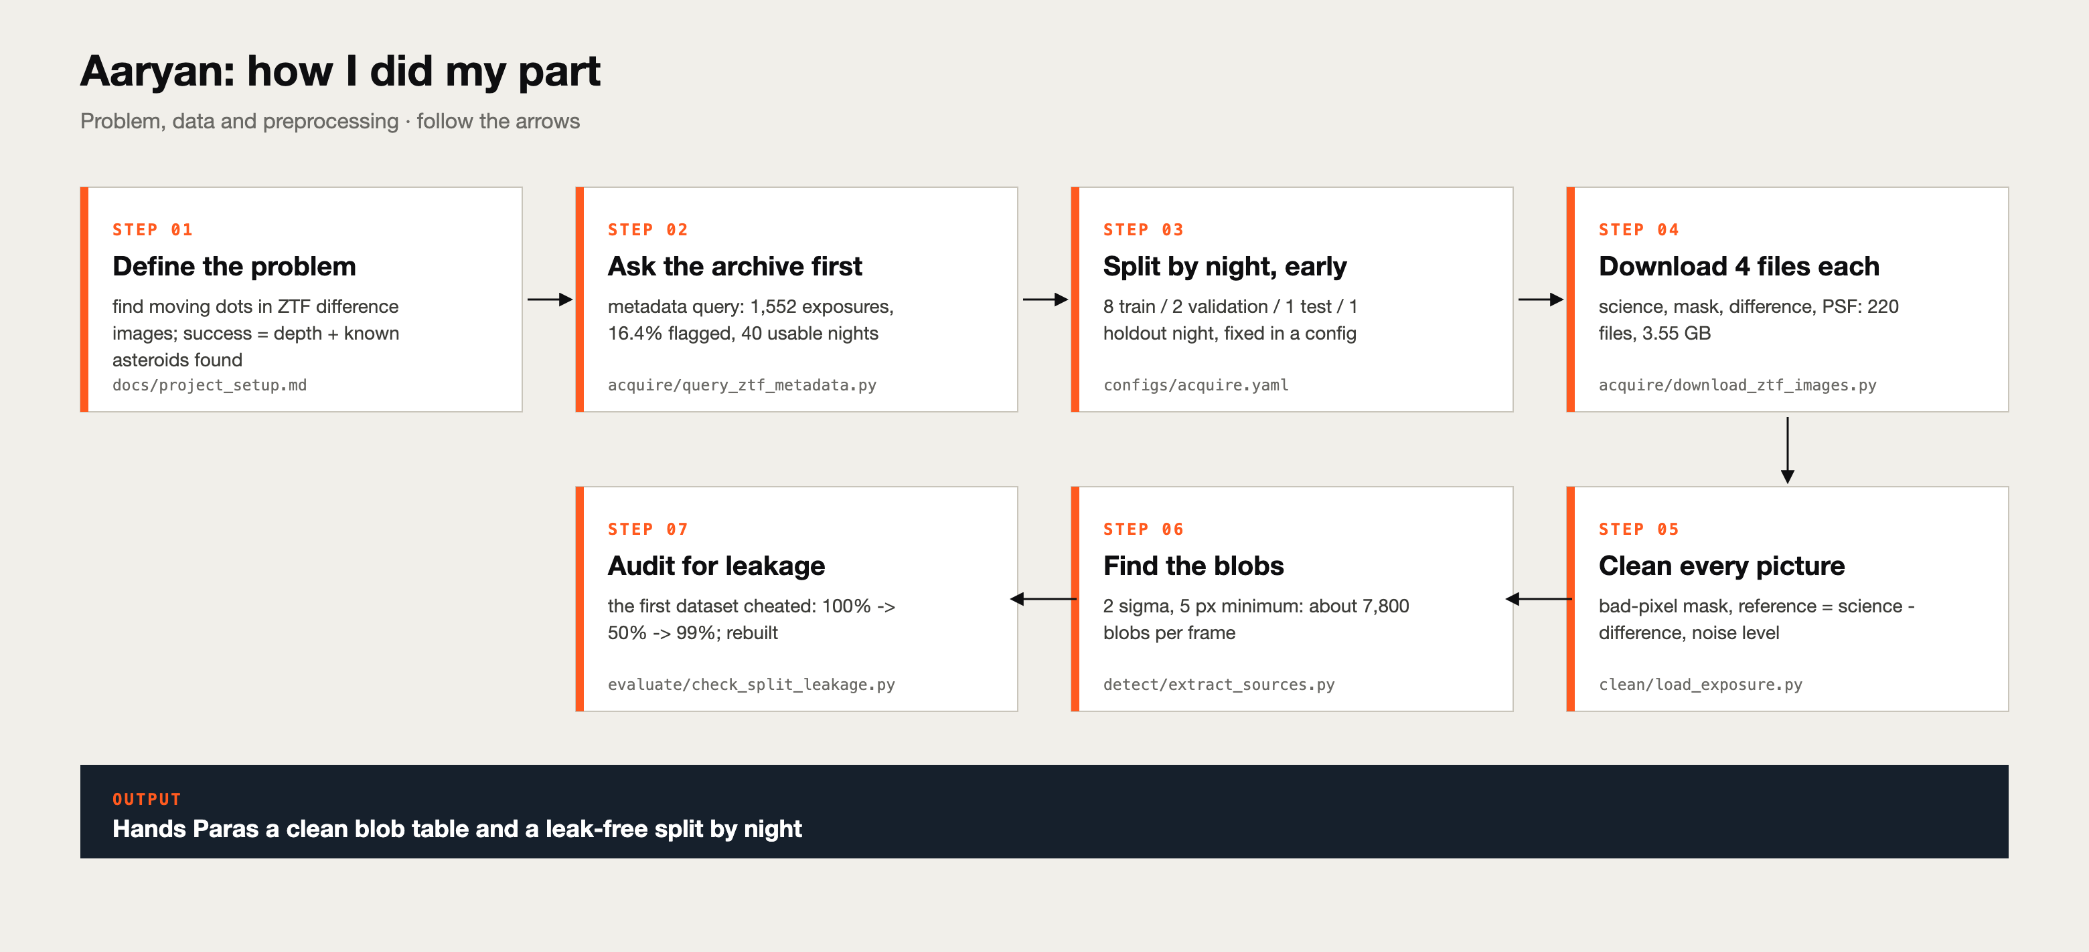
Figure. Aaryan's process.
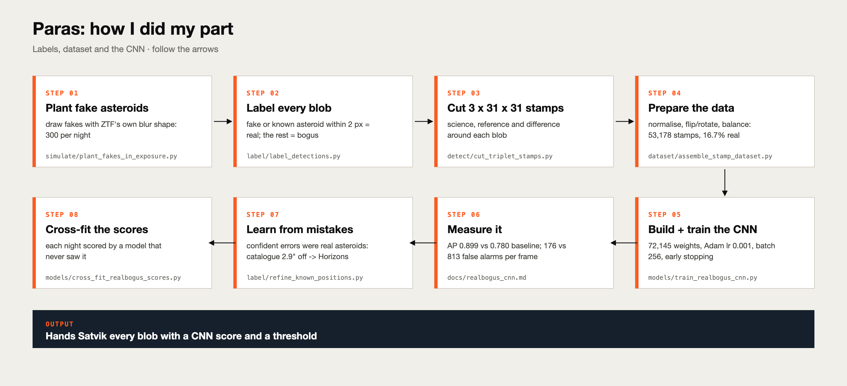
Figure. Paras's process.
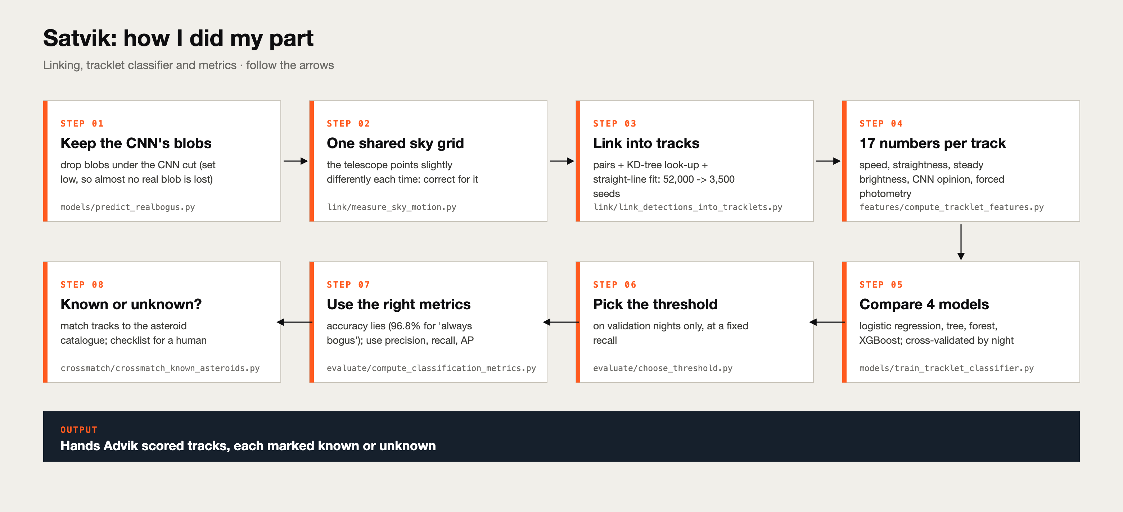
Figure. Satvik's process.
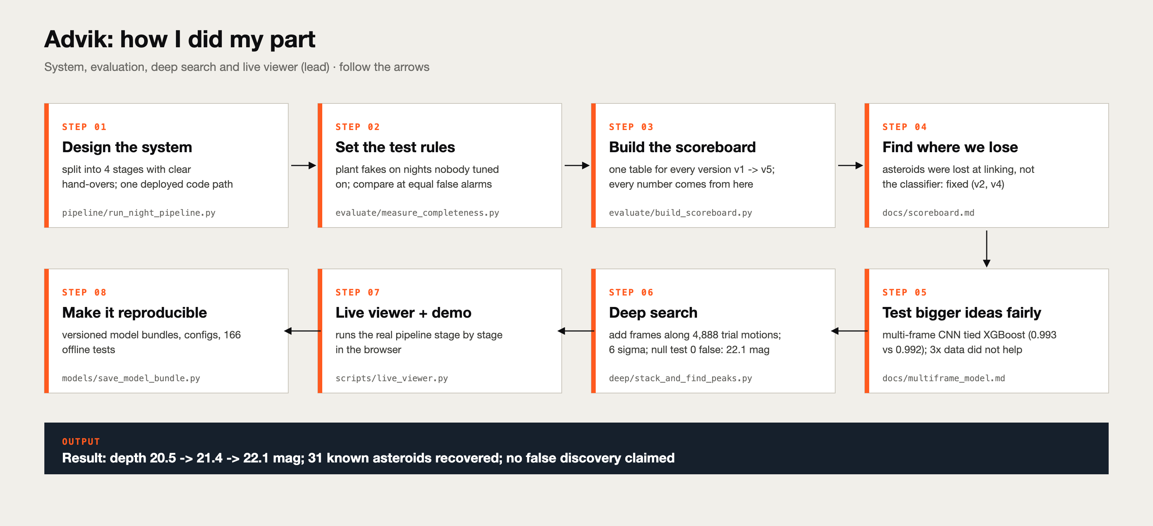
Figure. Advik's process.

13. Tools, code, and how to run it
Thing | Where
Runnable code | project/src/asthunt/<stage>/<verb_object>.py, one purpose per file
Settings | project/configs/*.yaml (night split, thresholds, sizes)
Trained models | project/models/v1 ... v5 (CNN + track model + thresholds + provenance)
Tests | project/tests: 166 offline tests (pytest -q, about 40 s)
Lessons and notebooks | project/docs/*.md and project/notebooks/*.ipynb, one per phase
Live viewer | python scripts/live_viewer.py (needs the raw images)
Web app | web/: cd web, npm install, npm run dev, open http://localhost:3000 (no Python or raw data needed)
Software | Python, NumPy, pandas, astropy, SEP, PyTorch, scikit-learn, XGBoost; Next.js for the web app

14. References
- Duev, D. A. et al. (2019). Real-bogus classification for the Zwicky Transient Facility using deep learning. MNRAS 489, 3582. (closest published work to our CNN)
- Mahabal, A. et al. (2019). Machine Learning for the Zwicky Transient Facility. PASP 131, 038002.
- Masci, F. J. et al. (2019). The Zwicky Transient Facility: Data Processing, Products, and Archive. PASP 131, 018003.
- Whidden, P. J. et al. (2019). Fast algorithms for slow moving asteroids. AJ 157, 119. (the shift-and-stack idea)
- Shallue, C. J. & Vanderburg, A. (2018). Identifying exoplanets with deep learning. AJ 155, 94. (the inspiration)
- Chen, T. & Guestrin, C. (2016). XGBoost: a scalable tree boosting system. KDD.
- Kingma, D. & Ba, J. (2015). Adam: a method for stochastic optimization. ICLR.
- Data: Zwicky Transient Facility, via NASA/IPAC Infrared Science Archive (IRSA). Use the acknowledgement text from the IRSA ZTF release notes.
Only the abstracts and bibliographic details were checked online; read the papers yourselves before quoting details (see 00_Start_Here/04_Course_Mapping.md).

15. Use of AI (declaration)
Edit this so it is true for each of you before submitting.
This project was developed with the assistance of an AI coding assistant (Claude, by Anthropic), used under the direction of Advik Divekar. The assistant helped to plan the project, write and test the source code, write the lesson documents, diagrams, the web app and these reports, and prepare study material. Each team member then studied, re-ran and [describe what you personally did] the part they present: Advik (system, evaluation and deep search), Aaryan (data and preprocessing), Paras (labels and the neural network), Satvik (linking, tree models and metrics). We understand and can explain the methods and results, and all references used are cited.

16. Glossary
Word | Meaning in plain words
Asteroid | a small rocky body orbiting the Sun; in our photos, a dot that moves in a straight line
ZTF | Zwicky Transient Facility: a telescope camera at Palomar Observatory that photographs the whole northern sky every few nights
Exposure / photo / frame | one 30-second picture of one patch of sky
Science / reference / difference image | tonight's photo / an old, very deep photo of the same sky / tonight minus old: only what changed is left
Blob (detection) | a spot in the difference image brighter than the noise
Stamp | a small 31 x 31 pixel cut-out around a blob, from all three images
Real / bogus | a real object (asteroid, planted fake) / junk (noise, bad subtraction, cosmic ray)
Planted fake (injection) | an artificial asteroid we paint into the images so we know the right answer
Tracklet (track) | blobs from different photos that line up as one moving object
Magnitude | brightness scale where a bigger number means fainter; each +1 is about 2.5x fainter
Depth | the magnitude where half the planted fakes are found; bigger is better
CNN | convolutional neural network: learns patterns in pictures with small sliding filters
XGBoost | a model made of many small decision trees, each one fixing the mistakes of the ones before
Precision / recall | of what we flagged, how much was real / of what was real, how much we flagged
Average precision (AP) | one number summarising precision at every recall; 1.0 is perfect; good for rare positives
Leakage | when the test data secretly gives away the answer, so the score is too good to be true
Overfitting | learning the training examples by heart instead of the general pattern
Sigma (σ) | the typical size of the noise; '5 sigma' means 5 times bigger than typical noise

