ASTEROID HUNTER
Advik: my part, start to end
System architecture, evaluation, deep search and live viewer (lead)
Course: Machine Learning (702DB0C015) · B.Tech CSE (Data Science), Semester V · MPSTME, NMIMS · 2026-27
Team: Advik (lead), Aaryan, Paras, Satvik
Course marks this part covers: Model Evaluation and Performance (3); Documentation and Presentation (2); integration of all parts
Date: October 2026

Contents
- My part in one page
- Where my part sits in the project
- How I did it, step by step
- My results
- Problems I hit and how they were fixed
- What I handed over
- Diagrams for my slides
- Questions I should be ready for
- Use of AI

1. My part in one page
About this document. It was drafted with the help of an AI assistant (Claude, by Anthropic) from the project's own files, as the course's GenAI policy allows for planning and learning. Before you submit it, read it fully, change anything that is not true for you, and rewrite the parts you present in your own words (see 00_Start_Here/07_AI_Use_and_Integrity.md).
My part holds everything together and decides whether the numbers can be believed. I designed the system and the hand-overs, set the testing rules, built the scoreboard every number comes from, found where asteroids were lost, tested bigger ideas fairly, built the deep search that goes 0.7 magnitude fainter, and made the live viewer and web app used in the demo.

The steps in one line each
- Design the system
- Set the testing rules
- Build the scoreboard
- Find where asteroids are lost
- Test bigger ideas fairly
- Build the deep search
- Fast movers and the live monitor
- Live viewer and web app
- Make it reproducible

My key results
What | Result
Depth on the test night (50% completeness) | v1 20.5 → v4 21.4 → deep search 22.1
Known asteroids, test split (v1 → v4) | 39/44 → 40/44
Real search of the test night | 31 known asteroids recovered, 16.2 to 21.8 mag
Deep search false peaks at 5σ / 6σ | 6,179 / 44 per stack
Deep search peaks per stack, first → final | 47,550 → 94
Null test false tracks per night | 16 → 0 (20 of 20 known asteroids kept)
Multi-frame CNN vs XGBoost | AP 0.9933 vs 0.9924: a tie
Offline tests | 166

2. Where my part sits in the project
The project finds moving asteroids in ZTF telescope images. Data flows through four parts, one per person: Aaryan (data and preprocessing) → Paras (labels and the CNN) → Satvik (linking, track model, metrics) → Advik (evaluation, deep search, demo). Each part hands a clear result to the next.
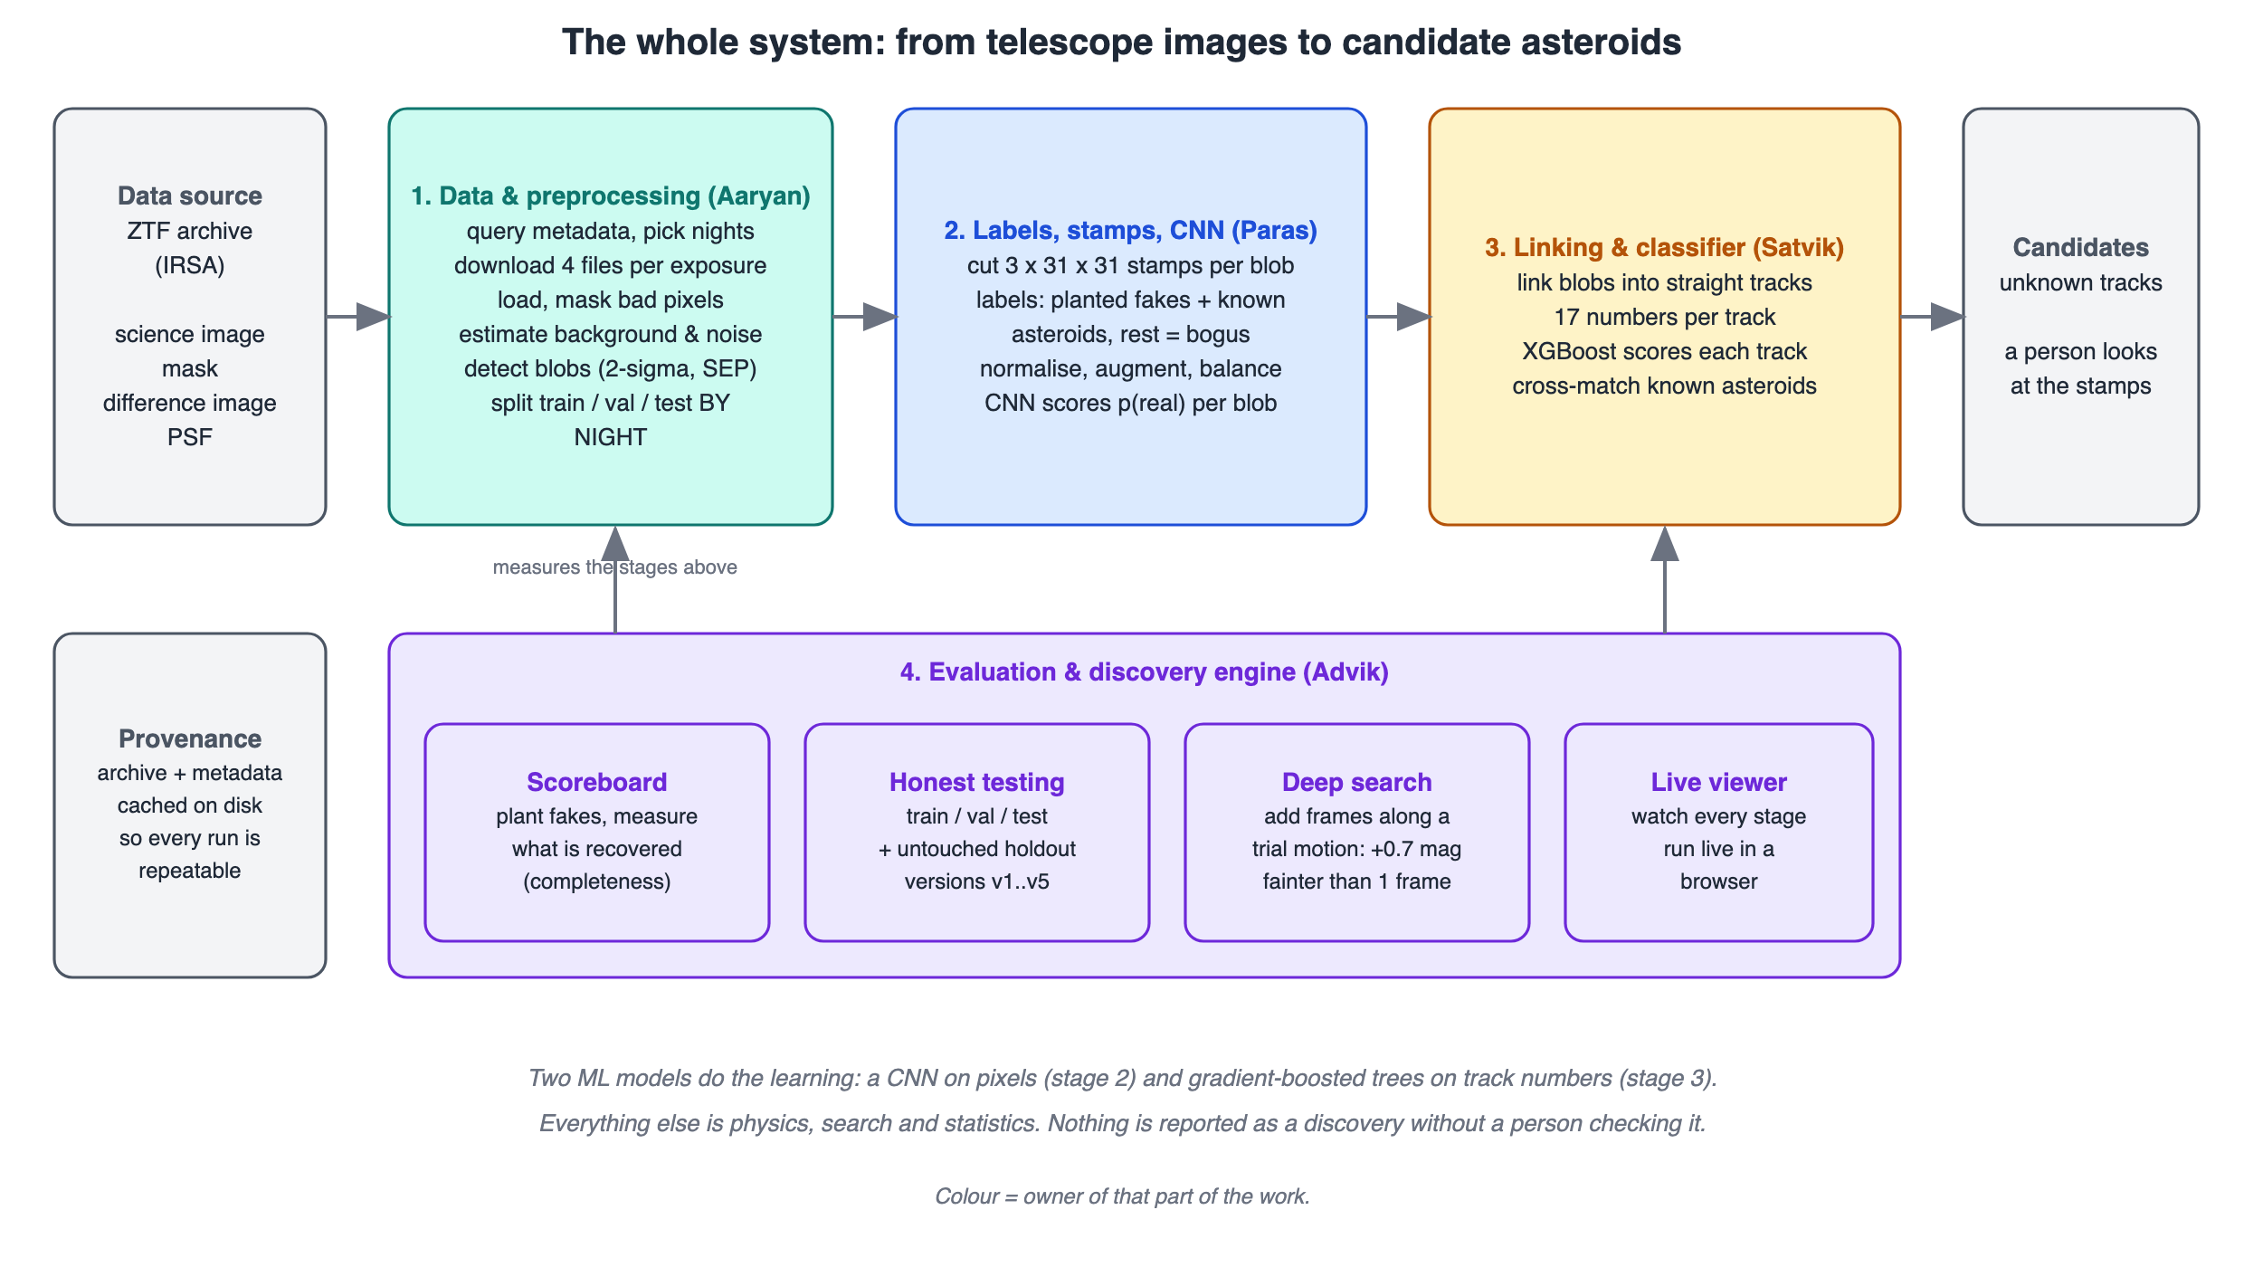
The whole system (00_Start_Here/11_Diagrams/01_system_overview.svg).
The one ML architecture at the centre of the project is the real/bogus CNN (00_Start_Here/00_How_Our_Model_Works.svg): it looks at three 31 x 31 pictures of a blob and gives the probability that it is a real moving object (average precision 0.899 on validation nights, 0.938 on the test night, against 0.780 for a simple model).

3. How I did it, step by step
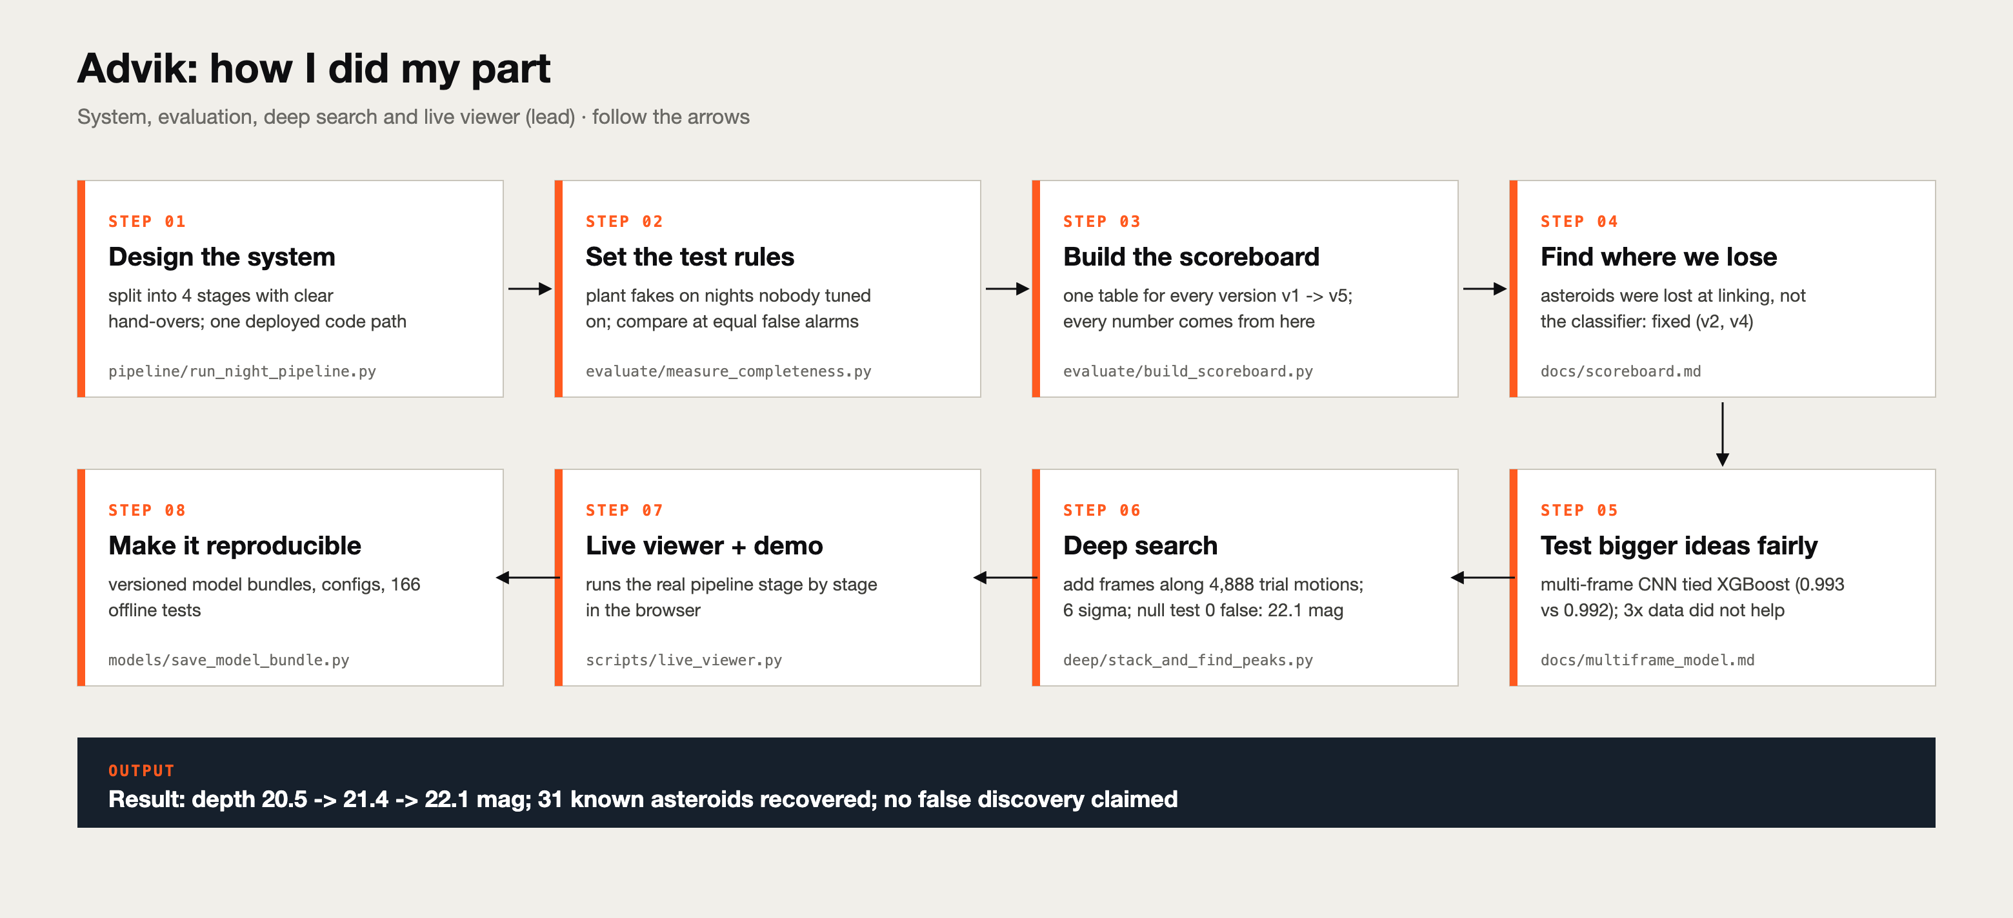
My process (01_Advik/00_Process_Diagram_Advik.svg).

Step 1. Design the system
Four stages with clear hand-overs (Aaryan → Paras → Satvik → me) and one deployed function, run_night_pipeline, used both for evaluation (with fakes) and for the real search (without), so what we test is what we deploy. Model versions are saved as bundles (CNN + track model + thresholds + provenance).
Code / file: pipeline/run_night_pipeline.py, models/save_model_bundle.py

Step 2. Set the testing rules
Plant 300 fakes per night, run the normal pipeline, count what comes out by brightness (completeness). Only held-out nights count. Compare models at the same false-alarm level. A holdout night (2022-06-17) is opened only by the scoreboard.
Code / file: evaluate/measure_completeness.py

Step 3. Build the scoreboard
One function computes blob AP and recall, junk kept per photo, track AP, depth, known asteroids recovered and unexplained alarms, for every version and split, and writes reports/scoreboard.csv. Before it, the same baseline showed 813 and 804 false alarms in two lessons.
Code / file: evaluate/build_scoreboard.py

Step 4. Find where asteroids are lost
v1 looked perfect (track AP 0.999) but depth was only 20.5. Measuring each stage showed the loss was at linking: 4-of-5 linked 184/294 fakes, 3-of-5 linked 200/294 (v2). Looking at 15 false alarms by eye led to two new feature groups (v4).
Code / file: docs/scoreboard.md

Step 5. Test bigger ideas fairly
A multi-frame CNN tied XGBoost (0.9933 vs 0.9924), so we kept the simple one. Three times more data (v5) looked 0.8 mag worse at its own threshold, but at matched false alarms v4 was equal or slightly better: more data did not help.
Code / file: docs/multiframe_model.md, docs/more_data.md

Step 6. Build the deep search
Shift-and-stack over 4,888 trial motions on the GPU. Statistics: 6,179 false peaks per stack at 5σ but 44 at 6σ, so we use 6σ; a null test with shuffled times went from 16 false tracks to 0 after a velocity-consistency cut, keeping 20 of 20 known asteroids. Depth 22.1 vs 21.4.
Code / file: deep/stack_and_find_peaks.py, configs/deep.yaml

Step 7. Fast movers and the live monitor
A trail-shaped filter finds fast near-Earth objects (97% of planted trails, 93% on a later night); the monitor watches the archive and runs every search on new nights.
Code / file: fast/, pipeline/run_live_monitor.py

Step 8. Live viewer and web app
The live viewer runs the real functions stage by stage and draws each one. The web app (web/) shows the pipeline on a real window of the test night and runs the trained CNN in the browser.
Code / file: scripts/live_viewer.py, web/

Step 9. Make it reproducible
Settings in config files, git commit in every model bundle, seeded random fakes, a pinned environment, and 166 offline tests (end-to-end, leakage, viewer equals pipeline).
Code / file: project/tests/

4. My results
What | Result
Depth on the test night (50% completeness) | v1 20.5 → v4 21.4 → deep search 22.1
Known asteroids, test split (v1 → v4) | 39/44 → 40/44
Real search of the test night | 31 known asteroids recovered, 16.2 to 21.8 mag
Deep search false peaks at 5σ / 6σ | 6,179 / 44 per stack
Deep search peaks per stack, first → final | 47,550 → 94
Null test false tracks per night | 16 → 0 (20 of 20 known asteroids kept)
Multi-frame CNN vs XGBoost | AP 0.9933 vs 0.9924: a tie
Offline tests | 166

The scoreboard (project/reports/scoreboard.csv)
nights | version | blob AP | stage-1 recall | junk kept per photo | track AP (saturated) | depth (mag) | known found | unexplained per night
test | v1 | 0.942 | 97.4% | 1,245 | 0.998 | 20.53 | 39/44 | 0.0
test | v2 | 0.942 | 99.2% | 4,293 | 0.992 | 21.39 | 40/44 | 13.3
test | v4 | 0.942 | 99.2% | 4,293 | 0.993 | 21.34 | 40/44 | 5.0
test | v5 | 0.940 | 99.2% | 3,857 | 0.993 | 20.56 | 38/44 | 0.3
validation | v1 | 0.919 | 96.0% | 1,184 | 1.000 | 20.18 | 21/28 | 0.0
validation | v4 | 0.919 | 99.2% | 3,901 | 0.998 | 20.49 | 24/28 | 0.0
holdout | v1 | 0.905 | 95.4% | 1,468 | 1.000 | 20.14 | 16/18 | 0.0
holdout | v4 | 0.905 | 98.5% | 4,716 | 0.998 | 20.47 | 17/18 | 0.3

Every number above can be traced to a file in the project (the lesson documents in project/docs, the knowledge pack in this folder, or project/reports/scoreboard.csv). If a number changes, tell Advik so the slides and report stay in sync.

5. Problems I hit and how they were fixed

A metric that cannot move
Track AP was about 0.999 for every version because most tracks are easy planted fakes. Depth and known asteroids have room to show progress, so those became the headline metrics.

Comparing at different thresholds
v5 looked 0.8 mag worse only because it sat at a different operating point. Always compare at the same false-alarm level.

Ghosts in the deep search
151 of 242 unknown tracks were within 30 px of a known asteroid: echoes. Masking bright movers and the consistency cut removed them; the null test proves it.

A silent failure
A night with 18 photos found nothing in the deep search, because it needs at least 20. Now it checks and says so.

The test night was looked at
Real bugs were fixed using it, which is exactly why the separate holdout night exists.

6. What I handed over
To the team: one list of numbers with their source files, the demo (live viewer and web app), and the report chapters on evaluation, the deep search and limitations.

Files in my folder
File | What it is
README.md | my part step by step and a guide to the folder
00_Process_Diagram_Advik.svg | how I did my part, as one picture
01_Part_Brief.md | what is mine, what I hand over, where the code is
02_Knowledge_Pack.md | everything I must understand, in detail
03_Presentation_Guide.md | slide by slide: what to say and for how long
04_Viva_QA.md | questions and model answers
05_Handbook_Advik.html / .pdf | files 01-04 plus diagrams in one printable file
06_Report_Advik.docx | this report
07_Diagrams/ | pictures for my slides, numbered in step order

7. Diagrams for my slides
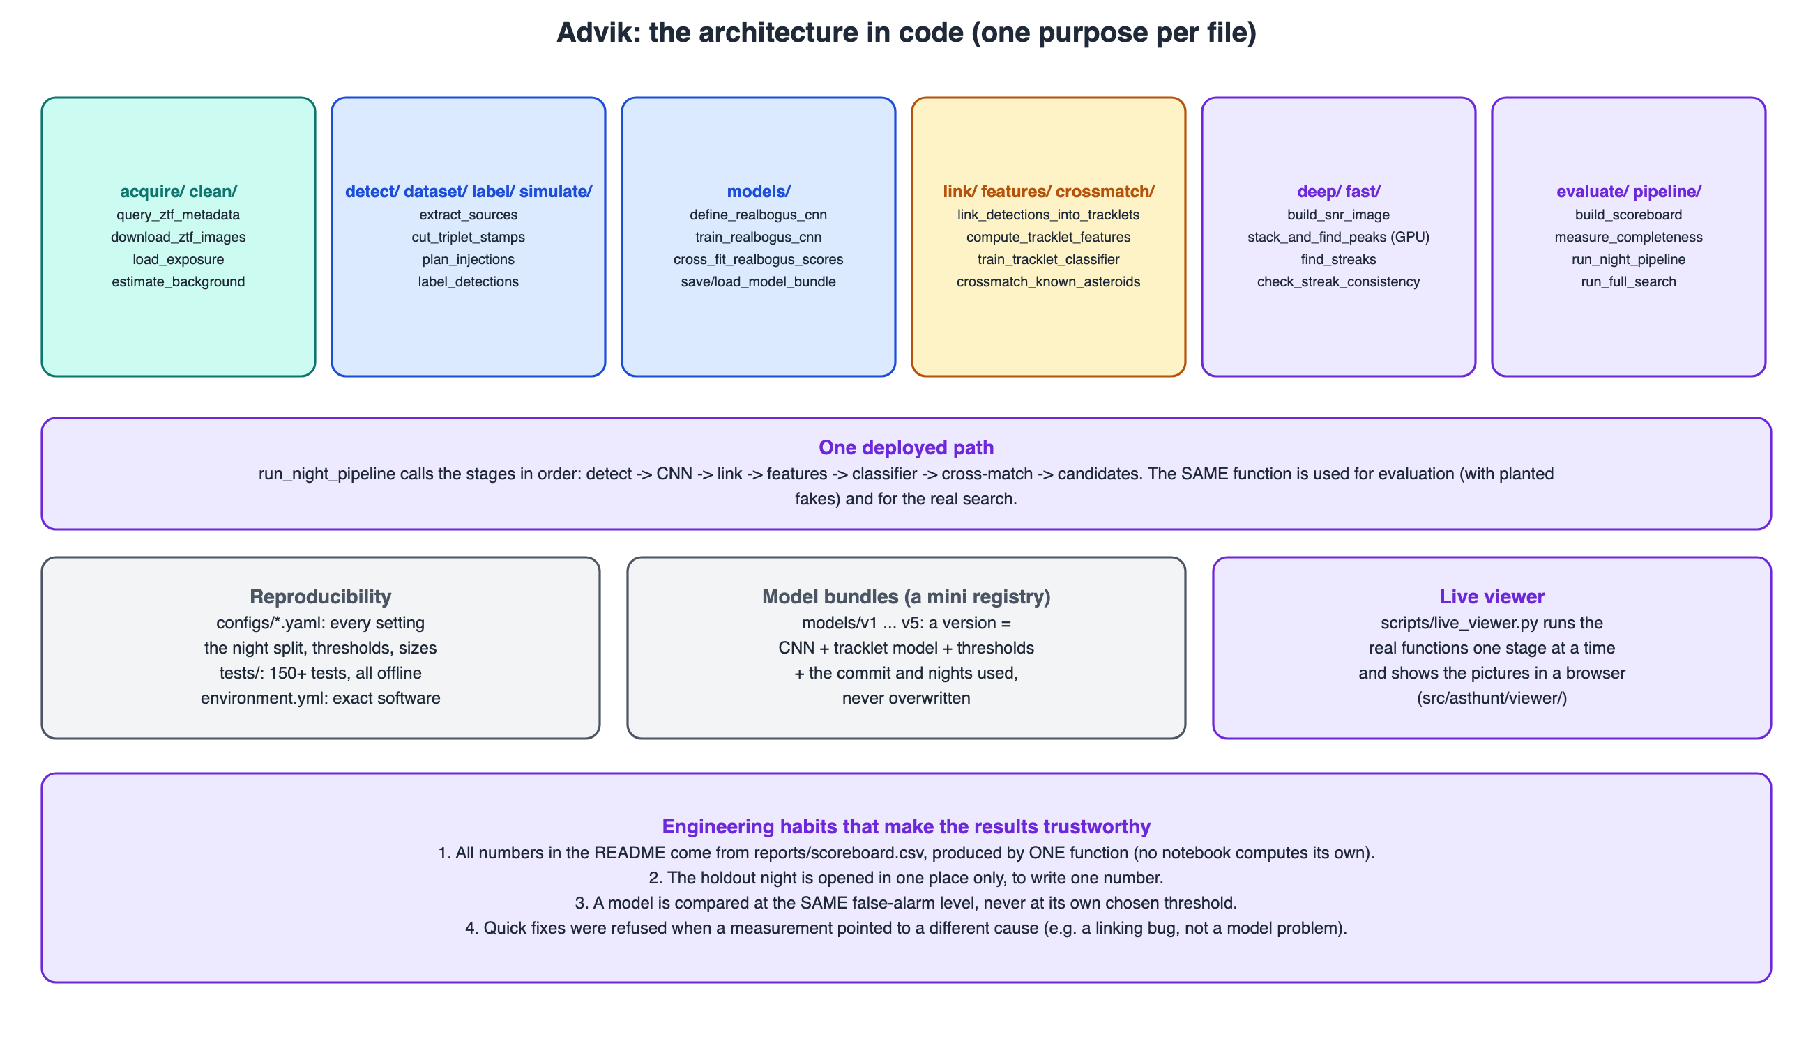
The full architecture (01_Advik/07_Diagrams/01_architecture_full.svg)
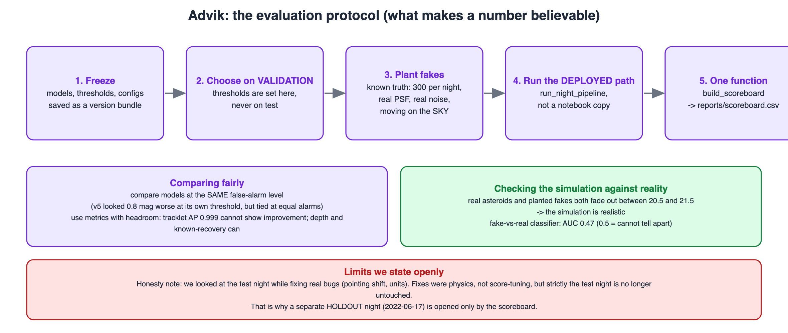
The evaluation protocol (02_evaluation_protocol.svg)
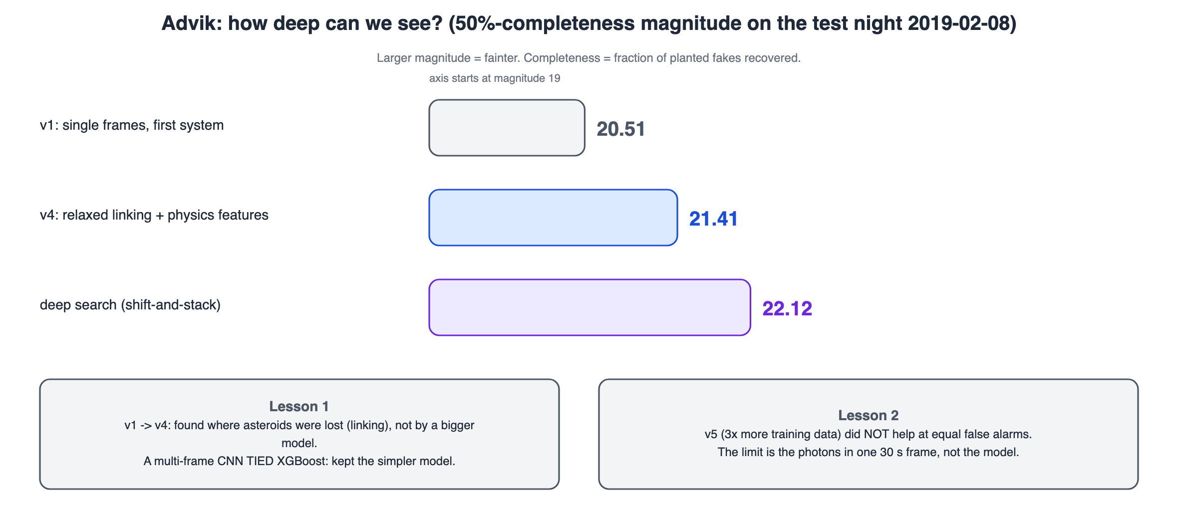
Versions on the scoreboard (03_scoreboard_versions.svg)
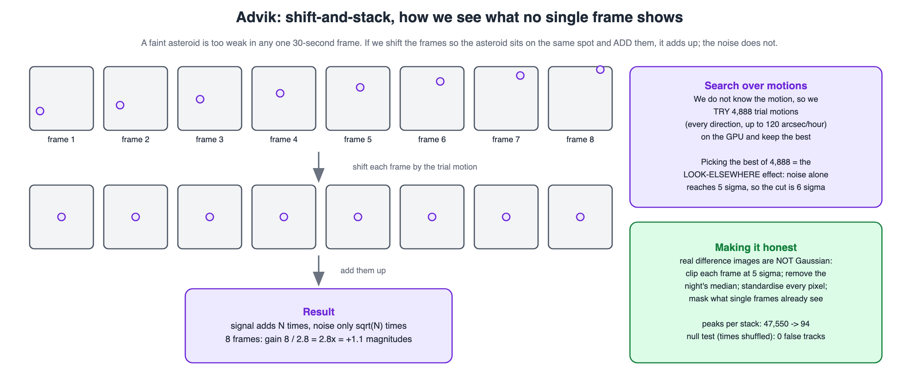
Shift-and-stack (04_shift_and_stack.svg)
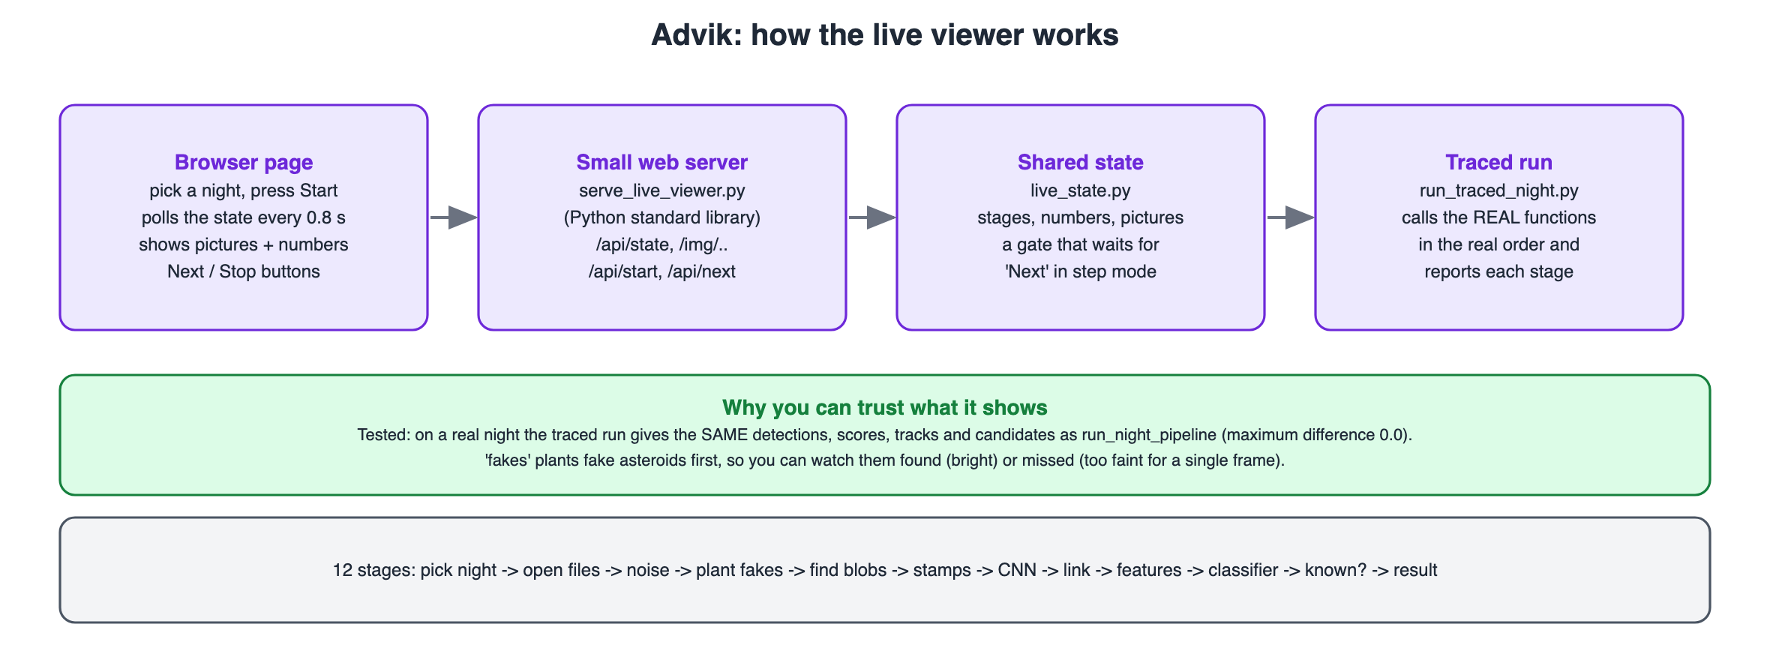
The live viewer (05_live_viewer_flow.svg)

8. Questions I should be ready for

Why does the scoreboard call the pipeline instead of reading saved files?
So that it measures exactly what we deploy; saved files or notebook copies drift from the real code.

Why must thresholds live in the same bundle as the models?
A threshold only makes sense for the model it was chosen for; mixing them silently changes the operating point.

Why 6σ and not 5σ in the deep search?
With 4,888 motions per pixel, chance alone reaches 5σ thousands of times (6,179 false peaks); at 6σ only 44. The cut is set from pure-noise data.

What does the null test prove?
With shuffled times no real object can line up, so anything found is false. 0 false tracks means the cuts remove chance alignments; it does not prove every candidate is real.

Why did more data not help?
The limit is how much light one 30-second photo holds, not how much the model knows. Adding photos (the deep search) was the fix.
More questions with model answers are in 04_Viva_QA.md and 00_Start_Here/06_Whole_Project_Viva_QA.md. If you do not know: say what you would check and how, never make up a number.

9. Use of AI
The project's code and documents were developed with the help of an AI coding assistant (Claude, by Anthropic) under Advik's direction, which the course allows for planning, learning and deployment when it is declared. Edit this paragraph so it says what you did yourself, for example: re-ran the notebooks of my part, changed one setting and recorded what happened, wrote my slides in my own words.
Before presenting: re-run your notebooks, change one setting, and write the explanation of each step above in your own words. That is what makes this part yours (00_Start_Here/07_AI_Use_and_Integrity.md).

