ASTEROID HUNTER
Aaryan: my part, start to end
Problem, data and preprocessing
Course: Machine Learning (702DB0C015) · B.Tech CSE (Data Science), Semester V · MPSTME, NMIMS · 2026-27
Team: Advik (lead), Aaryan, Paras, Satvik
Course marks this part covers: Problem Understanding and Formulation (3); Data Preprocessing and Exploration (3, shared with Paras)
Date: October 2026

Contents
- My part in one page
- Where my part sits in the project
- How I did it, step by step
- My results
- Problems I hit and how they were fixed
- What I handed over
- Diagrams for my slides
- Questions I should be ready for
- Use of AI

1. My part in one page
About this document. It was drafted with the help of an AI assistant (Claude, by Anthropic) from the project's own files, as the course's GenAI policy allows for planning and learning. Before you submit it, read it fully, change anything that is not true for you, and rewrite the parts you present in your own words (see 00_Start_Here/07_AI_Use_and_Integrity.md).
My part is the start of the pipeline. I defined the problem, found and downloaded the data, split it by night, cleaned every image, found the blobs that every later model works on, and proved that our first dataset was cheating (leakage). If the data is wrong or leaks, every model and number after it is wrong.

The steps in one line each
- Define the problem
- Ask the archive before downloading
- Split by night, before modelling
- Download safely
- Clean every photo
- Find the blobs
- Explore the data (EDA)
- Audit for leakage

My key results
What | Result
Exposures checked before downloading | 1,552 (16.4% removed for quality flags)
Files downloaded | 220 files, 3.55 GB, nothing missing
Split | 8 train / 2 validation / 1 test / 1 holdout nights
Blobs per photo at 2σ | about 7,800 (only 173 with SNR > 5)
Sources: science vs difference image (5σ) | 1,950 vs 334: subtraction removes most stars
Leakage experiment (accuracy, 50/50 balanced set) | 100% → 50% → 99%
Hard negatives (track 3-10 / 1-3 / 0.5-1.5 px off the line; balanced accuracy) | 99% / 96% / 89%

2. Where my part sits in the project
The project finds moving asteroids in ZTF telescope images. Data flows through four parts, one per person: Aaryan (data and preprocessing) → Paras (labels and the CNN) → Satvik (linking, track model, metrics) → Advik (evaluation, deep search, demo). Each part hands a clear result to the next.
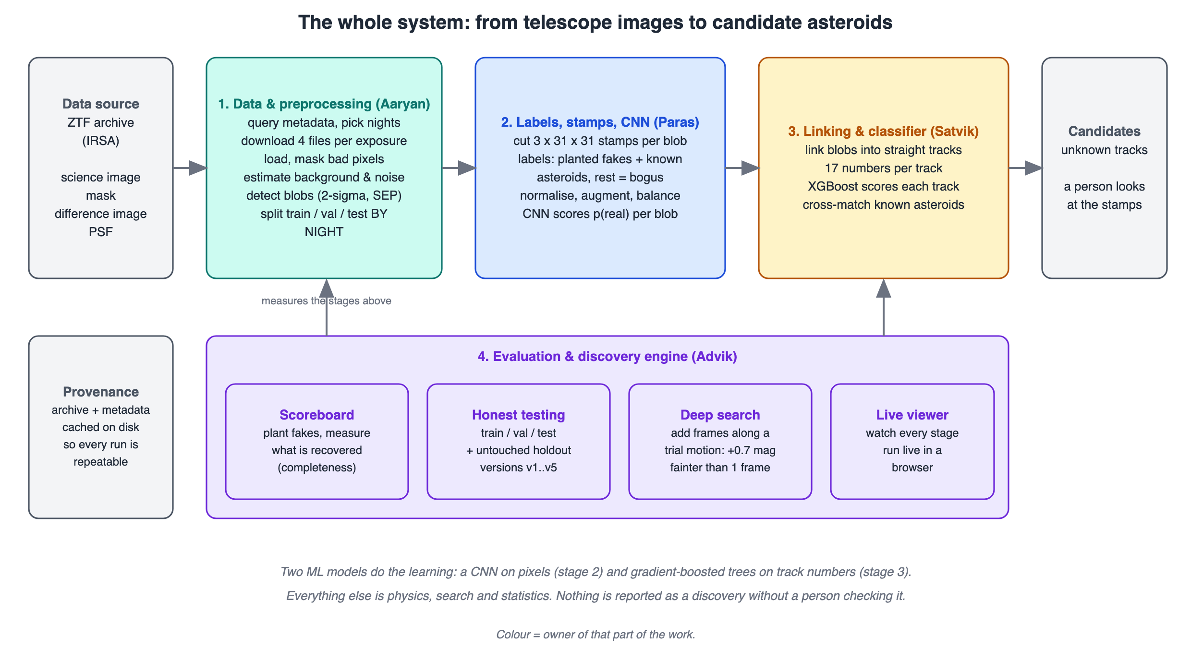
The whole system (00_Start_Here/11_Diagrams/01_system_overview.svg).
The one ML architecture at the centre of the project is the real/bogus CNN (00_Start_Here/00_How_Our_Model_Works.svg): it looks at three 31 x 31 pictures of a blob and gives the probability that it is a real moving object (average precision 0.899 on validation nights, 0.938 on the test night, against 0.780 for a simple model).

3. How I did it, step by step
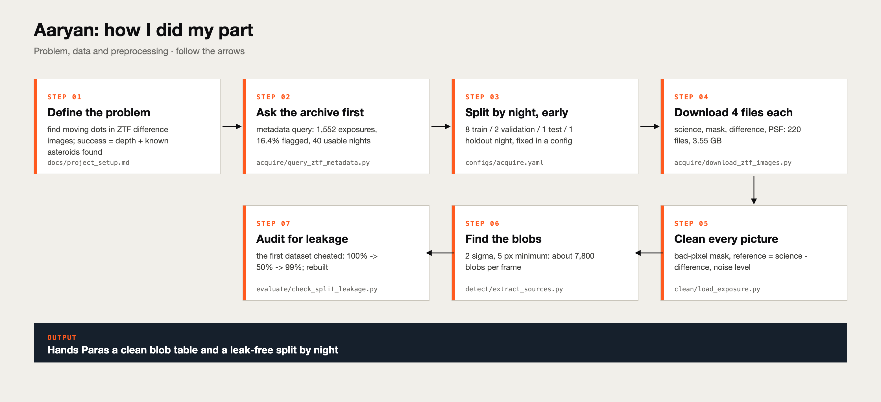
My process (02_Aaryan/00_Process_Diagram_Aaryan.svg).

Step 1. Define the problem
I wrote down exactly what goes in (a night of photos of one patch of sky) and what comes out (a ranked list of tracks, each marked known or unknown), why it is hard, why machine learning helps, and how success is measured: depth, known asteroids found and false alarms, never accuracy.
Code / file: docs/project_setup.md, 00_Start_Here/01_Project_Overview.md

Step 2. Ask the archive before downloading
One metadata query took seconds and told us there were 1,552 exposures of our patch (898 r, 478 g, 176 i band), that 16.4% had quality warnings (removed), and that only 40 nights have at least 4 good photos. Choosing from a table is cheap; downloading is not.
Code / file: acquire/query_ztf_metadata.py

Step 3. Split by night, before modelling
8 nights for training, 2 for validation, 1 test night (2019-02-08) and later 1 holdout night, written in configs/acquire.yaml before any model was trained, so the split could not change after a bad result. Photos from one night are very alike, so a random split would leak.
Code / file: configs/acquire.yaml, evaluate/check_split_leakage.py

Step 4. Download safely
4 files per exposure: 220 files, 3.55 GB, nothing missing. The downloader is idempotent (running it twice = once), atomic (writes a .part file and renames it only when complete), retries when the archive is busy, and records files that do not exist.
Code / file: acquire/download_ztf_images.py

Step 5. Clean every photo
Read the files, build the bad-pixel mask (satellite trails, saturated, dead, noisy pixels, empty areas; but not 'ghosts', which cover 4% of the chip), compute reference = science − difference, and measure the background and the noise robustly (1.4826 x MAD).
Code / file: clean/load_exposure.py, clean/estimate_background.py

Step 6. Find the blobs
Smooth with the star's own shape (a matched filter), keep groups of at least 5 pixels at least 2σ above the noise. About 7,800 blobs per photo, only 173 with SNR > 5. Detection is tuned to miss nothing; the CNN is tuned to remove junk.
Code / file: detect/extract_sources.py

Step 7. Explore the data (EDA)
The threshold study showed a surprise: 1.5σ gives fewer blobs (6,141) than 2σ (7,764), because noise peaks merge into big blobs and can swallow a faint asteroid. Measuring beats rules of thumb.
Code / file: docs/difference_imaging.md

Step 8. Audit for leakage
Our first dataset scored 100%: a warning sign. I found four kinds of leakage and proved it with an experiment: trained and tested on easy data 100%; tested on realistic near-misses 50% (a coin flip); trained on realistic data 99%. These are accuracies on a 50/50 balanced set, where accuracy is a fair measure; on the real, 3%-positive data we use precision and recall instead. We rebuilt the data.
Code / file: docs/leakage_audit.md

4. My results
What | Result
Exposures checked before downloading | 1,552 (16.4% removed for quality flags)
Files downloaded | 220 files, 3.55 GB, nothing missing
Split | 8 train / 2 validation / 1 test / 1 holdout nights
Blobs per photo at 2σ | about 7,800 (only 173 with SNR > 5)
Sources: science vs difference image (5σ) | 1,950 vs 334: subtraction removes most stars
Leakage experiment (accuracy, 50/50 balanced set) | 100% → 50% → 99%
Hard negatives (track 3-10 / 1-3 / 0.5-1.5 px off the line; balanced accuracy) | 99% / 96% / 89%

Threshold study (one training photo)
Threshold | Blobs | Median size
1.5σ | 6,141 | 11 px
2.0σ (chosen) | 7,764 | 6 px
3.0σ | 731 | 8 px
5.0σ | 334 | 9 px

The four kinds of leakage we found
Kind | What it is | In our first dataset
Target leakage | a feature contains the answer | magnitude and true speed were filled in only for planted fakes
Group leakage | train and test share a source | all tracks came from the same 4 images
Shortcut learning | the classes differ in an easy, unreal way | random junk tracks were 222.7+ px off a line; real ones at most 2.6 px
Distribution shift | real use differs from training | the test night is sharper and deeper

Every number above can be traced to a file in the project (the lesson documents in project/docs, the knowledge pack in this folder, or project/reports/scoreboard.csv). If a number changes, tell Advik so the slides and report stay in sync.

5. Problems I hit and how they were fixed

The first dataset cheated
A perfect score is a symptom, not a success. Asking 'what would have to be true for 100%?' found the leaks. Rules that came out: features must be measurable on new data, split by night, keep derived examples with their source, use realistic negatives.

Empty pixels made fake blobs
Treating NaN as 0 creates edges that look like detections. Fix: mask them before detecting.

The archive was busy
It answered '503 busy' twice during downloads; retries with growing waits recovered without losing anything.

6. What I handed over
Paras gets the output of load_exposure, the blob table from extract_sources (position, flux, SNR, shape), the split by night and the settings files.

Files in my folder
File | What it is
README.md | my part step by step and a guide to the folder
00_Process_Diagram_Aaryan.svg | how I did my part, as one picture
01_Part_Brief.md | what is mine, what I hand over, where the code is
02_Knowledge_Pack.md | everything I must understand, in detail
03_Presentation_Guide.md | slide by slide: what to say and for how long
04_Viva_QA.md | questions and model answers
05_Handbook_Aaryan.html / .pdf | files 01-04 plus diagrams in one printable file
06_Report_Aaryan.docx | this report
07_Diagrams/ | pictures for my slides, numbered in step order

7. Diagrams for my slides
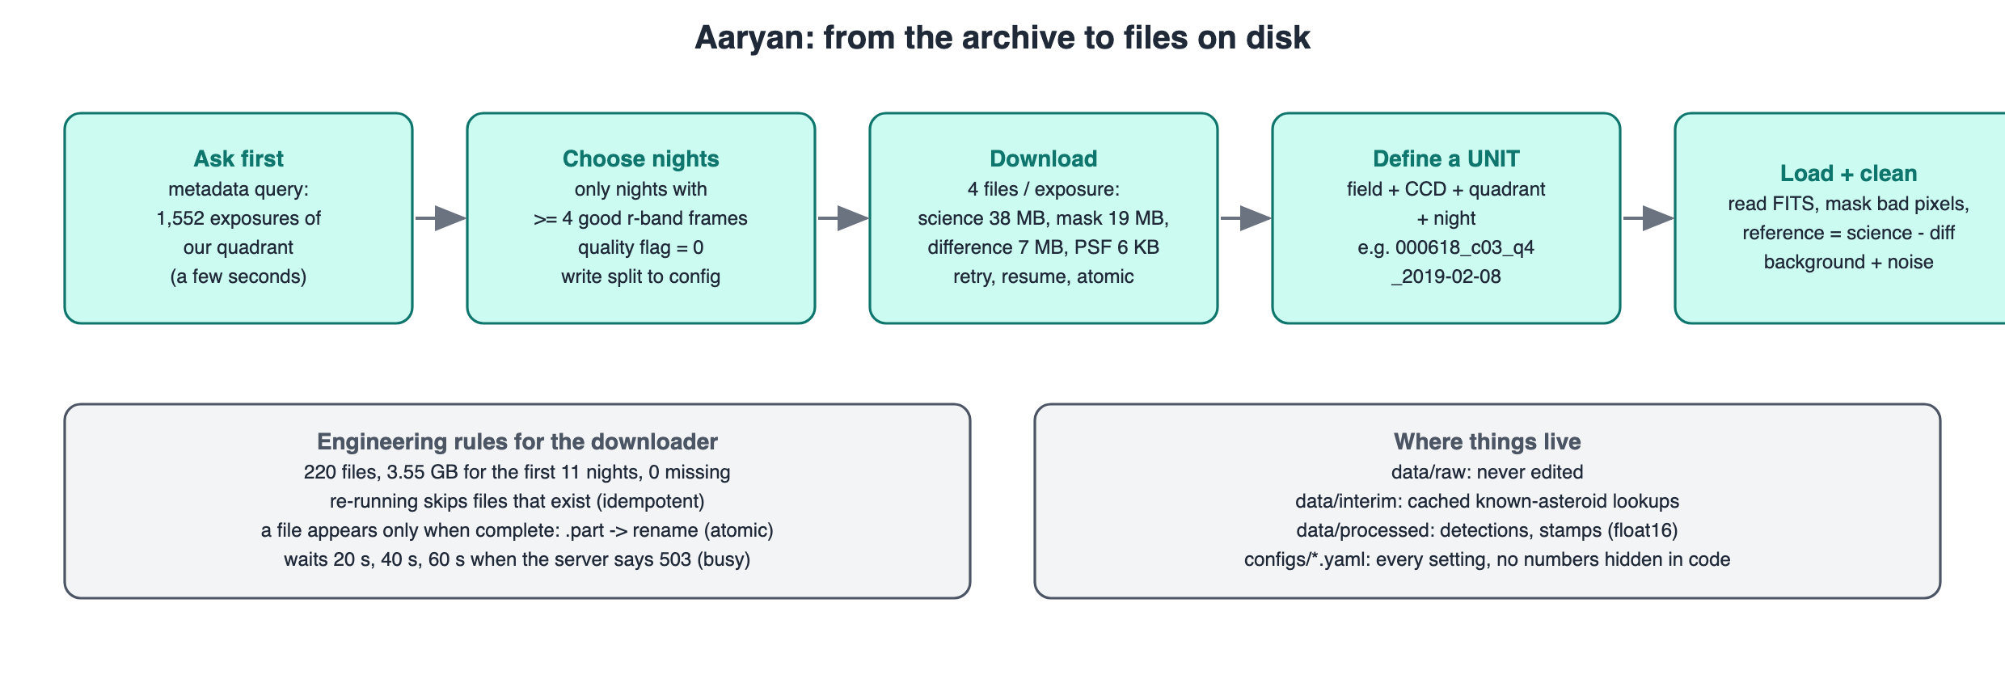
How the data flows (02_Aaryan/07_Diagrams/01_data_flow.svg)
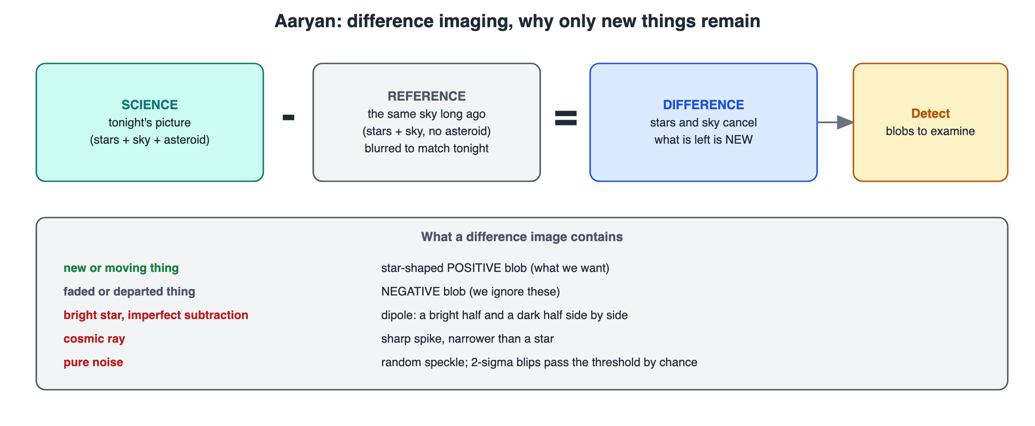
Difference imaging (02_difference_imaging.svg)
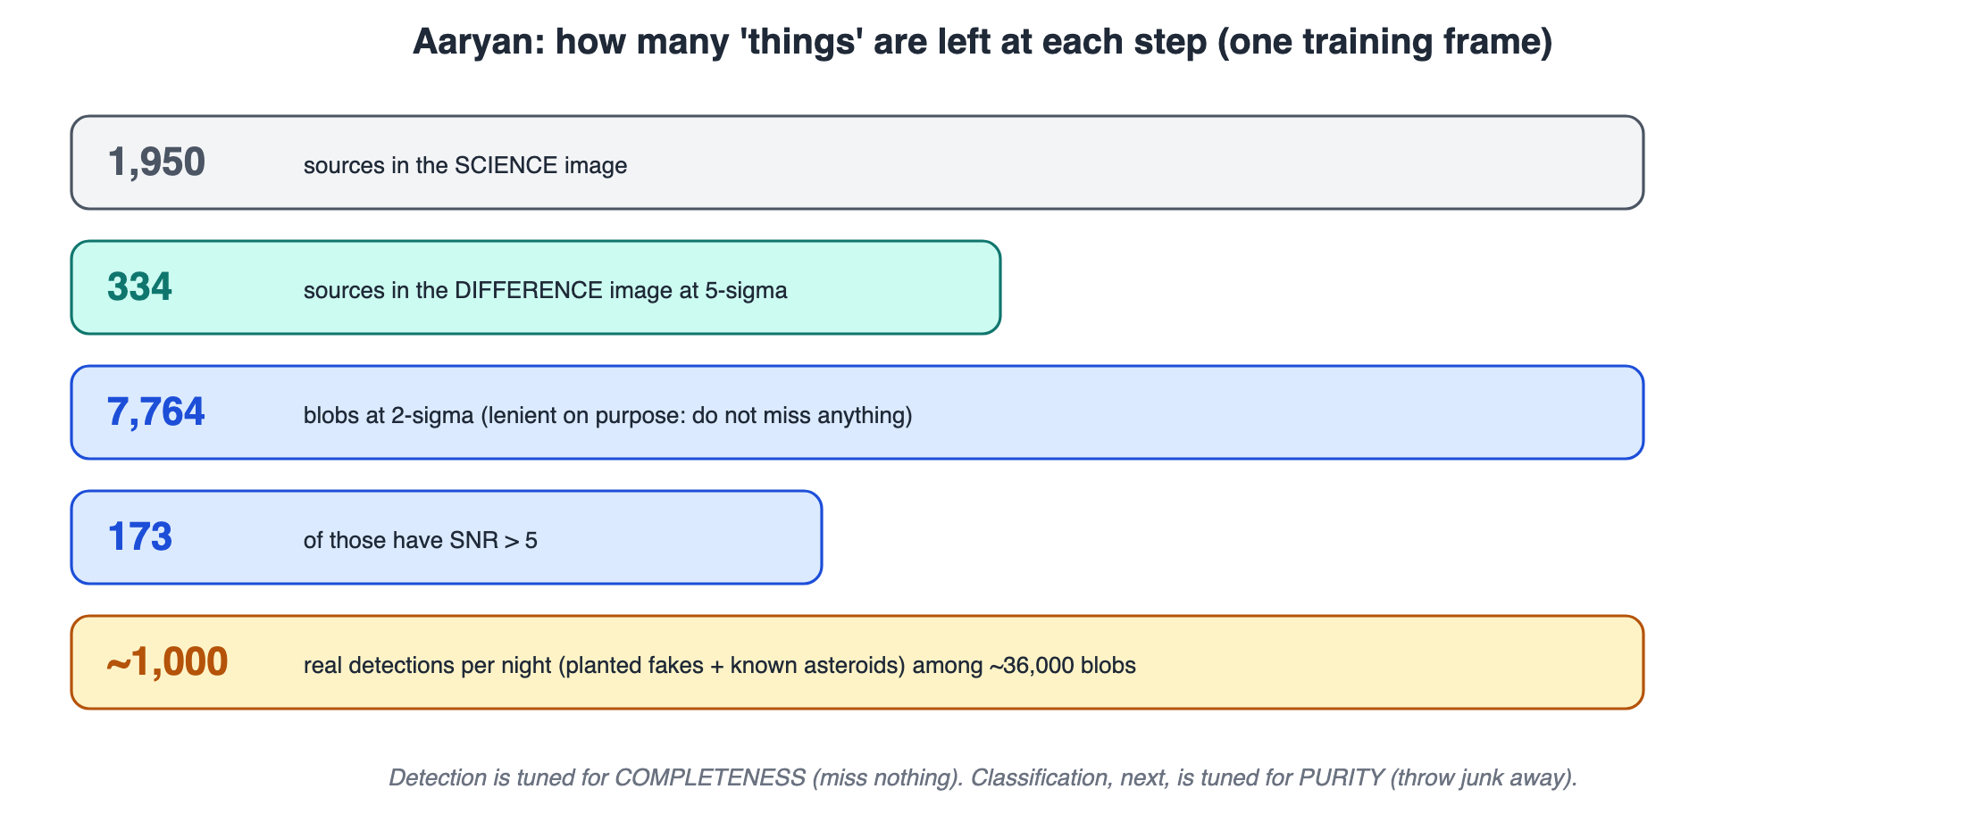
From pixels to blobs (03_preprocessing_funnel.svg)
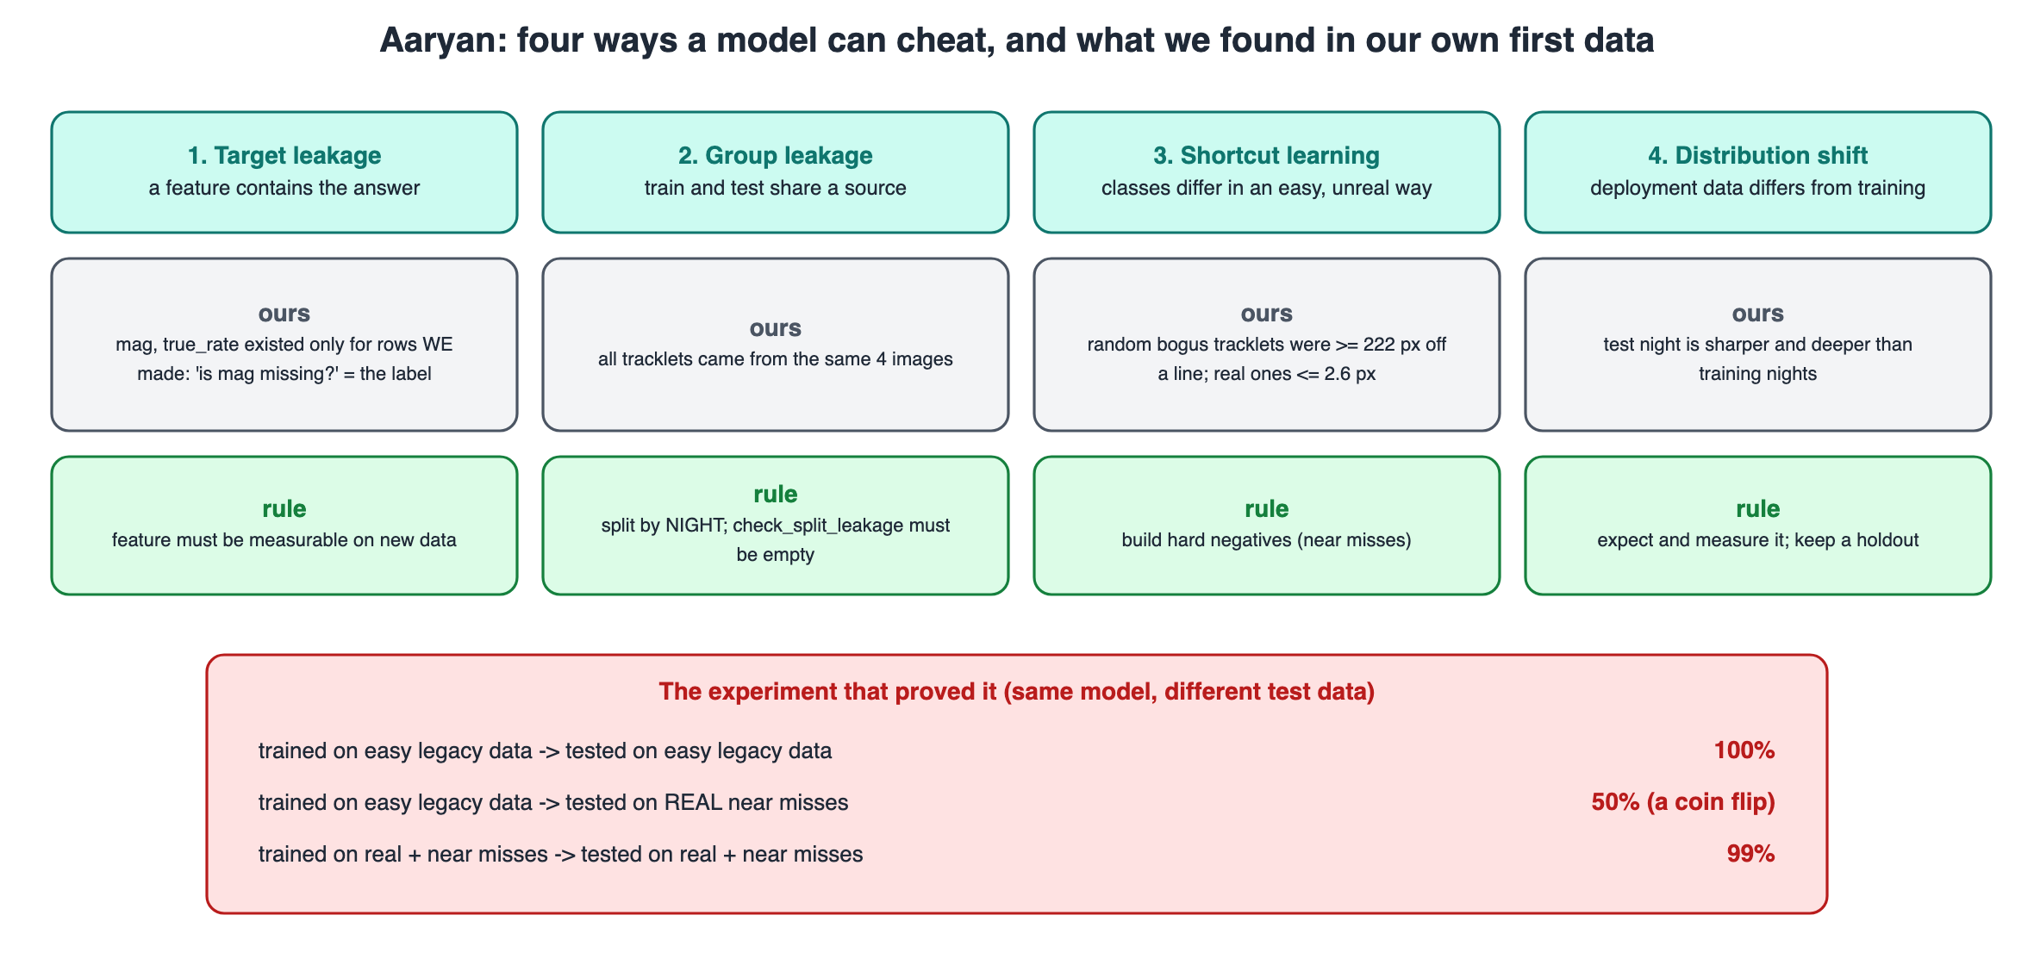
Leakage types and the experiment (04_leakage_types.svg)

8. Questions I should be ready for

Why query metadata before downloading?
It takes seconds and tells us which nights are worth downloading (enough good photos, no quality flags), so we never waste hours on unusable data.

Why split by night and not randomly?
Photos from one night share sky, weather and blur. A random split puts near-copies in both training and test, so the score is too good. Splitting by night tests the model on genuinely new conditions.

Why does 1.5σ give fewer blobs than 2σ?
At 1.5σ neighbouring noise peaks touch and merge into one big blob, so the count drops and a faint asteroid next to noise can be swallowed.

Why is the ghost bit not masked?
Ghosts cover about 4% of the chip; masking them would hide real objects there. The CNN learns to reject ghosts instead.

What does 100% → 50% → 99% prove?
That the first model learned a shortcut. On realistic hard examples it was a coin flip; trained on realistic data it is genuinely good.
More questions with model answers are in 04_Viva_QA.md and 00_Start_Here/06_Whole_Project_Viva_QA.md. If you do not know: say what you would check and how, never make up a number.

9. Use of AI
The project's code and documents were developed with the help of an AI coding assistant (Claude, by Anthropic) under Advik's direction, which the course allows for planning, learning and deployment when it is declared. Edit this paragraph so it says what you did yourself, for example: re-ran the notebooks of my part, changed one setting and recorded what happened, wrote my slides in my own words.
Before presenting: re-run your notebooks, change one setting, and write the explanation of each step above in your own words. That is what makes this part yours (00_Start_Here/07_AI_Use_and_Integrity.md).

