ASTEROID HUNTER
Paras: my part, start to end
Labels, dataset and the neural network (CNN)
Course: Machine Learning (702DB0C015) · B.Tech CSE (Data Science), Semester V · MPSTME, NMIMS · 2026-27
Team: Advik (lead), Aaryan, Paras, Satvik
Course marks this part covers: Model Development (4, shared with Satvik); the model-ready data part of Data Preprocessing (3, shared with Aaryan)
Date: October 2026

Contents
- My part in one page
- Where my part sits in the project
- How I did it, step by step
- My results
- Problems I hit and how they were fixed
- What I handed over
- Diagrams for my slides
- Questions I should be ready for
- Use of AI

1. My part in one page
About this document. It was drafted with the help of an AI assistant (Claude, by Anthropic) from the project's own files, as the course's GenAI policy allows for planning and learning. Before you submit it, read it fully, change anything that is not true for you, and rewrite the parts you present in your own words (see 00_Start_Here/07_AI_Use_and_Integrity.md).
My part is the deep-learning heart of the project. The sky is not labelled, so I made labels (planted fakes and known asteroids), built a clean dataset of small three-channel pictures, and trained the CNN that decides for every blob whether it is real or junk. The model even found a mistake in our labels.

The steps in one line each
- Plant fake asteroids
- Label every blob
- Cut stamps
- Prepare the data
- Learn the theory first
- Build and train the CNN
- Measure it fairly
- Learn from its mistakes
- Check the fakes are realistic
- Cross-fit the scores

My key results
What | Result
Validation average precision | 0.899 (CNN) vs 0.780 (baseline)
Precision at 90% recall | 0.522 vs 0.191
False alarms per photo at 90% recall | 176 vs 813 (4.6x fewer)
Test-night average precision | 0.938
Test night, deployed cut (recall / precision) | 99.1% / 6.1%: tuned for recall on purpose
Test night, cut for 90% recall (precision, false alarms per photo) | 90.5%, 26
Catalogue position error | 2.72 px (SkyBoT) → 0.26 px (Horizons)
Fake vs real classifier (realism) | AUC 0.46-0.48 (0.5 = cannot tell)
Learnable weights | 72,145

2. Where my part sits in the project
The project finds moving asteroids in ZTF telescope images. Data flows through four parts, one per person: Aaryan (data and preprocessing) → Paras (labels and the CNN) → Satvik (linking, track model, metrics) → Advik (evaluation, deep search, demo). Each part hands a clear result to the next.
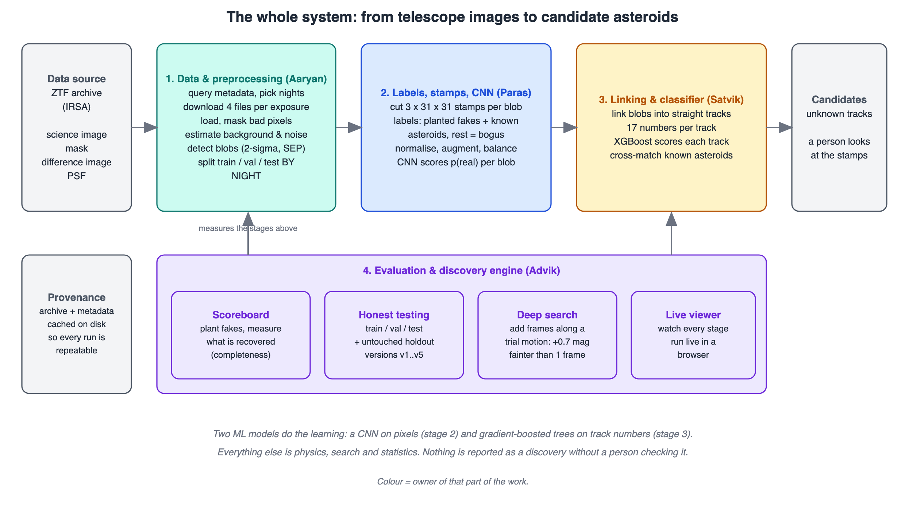
The whole system (00_Start_Here/11_Diagrams/01_system_overview.svg).
The one ML architecture at the centre of the project is the real/bogus CNN (00_Start_Here/00_How_Our_Model_Works.svg): it looks at three 31 x 31 pictures of a blob and gives the probability that it is a real moving object (average precision 0.899 on validation nights, 0.938 on the test night, against 0.780 for a simple model).

3. How I did it, step by step
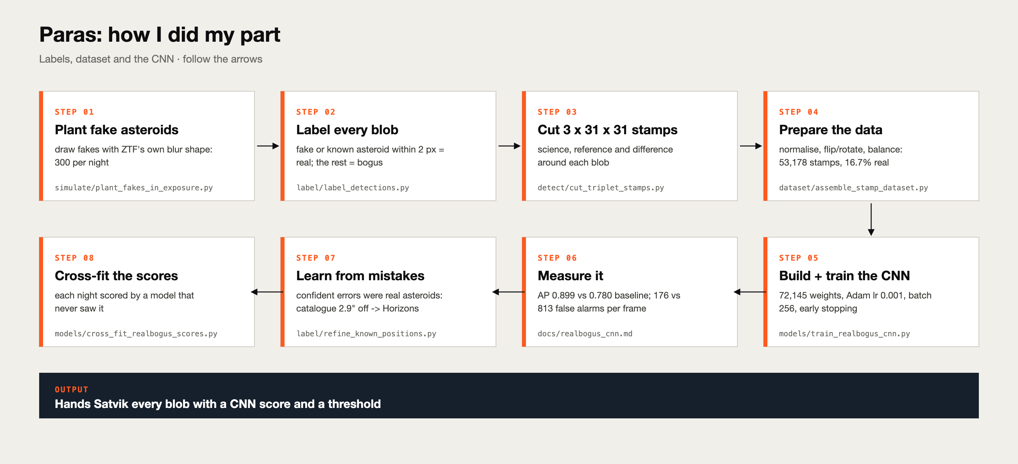
My process (03_Paras/00_Process_Diagram_Paras.svg).

Step 1. Plant fake asteroids
For each night, 300 fakes with brightness 17-22 mag and speed 5-100 arcsec/hour in a random direction. Each fake is drawn with ZTF's own PSF for that photo, placed at a sub-pixel position, given realistic Poisson noise, and added to both science and difference images, exactly like a new object.
Code / file: simulate/plant_fakes_in_exposure.py

Step 2. Label every blob
A blob within 2 pixels of a fake or of a known asteroid (positions from the catalogue, matched with a fast KD-tree look-up) is 'real'; the rest is 'bogus'. One training night: 1,059 real vs 36,161 bogus (1 : 34). We accept some label noise: a 'bogus' could be an uncatalogued asteroid.
Code / file: label/label_detections.py, label/match_detections_to_positions.py

Step 3. Cut stamps
For each blob, a 31 x 31 pixel square from the science, reference and difference images: the CNN's input (3 x 31 x 31).
Code / file: detect/cut_triplet_stamps.py

Step 4. Prepare the data
Normalise each stamp ((value − median) / (1.4826 x MAD), clipped to [−10, 50]); augment training stamps with rotations and mirroring; balance training to all 8,863 real + 5 bogus each = 53,178 stamps (16.7% real). Validation keeps the true mix (67,041 stamps, 3.2% real).
Code / file: dataset/assemble_stamp_dataset.py

Step 5. Learn the theory first
In a from-scratch notebook I built a small network with NumPy: forward pass, loss, backpropagation, and a gradient check (both methods gave −0.02896520), then saw over-fitting and why early stopping helps.
Code / file: notebooks/neural_networks.ipynb

Step 6. Build and train the CNN
5 convolution layers, 3 max-pools, dropout 0.3, two dense layers: 72,145 weights. Adam (learning rate 0.001), batch 256, up to 25 epochs, early stopping on validation AP (patience 4). Best validation AP 0.899 at epoch 21.
Code / file: models/define_realbogus_cnn.py, models/train_realbogus_cnn.py

Step 7. Measure it fairly
Against the baseline (logistic regression on 6 numbers), at the same 90% recall: false alarms fall from 813 to 176 per photo (4.6x). On the untouched test night AP 0.938.
Code / file: docs/realbogus_cnn.md

Step 8. Learn from its mistakes
The CNN's most confident 'bogus' blobs were clean point sources, and every one was a known asteroid. The catalogue (SkyBoT) was about 2.9 arcsec off in a constant direction. Switching to JPL Horizons cut the median error from 2.72 to 0.26 px.
Code / file: label/refine_known_positions.py, docs/label_quality.md

Step 9. Check the fakes are realistic
A classifier asked to tell fakes from real known asteroids (same brightness, cross-validated by night) scored AUC 0.46-0.48: it cannot tell them apart.
Code / file: evaluate/measure_injection_realism.py

Step 10. Cross-fit the scores
8 training nights in 4 folds of 2: each fold is scored by a CNN trained on the other 6 nights, so the next model never sees over-confident scores.
Code / file: models/cross_fit_realbogus_scores.py

4. My results
What | Result
Validation average precision | 0.899 (CNN) vs 0.780 (baseline)
Precision at 90% recall | 0.522 vs 0.191
False alarms per photo at 90% recall | 176 vs 813 (4.6x fewer)
Test-night average precision | 0.938
Test night, deployed cut (recall / precision) | 99.1% / 6.1%: tuned for recall on purpose
Test night, cut for 90% recall (precision, false alarms per photo) | 90.5%, 26
Catalogue position error | 2.72 px (SkyBoT) → 0.26 px (Horizons)
Fake vs real classifier (realism) | AUC 0.46-0.48 (0.5 = cannot tell)
Learnable weights | 72,145

Counting the 72,145 weights
Layer | Formula | Weights
conv1 3→16 | (3 x 9 + 1) x 16 | 448
conv2 16→16 | (16 x 9 + 1) x 16 | 2,320
conv3 16→32 | (16 x 9 + 1) x 32 | 4,640
conv4 32→32 | (32 x 9 + 1) x 32 | 9,248
conv5 32→64 | (32 x 9 + 1) x 64 | 18,496
dense 576→64 | 576 x 64 + 64 | 36,928
output 64→1 | 64 + 1 | 65
Total |  | 72,145

Our CNN on the whole test night (41,522 blobs, 3.2% real): recall and precision together
Cut | Recall | Precision | F1 | False alarms per photo
Stage-1 cut (deployed) | 99.1% | 6.1% | 0.11 | 4,144
Cut for 95% recall | 95.0% | 55.0% | 0.70 | 210
Cut for 90% recall | 90.1% | 90.5% | 0.90 | 26
Recall alone can look too good: the deployed stage-1 cut keeps 99.1% of real blobs, but only 6.1% of the blobs it keeps are real (4,144 junk blobs per photo). That is a deliberate choice: an asteroid dropped here is lost for good, while junk is removed later by linking and the track model. Asking for 90% recall instead gives 90.5% precision. Average precision over all cuts is 0.944 (random guessing would score 0.032). The whole pipeline is judged at the end by depth, known asteroids recovered and unexplained alarms per night.

Every number above can be traced to a file in the project (the lesson documents in project/docs, the knowledge pack in this folder, or project/reports/scoreboard.csv). If a number changes, tell Advik so the slides and report stay in sync.

5. Problems I hit and how they were fixed

The labels were wrong in a hidden way
A systematic offset hid behind chance coincidences. Lesson: check the direction of errors, not only their size, and look at the model's most confident 'mistakes'.

Fakes moved straight in pixels
Real asteroids move straight on the sky, and the telescope shifts between photos. Fakes are now planned on the sky and converted to each photo's pixels.

Saturated stars broke the storage
Star cores above 65,504 became 'infinity' in float16. Fix: clip before converting.

Probabilities are inflated
Training is 16.7% real but the sky is about 3%, so a score of 0.6 was real only about 30% of the time. Satvik's base-rate adjustment corrects it.

6. What I handed over
Satvik gets the detections table with a CNN 'score' column (cross-fitted for training nights) and the CNN cut (0.0081 in model v4).

Files in my folder
File | What it is
README.md | my part step by step and a guide to the folder
00_Process_Diagram_Paras.svg | how I did my part, as one picture
01_Part_Brief.md | what is mine, what I hand over, where the code is
02_Knowledge_Pack.md | everything I must understand, in detail
03_Presentation_Guide.md | slide by slide: what to say and for how long
04_Viva_QA.md | questions and model answers
05_Handbook_Paras.html / .pdf | files 01-04 plus diagrams in one printable file
06_Report_Paras.docx | this report
07_Diagrams/ | pictures for my slides, numbered in step order

7. Diagrams for my slides
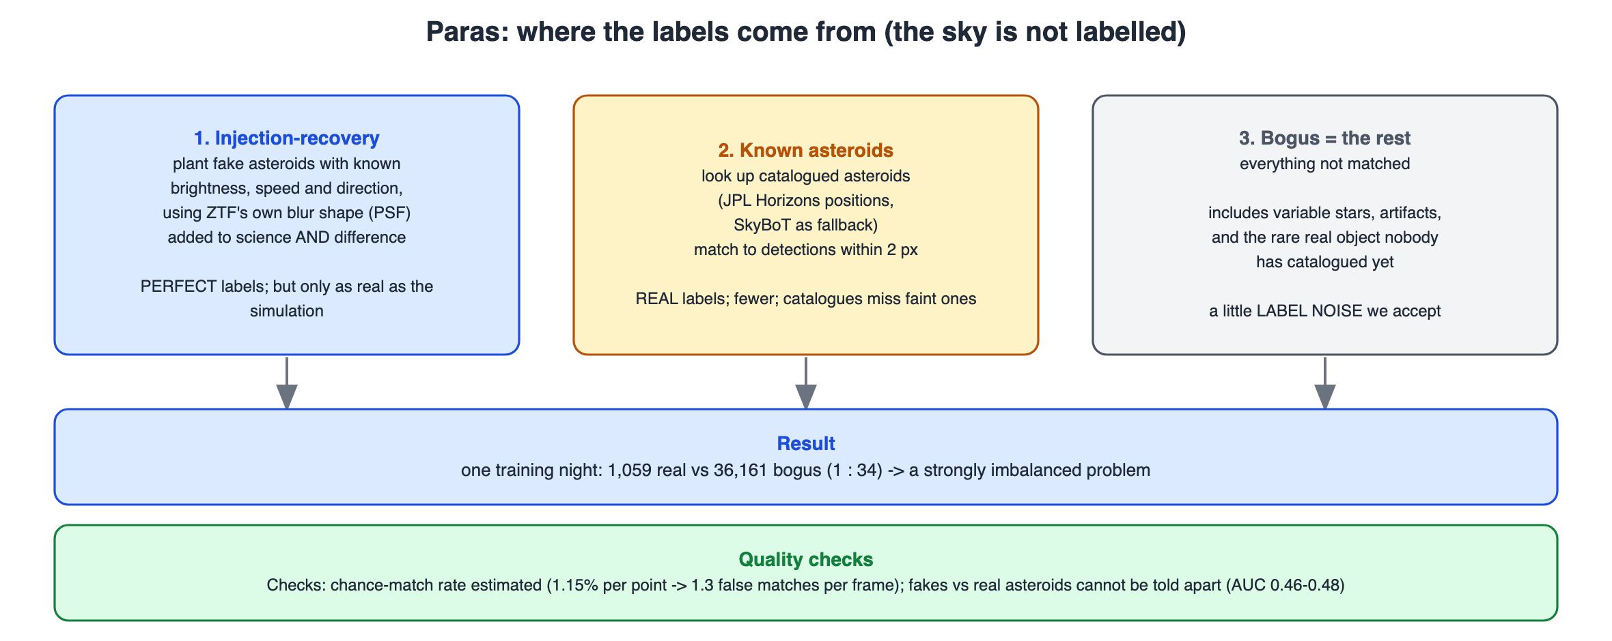
Where labels come from (03_Paras/07_Diagrams/01_label_sources.svg)
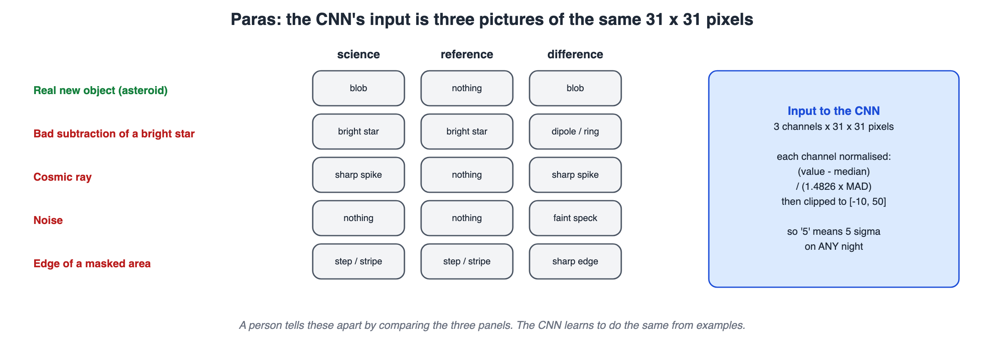
The three channels of a stamp (02_triplet_stamp.svg)
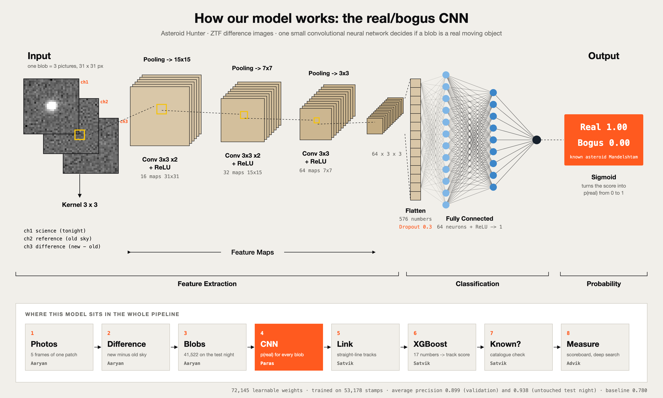
The CNN architecture (00_Start_Here/00_How_Our_Model_Works.svg)
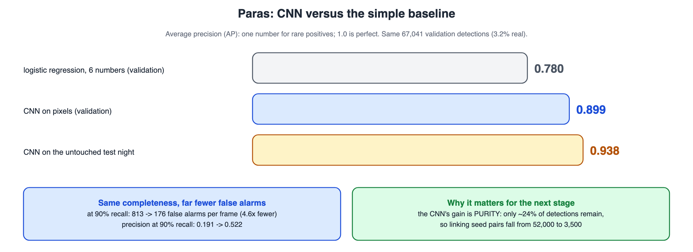
CNN results (04_cnn_results.svg)
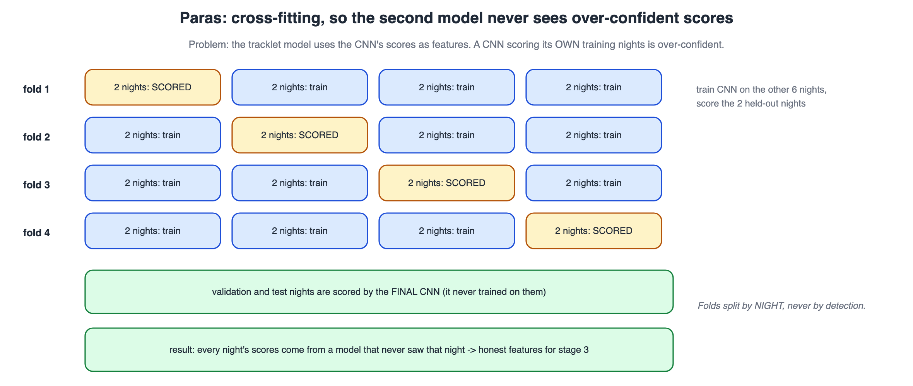
Cross-fitting (05_cross_fitting.svg)

8. Questions I should be ready for

Why three channels?
A real new object appears in science and difference but not in reference; a bad subtraction appears in science and reference. A filter that sees all three learns that difference directly.

Why balance training but not validation?
With 3% positives the easy answer 'always bogus' dominates training. Validation must keep the real mix so its precision and false-alarm numbers are honest.

Why not judge by training loss?
Training data is balanced and augmented, so its loss is not comparable. We judge by validation average precision on realistic data.

Why add fakes to both science and difference?
So that reference = science − difference stays unchanged: exactly what a new object looks like.

What is cross-fitting?
Each training night is scored by a CNN that never saw it, so the next model learns from honest scores, like on new data.
More questions with model answers are in 04_Viva_QA.md and 00_Start_Here/06_Whole_Project_Viva_QA.md. If you do not know: say what you would check and how, never make up a number.

9. Use of AI
The project's code and documents were developed with the help of an AI coding assistant (Claude, by Anthropic) under Advik's direction, which the course allows for planning, learning and deployment when it is declared. Edit this paragraph so it says what you did yourself, for example: re-ran the notebooks of my part, changed one setting and recorded what happened, wrote my slides in my own words.
Before presenting: re-run your notebooks, change one setting, and write the explanation of each step above in your own words. That is what makes this part yours (00_Start_Here/07_AI_Use_and_Integrity.md).

