ASTEROID HUNTER
Satvik: my part, start to end
Linking, the tracklet classifier (trees) and metrics
Course: Machine Learning (702DB0C015) · B.Tech CSE (Data Science), Semester V · MPSTME, NMIMS · 2026-27
Team: Advik (lead), Aaryan, Paras, Satvik
Course marks this part covers: Model Development (4, shared with Paras); the evaluation-metrics foundation of Model Evaluation (3, shared with Advik)
Date: October 2026

Contents
- My part in one page
- Where my part sits in the project
- How I did it, step by step
- My results
- Problems I hit and how they were fixed
- What I handed over
- Diagrams for my slides
- Questions I should be ready for
- Use of AI

1. My part in one page
About this document. It was drafted with the help of an AI assistant (Claude, by Anthropic) from the project's own files, as the course's GenAI policy allows for planning and learning. Before you submit it, read it fully, change anything that is not true for you, and rewrite the parts you present in your own words (see 00_Start_Here/07_AI_Use_and_Integrity.md).
My part turns single blobs into moving objects and decides how we judge every model. I join the CNN's blobs into straight-line tracks, describe each track with 17 numbers, compare four classic ML models to score them, choose the operating point, check which tracks are known asteroids, and define the metrics the whole project uses.

The steps in one line each
- Keep the CNN's blobs
- Put every photo on one sky grid
- Link into tracks
- Describe each track with 17 numbers
- Compare four models
- Choose the operating point
- Define the metrics
- Known or unknown?

My key results
What | Result
Seed pairs before / after the CNN filter | 52,000 → 3,500 (about 15x cheaper)
Linking time per night | about 0.2 s
Leftover error of real asteroids | about 2.5 px → 0.05-0.47 px after the shared sky grid
Track models (cross-validated AP) | 0.999 / 0.983 / 0.999 / 0.999 (LR / tree / forest / XGBoost): saturated, because 96% of tracks are easy planted fakes; not used to judge
How versions are judged instead (test, v1 → v4) | depth 20.53 → 21.34 mag; known found 39/44 → 40/44; unexplained 0.0 → 5.0 per night
Test night 'false positives' | 9 of 9 were real known asteroids the labels missed
Real search, validation night 2023-09-15 | 31,953 blobs → 13 tracks → 10 known asteroids, 0 unknown
Baseline at 90% recall | cut 0.082, precision 19.3%, about 804 false alarms per photo

2. Where my part sits in the project
The project finds moving asteroids in ZTF telescope images. Data flows through four parts, one per person: Aaryan (data and preprocessing) → Paras (labels and the CNN) → Satvik (linking, track model, metrics) → Advik (evaluation, deep search, demo). Each part hands a clear result to the next.
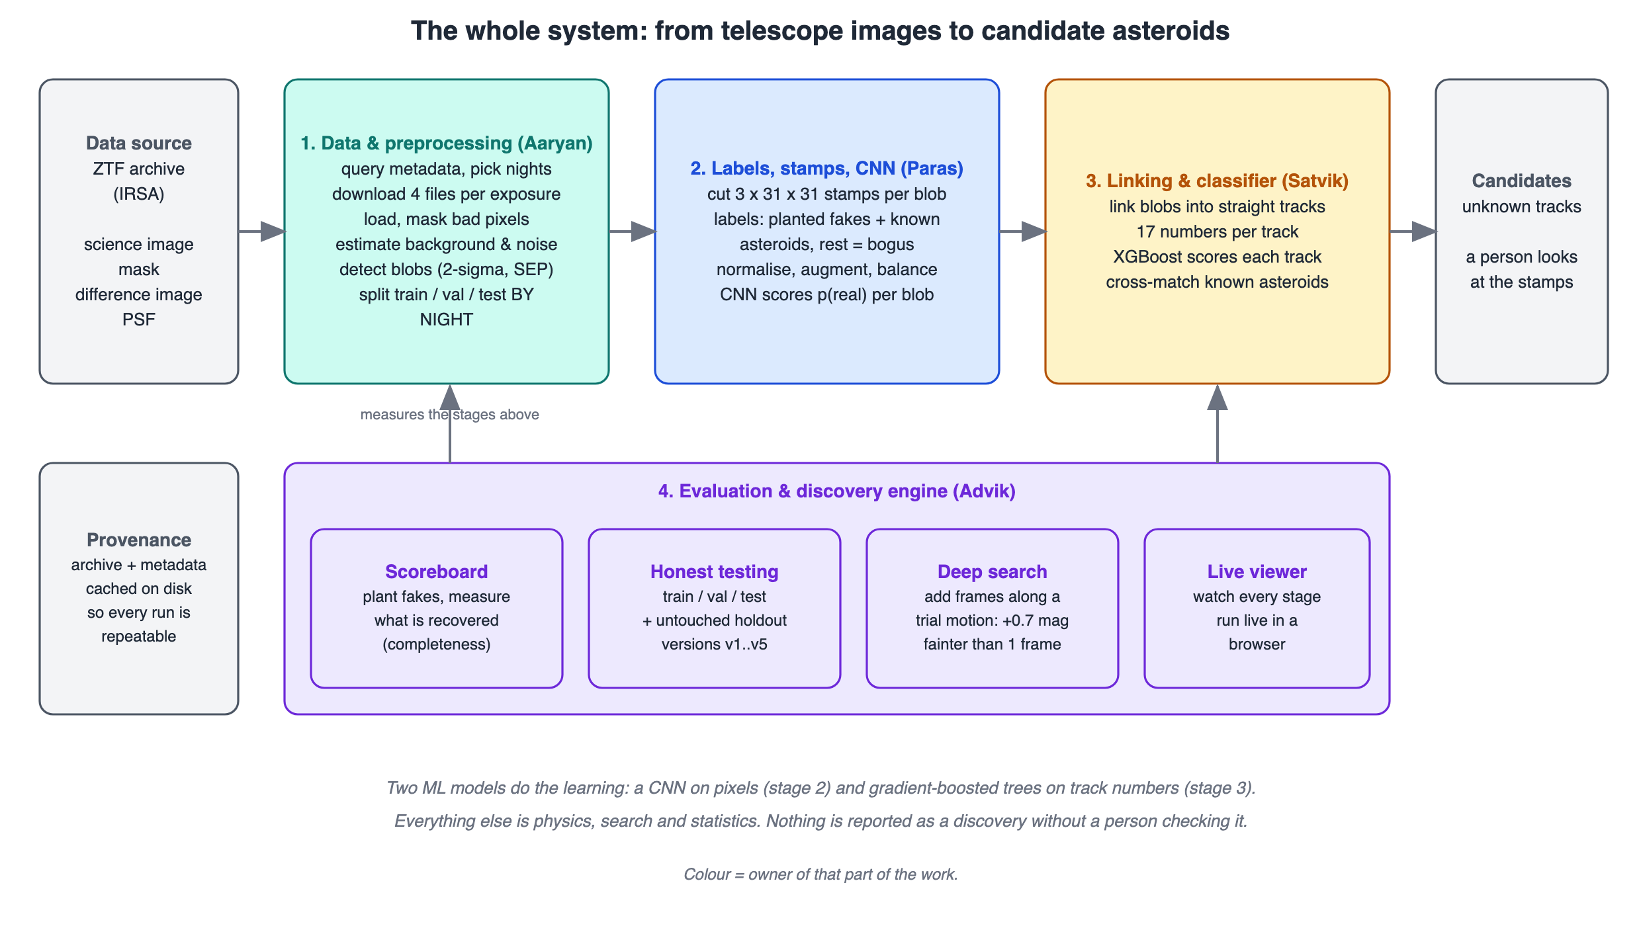
The whole system (00_Start_Here/11_Diagrams/01_system_overview.svg).
The one ML architecture at the centre of the project is the real/bogus CNN (00_Start_Here/00_How_Our_Model_Works.svg): it looks at three 31 x 31 pictures of a blob and gives the probability that it is a real moving object (average precision 0.899 on validation nights, 0.938 on the test night, against 0.780 for a simple model).

3. How I did it, step by step
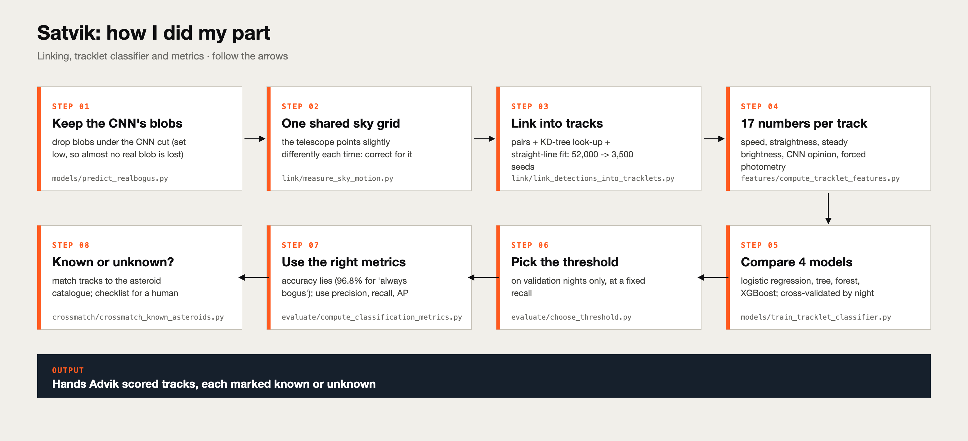
My process (04_Satvik/00_Process_Diagram_Satvik.svg).

Step 1. Keep the CNN's blobs
Only blobs above the CNN cut are linked. This removes most junk, so the search is about 15x cheaper (seed pairs fall from 52,000 to 3,500) and a night links in about 0.2 seconds.
Code / file: models/predict_realbogus.py

Step 2. Put every photo on one sky grid
The telescope points slightly differently each time (up to 12 px on the test night). Every blob gets x_common, y_common: its sky position projected onto photo 1's pixel grid. Real asteroids' leftover error fell from about 2.5 px to 0.05-0.47 px.
Code / file: link/measure_sky_motion.py

Step 3. Link into tracks
Never try all combinations (about 2 x 10^19). Seed: pairs of blobs in two photos at a plausible speed (KD-tree). Predict: where the object must be in the other photos; look it up (within 2 px). Keep: at least 3 of 5 photos, at most 1.5 px off a straight line, fitted speed at least 8 arcsec/hour. Remove duplicates.
Code / file: link/link_detections_into_tracklets.py, configs/link.yaml

Step 4. Describe each track with 17 numbers
Motion, brightness, strength, the CNN's opinion, shape, plus (in v4) static neighbours and forced photometry. Each number has a physical reason; the last two groups came from looking at 15 false alarms by eye.
Code / file: features/compute_tracklet_features.py

Step 5. Compare four models
Logistic regression, a decision tree, a random forest and XGBoost (300 trees, depth 3, learning rate 0.05, 80% rows and columns per tree), all cross-validated by night (GroupKFold).
Code / file: models/train_tracklet_classifier.py

Step 6. Choose the operating point
On validation nights only: keep 95% of real tracks. The v4 cut is 0.601.
Code / file: evaluate/choose_threshold.py

Step 7. Define the metrics
Confusion matrix, precision, recall, false-positive rate, average precision, PR vs ROC curves, calibration and base-rate adjustment. I showed why accuracy and ROC AUC mislead when real objects are rare.
Code / file: evaluate/compute_classification_metrics.py, docs/metrics_evaluation.md

Step 8. Known or unknown?
Each blob is matched to the nearest catalogue position in its photo (4 px). A track is 'known' if at least half its blobs match the same asteroid. Every unknown goes through a written checklist, and we always look at the pictures.
Code / file: crossmatch/crossmatch_known_asteroids.py

4. My results
What | Result
Seed pairs before / after the CNN filter | 52,000 → 3,500 (about 15x cheaper)
Linking time per night | about 0.2 s
Leftover error of real asteroids | about 2.5 px → 0.05-0.47 px after the shared sky grid
Track models (cross-validated AP) | 0.999 / 0.983 / 0.999 / 0.999 (LR / tree / forest / XGBoost): saturated, because 96% of tracks are easy planted fakes; not used to judge
How versions are judged instead (test, v1 → v4) | depth 20.53 → 21.34 mag; known found 39/44 → 40/44; unexplained 0.0 → 5.0 per night
Test night 'false positives' | 9 of 9 were real known asteroids the labels missed
Real search, validation night 2023-09-15 | 31,953 blobs → 13 tracks → 10 known asteroids, 0 unknown
Baseline at 90% recall | cut 0.082, precision 19.3%, about 804 false alarms per photo

Confusion matrix of the baseline (validation, cut 0.5)
 | Predicted real | Predicted junk
Really real (2,129) | 1,547 (true positives) | 582 (missed)
Really junk (64,912) | 493 (false alarms) | 64,419 (true negatives)

What the numbers say
Metric | Value | Meaning
Recall | 72.7% | 1,547 of 2,129 real blobs found
Precision | 75.8% | 1,547 of 2,040 flagged were real
Accuracy | 98.4% | looks great, but 'always junk' gets 96.8%
ROC AUC vs AP | 0.95 vs 0.78 | ROC hides false alarms when positives are rare

Our CNN on the whole test night (41,522 blobs, 3.2% real): recall and precision together
Cut | Recall | Precision | F1 | False alarms per photo
Stage-1 cut (deployed) | 99.1% | 6.1% | 0.11 | 4,144
Cut for 95% recall | 95.0% | 55.0% | 0.70 | 210
Cut for 90% recall | 90.1% | 90.5% | 0.90 | 26
Recall alone can look too good: the deployed stage-1 cut keeps 99.1% of real blobs, but only 6.1% of the blobs it keeps are real (4,144 junk blobs per photo). That is a deliberate choice: an asteroid dropped here is lost for good, while junk is removed later by linking and the track model. Asking for 90% recall instead gives 90.5% precision. Average precision over all cuts is 0.944 (random guessing would score 0.032). The whole pipeline is judged at the end by depth, known asteroids recovered and unexplained alarms per night.

The 17 features
Group | Numbers | Physical idea
Motion | n_detections, rate, max_residual | steady straight motion
Brightness | mag_mean, mag_std | brightness stays steady
Strength | snr_mean, snr_min | one weak point = weak track
CNN opinion | score_mean, score_min | what the CNN thought
Shape | npix_std, elongation_mean | a point stays a point
Static neighbours | mean, max | a mover leaves nothing behind
Forced photometry | min, median, std, stack_snr | faint signal even where missed

Every number above can be traced to a file in the project (the lesson documents in project/docs, the knowledge pack in this folder, or project/reports/scoreboard.csv). If a number changes, tell Advik so the slides and report stay in sync.

5. Problems I hit and how they were fixed

The biggest bug of the project
Bright known asteroids did not link while fakes linked perfectly. Every real asteroid had the same leftover pattern (0.6, 2.5, 2.4, 0.6, 1.7 px): identical errors across different objects point to a per-photo problem, the pointing shift. Fixed with the shared sky grid.

Stationary junk looked like slow movers
78 'unknown' tracks moved at about 2.5 arcsec/hour: centroid wobble of stationary sources. The minimum speed must beat measurement noise, so it is 8 arcsec/hour.

My own feature had a bug
It counted a slow asteroid's own blobs as 'static neighbours' and flagged 22% of real tracks. Found by checking real examples; fixed to 0.4%; a test was written.

Numbers can lie, pictures do not
Three interesting unknowns on the test night looked like asteroids in the numbers but were a galaxy residual, satellite trails and a saturated-star bleed.

6. What I handed over
Advik gets tracks with a tracklet_score and a known_name, from the deployed function run_night_pipeline.

Files in my folder
File | What it is
README.md | my part step by step and a guide to the folder
00_Process_Diagram_Satvik.svg | how I did my part, as one picture
01_Part_Brief.md | what is mine, what I hand over, where the code is
02_Knowledge_Pack.md | everything I must understand, in detail
03_Presentation_Guide.md | slide by slide: what to say and for how long
04_Viva_QA.md | questions and model answers
05_Handbook_Satvik.html / .pdf | files 01-04 plus diagrams in one printable file
06_Report_Satvik.docx | this report
07_Diagrams/ | pictures for my slides, numbered in step order

7. Diagrams for my slides
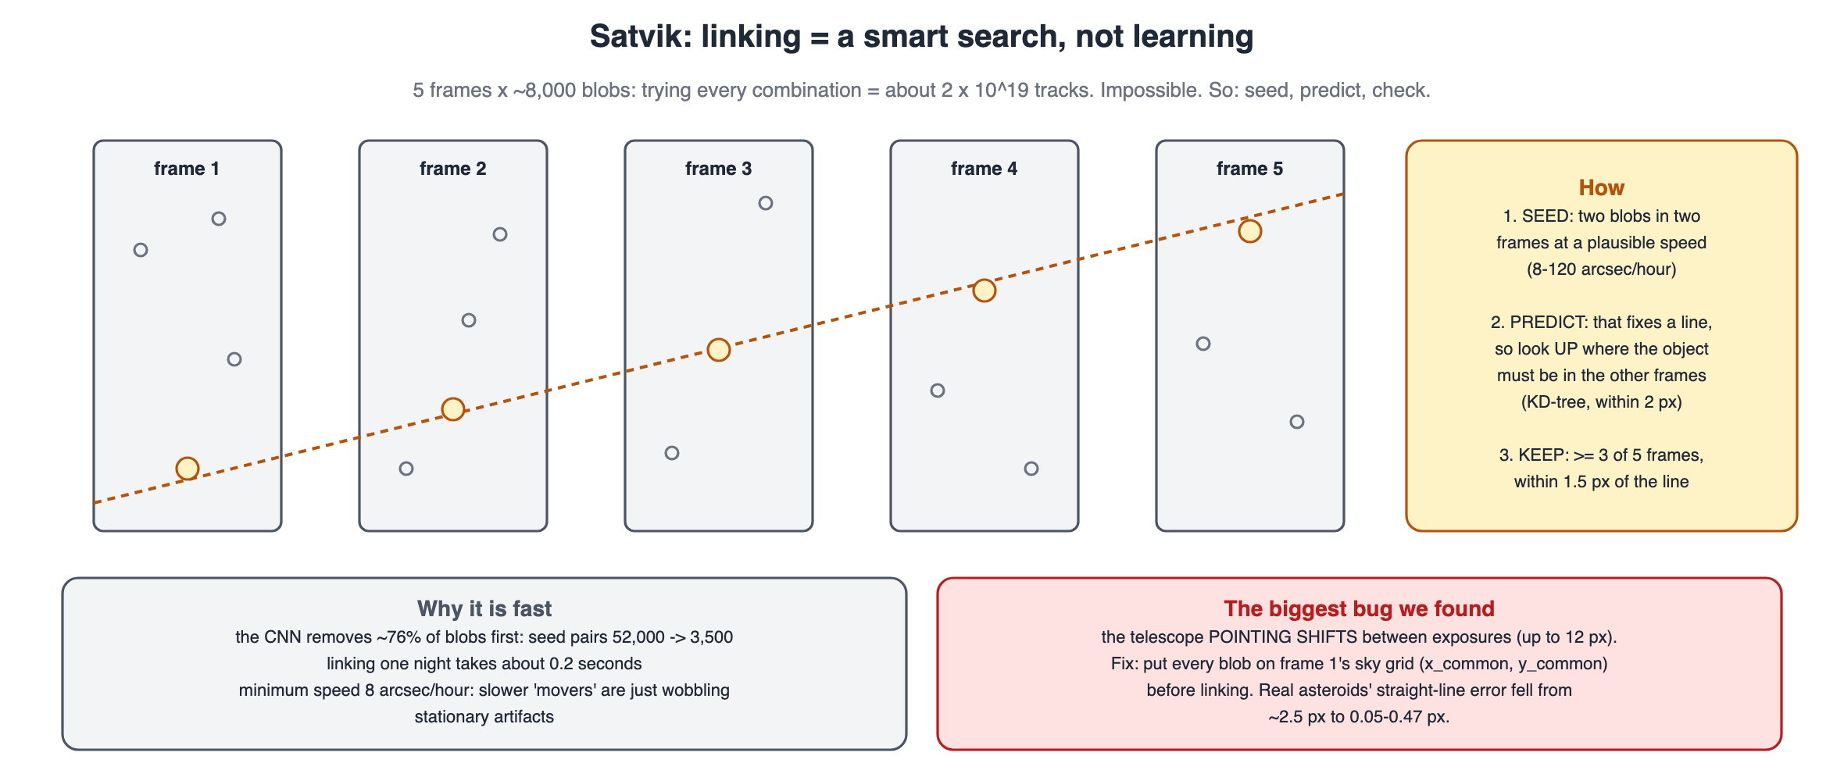
Linking by seed and predict (04_Satvik/07_Diagrams/01_linking.svg)
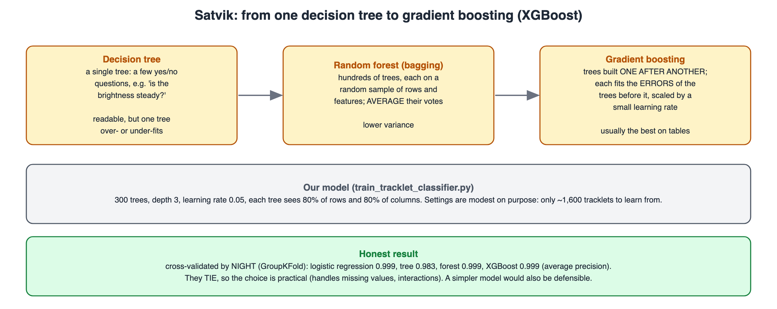
Tree, forest, boosting (02_boosting.svg)
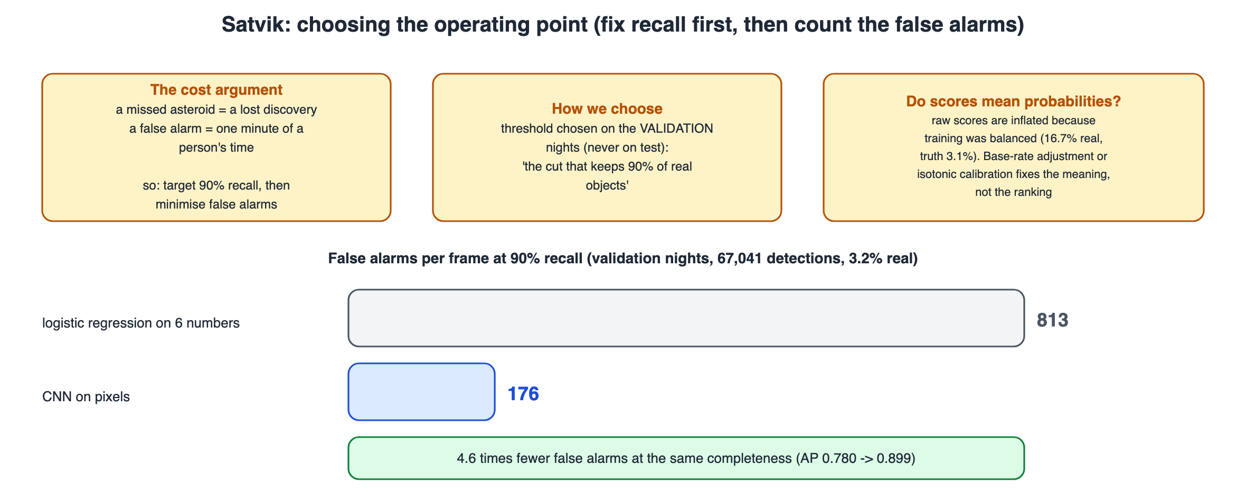
Choosing the operating point (03_operating_point.svg)
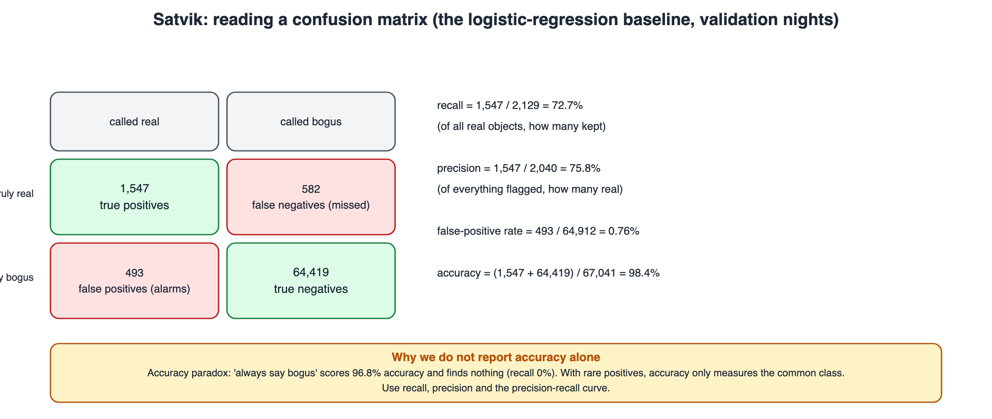
Confusion matrix and metrics (04_confusion_metrics.svg)

8. Questions I should be ready for

Why is linking not machine learning?
Physics gives the rule: over half an hour an asteroid moves in a straight line at a steady speed. It is a search, made fast with KD-trees.

Why cross-validate by night?
Tracks from one night are alike; a random K-fold leaks them across folds and inflates scores.

Why is accuracy the wrong metric?
With 3% positives, 'always junk' is 96.8% accurate and useless. Precision, recall and AP measure what we care about.

Why do four models tie, and why XGBoost?
Most tracks are planted fakes, which are easy, so AP is saturated. XGBoost handles missing values and interactions without extra work; logistic regression would also be defensible.

Why does identical residual pattern mean a per-photo problem?
Different asteroids have different motions; if their errors match photo by photo, the error belongs to the photos (pointing), not to the objects.
More questions with model answers are in 04_Viva_QA.md and 00_Start_Here/06_Whole_Project_Viva_QA.md. If you do not know: say what you would check and how, never make up a number.

9. Use of AI
The project's code and documents were developed with the help of an AI coding assistant (Claude, by Anthropic) under Advik's direction, which the course allows for planning, learning and deployment when it is declared. Edit this paragraph so it says what you did yourself, for example: re-ran the notebooks of my part, changed one setting and recorded what happened, wrote my slides in my own words.
Before presenting: re-run your notebooks, change one setting, and write the explanation of each step above in your own words. That is what makes this part yours (00_Start_Here/07_AI_Use_and_Integrity.md).

