NMIMS UNIVERSITY
School of Technology Management & Engineering · BTech Computer Science and Engineering
Design Experience — Problem Definition & Solution Design
CertifyAI
Verified embedded-emissions infrastructure for Indian metal exporters
The trusted data pipe that carries carbon numbers from Indian mills, through fabricators, to EU importers
Item | Detail
Project | CertifyAI (working name)
Team | Advik Divekar · Heet Ranpura · Akshada Jangam · Siddhesh Roulo · Paras Jadhav
Faculty advisor | [Name, designation]
Document status | v1.0 — Design stage. Defines the problem and the proposed solution. Contains no measured results.
Date | October 2026

Contents
How to read this document
1. Executive summary
2. Problem identification
3. Existing solutions and the gap
4. Proposed solution
5. Business model and defensibility
6. Feasibility and risks
8. Validation and build plan
9. Sources (and Appendix A: Glossary)
How to read this document
This document replaces the earlier ComplianceCopilot / CertifyAI report. It does one job: it states the problem we are solving, the evidence for it, and the solution we propose, at the level of product and technical architecture.
Three conventions are used throughout:
- Facts are cited to a public source listed in Section 9. If a number has no source, it is not in this document.
- Hypotheses are marked [TO VALIDATE]. They are beliefs that must be confirmed through customer interviews or experiments before we rely on them (Section 8).
- Design decisions are stated with their rationale, so they can be challenged and revised.
What this document is not
It reports no accuracy figures, latency figures, sprint metrics or user-testing results, because nothing has been built or tested yet. Those sections will be added only when the team has real data, with the raw evidence (repository history, test logs, interview notes) kept alongside.

1. Executive summary
Since 1 January 2026, every EU importer of steel, aluminium, cement, fertilisers, hydrogen or electricity must declare the carbon emissions embedded in those goods under the EU Carbon Border Adjustment Mechanism (CBAM), and from February 2027 must buy certificates priced against the EU carbon market to cover them. When an importer cannot obtain real, verifiable emissions data from the foreign producer, it must use default values set by the European Commission, which include phased-in mark-ups and are designed to be unfavourable.
For an Indian exporter this turns carbon data into a sales requirement. A supplier who can hand its EU buyer verified, actual emissions figures saves that buyer money compared with the default; a supplier who cannot is more expensive to buy from. India's iron and steel exports to the EU already fell 35.1% in FY25 to USD 3.05 billion in the run-up to CBAM (GTRI).
The problem is harder than "calculate a number". Under the 2025 CBAM simplification, small downstream producers such as fastener makers or casting shops must use emissions data from their upstream steel or aluminium suppliers for the precursors they consume. The number an EU importer needs is therefore produced by a chain of companies, most of them SMEs with no carbon-accounting capability, and it must survive third-party verification.
Our solution in one sentence
CertifyAI is a data platform that lets Indian metal producers turn their everyday operating records into verifiable, signed emissions statements, links those statements across the supply chain, and delivers them to EU importers and verifiers, with deterministic, auditable calculations at the core and AI used only to read paperwork.

The product starts with one wedge (CBAM data for downstream steel and aluminium SMEs) and is designed to grow into a general verified product-data network for Indian exporters: India's own Carbon Credit Trading Scheme, product carbon footprints for automotive buyers, and future EU data obligations.
2. Problem identification
2.1 Background: what CBAM requires
CBAM is an EU regulation that puts a carbon price on certain imported goods equivalent to what EU producers pay under the EU Emissions Trading System (ETS). The rules that shape our problem are:
Rule | What it means | Why it matters to us
Definitive period from 1 Jan 2026 | After a reporting-only transitional period (Oct 2023 to Dec 2025), CBAM now carries a financial obligation. | Demand is real and current, not speculative.
Certificate sales from 1 Feb 2027; annual declaration due 30 September | Importers file one declaration per year and surrender certificates for the embedded emissions of goods imported the previous year. | Creates a predictable yearly cycle for selling and for data collection.
50-tonne de minimis threshold | Importers bringing in less than 50 tonnes of CBAM goods per year are exempt (not for hydrogen or electricity). | Our real buyers are mid-to-large importers; tiny one-off importers are not.
Default values with phased-in mark-ups | If actual data is not available, the importer must use Commission default values, which include mark-ups. Defaults are due for revision by Dec 2027. | The gap between default and actual emissions is the money our customers save.
Only actual data needs verification | Default values can be used without verification; actual emissions must be verified by an accredited verifier. Physical site visits are required only in the first verification year. | Our product must make actual data cheaper and easier to verify than simply accepting the default.
Downstream precursor rule | Downstream steel and aluminium producers below 20 MW thermal input no longer measure on-site emissions; they must allocate emissions from upstream precursors. | The required data lives with the supplier's supplier. This creates the supply-chain problem in Section 2.3.
Operator access to the EU CBAM portal | Non-EU operators can open an account, upload installation-level emissions data and choose which EU customers (by EORI number) can see it. | There is an official delivery channel. We integrate with it rather than competing with it.
Proposed downstream expansion from 2028 | The Commission has proposed adding about 180 steel- and aluminium-intensive downstream product categories (e.g. car parts, machinery, appliances), subject to the EU legislative process. | If adopted, a large share of Indian engineering-goods SMEs comes into scope.

2.2 Why this hurts Indian exporters
- Exports are already under pressure. GTRI reports India's steel and aluminium exports to the EU fell 24.4% in FY25, with iron and steel down 35.1% to USD 3.05 billion, ahead of the CBAM financial phase.
- The carbon-price gap is large. GTRI estimates Indian carbon prices will stay below about USD 10/tCO₂ even under India's Carbon Credit Trading Scheme, against an EU ETS benchmark of about USD 71/tCO₂, leaving a gap of roughly USD 61 per tonne of CO₂ that CBAM is designed to charge.
- The burden lands on companies least able to carry it. Large integrated mills have sustainability teams. The fabricators who buy their steel (fastener, forging, casting and auto-component SMEs) typically do not, yet they are the ones shipping finished goods to EU buyers.
- Buyers are switching on data, not just price. An importer comparing two suppliers will prefer the one whose verified emissions are lower than the default, because it directly reduces certificate cost. [TO VALIDATE]: how strongly importers weigh this today, and whether they already demand data in purchase contracts.
Note on trade policy: the India–EU Free Trade Agreement was concluded on 27 January 2026 and is pending ratification. CBAM is a separate EU measure; the team should verify how the final agreement text treats CBAM before making any claim about it.
2.3 Root cause: it is a supply-chain data problem
The visible symptom is "the SME cannot produce a CBAM number". The root causes are structural:
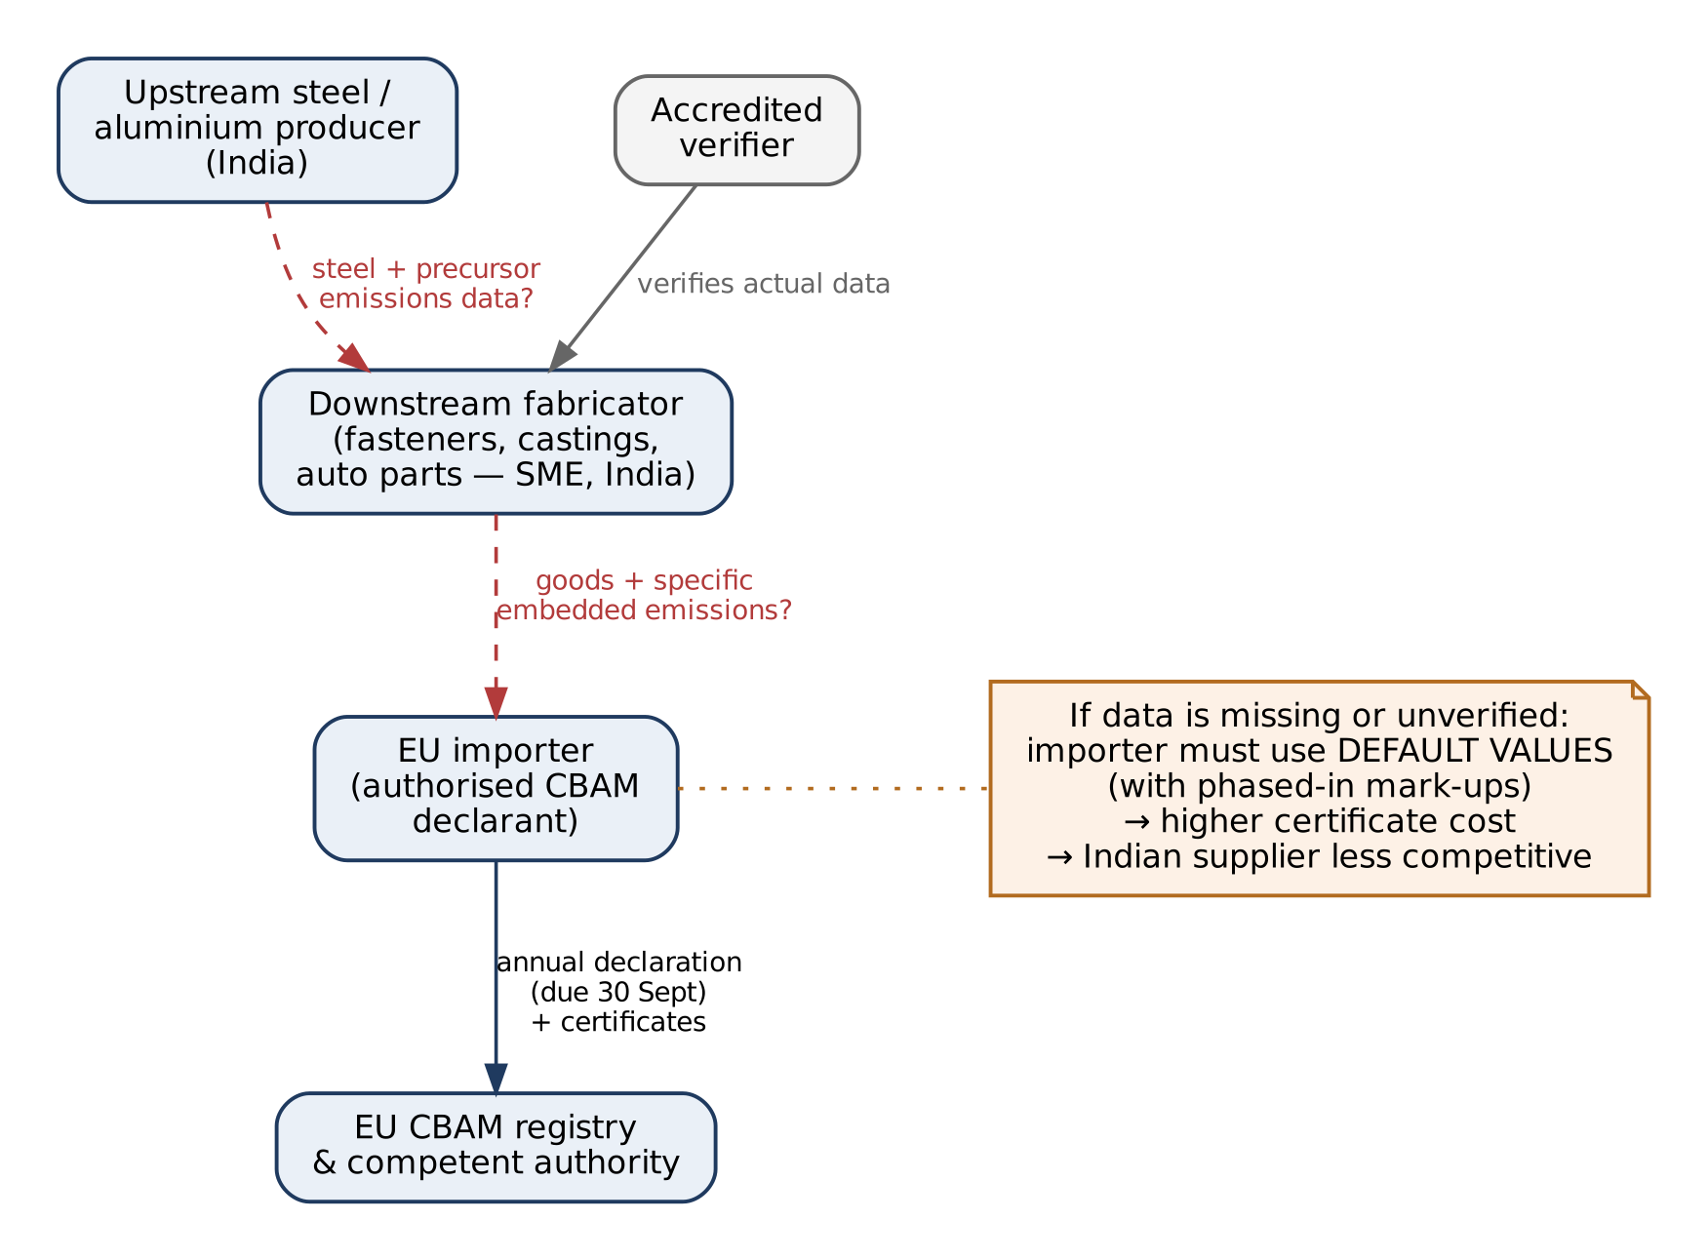
Figure 1. Where the data breaks. Red dashed arrows are the data flows that are missing or unreliable today.
# | Root cause | Explanation
R1 | No measurement system at the SME | The data needed (fuel, electricity, material inputs, output by product) exists, but scattered across electricity bills, purchase invoices, Tally ledgers and handwritten production logs. Nobody has turned it into a structured, auditable record.
R2 | Dependency on upstream data | Because of the precursor rule, a fabricator's number depends on its steel or aluminium supplier's emissions data. If the mill does not provide it, the fabricator falls back to defaults regardless of how well it measures itself.
R3 | Trust and verifiability | An emissions figure in a spreadsheet is worthless to an importer unless an accredited verifier can trace it to evidence. Most SME records are not organised for an audit.
R4 | Fragmented requests | Each EU buyer asks for data in its own template and on its own timeline, so suppliers re-enter the same information many times. [TO VALIDATE]
R5 | Rule churn | CBAM was amended within its first year (the 2025 simplification), default values are due for revision by 2027 and a downstream expansion is proposed for 2028. Any one-off spreadsheet or consultant report goes out of date.
R6 | Cost of expertise | Carbon consultants and verifiers are scarce and priced for large companies, so an SME cannot pay a consultant every year for every buyer. [TO VALIDATE]: actual consultant and verifier pricing in India.

2.4 Why the obvious solutions fail
- A spreadsheet template handles R1 partly, but not R2 (no link to suppliers), R3 (no evidence trail) or R5 (formulas go stale).
- A consultant handles R1 and R3 for one year and one buyer, but does not scale (R4, R6) and leaves no reusable system behind.
- An "upload documents, AI gives an answer" tool fails R3 outright: a number produced by a language model cannot be verified, reproduced or defended in an audit.
- The official EU portal is a delivery channel (it stores and shares data) but does not help the SME produce the data in the first place (R1–R3).
2.5 Stakeholders
Stakeholder | Who they are | What they need | What they fear
Downstream fabricator (primary user) | Owner or plant manager of a fastener, forging, casting or auto-component SME exporting to the EU | A verified emissions figure per product, produced with minimal effort, accepted by all their EU buyers | Losing EU customers; consultant costs; exposing sensitive cost data
Upstream mill | Steel or aluminium producer supplying the fabricator | One way to supply precursor emissions data to many downstream customers | Repeated ad-hoc data requests; loss of confidentiality
EU importer (economic buyer) | Authorised CBAM declarant buying from Indian suppliers | Reliable, verified supplier data in a usable format, on time for the 30 September declaration | Paying for default-value certificates; penalties for wrong declarations
Accredited verifier | Third party that verifies actual emissions data | Organised evidence, traceable calculations, efficient sampling | Untraceable figures; reputational risk
Consultant / export council (channel) | Advisors and associations helping many SMEs | A tool to serve many clients at once | Being displaced (they become a channel instead)

2.6 Problem statement
Problem statement
Indian SME manufacturers of steel and aluminium goods cannot provide their EU buyers with verifiable, product-level embedded-emissions data, because the data is scattered across unstructured operating records, depends on precursor data held by their upstream suppliers, and is not organised for third-party verification.
As a result, EU importers fall back to punitive default values, which raises the cost of buying from Indian suppliers and puts their EU business at risk. This risk grows if CBAM is extended to downstream goods from 2028.

2.7 Scope
In scope (first version) | Out of scope (for now)
Downstream steel and aluminium producers in India (fasteners, forgings, castings, simple fabricated parts) exporting CBAM goods to the EU | Cement, fertilisers, hydrogen, electricity
Their upstream mills, as data providers | Large integrated steel plants measuring complex production routes on-site
EU importers, as recipients of the data | Filing the importer's own CBAM declaration on their behalf
Preparing data for accredited verification | Acting as a verifier ourselves
Indian deployment and data residency | Non-Indian supplier countries

3. Existing solutions and the gap
3.1 Landscape
Category | Examples | What they do well | Where they stop
Official channel | EU CBAM portal, operator access | Authoritative storage and sharing of installation emissions with EU customers | Does not help the operator collect, calculate or evidence the data
Importer-side CBAM software | e.g. CarbonChain, CBAMBOO and others | Helps EU declarants manage supplier requests and file declarations | Built around the importer; Indian SMEs are a data source, not the customer
India-focused CBAM / carbon tools | e.g. The Sustainability Cloud (CBAM module with importer data exchange and verifier access); Cero; CarbonView (Clairco); consulting-led firms such as Envint | Local presence, Indian reporting frameworks (e.g. BRSR), consulting support | [TO VALIDATE]: depth of precursor handling across companies, evidence-grade provenance and SME-level pricing. Must be mapped in detail through demos and interviews.
Consultants | Sustainability and CBAM advisory firms | Expertise, hand-holding | Per-engagement cost; no reusable system; does not scale across buyers
General carbon accounting | Corporate GHG (Scope 1–3) tools | Company-level footprints | Not product-level, not CBAM methodology, not built for verification of embedded emissions

Honest assessment: CBAM software is no longer an empty market, including in India. Our case therefore cannot rest on "nobody does this". It rests on a specific technical and structural angle, described next. Validating that this angle matters to customers is the first job in Section 8.
3.2 The gap we target
Gap | Why it is underserved | Our angle
Multi-company precursor chains | Most tools model one company's emissions. The precursor rule makes the fabricator's number depend on the mill's statement. | A supply-chain graph of signed statements that propagates updates from mill to fabricator to importer.
Evidence-grade provenance | Spreadsheets and dashboards show numbers, not the trail behind them. | Every figure links back to hashed source documents and a reproducible calculation trace.
Reproducibility under changing rules | Rules and defaults change; old reports become impossible to recompute. | Versioned methodology packs and a bitemporal ledger.
SME onboarding cost | SME data lives in bills and handwritten logs, not ERPs. | AI-assisted extraction with mandatory human confirmation, tuned for Indian document formats.
One statement, many buyers | Suppliers re-enter data for each importer. [TO VALIDATE] | Statements are produced once and shared by grant, including through the EU portal.

3.3 Relevant standards and frameworks
- Regulation (EU) 2023/956 establishing CBAM, its implementing acts (in force from 1 January 2026) and the 2025 simplification amendment.
- EU ETS monitoring and reporting rules: CBAM embedded emissions are calculated in line with the EU ETS after the transitional period. Our calculation packs must follow these rules exactly.
- ISO 14064-1 / 14064-3 (GHG quantification and verification) and ISO 14067 (product carbon footprint), as general references for verification practice and future product-footprint work.
- GHG Protocol and the WBCSD PACT framework for exchanging product carbon footprints between companies, as targets for interoperability in later stages.
- India's Carbon Credit Trading Scheme (CCTS): emission-intensity targets have been notified for sectors including aluminium (October 2025) and secondary aluminium (January 2026), with iron and steel still pending at the time of the cited source.
- India's Digital Personal Data Protection Act, 2023 for handling of personal data in the platform.
- Digital signature and credential standards (e.g. Ed25519 signatures, JSON Web Signatures, W3C Verifiable Credentials) as candidate formats for signed statements.
4. Proposed solution
4.1 What CertifyAI is
CertifyAI is a system of record for product-level emissions data. A supplier connects its operating records once; the platform turns them into verified, signed emissions statements per product and period; downstream customers, EU importers and verifiers consume those statements through a portal, an API and the official EU channel.
Value for each stakeholder
Stakeholder | Value proposition
Fabricator | Turn existing bills and logs into a verifiable emissions statement per product, without hiring a carbon team. See how much your buyer saves versus the default value.
Mill | Publish precursor emissions once and share them with every downstream customer under your control.
EU importer | Receive supplier data that is verified, traceable and on time, and see which suppliers are still on defaults and what that is costing.
Verifier | Audit faster: every figure drills down to evidence and to the exact calculation that produced it.

4.2 How it works: the fabricator's journey
- Set up the installation. Register the plant, its production processes and the goods it ships (by CN code).
- Connect evidence. Upload or forward electricity bills, fuel and material purchase invoices, production records and Tally/ERP exports. Each file is stored under its content hash.
- Confirm extracted data. AI proposes the values it read (e.g. kWh, fuel quantity, tonnes produced) with a confidence score; a person confirms or corrects each one in a review screen.
- Link precursors. Select the steel or aluminium supplier for each input. If the supplier is on CertifyAI, its signed statement is linked automatically; if not, the default value is used and the cost of that gap is shown, with an invitation to the supplier.
- Calculate. The methodology engine computes specific embedded emissions per product and period, with a full calculation trace.
- Verify. An accredited verifier reviews the trace and evidence in the verifier workspace and signs an opinion.
- Share. The supplier signs the statement and grants it to chosen EU importers, through the importer portal, the API, or by uploading it to the EU CBAM portal.
- Stay current. If an upstream statement or a rule changes, affected statements are flagged as stale and recalculated.
4.3 Design principles
Principle | What it means in practice
Deterministic core, probabilistic edges | No number in a statement is produced by an AI model. AI only reads documents; a person confirms every extracted value before it counts.
Every number has provenance | Any figure can be traced to the source documents (by hash) and the formula that produced it.
Reproducible at any point in time | Re-running a past statement gives the identical result, even after rules or emission factors change.
Methodology as code | Calculation rules are versioned, tested packages. A rule change is a new version, never an in-place edit.
Suppliers own their data | Data is shared only by explicit grant to a named recipient, can be revoked, and discloses only what is needed.
Trust through cryptography and third parties | Statements are digitally signed, the audit trail is tamper-evident, and accredited verifiers attest to the results.

4.4 System architecture
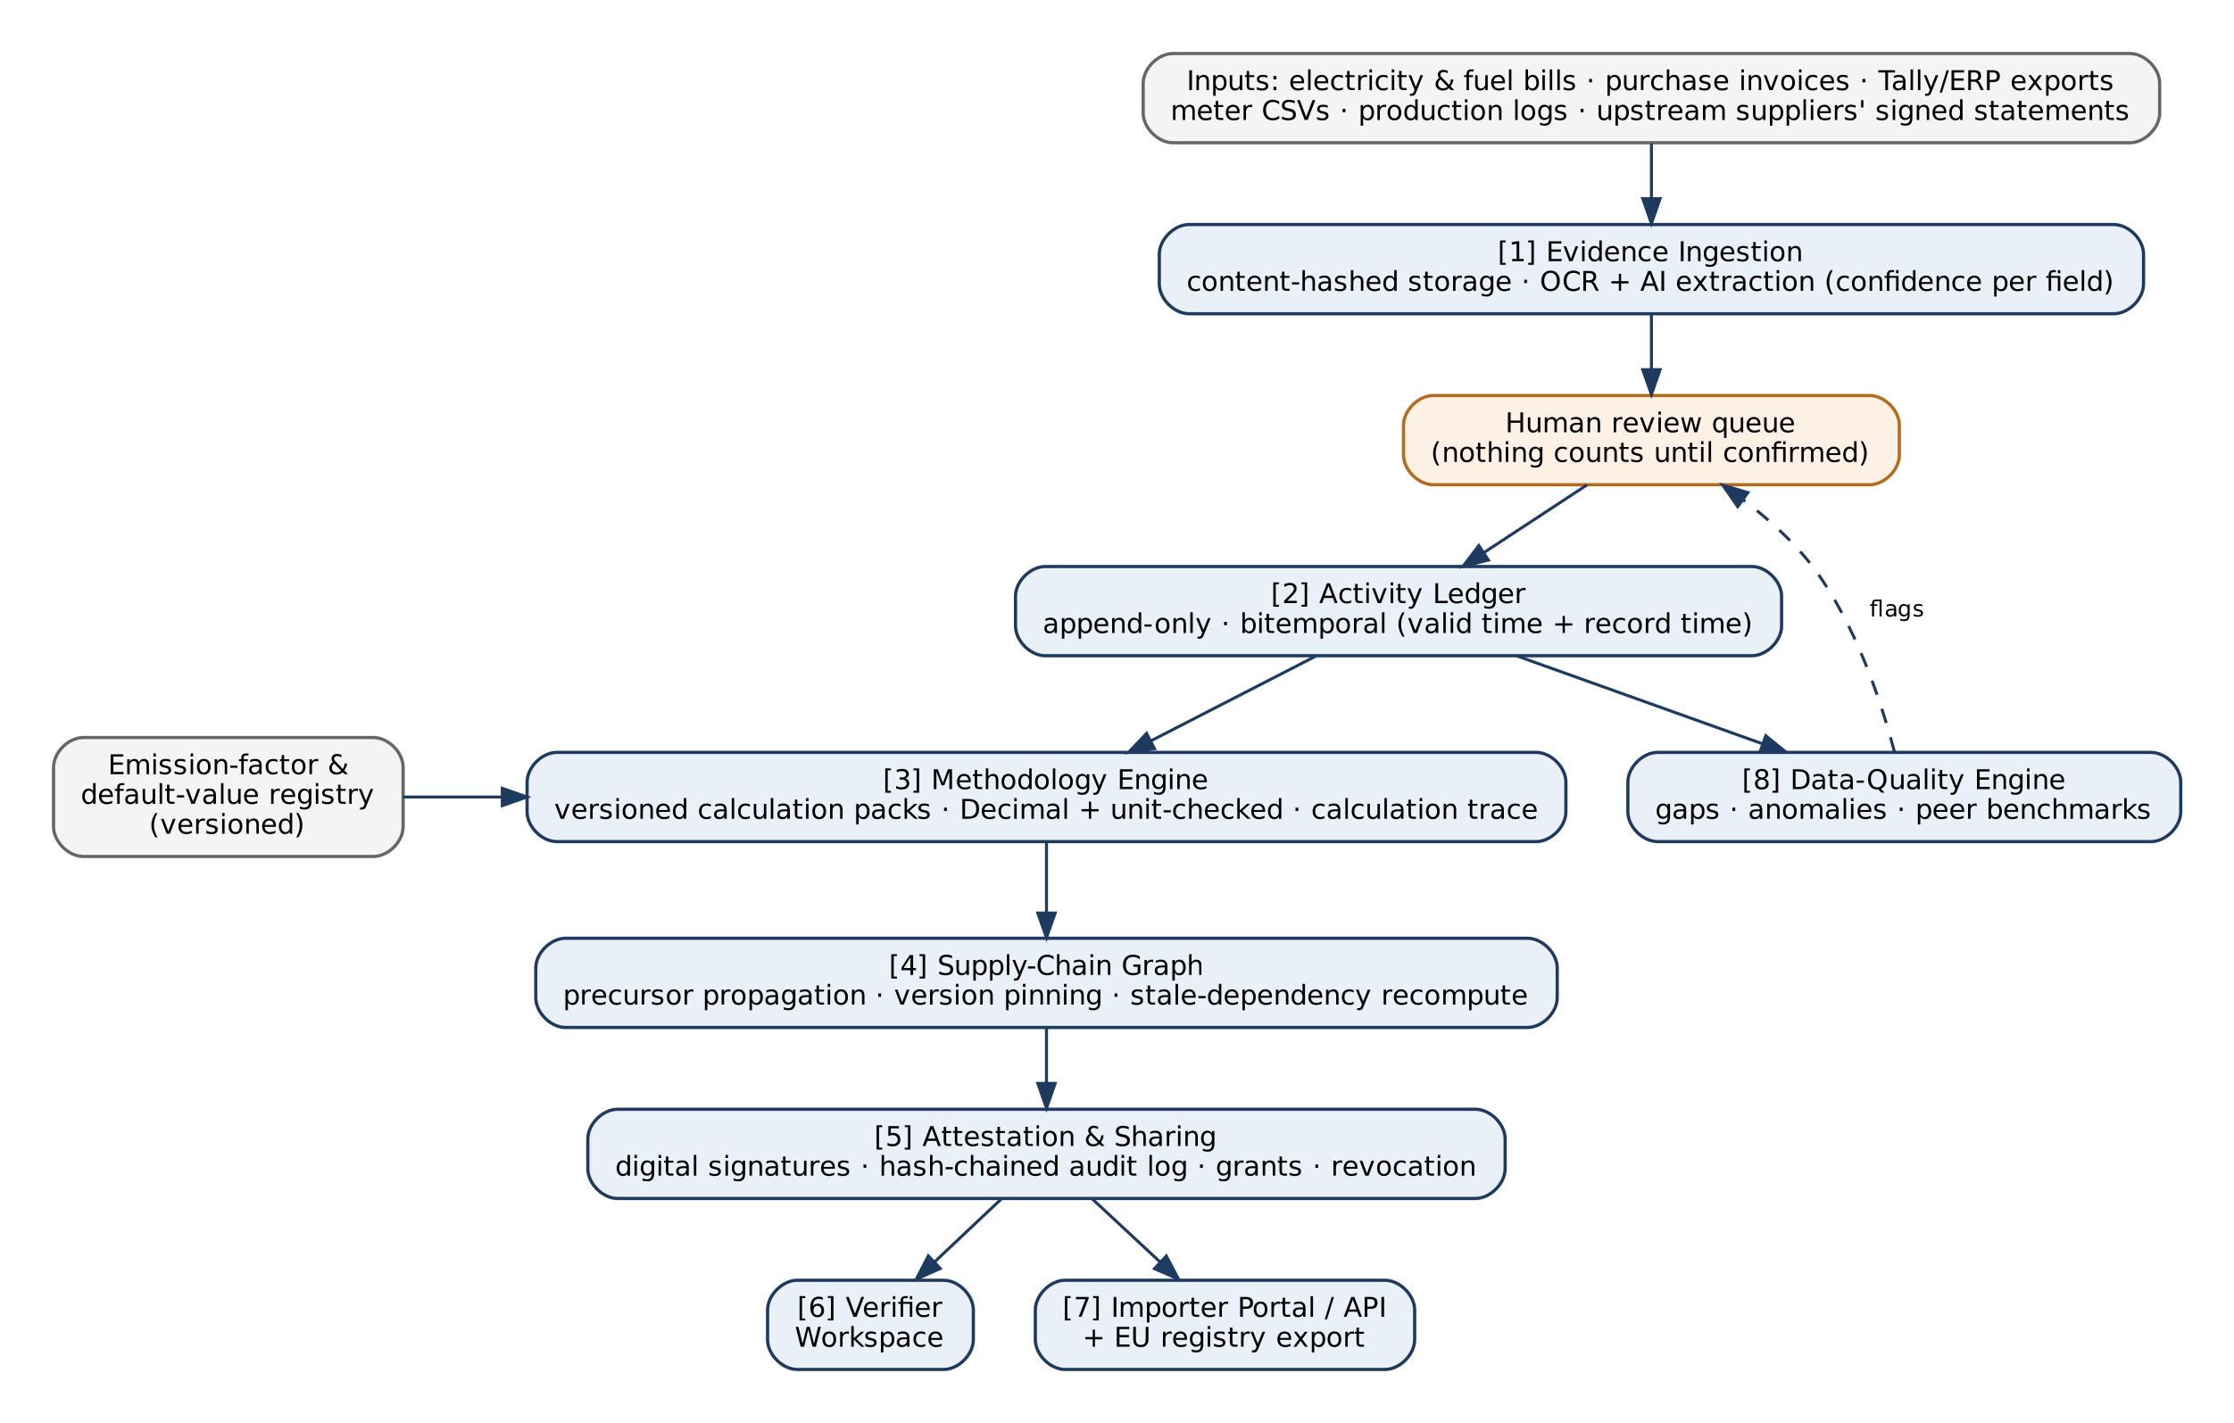
Figure 2. CertifyAI component architecture.
Component | Responsibility | Key design choices
[1] Evidence ingestion | Accept files and exports; extract structured values | Content-addressed storage (SHA-256); OCR plus a vision-capable language model with structured output; per-field confidence; routed to human review
[2] Activity ledger | Store confirmed operating data | Append-only; corrections supersede, never overwrite; bitemporal (when the fact was true, and when we recorded it)
[3] Methodology engine | Compute embedded emissions | Pure functions over a ledger snapshot plus a methodology version; Decimal arithmetic; unit-checked quantities; regulation-defined rounding; outputs a calculation trace
Emission-factor registry | Hold factors and default values | Versioned with validity periods; every calculation pins the exact versions used
[4] Supply-chain graph | Link statements across companies | Precursor references by statement ID and hash; version pinning; cycle detection; stale-dependency marking and recompute
[5] Attestation & sharing | Make statements trustworthy and shareable | Digital signatures by supplier and verifier; hash-chained audit log per period; grants and revocation; selective disclosure
[6] Verifier workspace | Support third-party verification | Read-only access; drill-down from figure to evidence; sampling; issue log; signed opinion
[7] Importer portal / API | Deliver data to buyers | Request tracking per supplier; export to formats needed for the EU registry and declarations
[8] Data-quality engine | Catch errors and gaps | Completeness checks; flagged gap-filling; anomaly detection against peer benchmarks as the network grows

4.5 Core domain model
Entity | Description
Organization | A company on the platform, with a role: supplier, importer, verifier or consultant
Installation | A physical production site, the unit at which CBAM emissions are monitored
ProductionProcess / Good | A process at the installation and the goods it produces, identified by CN code
ActivityRecord | A confirmed quantity (fuel, electricity, material input, output) for a period, linked to evidence
Evidence | A source file with its content hash, extracted fields, confidence and reviewer
EmissionFactor / DefaultValue | Versioned reference values with source and validity period
CalculationRun | One execution of the engine: methodology version, input snapshot hash, outputs, trace
EmissionsStatement | Specific embedded emissions (direct and indirect) per good and period; signed
PrecursorRef | Link from a statement to the upstream statement it relies on (ID plus hash), or to a default value
VerificationOpinion | A verifier's signed conclusion on a statement
ShareGrant | Permission for a named recipient to read a statement; revocable

The key relationship is PrecursorRef: statements point to other companies' signed statements, forming a directed acyclic graph across the supply chain. This is what lets an upstream correction flow correctly to every downstream customer.
4.6 The hard engineering problems
These problems are what make CertifyAI a real engineering project rather than a wrapper around a language model.
Problem | Why it is hard | Our approach
Allocation across products | One plant's fuel and electricity serve many products; emissions must be split according to the methodology, and the parts must add back to the total. | Allocation rules inside methodology packs; property-based tests that totals are conserved and values are never negative.
Multi-tier propagation | When a mill revises its statement, every dependent downstream statement becomes wrong, possibly across several tiers and many companies. | Treat statements like a build system: dependencies are pinned by version, changes mark dependents stale, recomputation runs in dependency order.
Reproducibility | Rules, defaults and factors change; audits ask what was known at a past date. | Bitemporal ledger plus pinned methodology and factor versions; any run can be replayed exactly.
Numerical correctness | Mixed units, rounding rules and floating-point error can silently change results. | Decimal arithmetic, unit-typed quantities (no adding kWh to tonnes), and golden tests against the Commission's published worked examples.
Trust without a central authority | Importers must trust data produced by suppliers they cannot inspect. | Hashed evidence, signed statements, tamper-evident audit logs and independent verifier signatures.
Messy Indian source documents | Electricity bills from different state utilities, handwritten logs and varied invoice formats. | Extraction with per-field confidence, a fast review UI, and a growing library of document templates.
Selective disclosure | Suppliers will not share raw costs or volumes with every buyer. | Share the per-tonne result and its verification status; keep raw evidence visible only to the supplier and its verifier.

4.7 Where AI is used, and where it is not
Task | AI? | Reason
Reading values from bills, invoices and logs | Yes, with mandatory human confirmation | Unstructured input; AI saves time; a person stays accountable for every value
Classifying documents and suggesting CN codes or process mapping | Yes, as a suggestion | Speeds up onboarding; always confirmed
Calculating emissions | No | Must be deterministic, reproducible and verifiable
Deciding which rule or default value applies | No | Encoded in versioned methodology packs
Signing, sharing, verification | No | Legal and trust functions
Explaining a result in plain language | Optional | Generated from the calculation trace, never instead of it

4.8 Security and data protection
- Data hosted in an Indian cloud region; encryption in transit and at rest; strict tenant isolation.
- Compliance with India's DPDP Act for any personal data; role-based access per organization.
- No supplier document is sent to an external AI provider without a contract that excludes training on it and limits retention.
- Signing keys managed separately from application data; every access to shared statements is logged.
4.9 Technology choices
Need | Choice | Rationale
Core data, ledger, supply-chain graph | PostgreSQL | Relational integrity, JSON support, and recursive queries handle the graph at our scale. A separate graph database is not needed yet.
Methodology engine | Python package with Pydantic, Decimal and a unit library (e.g. pint) | Testable and readable by domain experts; versioned independently of the application.
API | FastAPI | Typed, OpenAPI out of the box, same language as the engine.
Background jobs and recompute | A Postgres- or Redis-backed job queue | Enough for our event volume; a streaming platform is unnecessary at this stage.
Frontend | React / Next.js | Team familiarity; good for review-heavy interfaces.
Files | S3-compatible object storage, content-addressed and encrypted | Evidence integrity.
AI extraction | One vision-capable model behind an internal interface | Provider can be swapped; never on the decision path.
Deployment | Managed Postgres plus a few containers on a simple platform | Lowest operational burden; scale up only when usage demands it.

What we deliberately do not build (yet)
Kubernetes, Kafka, a graph database, a vector database and a microservice per feature. Each was in the earlier report; none is justified by the problem at this stage. Choosing the simplest architecture that solves the problem is itself a design decision we can defend.

5. Business model and defensibility
5.1 Who pays
Payer | Model | Status
Supplier (fabricator, mill) | Annual subscription per installation, possibly tiered by number of products | [TO VALIDATE]
EU importer | Fee per connected supplier, or API access | [TO VALIDATE]
Channel partners | Consultants and export councils resell or onboard clusters of SMEs | [TO VALIDATE]

5.2 Customer value: how savings are calculated
Our sales argument is a calculation, not a promise. For each product the buyer's saving is approximately:
Saving ≈ (default emissions − actual verified emissions) × tonnes imported × certificate price, adjusted for free allocation
All four terms come from public rules or the customer's own data, so the platform can show this figure per supplier and per product. Free allocation to EU producers phases out between 2026 and 2034, so the saving grows over time.
5.3 Go-to-market
- Start with industrial clusters where many small steel and aluminium processors export to the EU (for example fastener and hand-tool makers, forging and casting clusters, auto-component suppliers). [TO VALIDATE]: which cluster has the highest concentration of EU-bound CBAM goods.
- Reach SMEs through export promotion councils, industry associations and consultants rather than one by one.
- Use the supplier invitation loop: every fabricator on defaults sees what its mill's missing data costs and can invite the mill.
- Approach EU importers who already buy from those clusters, so that both sides of a supply relationship join together.
5.4 Moat
- Network of signed statements across mills, fabricators and importers: the more companies join, the fewer defaults remain, and the more valuable joining becomes.
- Peer benchmark data (e.g. energy per tonne by process), which improves error detection and cannot be copied without the network.
- Extraction that works on Indian documents, improving with every reviewed file.
- Verifier relationships and workflows built into the platform.
- Methodology packs kept current as rules change.
5.5 Long-term vision
Stage | Product | Trigger
1. Wedge | CBAM statements for downstream steel and aluminium SMEs | CBAM definitive period (2026), certificate purchases (2027)
2. Network | Upstream mills and EU importers on the platform; peer benchmarks; verifier workflows | Supplier invitation loop; importer demand
3. Downstream expansion | Car parts, machinery and other downstream goods | Proposed CBAM extension from 2028, if adopted
4. Domestic compliance | Emission-intensity reporting under India's CCTS | Notified targets for metal sectors
5. Verified product data | Product carbon footprints (PACT-compatible) for automotive and industrial buyers; other EU data obligations | Buyer demand beyond CBAM
6. Finance | Verified emissions data for green lending and trade finance | Lenders needing trustworthy data

6. Feasibility and risks
6.1 Feasibility
Dimension | Assessment | Reasoning
Technical | Feasible | All components use mature technology. The hard part is correctness and data modelling, which suits a CS team.
Domain knowledge | Main constraint | CBAM methodology is detailed and changes. Needs a domain advisor (consultant or verifier) and disciplined use of official Commission guidance and worked examples.
Data availability at SMEs | [TO VALIDATE] | We believe the needed inputs exist in bills and logs; interviews must confirm.
Market demand | [TO VALIDATE] | Regulation creates the need; whether SMEs or importers will pay, and how much, is unproven.
Cost to run | Low at pilot scale | Simple architecture; AI costs limited to document extraction.

6.2 Risk register
Risk | Impact | Mitigation
Importers keep using spreadsheets and email instead of a platform | High | Interview importers before building; integrate with the EU portal so suppliers can deliver through the official channel anyway.
SMEs will not pay | High | Test pricing early; explore importer-paid or channel-paid models.
Upstream mills refuse to share data | High | Selective disclosure; show mills the commercial benefit to their customers; fall back to defaults with the gap made visible.
Regulation changes again | Medium | Versioned methodology packs; monitor official sources; avoid hard-coding rules.
Calculation error in a customer statement | High | Golden tests against Commission examples; human confirmation of inputs; verifier review; reproducible traces.
Strong competitors in India | Medium | Detailed competitor mapping; focus on the multi-tier precursor and provenance angle; move fast within one cluster.
Team lacks domain expertise | Medium | Recruit a domain advisor; build relationships with one verifier early.

8. Validation and build plan
8.1 Hypotheses to validate first
# | Hypothesis | How we test it | Evidence that confirms it
H1 | EU importers are actively requesting emissions data from Indian steel/aluminium suppliers | Interviews with 5–10 importers or customs brokers; ask suppliers for real request emails or templates | Most interviewees describe current, concrete requests
H2 | Downstream SMEs cannot currently answer those requests with verifiable data | Interviews with 15–20 fabricators | Majority use defaults, consultants or nothing
H3 | The inputs needed for calculation exist in SME records | Collect anonymised sample bills and logs from 3–5 plants | Inputs for at least one product can be reconstructed from records
H4 | Upstream mills will share precursor data if asked through a platform | Interviews with 3–5 mills | At least some mills are willing under defined conditions
H5 | Someone will pay, and roughly how much | Pricing questions; letters of intent; paid pilot offer | At least one paid or committed pilot
H6 | Verifiers would work from our workspace and it would save them time | Interviews with 2–3 accredited verifiers | Verifiers confirm the evidence format is acceptable

8.2 Phases
Phase | Goal | Exit criterion
0. Discovery | Test H1–H6 through interviews and document collection | Written interview notes; decision to proceed, adjust or pivot
1. Calculation core | Methodology engine for one product family (e.g. steel fasteners) | Reproduces the Commission's published worked examples exactly
2. Single-plant pilot | Ingestion, review, ledger and statement for one real installation | A complete statement built from real records, with full trace
3. Two-tier chain | Link a mill's statement to a fabricator's | Upstream revision correctly propagates downstream
4. Delivery and verification | Signing, sharing, importer portal, verifier workspace, EU portal export | An importer receives, and a verifier reviews, a real statement

8.3 Success metrics (to be measured, not yet measured)
- Time to produce a first statement for a new installation.
- Share of extracted values accepted without correction, and correction rate by document type.
- Share of precursor inputs covered by actual (non-default) upstream data.
- Verifier time per statement, compared with the verifier's usual process.
- Estimated saving for the importer versus default values, per supplier.
- Number of companies connected per supply chain.
9. Sources
All facts in this document come from the sources below (accessed October 2026). Regulatory details should be re-checked against the Official Journal of the EU and the European Commission's CBAM pages before use in any customer-facing material.
- CarbonChain — "CBAM Omnibus: What the New Rules Mean for Importers". https://www.carbonchain.com/blog/cbam-omnibus-new-rules-for-importers
- EY — "EU adopts CBAM Omnibus Regulation" (22 October 2025). https://www.ey.com/en_gl/technical/tax-alerts/eu-adopts-cbam-omnibus-regulation
- Cassidy Levy — "Key Omnibus Simplifications to CBAM Now Final". https://www.cassidylevy.com/news/key-omnibus-simplifications-to-cbam-now-final/
- CMS — "CBAM implementation package published and proposals for future expansion" (22 December 2025). https://cms.law/en/gbr/legal-updates/cbam-implementation-package-published-and-proposals-for-future-expansion
- DQS — "CBAM portal open for non-EU country exporters" (13 January 2025). https://www.dqsglobal.com/en/explore/blog/cbam-portal-open-for-non-eu-country-exporters
- AlCircle, reporting GTRI — "Indian steel and aluminium exports to EU plunge 24.4 per cent ahead of CBAM rollout". https://www.alcircle.com/news/indian-steel-and-aluminium-exports-to-eu-plunge-24-4-per-cent-ahead-of-cbam-rollout-gtri-reports-115600
- ICAP — "India notifies emission intensity targets for nine sectors under Carbon Credit Trading Scheme". https://icapcarbonaction.com/en/news/india-notifies-emission-intensity-targets-nine-sectors-under-carbon-credit-trading-scheme
- European Commission IP Helpdesk — "EU–India Free Trade Agreement concluded" (29 January 2026). https://intellectual-property-helpdesk.ec.europa.eu/news-events/news/eu-india-free-trade-agreement-concluded-major-global-trade-milestone-2026-01-29_en
- The Sustainability Cloud — "Best CBAM Software in India 2026" (vendor-authored; used only to identify market participants). https://www.thesustainabilitycloud.com/blog/cbam-software-in-india/
- Coolset — "Top CBAM software tools". https://www.coolset.com/academy/top-cbam-software-tools
- CBAM Guide — "CBAMBOO CBAM Software Review 2026". https://cbamguide.com/software/cbamboo/
- Regulation (EU) 2023/956 of the European Parliament and of the Council establishing a carbon border adjustment mechanism. Official Journal of the European Union.
Appendix A. Glossary
Term | Meaning
CBAM | Carbon Border Adjustment Mechanism: EU regulation applying a carbon price to imports of certain goods
Authorised CBAM declarant | An EU importer authorised to import CBAM goods and file the annual declaration
Embedded emissions | Greenhouse gases emitted in producing a good, including relevant precursors
Specific embedded emissions | Embedded emissions per tonne of a good
Precursor | An input material (e.g. steel billet, aluminium ingot) whose emissions are counted in the downstream good
Default value | Commission-set emissions value used when actual data is unavailable; includes phased-in mark-ups
Installation | A physical site where production takes place and emissions are monitored
CN code | Combined Nomenclature: the EU's product classification for customs
Verifier | An accredited body that checks actual emissions data
Bitemporal | Data model that records both when a fact was true and when it was recorded
CCTS | India's Carbon Credit Trading Scheme
PACT | WBCSD Partnership for Carbon Transparency: framework for exchanging product carbon footprints

