NAME: Advik Sharma
ROLL NO:. CSC/20/32

DIP PRACTICAL QUES 1

1. Write program to read and display digital image using MATLAB or SCILAB
a. Become familiar with SCILAB/MATLAB Basic commands
b. Read and display image in SCILAB/MATLAB
c. Resize given image
d. Convert given color image into gray-scale image
e. Convert given color/gray-scale image into black & white image
f. Draw image profile
g. Separate color image in three R G & B planes
h. Create color image using R, G and B three separate planes
i. Flow control and LOOP in SCILAB
j. Write given 2-D data in image file

ANS.
b.
clear all;
close all;
clc;
img = imshow('colour.jpg')
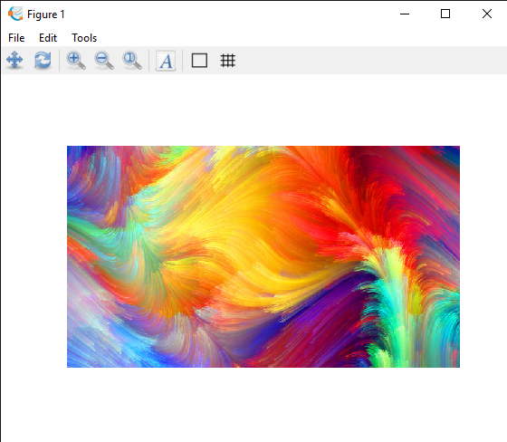

c.
clear all;
close all;
clc;
pkg load image
img = imread('colour.jpg');
subplot(1,2,1)
imshow(img);
title('original image')

resized_img = imresize(img,0.1);
subplot(1,2,2)
imshow(resized_img);
title('resized image')
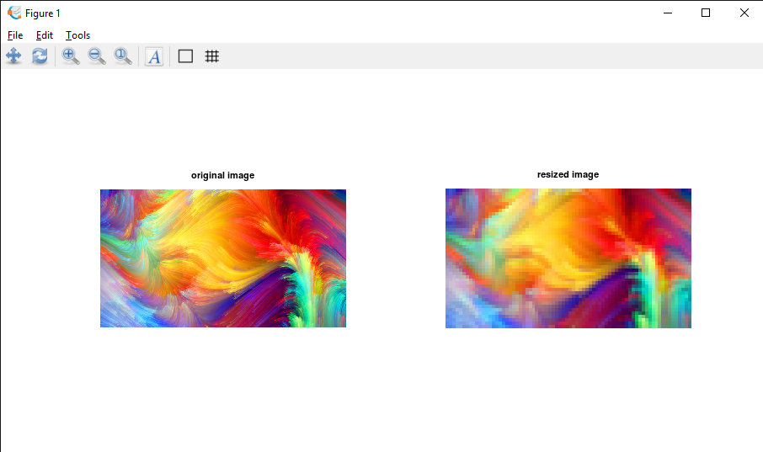

d.
clear all;
close all;
clc;
pkg load image
img = imread('colour.jpg');
grayscale_img = rgb2gray(img);
imshow(grayscale_img)
title('grayscale')
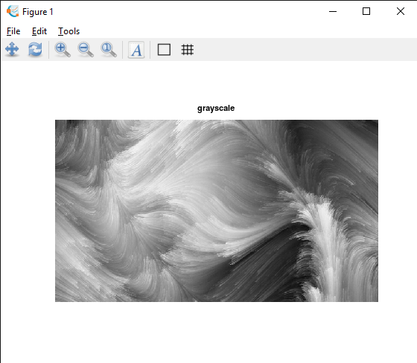

e.
clear all;
close all;
clc;
pkg load image
img = imread('colour.jpg');
bw_img = im2bw(img);
imshow(bw_img)
title('black and white')
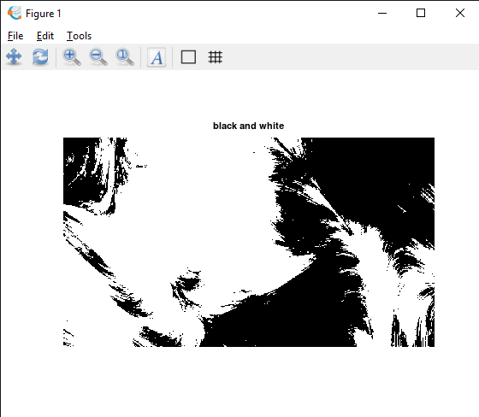

g.
clear all;
close all;
clc;
pkg load image;
img = imread('colour.jpg');
red_img=img(:,:,1);
green_img=img(:,:,2);
blue_img=img(:,:,3);

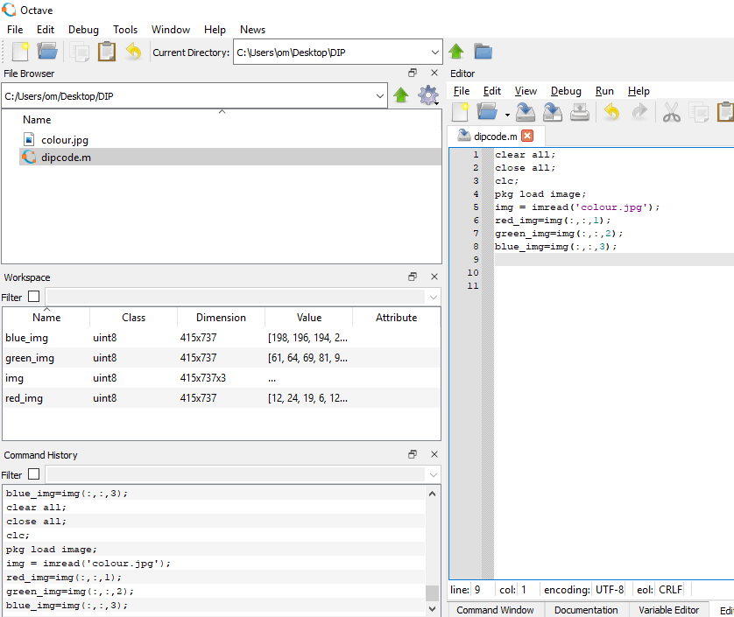

h.
clear all;
close all;
clc;
pkg load image;
img = imread('colour.jpg');
temp_img=img;

subplot(2,2,1);
imshow(img);
title('original img');

#red image
img(:,:,2)=0;
img(:,:,3)=0;
subplot(2,2,2);
imshow(img);
title('red img');

#green image
img=temp_img;
img(:,:,1)=0;
img(:,:,3)=0;
subplot(2,2,3);
imshow(img);
title('green img');

#blue image
img=temp_img;
img(:,:,1)=0;
img(:,:,2)=0;
subplot(2,2,4);
imshow(img);
title('blue img');
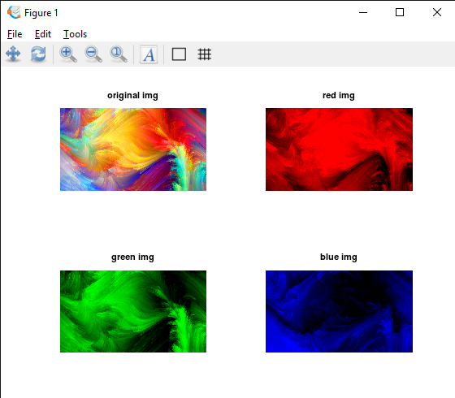

j.
clear all;
close all;
clc;
pkg load image;
m=[0:9];
n=reshape(m,2,5);
imshow(n,[]);
