**Normal Mode**

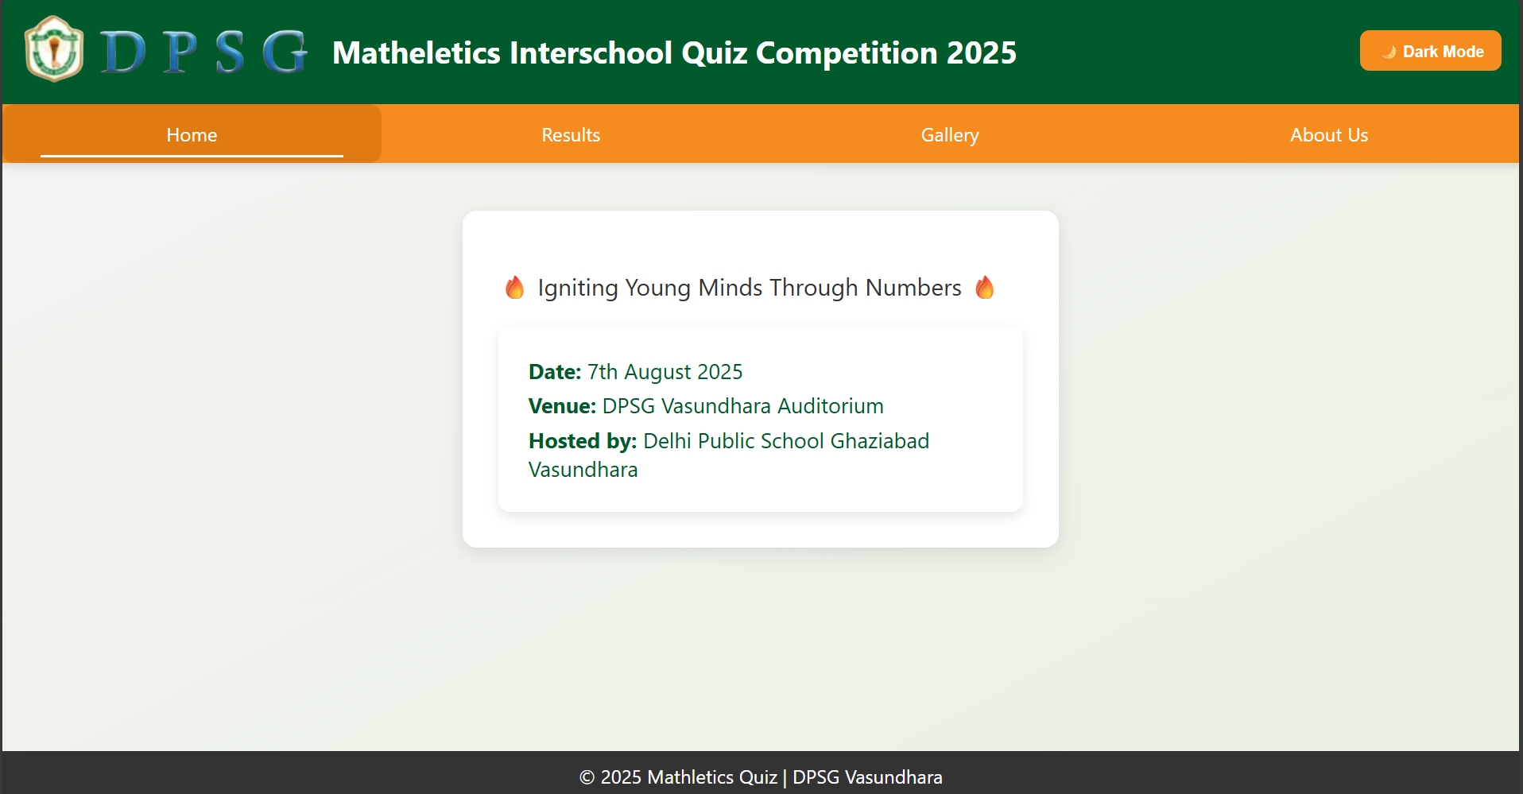

**Dark Mode**



