Programa de Residencia em Inteligencia Artificial – HUB
Nome: Bruna Fortunato

1. Crie ao menos três ambientes conda

(base) engbruna@hub-G3-3590:~$ conda create -n ambiente1
Collecting package metadata (current_repodata.json): done
Solving environment: done

## Package Plan ##

environment location: /home/engbruna/miniconda3/envs/ambiente1

Proceed ([y]/n)? y

Preparing transaction: done
Verifying transaction: done
Executing transaction: done
#
# To activate this environment, use
#
# $ conda activate ambiente1
#
# To deactivate an active environment, use
#
# $ conda deactivate

(base) engbruna@hub-G3-3590:~$ conda create -n ambiente2
Collecting package metadata (current_repodata.json): done
Solving environment: done

## Package Plan ##

environment location: /home/engbruna/miniconda3/envs/ambiente2

Proceed ([y]/n)? y

Preparing transaction: done
Verifying transaction: done
Executing transaction: done
#
# To activate this environment, use
#
# $ conda activate ambiente2
#
# To deactivate an active environment, use
#
# $ conda deactivate

(base) engbruna@hub-G3-3590:~$ conda create -n ambiente3
Collecting package metadata (current_repodata.json): done
Solving environment: done

## Package Plan ##

environment location: /home/engbruna/miniconda3/envs/ambiente3

Proceed ([y]/n)? y

Preparing transaction: done
Verifying transaction: done
Executing transaction: done
#
# To activate this environment, use
#
# $ conda activate ambiente3
#
# To deactivate an active environment, use
#
# $ conda deactivate

Exercicio 2 Liste os ambientes criados

(base) engbruna@hub-G3-3590:~$ conda-env list
# conda environments:
#
base * /home/engbruna/miniconda3
ambiente1 /home/engbruna/miniconda3/envs/ambiente1
ambiente2 /home/engbruna/miniconda3/envs/ambiente2
ambiente3 /home/engbruna/miniconda3/envs/ambiente3

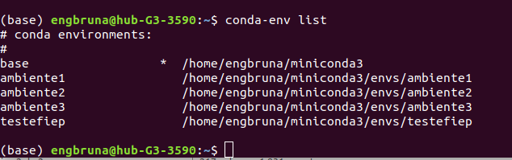Figura 1: Lista dos ambientes criados

Exercicio 3 Instale ao menos dois pacotes em cada ambiente

(ambiente1) engbruna@hub-G3-3590:~$ conda install zstd
Collecting package metadata (current_repodata.json): done
Solving environment: done

## Package Plan ##

environment location: /home/engbruna/miniconda3/envs/ambiente1

added / updated specs:
- zstd

The following NEW packages will be INSTALLED:
Instale ao menos dois pacotes em cada ambiente
_libgcc_mutex pkgs/main/linux-64::_libgcc_mutex-0.1-main
libgcc-ng pkgs/main/linux-64::libgcc-ng-9.1.0-hdf63c60_0
libstdcxx-ng pkgs/main/linux-64::libstdcxx-ng-9.1.0-hdf63c60_0
xz pkgs/main/linux-64::xz-5.2.4-h14c3975_4
zlib pkgs/main/linux-64::zlib-1.2.11-h7b6447c_3
zstd pkgs/main/linux-64::zstd-1.3.7-h0b5b093_0

Proceed ([y]/n)? y

Preparing transaction: done
Verifying transaction: done
Executing transaction: done
(ambiente1) engbruna@hub-G3-3590:~$ conda install zope
Collecting package metadata (current_repodata.json): done
Solving environment: done

## Package Plan ##

environment location: /home/engbruna/miniconda3/envs/ambiente1

added / updated specs:
- zope

The following packages will be downloaded:

package | build
---------------------------|-----------------
zope-1.0 | py37_1 4 KB
------------------------------------------------------------
Total: 4 KB

The following NEW packages will be INSTALLED:

ca-certificates pkgs/main/linux-64::ca-certificates-2019.8.28-0
certifi pkgs/main/linux-64::certifi-2019.9.11-py37_0
libedit pkgs/main/linux-64::libedit-3.1.20181209-hc058e9b_0
libffi pkgs/main/linux-64::libffi-3.2.1-hd88cf55_4
ncurses pkgs/main/linux-64::ncurses-6.1-he6710b0_1
openssl pkgs/main/linux-64::openssl-1.1.1d-h7b6447c_2
pip pkgs/main/linux-64::pip-19.2.3-py37_0
python pkgs/main/linux-64::python-3.7.4-h265db76_1
readline pkgs/main/linux-64::readline-7.0-h7b6447c_5
setuptools pkgs/main/linux-64::setuptools-41.2.0-py37_0
sqlite pkgs/main/linux-64::sqlite-3.29.0-h7b6447c_0
tk pkgs/main/linux-64::tk-8.6.8-hbc83047_0
wheel pkgs/main/linux-64::wheel-0.33.6-py37_0
zope pkgs/main/linux-64::zope-1.0-py37_1

Proceed ([y]/n)? y

Downloading and Extracting Packages
zope-1.0 | 4 KB | ###################################################### | 100%
Preparing transaction: done
Verifying transaction: done(ambiente1) engbruna@hub-G3-3590:~$ conda install zstd
Collecting package metadata (current_repodata.json): done
Solving environment: done

## Package Plan ##

environment location: /home/engbruna/miniconda3/envs/ambiente1

added / updated specs:
- zstd

The following NEW packages will be INSTALLED:

_libgcc_mutex pkgs/main/linux-64::_libgcc_mutex-0.1-main
libgcc-ng pkgs/main/linux-64::libgcc-ng-9.1.0-hdf63c60_0
libstdcxx-ng pkgs/main/linux-64::libstdcxx-ng-9.1.0-hdf63c60_0
xz pkgs/main/linux-64::xz-5.2.4-h14c3975_4
zlib pkgs/main/linux-64::zlib-1.2.11-h7b6447c_3
zstd pkgs/main/linux-64::zstd-1.3.7-h0b5b093_0

Proceed ([y]/n)? y

Preparing transaction: done
Verifying transaction: done
Executing transaction: done
(ambiente1) engbruna@hub-G3-3590:~$ conda install zope
Collecting package metadata (current_repodata.json): done
Solving environment: done

## Package Plan ##

environment location: /home/engbruna/miniconda3/envs/ambiente1

added / updated specs:
- zope

The following packages will be downloaded:

package | build
---------------------------|-----------------
zope-1.0 | py37_1 4 KB
------------------------------------------------------------
Total: 4 KB

The following NEW packages will be INSTALLED:

ca-certificates pkgs/main/linux-64::ca-certificates-2019.8.28-0
certifi pkgs/main/linux-64::certifi-2019.9.11-py37_0
libedit pkgs/main/linux-64::libedit-3.1.20181209-hc058e9b_0
libffi pkgs/main/linux-64::libffi-3.2.1-hd88cf55_4
ncurses pkgs/main/linux-64::ncurses-6.1-he6710b0_1
openssl pkgs/main/linux-64::openssl-1.1.1d-h7b6447c_2
pip pkgs/main/linux-64::pip-19.2.3-py37_0
python pkgs/main/linux-64::python-3.7.4-h265db76_1
readline pkgs/main/linux-64::readline-7.0-h7b6447c_5
setuptools pkgs/main/linux-64::setuptools-41.2.0-py37_0
sqlite pkgs/main/linux-64::sqlite-3.29.0-h7b6447c_0
tk pkgs/main/linux-64::tk-8.6.8-hbc83047_0
wheel pkgs/main/linux-64::wheel-0.33.6-py37_0
zope pkgs/main/linux-64::zope-1.0-py37_1

Proceed ([y]/n)? y

Downloading and Extracting Packages
zope-1.0 | 4 KB | ###################################################### | 100%
Preparing transaction: done
Verifying transaction: done
Executing transaction: done
(ambiente1) engbruna@hub-G3-3590:~$ conda install zlib
Collecting package metadata (current_repodata.json): done
Solving environment: done

# All requested packages already installed.

Executing transaction: done
(ambiente1) engbruna@hub-G3-3590:~$ conda install zlib
Collecting package metadata (current_repodata.json): done
Solving environment: done

# All requested packages already installed.

Exercicio 4 Liste os pacotes de cada ambiente
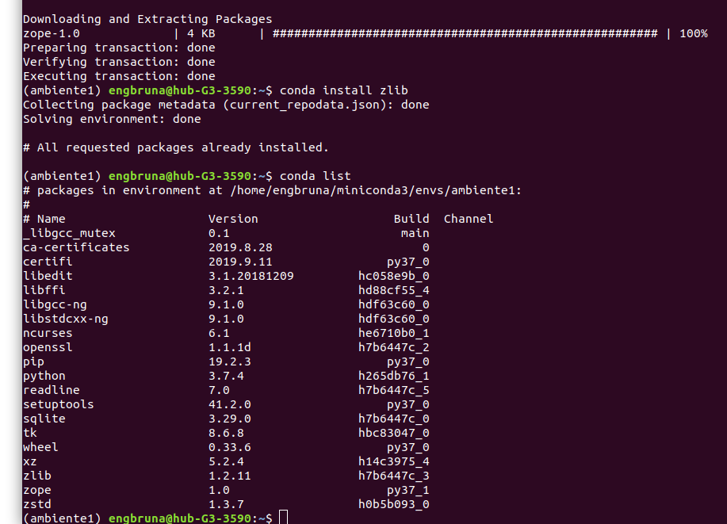

Exercicio 5 Apague um dos ambientes

(base) engbruna@hub-G3-3590:~$ conda env remove -n ambiente1

Remove all packages in environment /home/engbruna/miniconda3/envs/ambiente1:

(base) engbruna@hub-G3-3590:~$ conda-env list
# conda environments:
#
base * /home/engbruna/miniconda3
ambiente2 /home/engbruna/miniconda3/envs/ambiente2
ambiente3 /home/engbruna/miniconda3/envs/ambiente3
testefiep /home/engbruna/miniconda3/envs/testefiep
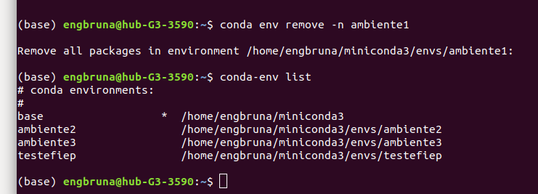

Exercicio 6 O pacote Rstudio está presente no canal conda-forge?

O pacote Rstudo não esta disponivel no canal Conda-forge

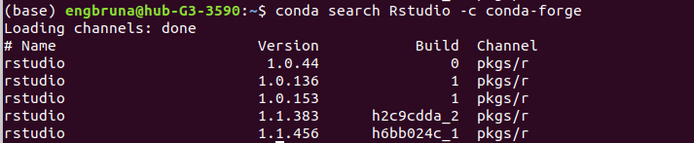
Exercicio 7 Quais as dependências instaladas após instalar o python?

Criando um ambiente novo chamado ambientePhyton, pois assim consigo visualizar se existe somente o pacote do phyton como dependencia

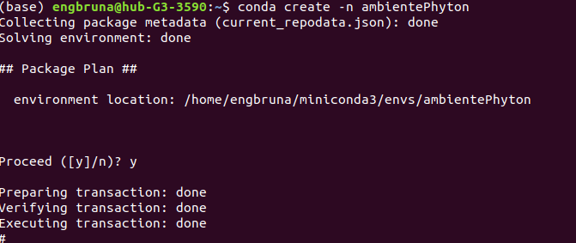

Entrando no ambientephyton (o novo criado)

Instalando o Python no ambiente novo, ambientePhyton

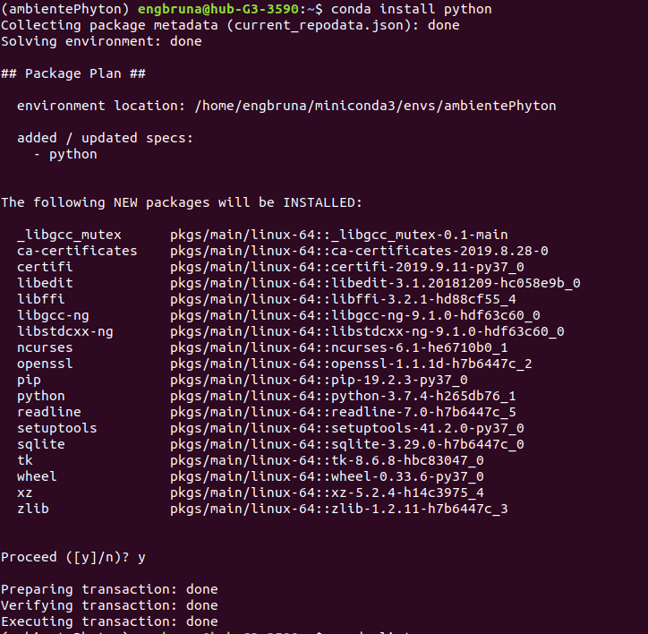

Exibindo as dependencias do ambiente novo, com o Python

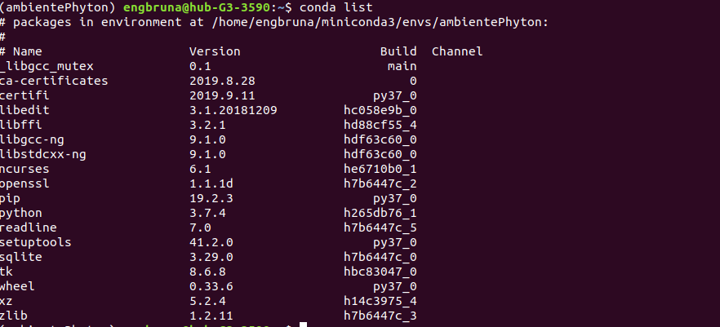

Portanto, pela figura anterior podemos visualizar todas as dependencias do python

8 Instale o pacote Pandas pelo pip

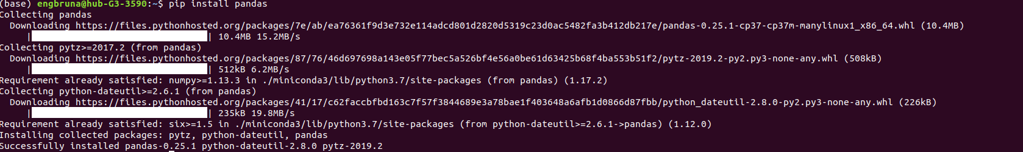

9 Monte um ambiente conda novo com python versão 3 Execute o comando python para entrar no interpretador python A partir do interpretador execute o comando print "teste" Após terminar a execução execute ctrl+d para sair do interpretador Qual é o erro apresentado? O que deve ser feito para o print funcionar? Verifique se o mesmo comando apresenta erro no python 2

Criando um novo ambiente

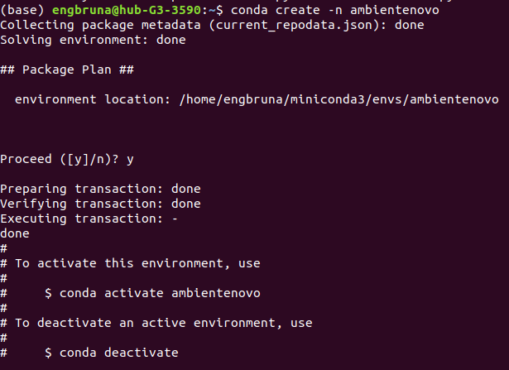

Instalando o pacote especifico : Python versao 3 e imprimindo a string teste no python

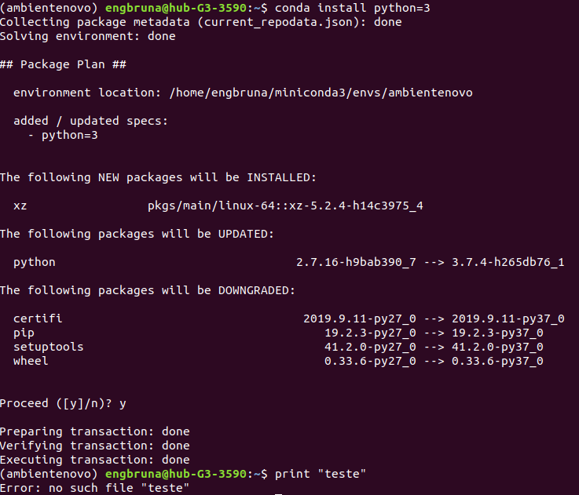

Neste caso o python procurou um arquivo com o argumento “teste” dentro do print. O erro foi de sintaxe, para imprimir corretamente sera necessario utilizar o comando

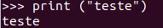

Realizando o mesmo procedimento porem utilizando o pyhton 2

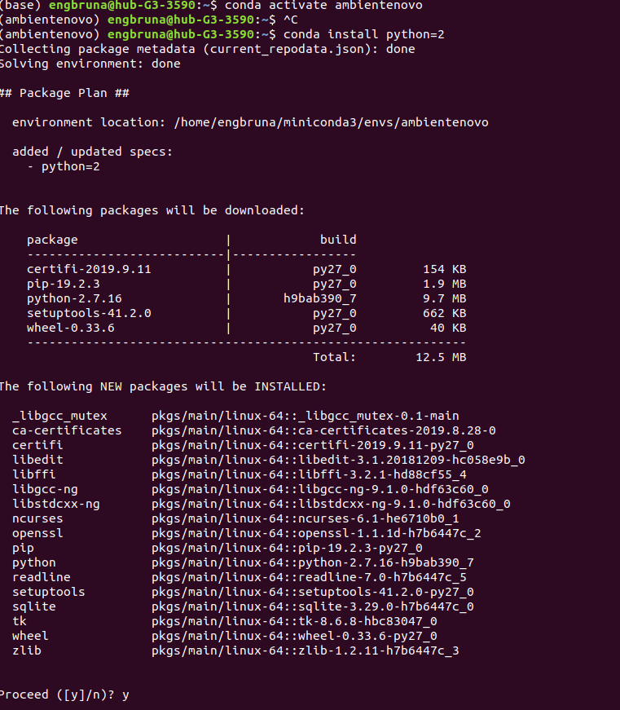
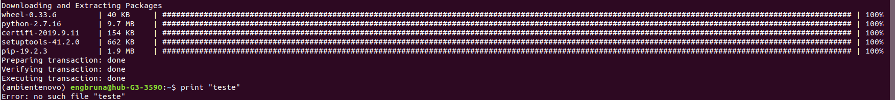

Percebe-se que o mesmo erro foi apresentado.

Ex 10 Exporte um dos ambientes criados e passe por email para todos os alunos
Ex 11 Escolha um dos ambientes enviados e monte no seu computador

