**Assignment 5**

1. Write an HTML code to display images as in the following given output by using table and image

tags.

<!DOCTYPE html>

<html lang="en">

<head>

    <meta charset="UTF-8">

    <meta name="viewport" content="width=device-width, initial-scale=1.0">

    <title>Photos</title>

</head>

<body>

    <table border="20" width ="50">

        <tr>

            <td >       <!--column 1  -->

                <img src="img1.jpeg" alt="image"  width="250" height="200">

                <img src="imag2.jpeg" alt="image"  width="250" height="200">

            </td>

            <td>       <!-- column 2 -->

                <img src="img4.jpeg" alt="image"  width="500" height="500">

            </td>

            <td >      <!-- column 3 -->

                <img src="img3.jpeg" alt="image "  width="250" height="200">

                <img src="img5.jpeg" alt="image "  width="250" height="200">

            </td>

        </tr>

        <tr>

            <td colspan="3" align="center" ><font face="Brush Script MT" size="25"><b>Taylor Swift </b></font></td>

        </tr>

    </table>

</body>

</html>

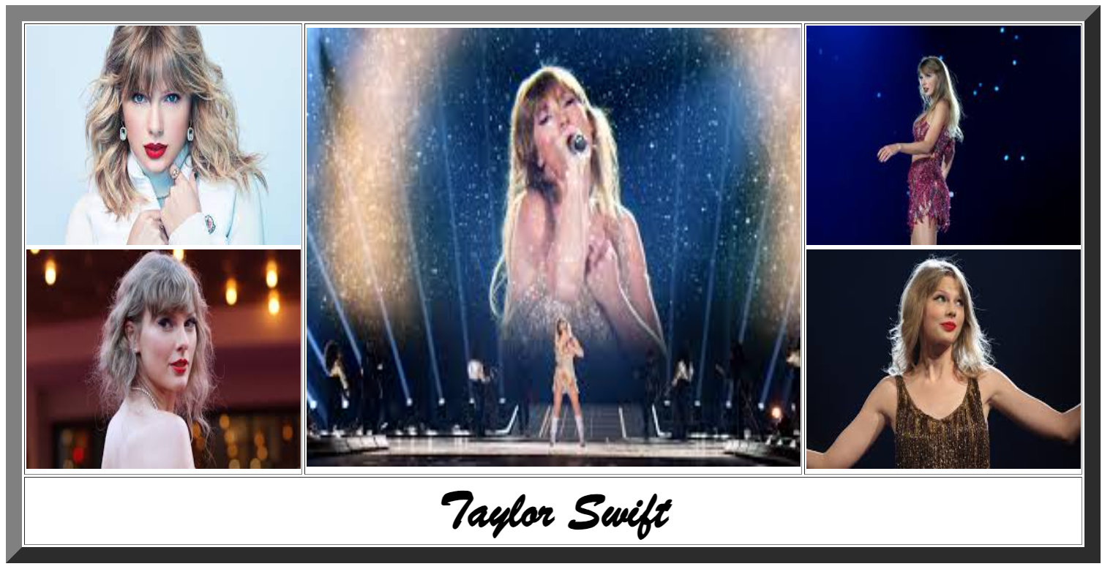

2. Write an HTML document table with lists of veg food and Non-veg with unordered list.

<!DOCTYPE html>

<html lang="en">

<head>

    <meta charset="UTF-8">

    <meta name="viewport" content="width=device-width, initial-scale=1.0">

    <title>Food</title>

</head>

<body>

    <table border="4">

        <tr>

            <td>

                <h2 align="center">Veg Food</h2>

                <ul type="circle">

                    <li>Rasam</li>

                    <li>Paneer</li>

                    <li>Mushroom</li>

                    <li>potato Baji</li>

                    <li>gobi manchuri</li>

                </ul>

            </td>

            <td>

                <h2 align="center">Non-Veg</h2>

                <ul type="circle">

                    <li>butter chicken</li>

                    <li>fish fry</li>

                    <li>Prawn Curry</li>

                    <li> pork </li>

                    <li>Crab</li>

                </ul>

            </td>

        </tr>

    </table>

</body>

</html>

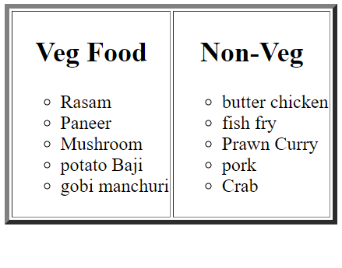

3. Write an HTML document to play audio and video files.

<!DOCTYPE html>

<html lang="en">

<head>

    <meta charset="UTF-8">

    <meta name="viewport" content="width=device-width, initial-scale=1.0">

    <title>Audio Video files</title>

</head>

<body>

    <h5 align="center"></h5> <font face="Brush Script MT" size="25"><b>Taylor Swift</b></font>

    <h2>Audio</h2>

    <audio src="taylor_style.mp3" controls>audio</audio>

    <br>

    <h2>video</h2>

    <video src=" taylor video.mp4" controls  width="500" height="300">Video</video>

</body>

</html>

