Create a Login Page where we have 2 parts

Top: Register Page

part 1: image

part2 : form

* User Name
* Email
* Password
* button

success

Redirect to Login

Top: LoginPage

part 1: Image

part2 : Form

* Email
* Password
* Button

**Registration**

**HTML**

<!DOCTYPE html>

<html lang="en">

<head>

    <meta charset="UTF-8">

    <meta name="viewport" content="width=device-width, initial-scale=1.0">

    <title>registration Page</title>

    <link rel="stylesheet" href="regist.css">

</head>

<body>

    <div class="container">

        <!-- Register Page -->

        <div class="page register-page">

            <div class="content">

                <div class="image">

                    <img src="img5.jpeg" alt="Register Image">

                </div>

                <div class="form-container">

                    <h2>Register</h2>

                    <form >

                        <input type="text" name="username" placeholder="User Name" required>

                        <input type="email" name="email" placeholder="Email" required>

                        <input type="password" name="password" placeholder="Password" required>

                        <button type="submit">Register</button>

                    </form>

                    <div class="success-message">

                        <!-- This will be shown when registration is successful -->

                    </div>

                </div>

            </div>

        </div>

    </div>

</body>

</html>

**CSS**

body {

    font-family: Arial, sans-serif;

    margin: 0;

    padding: 0;

    background-color: #f4f4f4;

}

.container {

    max-width: 600px;

    margin: 50px auto;

}

.page {

    background-color: #fff;

    border-radius: 10px;

    overflow: hidden;

    box-shadow: 0 0 10px rgba(0, 0, 0, 0.1);

    margin-bottom: 20px;

}

.content {

    display: flex;

}

.image img {

    max-width: 100%;

    height: 500px;

}

.form-container {

    flex: 1;

    padding: 20px;

}

.form-container h2 {

    margin-top: 0;

    text-align: center;

}

.form-container form {

    display: flex;

    flex-direction: column;

}

.form-container form input {

    margin-bottom: 10px;

    padding: 10px;

    border: 1px solid #ccc;

    border-radius: 5px;

}

.form-container form button {

    padding: 10px;

    background-color: #007bff;

    color: #fff;

    border: none;

    border-radius: 5px;

    cursor: pointer;

}

.form-container form button:hover {

    background-color: #0056b3;

}

.success-message {

    text-align: center;

    color: green;

    margin-top: 10px;

}

.login-page {

    display: none;

}

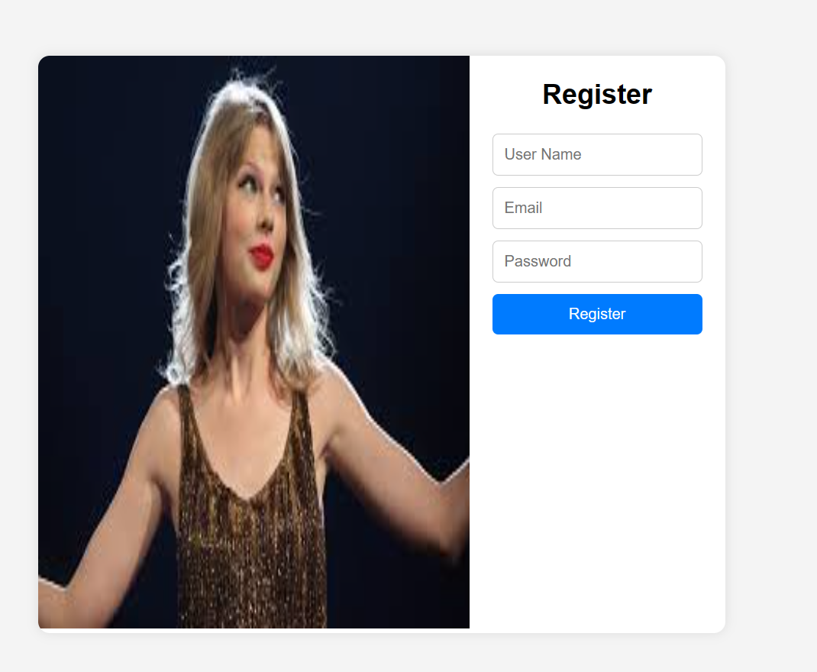

**Login page**

<!DOCTYPE html>

<html lang="en">

<head>

    <meta charset="UTF-8">

    <meta name="viewport" content="width=device-width, initial-scale=1.0">

    <title>login page</title>

    <link rel="stylesheet" href="regist.css">

</head>

<body>

    <!-- Login Page -->

        <div class="content">

            <div class="image">

                <img src="img3.jpeg" alt="Login Image">

            </div>

            <div class="form-container">

                <h2>Login</h2>

                <form>

                    <input type="email" name="email" placeholder="Email" required>

                    <input type="password" name="password" placeholder="Password" required>

                    <button type="submit">Login</button>

                </form>

            </div>

        </div>

    </div>

</body>

</html>

