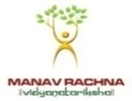

**MANAV RACHNA UNIVERSITY, FARIDABAD**

**Department of Computer Science & Technology**

**Course: B.Tech(CSE) Semester:IV Subject: Programming for Problem Solving using Python(CSW208B) Session: 2020-21**

***Lab -2:*** *Programming constructs in python -hands-on practice*

***Learning Outcome* :** *Student will be able to understand the basics of Python programming language*

***Blooms Taxonomy Level****: BT2*, *BT3*

1. [Check whether a number is even or odd](https://www.programiz.com/python-programming/examples/prime-number)

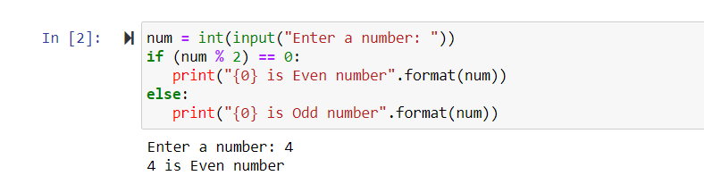

1. [Check whether an entered year is leap year or not.](https://www.programiz.com/python-programming/examples/prime-number)

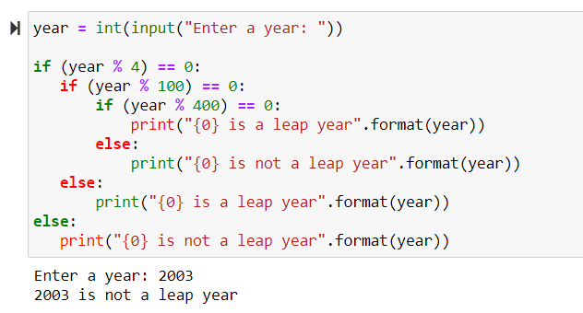

1. Write a program to check whether a character is vowel or consonants.

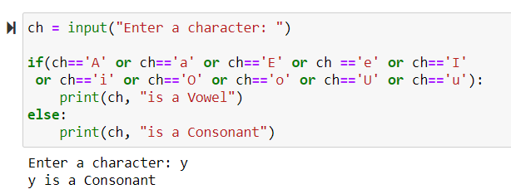

1. Write a program to find the smallest of two numbers.

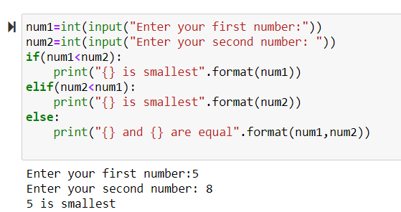

1. [Find the Factorial of a Number](https://www.programiz.com/python-programming/examples/factorial)

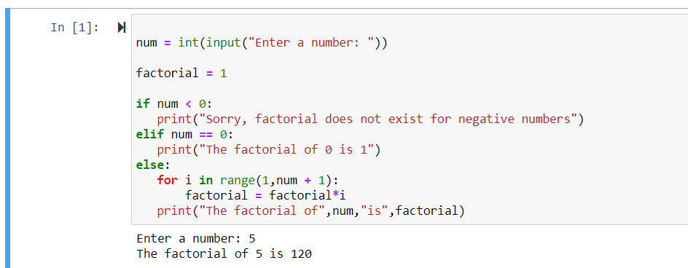

1. Write a program to print this patterns

*

* *

* * *

* * * *

1. Write a program to print this series

1 1 2 3 5 8 13

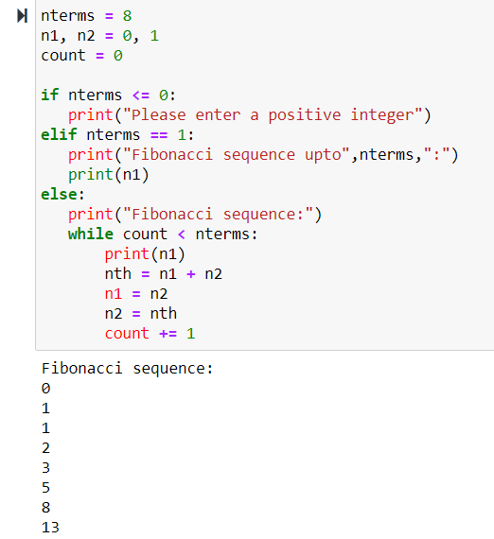

1. [Check whether a number is prime or not](https://www.programiz.com/python-programming/examples/prime-number)
2. [Make a Simple Calculator](https://www.programiz.com/python-programming/examples/calculator).