SOFTWARE ENGINEERING LAB
L | T | P | C
0 | 0 | 2 | 1

Course Outcomes
- Ability to translate end-user requirements into system and software requirements
- Ability to generate a high-level design of the system from the software requirements
- Will have experience and/or awareness of testing problems and will be able to develop a simple testing report

List of Experiments
Do the following seven exercises for any two projects given in the list of sample projects or any other Projects:
- Development of problem statements.
- Preparation of Software Requirement Specification Document, Design Documents and Testing Phase related documents.
- Preparation of Software Configuration Management and Risk Management related documents.
- Study and usage of any Design phase CASE tool
- Performing the Design by using any Design phase CASE tools.
- Develop test cases for unit testing and integration testing
- Develop test cases for various white box and black box testing techniques.

Sample Projects:
  - Passport automation System
  - Book Bank
  - Online Exam Registration
  - Stock Maintenance System
  - Online course reservation system
  - E-ticketing
  - Software Personnel Management System
  - Credit Card Processing
  - E-book management System.
  - Recruitment system

TEXT BOOKS:
- Software Engineering, A practitioner’s Approach- Roger S. Pressman, 6th edition, McGraw Hill International Edition.
- Software Engineering- Sommerville, 7th edition, Pearson Education.
- The unified modeling language user guide Grady Booch, James Rambaugh, Ivar Jacobson, Pearson Education.

REFERENCE BOOKS:
- Software Engineering, an Engineering approach- James F. Peters, Witold Pedrycz, John Wiley.
- Software Engineering principles and practice- Waman S Jawadekar, The McGraw-Hill

. PROJECT 1: PASSPORT AUTOMATION SYSTEM

EXERCISE 1: DEVELOPMENT OF PROBLEM STATEMENT

Aim
To develop the problem statement for the Passport Automation System by studying the existing passport application process, identifying its limitations, and proposing an automated software solution.

  - Problem Statement
The passport application process in many government offices is still partially manual. Applicants are required to visit passport offices several times to register, submit application forms, upload documents, pay fees, and attend verification. This process consumes a significant amount of time and often results in long queues, paperwork, human errors, delays, and difficulty in tracking the application status.
The Passport Automation System is proposed to automate the complete passport application process. It provides an online platform where citizens can register, apply for passports, upload required documents, make online payments, book appointments, and track the status of their applications. Passport officers can verify applications, approve or reject requests, and issue passports efficiently. The system reduces manual work, improves accuracy, enhances security, and provides faster services to citizens.

  - Existing System
The existing passport application system is a traditional process in which many activities are performed manually or require applicants to visit the passport office multiple times. Citizens must fill out forms, submit documents, and complete verification procedures through different stages before receiving a passport. This process is often slow, requires significant paperwork, and can cause delays.

    - Working of Existing System
- Applicant visits the passport office.
- Collects the passport application form.
- Fills the form manually.
- Submits supporting documents.
- Pays the application fee.
- Waits for document verification.
- Police verification is conducted.
- Passport officer approves the application.
- Passport is printed and dispatched.

    - Limitations in Existing System
- Time-consuming process.
- Long waiting queues.
- Excessive paperwork.
- Human errors in data entry.
- Difficult to track application status.
- Multiple visits to passport office.
- High operational cost.
- Poor record management.
- Risk of document loss.
- Less transparency.

  - Proposed System
The Passport Automation System is a web-based application that automates the passport application process.

    - The proposed system allows
      - Users to:
- Register online.
- Login securely.
- Fill passport application forms.
- Upload documents.
- Pay fees online.
- Book appointments.
- Track application status.
- Receive notifications.
- Download passport details after approval.

      - Passport officers to:
- Verify documents.
- Approve or reject applications.
- Update application status.
- Generate passports.

      - Administrators to:
- Manage users.
- Manage officers.
- Generate reports.
- Maintain the database.

  - Objectives

The objectives of the Passport Automation System are:
- To automate passport application processing.
- To reduce paperwork.
- To minimize human errors.
- To improve processing speed.
- To provide online services.
- To ensure secure data storage.
- To improve transparency.
- To enable status tracking.
- To provide better citizen services.

  - Scope of the Project

    - The system covers:
- User Registration
- Login Authentication
- Passport Application
- Document Upload
- Online Payment
- Appointment Booking
- Police Verification
- Passport Approval
- Passport Generation
- Status Tracking
- Report Generation
- User Management

    - Users of the System
- Applicant
- Passport Officer
- Administrator

    - Advantages of Proposed System
- Faster processing.
- Reduced paperwork.
- Better accuracy.
- Improved security.
- Easy status tracking.
- Online payment facility.
- Better record management.
- Reduced operational cost.
- Improved citizen satisfaction.

PROJECT 1: PASSPORT AUTOMATION SYSTEM

EXERCISE 2: Preparation of Software Requirement Specification Document, Design Documents and Testing Phase related documents.

2.Preparation of Software Requirement Specification Document

Aim
To prepare the Software Requirement Specification (SRS) document for the Passport Automation System by identifying and documenting all functional and non-functional requirements, system constraints, and software specifications.

Theory
A Software Requirement Specification (SRS) is a formal document that describes the complete requirements of a software system. It acts as an agreement between the customer and the software developer. The SRS document clearly explains what the software should do without describing how it will be implemented. It serves as the foundation for software design, development, testing and maintenance.
An SRS document helps developers understand the project requirements, reduces misunderstandings between stakeholders, and ensures that the final software meets user expectations. A well-written SRS improves software quality, minimizes development risks and provides a clear roadmap for the software development process.

Description
2.1. Product Perspective
The Passport Automation System is a web-based software application connected to a centralized database. It allows applicants and passport officers to access the system through the Internet. The system integrates user registration, application processing, document verification, online payment, appointment scheduling, police verification, and passport generation into a single platform.

2.2. Product Functions
The Passport Automation System performs the following major functions:
2.2.1. Applicant Functions
- User Registration
- Secure Login
- Passport Application Submission
- Upload Required Documents
- Online Fee Payment
- Appointment Booking
- View Application Status
- Download Application Receipt
2.2.2. Passport Officer Functions
- Login to the System
- Verify Applicant Details
- Verify Uploaded Documents
- Approve or Reject Applications
- Update Application Status
- Generate Passport
2.2.3. Administrator Functions
- Manage User Accounts
- Manage Passport Officers
- Generate Reports
- Maintain Database
- Monitor System Activities

2.3 User Characteristics
2.3.1. Applicant
- Basic knowledge of computers or smartphones.
- Internet access.
- Valid identity documents.
2.3.2. Passport Officer
- Knowledge of passport verification procedures.
- Authorized government employee.
2.3.3. Administrator
- Knowledge of system administration and database management.

2.4 Operating Environment
The Passport Automation System operates in the following environment:
- Operating System: Windows/Linux
- Web Browser: Google Chrome, Microsoft Edge, Mozilla Firefox
- Database: MySQL
- Internet Connection Required
- Application Server: Apache Tomcat (or equivalent)

2.5 Design Constraints
The system should satisfy the following constraints:
- Users must have Internet connectivity.
- Aadhaar or valid identity proof is mandatory.
- Police verification is compulsory before passport approval.
- Only authorized officers can approve passport applications.
- Secure authentication is required for all users.

2.6 Assumptions and Dependencies
- Users possess valid identity documents.
- Online payment services are available.
- Government verification systems are operational.
- The database server is available without interruption.

2.7. Specific Requirements
2.7.1 Functional Requirements
2.7.1.1. FR1 – User Registration
The system should allow new applicants to register by entering personal information such as name, email address, mobile number, and password.
2.7.1.2. FR2 – User Login
The system should authenticate registered users using their username and password.
2.7.1.3. FR3 – Passport Application
The system should allow applicants to fill and submit passport application forms.
2.7.1.4. FR4 – Document Upload
Applicants should upload supporting documents.
2.7.1.5. FR5 – Online Payment
Applicants should pay passport application fees through an online payment gateway.
2.7.1.6. FR6 – Appointment Booking
Applicants should select available appointment dates and time slots for document verification.
2.7.1.7. FR7 – Document Verification
Passport officers should verify all submitted documents.
2.7.1.8. FR8 – Police Verification
The system shall should forward applications for police verification before final approval.
2.7.1.9. FR9 – Passport Approval
Authorized passport officers should approve eligible applications.
2.7.1.10. FR10 – Status Tracking
Applicants shall should be able to view the current status of their passport applications at any time.

2.7.2. Non-Functional Requirements
2.7.2.1. Performance Requirements
- System response time should be less than 5 seconds.
- Support multiple users simultaneously.
- Fast retrieval of application records.
2.7.2.2. Security Requirements
- Username and password authentication.
- Password encryption.
- Secure database storage.
- Role-based access control.
- Secure online payment processing.
2.7.2.3. Reliability Requirements
- The system should be available 24×7.
- Daily database backup.
- Data should not be lost during unexpected failures.
2.7.2.4. Usability Requirements
- User-friendly interface.
- Easy navigation.
- Clear instructions and error messages.
2.7.2.5. Scalability Requirements
- The system should support a growing number of users and applications.
2.7.2.6. Maintainability Requirements
- Easy software updates.
- Modular design.
- Easy bug fixing.
2.7.2.7. Portability Requirements
The application should run on different operating systems and web browsers.

2.7.3. External Interface Requirements
2.7.3.1. User Interface
The system provides:
- Registration Page
- Login Page
- Dashboard
- Passport Application Form
- Payment Page
- Status Tracking Page
- Admin Dashboard
2.7.3.2. Hardware Interface
- Computer or Laptop
- Mobile Device
- Printer (optional)
- Scanner
- Internet Connection
2.7.3.3. Software Interface
- Operating System: Windows/Linux
- Database: MySQL
- Web Server: Apache Tomcat
- Programming Language: Java/Python/PHP
2.7.4. Hardware Requirements
- Intel Core i3 Processor or above
- 8 GB RAM
- 500 GB Hard Disk
- Internet Connection

2.7.5. Software Requirements
SOFTWARE | SPECIFICATION
Operating System | Windows 10/Linux
Programming Language | Java/Python/PHP
Database | MySQL
Web Server | Apache Tomcat
Browser | Chrome, Firefox, Edge

PROJECT 1: PASSPORT AUTOMATION SYSTEM

EXERCISE 3: Preparation of Software Configuration Management and Risk Management related documents.

Aim
To prepare the Software Configuration Management (SCM) and Risk Management documents for the Passport Automation System to ensure proper control of software changes, version management, and identification and mitigation of project risks.

Theory
Software development involves continuous modifications such as requirement changes, bug fixes, feature additions, and performance improvements. Software Configuration Management (SCM) is the process of managing these changes in a systematic manner. It ensures that all software components are properly identified, controlled, tracked and maintained throughout the software development life cycle.
Risk Management is the process of identifying potential risks that may affect the successful completion of a software project. It also includes analyzing the impact of these risks and planning appropriate strategies to reduce or eliminate them.
Both SCM and Risk Management help improve software quality, reduce development errors, and ensure successful project delivery.

3.1. Software Configuration Management (SCM)
3.1.1. Introduction
Software Configuration Management (SCM) is a software engineering discipline that controls and manages changes made to software products during development and maintenance. It ensures that all project documents, source code, database files, design documents, and test cases remain consistent and up to date.
For the Passport Automation System, SCM helps developers manage different versions of the software, track modifications, and maintain software integrity.

3.1.2. Objectives of SCM
The objectives of Software Configuration Management are:
- To identify all software configuration items.
- To control changes in software.
- To maintain different software versions.
- To prevent unauthorized modifications.
- To improve software quality.
- To maintain software consistency.
- To support team collaboration.
- To simplify software maintenance.

3.1.3. Configuration Items (CIs)
The following items are managed under SCM.
Configuration Item | Description
Requirement Document | Software Requirement Specification (SRS)
Design Document | UML diagrams, DFD, ER Diagram
Source Code | Program files
Database Scripts | SQL scripts and database schema
Test Cases | Unit and integration test cases
User Manual | User guide
Installation Guide | Software installation instructions
Project Reports | Progress and final reports

3.1.4. Configuration Identification
Each project document is assigned a unique identification number.
Item | ID
SRS Document | SRS-001
Design Document | DES-001
Source Code | SRC-001
Database | DB-001
Test Cases | TEST-001
User Manual | UM-001

3.1.5. Version Control
Version control helps maintain different versions of the software.
Example:
Version | Description
Version 1.0 | Initial Release
Version 1.1 | Login Module Updated
Version 1.2 | Online Payment Added
Version 2.0 | Police Verification Module Added
Version 2.1 | Security Improvements

3.1.6. Change Control Process
Whenever a change is required, the following process is followed.
- User requests a change.
- Change request is documented.
- Project manager reviews the request.
- Impact analysis is performed.
- Approval is obtained.
- Developers implement the change.
- Testing is carried out.
- Updated version is released.
3.1.7. Configuration Status Accounting

Configuration status accounting keeps track of all software changes.
It records:
- Current software version
- Approved changes
- Pending changes
- Completed changes
- Release history

Example:
Version | Date | Status
1.0 | 10-Jan-2026 | Released
1.1 | 20-Jan-2026 | Updated
2.0 | 15-Feb-2026 | Released

3.1.8. Configuration Audit
Configuration audits verify that all approved changes are correctly implemented.

Two types of audits are performed:
Functional Configuration Audit (FCA)
Checks whether all functional requirements are correctly implemented.
Physical Configuration Audit (PCA)
Checks whether all project documents, software files, and source code match the approved versions.

3.1.9. SCM Tools
Common Software Configuration Management tools include:
- Git
- GitHub
- GitLab
- Bitbucket
- Apache Subversion (SVN)

For this project, Git is used because it supports version control, collaboration, and rollback to previous versions.

3.2. Risk Management Document
3.2.1. Introduction
Risk Management is the process of identifying, analyzing, prioritizing, and controlling risks that may affect the Passport Automation System during development or operation.
Proper risk management helps avoid project delays, budget overruns, security issues, and system failures.

3.2.2. Objectives of Risk Management
- Identify project risks.
- Analyze the probability of occurrence.
- Measure the impact of each risk.
- Prepare mitigation plans.
- Monitor project risks continuously.

3.2.3. Risk Identification
Possible risks in the Passport Automation System include:
- Requirement changes
- Server failure
- Database failure
- Security attacks
- Internet connectivity issues
- Payment gateway failure
- Software bugs
- Hardware failure
- Data loss
- Delay in police verification

3.2.4. Risk Analysis
Risk | Probability | Impact
Requirement Changes | Medium | High
Server Failure | Low | High
Database Crash | Medium | High
Security Attack | Medium | High
Network Failure | Medium | Medium
Software Bugs | High | Medium
Payment Failure | Medium | High
Data Loss | Low | High
Unauthorized Access | Low | High

3.2.5. Risk Assessment Matrix
Risk | Probability | Severity | Priority
Database Failure | Medium | High | High
Security Attack | Medium | High | High
Software Bugs | High | Medium | High
Network Failure | Medium | Medium | Medium
Requirement Changes | Medium | High | High
Hardware Failure | Low | Medium | Low

3.2.6. Risk Mitigation Plan
Risk | Mitigation Strategy
Database Failure | Perform regular database backups
Security Attack | Use encryption and firewalls
Software Bugs | Conduct thorough testing
Network Failure | Provide backup internet connection
Payment Failure | Integrate reliable payment gateway
Data Loss | Daily backup and recovery plan
Requirement Changes | Review requirements before development
Unauthorized Access | Strong authentication and role-based access control

3.2.7. Risk Monitoring
The project manager regularly monitors project risks by:
- Reviewing weekly project reports.
- Conducting review meetings.
- Tracking software defects.
- Monitoring system performance.
- Updating the risk register.

3.2.8. Risk Register
Risk ID | Risk Description | Probability | Impact | Mitigation
R001 | Requirement Change | Medium | High | Requirement Review
R002 | Database Failure | Medium | High | Daily Backup
R003 | Security Breach | Medium | High | Encryption
R004 | Software Bugs | High | Medium | Testing
R005 | Payment Gateway Failure | Medium | High | Backup Payment Service
R006 | Network Failure | Medium | Medium | Redundant Network
R007 | Data Loss | Low | High | Recovery Plan

Advantages of SCM
- Controls software changes.
- Prevents version conflicts.
- Improves software quality.
- Supports team collaboration.
- Simplifies maintenance.
- Enables rollback to previous versions.
- Maintains document consistency.

Advantages of Risk Management
- Reduces project failures.
- Improves project planning.
- Identifies problems early.
- Reduces development delays.
- Improves software reliability.
- Enhances customer satisfaction.
- Supports successful project completion.

Conclusion
Software Configuration Management (SCM) ensures that all software components, documents, and source code are properly identified, controlled, and maintained throughout the development life cycle. Risk Management helps identify potential project risks, analyze their impact, and implement appropriate mitigation strategies. Together, these processes improve software quality, maintain consistency, reduce development risks, and contribute to the successful completion of the Passport Automation System.

PROJECT 1: PASSPORT AUTOMATION SYSTEM

EXERCISE 4: Study and usage of any Design phase CASE tool

Aim
To study the features of a Design Phase CASE (Computer-Aided Software Engineering) tool and use it to design the Passport Automation System by creating UML diagrams such as Use Case, Class, Activity, Sequence, and ER diagrams.

Theory
What is a CASE Tool?
A CASE (Computer-Aided Software Engineering) Tool is software that helps software engineers design, develop, test, and maintain software systems efficiently. CASE tools automate many software engineering activities, reducing manual work and improving the quality of software documentation.
CASE tools provide graphical interfaces for creating system models and diagrams instead of drawing them manually. They help developers visualize the structure and behavior of a software system before coding begins.
CASE tools improve productivity, reduce design errors, maintain consistency, and make software easier to understand and maintain.

4.1. What is a Design Phase CASE Tool?
A Design Phase CASE Tool is specifically used during the Design Phase of the Software Development Life Cycle (SDLC). It helps software engineers prepare the software architecture and create UML (Unified Modeling Language) diagrams that describe how the software will work.
The diagrams created during the design phase act as blueprints for software developers.

4.1.1. Importance of Design Phase CASE Tools
Design phase CASE tools are important because they:
- Help visualize the complete software system.
- Reduce design mistakes.
- Improve communication among team members.
- Generate professional documentation.
- Simplify future maintenance.
- Increase software quality.
- Reduce development time.

SDLC Phases and CASE Tools
SDLC Phase | CASE Tool Activity
Requirement Analysis | Requirement Documentation
System Design | UML Diagrams, ER Diagram, DFD
Coding | Code Generation (in some tools)
Testing | Test Case Management
Maintenance | Version Updates
Design Phase CASE tools are mainly used during the System Design phase.

4.1.2. Types of CASE Tools
CASE tools are classified into three categories.
4.1.2.1. Upper CASE Tools
These tools support the early stages of software development.
Examples:
- Requirement Analysis
- System Design
- UML Modeling
- Database Design
Examples of Upper CASE Tools:
- StarUML
- Visual Paradigm
- Rational Rose

4.1.2.2. Lower CASE Tools
These tools support the later stages of software development.
Examples:
- Coding
- Testing
- Maintenance
Examples:
- Selenium
- JUnit
- TestComplete

4.1.2.3. Integrated CASE Tools
These tools support the entire Software Development Life Cycle.
Examples:
- Enterprise Architect
- IBM Rational Software Architect

4.1.3. CASE Tool Used
StarUML
Star UML is a UML (Unified Modeling Language) tool, introduce by MKLab. It is an open-source modeling tool that supports the UML framework for system and software modeling. StarUML is based on UML version 1.4, it provides 11 different types of diagram and it accepts UML 2.0 notation. Version 2.0 was released for beta testing under a property license. StarUML is actively supporting the MDA (Model Driven Architecture). It approaches by supporting the UML profile concept and allowing it to generate code for multiple languages. It also provides a number of bug fixes and improved compatibility with the modern versions of the Windows Operating System. StarUML is mostly used by the Agile and small development teams, professional persons and used by the educational institutes

UML DIAGRAMS
Structural Diagrams
Use Case Diagram
Class Diagram
Object Diagram
Component Diagram
Deployment Diagram
Behavioral/Interaction Diagrams
Sequence Diagram
Collaboration Diagram
State Chart (State Machine) Diagram
Activity Diagram

Features of StarUML
- User-friendly interface
- UML 2.x support
- Fast diagram creation
- Drag-and-drop functionality
- Code generation support
- Reverse engineering
- Project documentation
- Cross-platform support

System Requirements
Hardware
- Intel Core i3 or above
- 4 GB RAM
- 500 GB Hard Disk
Software
- Windows 10/11 or Linux
- StarUML Software
- Java Runtime (if required)

Installation Procedure
- Download the StarUML installer from the official website.
- Run the installer.
- Accept the license agreement.
- Choose the installation directory.
- Click Install.
- Complete the installation.
- Launch StarUML.

Steps to Create a New Project
- Open StarUML.
- Select File → New Project.
- Save the project as Passport Automation System.
- Create a UML Model.
- Start adding diagrams.

The StarUML Design Phase CASE Tool was studied and used successfully to design the Passport Automation System. The required UML diagrams, including the Use Case, Class, Activity, Sequence, and ER diagrams, were created. Using a CASE tool improved the quality of software design, simplified documentation, and provided a clear blueprint for software development.

PROJECT 1: PASSPORT AUTOMATION SYSTEM

EXERCISE 5: Performing the Design by using any Design phase CASE tools.

The building blocks of UML can be defined as −
- Things
- Relationships
- Diagrams

5.1. THINGS
Things are the most important building blocks of UML. Things can be −
- Structural
- Behavioral
- Grouping
- Annotational

5.1.1. Structural Things
Structural things define the static part of the model. They represent the physical and conceptual elements. Following are the brief descriptions of the structural things.

Class − Class represents a set of objects having similar responsibilities.
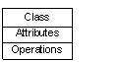

Interface − Interface defines a set of operations, which specify the responsibility of a class.
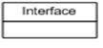
Collaboration −Collaboration defines an interaction between elements.
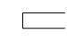

Use case −Use case represents a set of actions performed by a system for a specific goal.
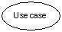

Component −Component describes the physical part of a system.

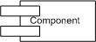

Node − A node can be defined as a physical element that exists at run time.

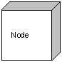

5.1.2. Behavioral Things
A behavioral thing consists of the dynamic parts of UML models. Following are the behavioral things −

Interaction − Interaction is defined as a behavior that consists of a group of messages exchanged among elements to accomplish a specific task.
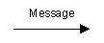

State machine − State machine is useful when the state of an object in its life cycle is important. It defines the sequence of states an object goes through in response to events. Events are external factors responsible for state change
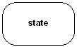

5.1.3. Grouping Things
Grouping things can be defined as a mechanism to group elements of a UML model together. There is only one grouping thing available −

Package − Package is the only one grouping thing available for gathering structural and behavioral things.
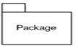

5.1.4. Annotational Things
Annotational things can be defined as a mechanism to capture remarks, descriptions, and comments of UML model elements. Note - It is the only one Annotational thing available. A note is used to render comments, constraints, etc. of an UML element.
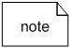

5.2. RELATIONSHIP
Relationship is another most important building block of UML. It shows how the elements are associated with each other and this association describes the functionality of an application.

There are four kinds of relationships available.
5.2.1. Dependency
Dependency is a relationship between two things in which change in one element also affects the other.
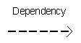
5.2.2. Association
Association is basically a set of links that connects the elements of a UML model. It also describes how many objects are taking part in that relationship.

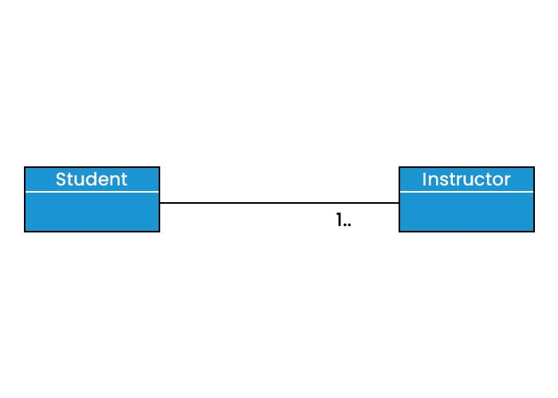

5.2.3. Generalization
Generalization can be defined as a relationship which connects a specialized element with a generalized element. It basically describes the inheritance relationship in the world of objects.
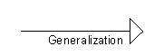

5.2.4. Realization
Realization can be defined as a relationship in which two elements are connected. One element describes some responsibility, which is not implemented and the other one implements them. This relationship exists in case of interfaces.
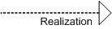
5.3. UML Diagrams
UML diagrams are the ultimate output of the entire discussion. All the elements, relationships are used to make a complete UML diagram and the diagram represents a system.
The visual effect of the UML diagram is the most important part of the entire process. All the other elements are used to make it complete.
UML includes the following nine diagrams, the details of which are described in the subsequent chapters.
- Class diagram
- Object diagram
- Use case diagram
- Sequence diagram
- Collaboration diagram
- Activity diagram
- Statechart diagram
- Deployment diagram
- Component diagram

It is very important to distinguish between the UML model. Different diagrams are used for different types of UML modeling. There are three important types of UML modeling.

5.3.1. Structural Modeling
Structural modeling captures the static features of a system. They consist of the following −
- Classes diagrams
- Objects diagrams
- Deployment diagrams
- Package diagrams
- Composite structure diagram
- Component diagram
Structural model represents the framework for the system and this framework is the place where all other components exist. Hence, the class diagram, component diagram and deployment diagrams are part of structural modeling. They all represent the elements and the mechanism to assemble them.
The structural model never describes the dynamic behavior of the system. Class diagram is the most widely used structural diagram.

5.3.2. Behavioral Modeling
Behavioral model describes the interaction in the system. It represents the interaction among the structural diagrams. Behavioral modeling shows the dynamic nature of the system. They consist of the following −
- Activity diagrams
- Interaction diagrams
- Use case diagrams
All the above show the dynamic sequence of flow in a system.

5.3.3. Architectural Modeling
Architectural model represents the overall framework of the system. It contains both structural and behavioral elements of the system. Architectural model can be defined as the blueprint of the entire system. Package diagram comes under architectural modeling.

5.3.4. UML - Basic Notations
UML notations are the most important elements in modeling. Efficient and appropriate use of notations is very important for making a complete and meaningful model. The model is useless, unless its purpose is depicted properly.
Different notations are available for things and relationships. UML diagrams are made using the notations of things and relationships. Extensibility is another important feature which makes UML more powerful and flexible.
Structural Things
Graphical notations used in structural things are most widely used in UML. These are considered as the nouns of UML models. Following are the list of structural things.
- Classes
- Object
- Interface
- Collaboration
- Use case
- Active classes
- Components
- Nodes
Class Notation
UML class is represented by the following figure. The diagram is divided into four parts.
- The top section is used to name the class.
- The second one is used to show the attributes of the class.
- The third section is used to describe the operations performed by the class.
- The fourth section is optional to show any additional components.
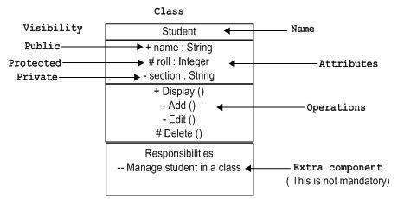
Classes are used to represent objects. Objects can be anything having properties and responsibility.

Object Notation
The object is represented in the same way as the class. The only difference is the name which is underlined as shown in the following figure.
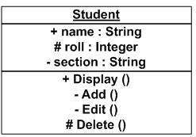
As the object is an actual implementation of a class, which is known as the instance of a class. Hence, it has the same usage as the class.

Interface Notation
Interface is represented by a circle as shown in the following figure. It has a name which is generally written below the circle.
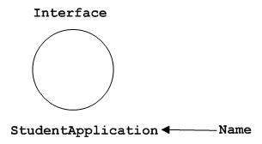
Interface is used to describe the functionality without implementation. Interface is just like a template where you define different functions, not the implementation. When a class implements the interface, it also implements the functionality as per requirement.

Collaboration Notation
Collaboration is represented by a dotted eclipse as shown in the following figure. It has a name written inside the eclipse.
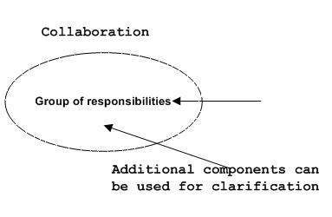
Collaboration represents responsibilities. Generally, responsibilities are in a group.

Use Case Notation
Use case is represented as an eclipse with a name inside it. It may contain additional responsibilities.
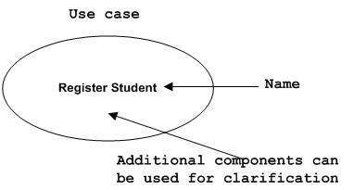
Use case is used to capture high level functionalities of a system.

Actor Notation
An actor can be defined as some internal or external entity that interacts with the system.
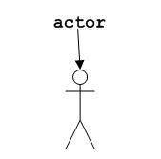
An actor is used in a use case diagram to describe the internal or external entities.
Initial State Notation
Initial state is defined to show the start of a process. This notation is used in almost all diagrams.
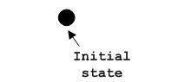
The usage of Initial State Notation is to show the starting point of a process.

Final State Notation
Final state is used to show the end of a process. This notation is also used in almost all diagrams to describe the end.
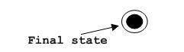
The usage of Final State Notation is to show the termination point of a process.

Active Class Notation
Active class looks similar to a class with a solid border. Active class is generally used to describe the concurrent behavior of a system.
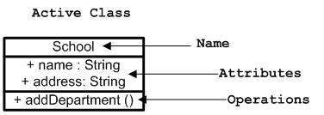
Active class is used to represent the concurrency in a system.

Component Notation
A component in UML is shown in the following figure with a name inside. Additional elements can be added wherever required.
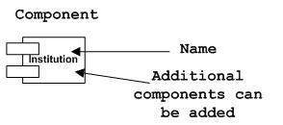
Component is used to represent any part of a system for which UML diagrams are made.

Node Notation
A node in UML is represented by a square box as shown in the following figure with a name. A node represents the physical component of the system.
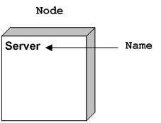
Node is used to represent the physical part of a system such as the server, network, etc.

Behavioral Things
Dynamic parts are one of the most important elements in UML. UML has a set of powerful features to represent the dynamic part of software and non-software systems. These features include interactions and state machines.
Interactions can be of two types −
- Sequential (Represented by sequence diagram)
- Collaborative (Represented by collaboration diagram)

Interaction Notation
Interaction is basically a message exchange between two UML components. The following diagram represents different notations used in an interaction.
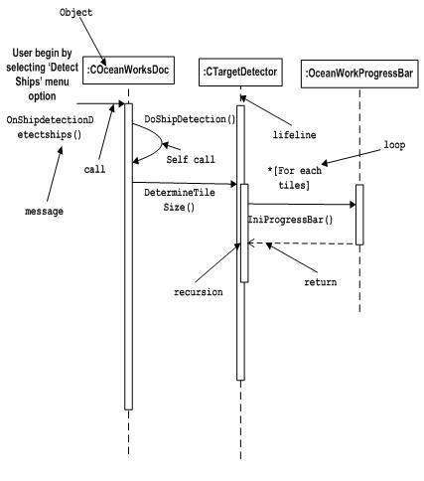
Interaction is used to represent the communication among the components of a system.

State Machine Notation
State machine describes the different states of a component in its life cycle. The notations are described in the following diagram.
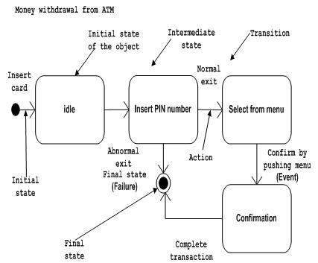
State machine is used to describe different states of a system component. The state can be active, idle, or any other depending upon the situation.

Grouping Things
Organizing the UML models is one of the most important aspects of the design. In UML, there is only one element available for grouping and that is package.

Package Notation
Package notation is shown in the following figure and is used to wrap the components of a system.
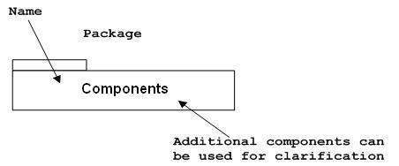

Annotational Things
In any diagram, explanation of different elements and their functionalities are very important. Hence, UML has notes notation to support this requirement.

Note Notation
This notation is shown in the following figure. These notations are used to provide necessary information of a system.
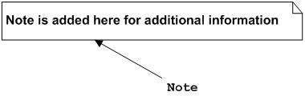

Relationships
A model is not complete unless the relationships between elements are described properly. The Relationship gives a proper meaning to a UML model. Following are the different types of relationships available in UML.
- Dependency
- Association
- Generalization
- Extensibility

Dependency Notation
Dependency is an important aspect in UML elements. It describes the dependent elements and the direction of dependency.
Dependency is represented by a dotted arrow as shown in the following figure. The arrow head represents the independent element and the other end represents the dependent element.
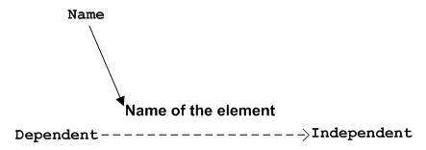
Dependency is used to represent the dependency between two elements of a system

Association Notation
Association describes how the elements in a UML diagram are associated. In simple words, it describes how many elements are taking part in an interaction.
Association is represented by a dotted line with (without) arrows on both sides. The two ends represent two associated elements as shown in the following figure. The multiplicity is also mentioned at the ends (1, *, etc.) to show how many objects are associated.
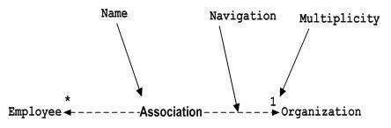
Association is used to represent the relationship between two elements of a system.

Generalization Notation
Generalization describes the inheritance relationship of the object-oriented world. It is a parent and child relationship.
Generalization is represented by an arrow with a hollow arrow head as shown in the following figure. One end represents the parent element and the other end represents the child element.
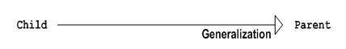
Generalization is used to describe parent-child relationship of two elements of a system.

Extensibility Notation
All the languages (programming or modeling) have some mechanism to extend its capabilities such as syntax, semantics, etc. UML also has the following mechanisms to provide extensibility features.
- Stereotypes (Represents new elements)
- Tagged values (Represents new attributes)
- Constraints (Represents the boundaries)
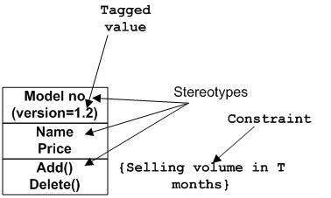

Extensibility notations are used to enhance the power of the language. It is basically additional elements used to represent some extra behavior of the system. These extra behaviors are not covered by the standard available notations.

  - USECASE DIAGRAM

Use case diagrams are used to gather the requirements of a system including internal and external influences. These requirements are mostly design requirements. Hence, when a system is analyzed to gather its functionalities, use cases are prepared and actors are identified. When the initial task is complete, use case diagrams are modelled to present the outside view.

The Passport Automation System Use Case Diagram shows the interactions between the Applicant, Passport Officer, and Administrator with the Passport Automation System.

Objectives Achieved
The Use Case Diagram satisfies the following objectives:
- Automates passport application processing.
- Reduces paperwork through online services.
- Provides online registration and login.
- Enables online document upload.
- Supports online fee payment.
- Allows appointment booking.
- Provides application status tracking.
- Enables passport verification and generation.
- Helps administrators manage the entire system.

Elements of the Use Case Diagram
There are three main elements:
- Actors
- Use Cases
- System Boundary

1. Actors
Actors are external users who interact with the Passport Automation System.
A) Applicant
The Applicant is a citizen applying for a passport.
Responsibilities
- Register
- Login
- Apply for Passport
- Upload Documents
- Pay Fees
- Book Appointment
- Track Application Status
- Download Receipt

B) Passport Officer
The Passport Officer verifies applications.
Responsibilities
- Login
- Verify Documents
- Verify Applicant
- Approve/Reject Application
- Generate Passport

C) Administrator
The Administrator manages the complete system.
Responsibilities
- Login
- Manage Users
- Manage Officers
- Generate Reports
- Maintain Database

Working of the Use Case Diagram
- The Applicant registers and logs into the system.
- The Applicant submits a passport application.
- Required documents are uploaded.
- The Applicant pays the application fee.
- The Applicant books an appointment.
- The Passport Officer logs in and verifies the documents and applicant details.
- The Passport Officer approves or rejects the application.
- If approved, the system generates the passport.
- The Applicant tracks the application status online.
- The Administrator manages users, officers, reports, and the database.

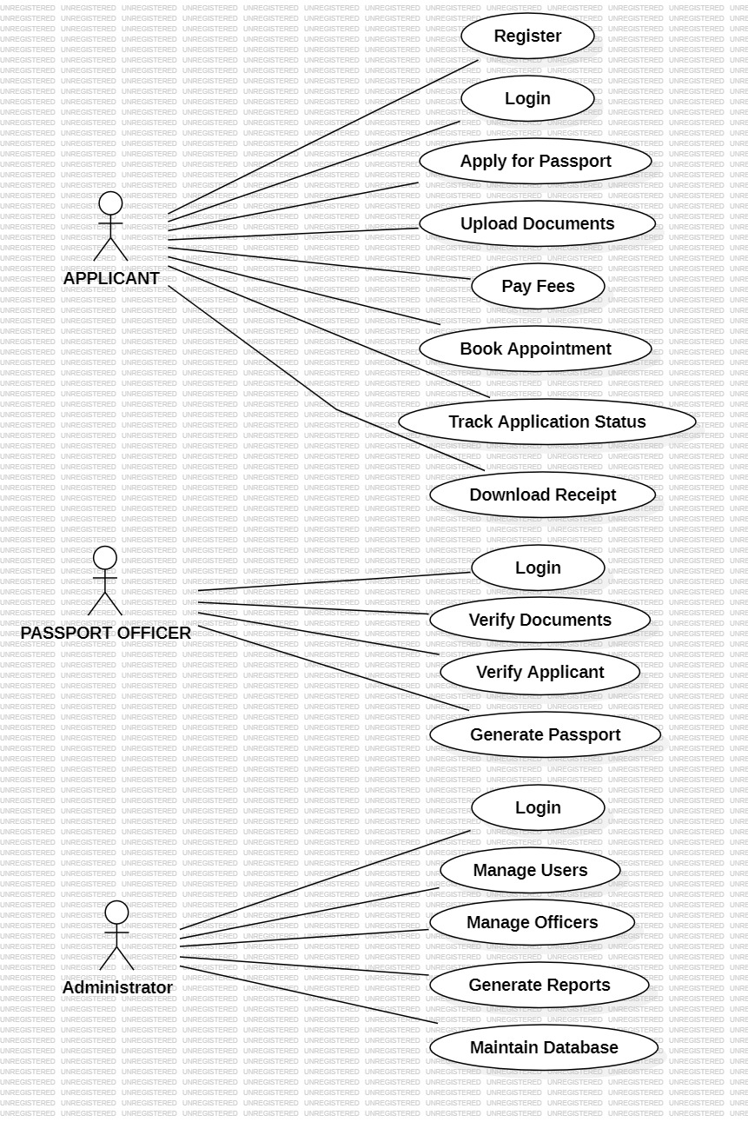
Fig 1: Use Case diagram for passport automation system
  - OBJECT DIAGRAM

Definition
An Object Diagram is a UML structural diagram that represents the objects (instances of classes), their current values, and the relationships among them at a specific moment. It helps to understand how the system behaves with real data.

Object Diagram Used in Passport Automation System
The object diagram consists of the following objects:
- applicant1 : Applicant
- application1 : Application
- document1 : Documents
- officer1 : Officer
- passport1 : Passport
- admin1 : Administrator
Each object represents one real entity in the Passport Automation System.

Difference Between Class Diagram and Object Diagram
Class Diagram | Object Diagram
Shows classes | Shows objects (instances)
Represents the system design | Represents the system at a specific moment
Displays attributes and methods | Displays actual attribute values
Used during design | Used to visualize runtime examples
Example: Applicant | Example: applicant1 : Applicant

Advantages of the Object Diagram
- Shows real-time instances of system objects.
- Helps visualize how classes are used in practice.
- Makes relationships between objects easier to understand.
- Useful for testing and validating the system design.
- Provides concrete examples that complement the class diagram.
- Improves understanding of object-oriented concepts.

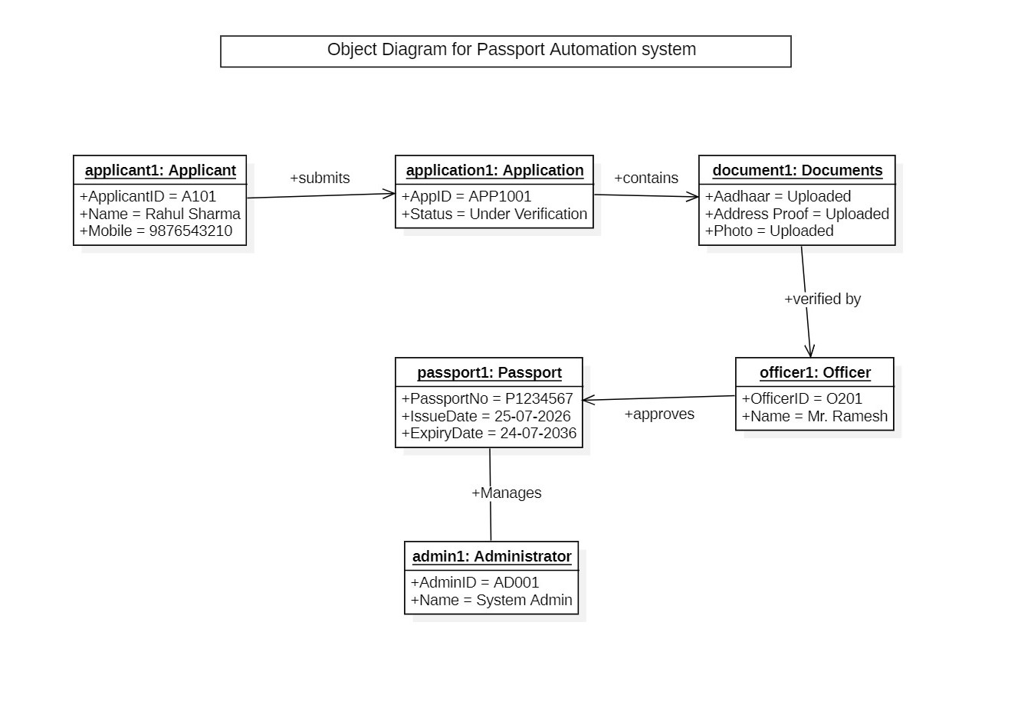

Fig 2. Object diagram for passport automation system

  - CLASS DIAGRAM

Class diagram is a static diagram, describes the attributes and operations of a class and also the constraints imposed on the system. The class diagrams are widely used in the modeling of object oriented systems because they are the only UML diagrams, which can be mapped directly with object-oriented languages.
Class diagram shows a collection of classes, interfaces, associations, collaborations, and constraints. It is also known as a structural diagram.
Purpose of Class Diagrams
The purpose of the class diagram can be summarized as −
- Analysis and design of the static view of an application.
- Describe responsibilities of a system.
- Base for component and deployment diagrams.
- Forward and reverse engineering

In the Passport Automation System, the Class Diagram models all the major entities involved in passport application processing and illustrates how they interact to achieve the system objectives.

Working of the Class Diagram
The workflow represented by the class diagram is:
- The Applicant registers and logs into the system.
- The applicant submits a Passport Application.
- Required Documents are uploaded.
- The application fee is paid through the Payment module.
- An Appointment is scheduled for verification.
- The Passport Officer verifies the documents and applicant details.
- If approved, a Passport is generated.
- The Administrator manages users, officers, reports, and the database.

Advantages of this Class Diagram
- Clearly represents the static structure of the Passport Automation System.
- Separates system responsibilities into different classes.
- Promotes modularity and easy maintenance.
- Supports online registration, payment, document upload, and status tracking.
- Reduces redundancy by organizing data into related classes.
- Makes future enhancements, such as adding police verification or SMS notifications, easier.
- Provides a blueprint for implementation in object-oriented programming languages like Java, C++, or Python.

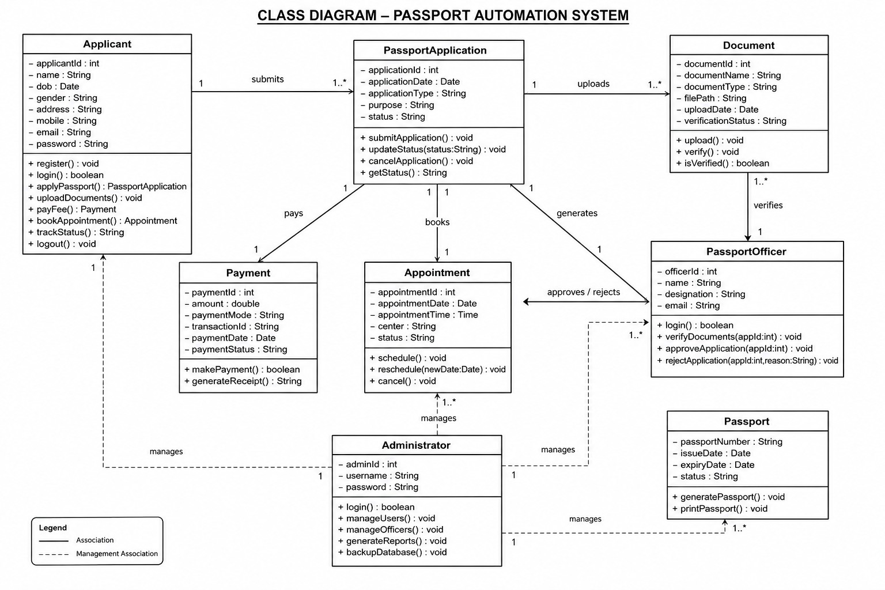

Fig 3. Class diagram for passport automation system

ACTIVITY DIAGRAM

An Activity Diagram is a UML behavioral diagram that illustrates the workflow of activities, decisions, and actions involved in a business process or software system. It represents the flow of control from the initial state to the final state.

Symbols Used in Activity Diagram
Symbol | Meaning
● | Initial (Start) Node
◎ | Final (End) Node
▭ Rounded Rectangle | Activity or Action
◇ Diamond | Decision or Branch
→ Arrow | Flow of Control
▬ Thick Bar | Fork or Join (Parallel Activities)

Activities in the Passport Automation System
The Activity Diagram contains the following major activities:
- Start
- Register
- Login
- Fill Passport Application
- Upload Documents
- Validate Documents
- Make Payment
- Book Appointment
- Verify Documents
- Decision (Approved or Rejected)
- Generate Passport
- Update Application Status
- Notify Applicant
- End

Explanation of Decision Node
The Decision Node (◇) is used to determine the next step based on verification.
- Approved: The passport is generated, the status is updated, and the applicant is notified.
- Rejected: The applicant receives a rejection notification, and the process ends or the application can be corrected and resubmitted.

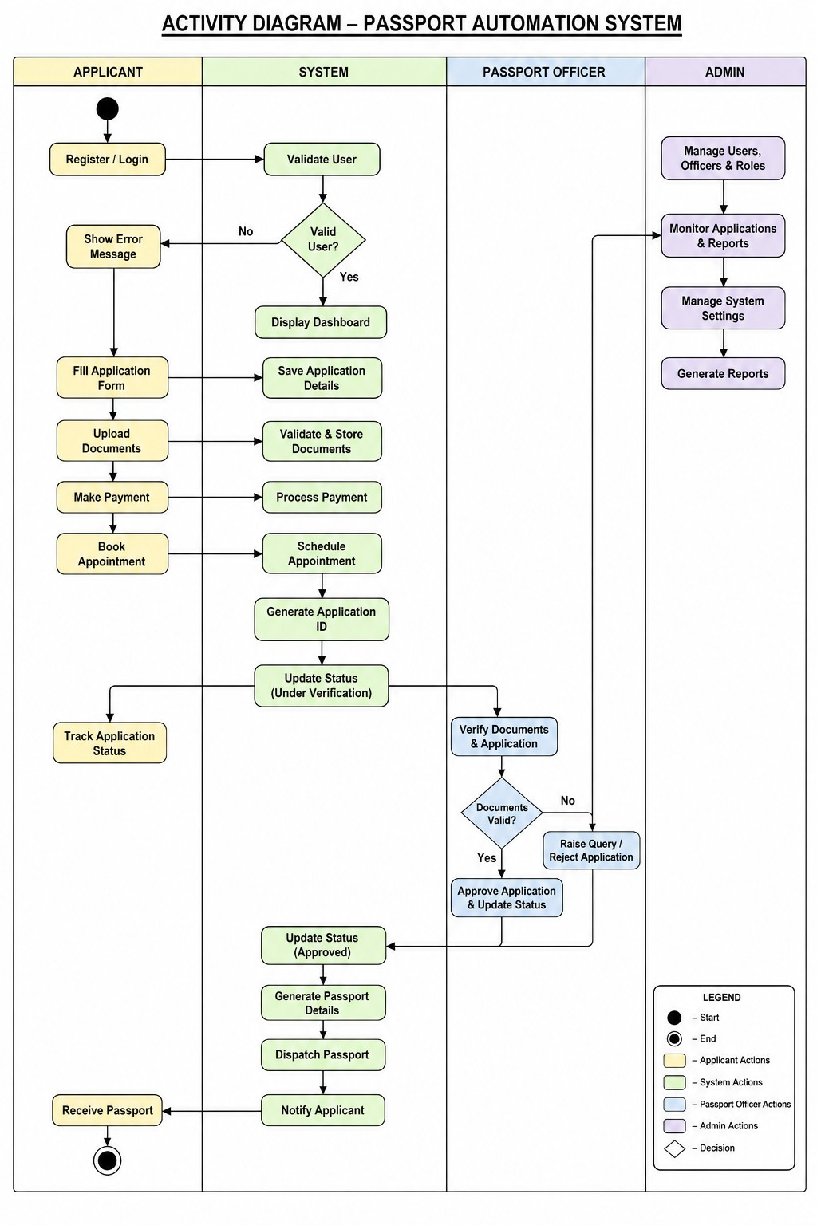
Fig 4. Activity diagram for passport automation system
Difference Between Activity Diagram and Flowchart
Activity Diagram | Flowchart
Part of UML | General process diagram
Models software workflows | Models any process
Supports parallel activities (fork/join) | Limited support for parallel activities
Uses UML symbols | Uses standard flowchart symbols
Focuses on system behavior | Focuses on procedural logic

Applications of Activity Diagram
Activity Diagrams are widely used in:
- Passport Automation System
- ATM System
- Library Management System
- Railway Reservation System
- Hospital Management System
- Banking Applications
- Online Shopping Systems
- Student Management Systems

STATECHART DIAGRAM

A State Chart Diagram is a UML behavioral diagram that describes the various states of an object and the transitions between those states based on events or conditions.

Objective of State Chart Diagram
The State Chart Diagram helps to:
- Model the life cycle of a passport application.
- Show state transitions clearly.
- Improve understanding of system behavior.
- Reduce processing errors.
- Track the application status at every stage.
- Increase transparency for applicants.

Symbols Used in the State Chart Diagram
Symbol | Meaning
● | Initial State (Start)
◎ | Final State (End)
Rounded Rectangle | State
Arrow (→) | Transition from one state to another
Decision/Guard | Determines the next state based on a condition (Approved/Rejected)

Advantages of the State Chart Diagram
- Shows the complete life cycle of a passport application.
- Clearly represents every state and transition.
- Helps developers understand system behavior.
- Makes it easier to identify missing or incorrect state transitions.
- Supports automation and status tracking.
- Improves transparency by defining application status at every stage.

Difference Between Activity Diagram and State Chart Diagram
Activity Diagram | State Chart Diagram
Represents the workflow of activities. | Represents the life cycle of an object through different states.
Focuses on actions performed in the system. | Focuses on state changes of an object.
Shows process flow. | Shows state transitions.
Used to model business processes. | Used to model object behavior.
Example: Registration → Login → Payment | Example: Submitted → Under Verification → Approved → Passport Generated
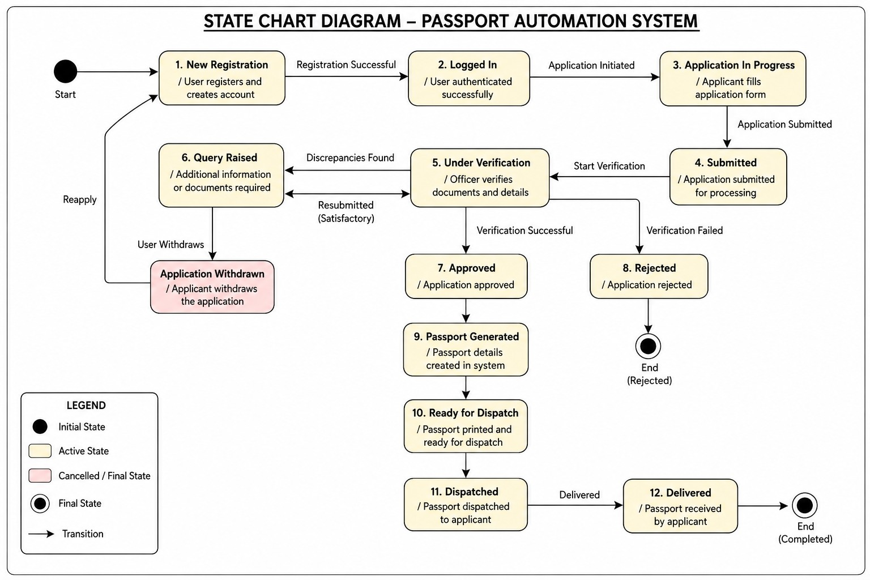

Fig 5. State chart diagram for passport automation system

SEQUENCE DIAGRAM

A Sequence Diagram is a UML behavioral diagram that represents the interaction between objects in a time sequence. It shows the order in which messages are exchanged to complete a specific process.

Symbols Used in Sequence Diagram
Symbol | Meaning
Actor | External user interacting with the system (Applicant)
Object | System components such as Payment Gateway or Passport Database
Lifeline | Vertical dashed line showing the existence of an object over time
Activation Bar | Thin rectangle showing when an object is performing an operation
Message Arrow | Communication between objects
Return Message | Response sent back after processing (optional dashed arrow)

Advantages of the Sequence Diagram
- Clearly shows the order of interactions between objects.
- Helps developers understand communication among system components.
- Makes the processing sequence easy to follow.
- Identifies missing interactions during software design.
- Supports system testing and debugging.
- Improves documentation and communication among stakeholders.

Difference Between Sequence Diagram and Activity Diagram
Sequence Diagram | Activity Diagram
Shows interactions between objects. | Shows the workflow of activities.
Focuses on message exchange. | Focuses on process flow.
Time is represented from top to bottom. | Flow is represented through activities and decisions.
Uses lifelines and message arrows. | Uses activities, decisions, and control flows.
Emphasizes object communication. | Emphasizes business process logic.

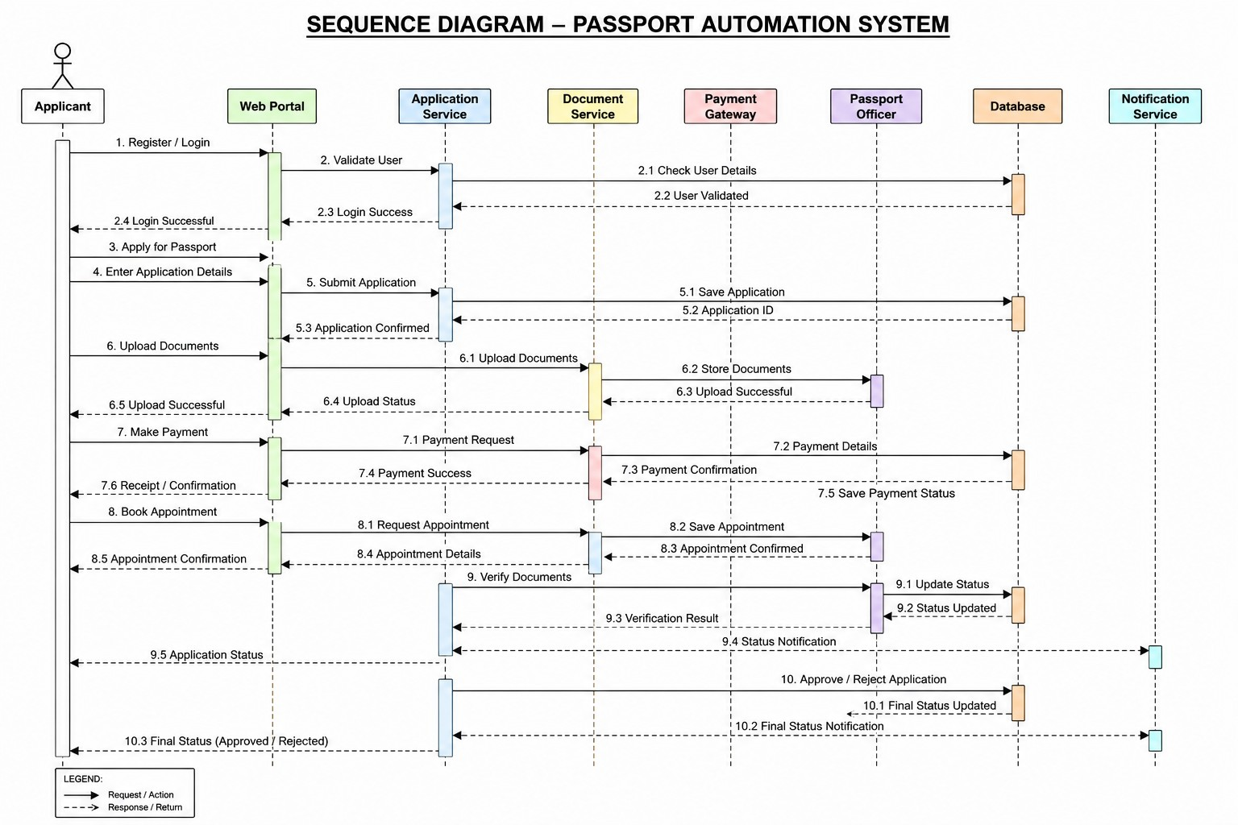

Fig 6. Sequence diagram for passport automation system
COLLABORATION DIAGRAM
A Collaboration Diagram is a UML behavioral diagram that represents the interaction among objects through message passing. It emphasizes the structural organization of objects and their communication to accomplish a particular function.

Difference Between Collaboration Diagram and Sequence Diagram
Collaboration Diagram | Sequence Diagram
Focuses on object relationships and communication. | Focuses on the chronological order of interactions.
Objects are connected through communication links. | Objects are represented with vertical lifelines.
Uses numbered messages to indicate sequence. | Uses messages arranged from top to bottom to indicate sequence.
Emphasizes structural organization. | Emphasizes the timing of message exchange.
Easier to understand object collaboration. | Easier to understand execution flow over time.

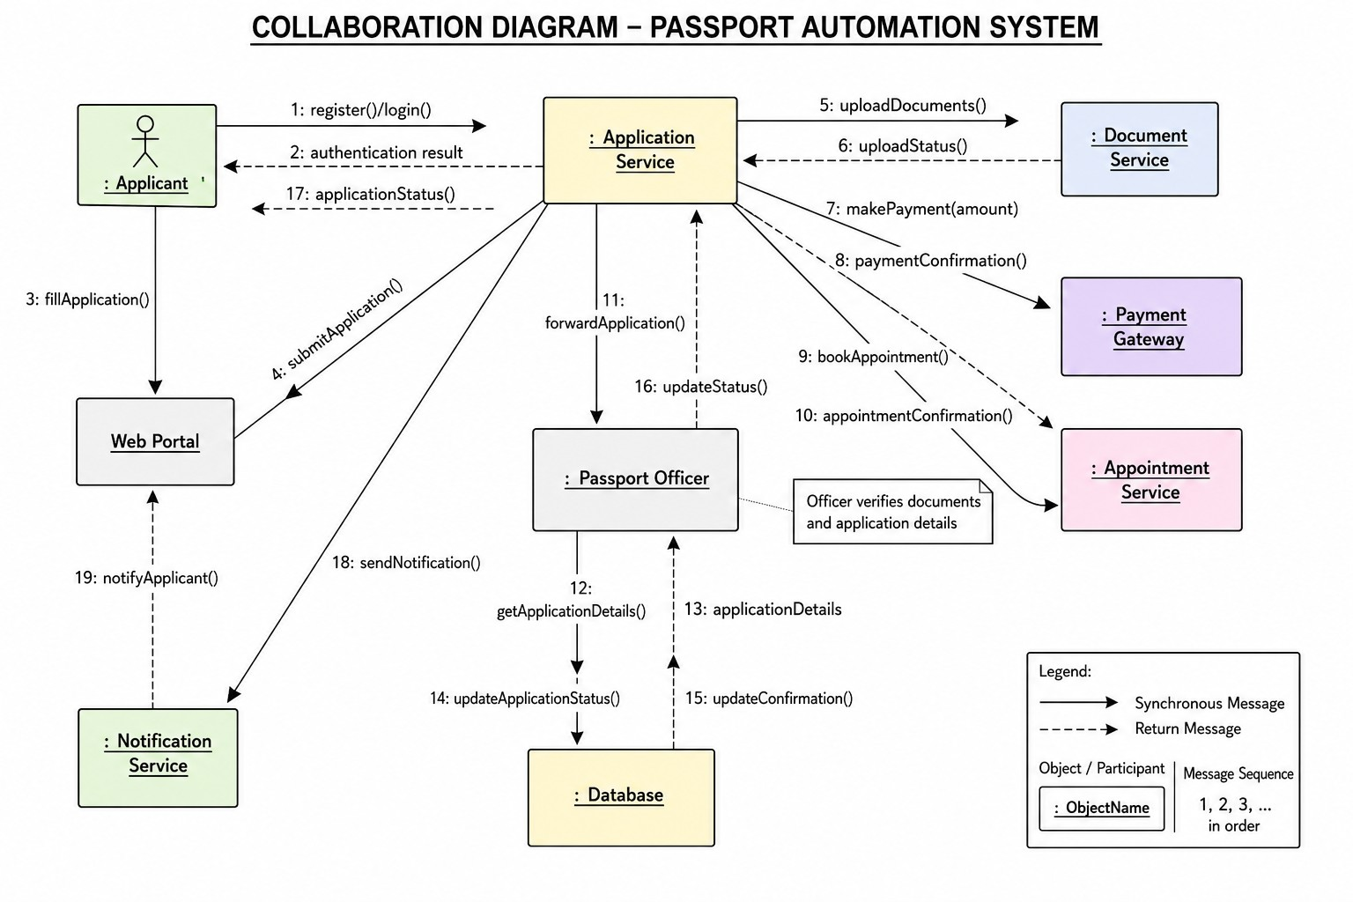

Fig 7. Collaboration diagram for passport automation system

COMPONENT DIAGRAM

A Component Diagram is a UML structural diagram that illustrates the organization and interaction of software components in a system. It helps developers understand the system architecture by showing components and their dependencies.

Components Used in the Passport Automation System
The main software components are:
- User Interface (UI)
- Authentication Component
- Application Processing Component
- Document Management Component
- Payment Component
- Verification Component
- Passport Generation Component
- Database Component
- Notification Component

Difference Between Class Diagram and Component Diagram
Class Diagram | Component Diagram
Shows classes, attributes, methods, and relationships. | Shows software components and their dependencies.
Represents the logical design. | Represents the physical software architecture.
Used in object-oriented design. | Used in software architecture and deployment planning.
Focuses on objects and classes. | Focuses on software modules.

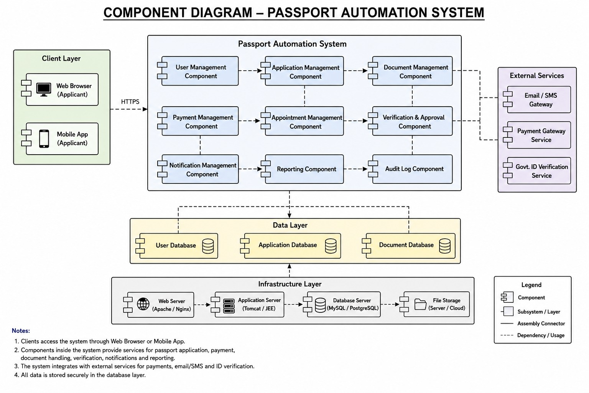

Fig 8. Component diagram for passport automation system

DEPLOYMENT DIAGRAM

A Deployment Diagram is a UML structural diagram that illustrates the physical deployment of hardware nodes, software components, and communication links in a system.

Hardware Nodes in the Passport Automation System
The Deployment Diagram contains the following hardware nodes:
- Applicant Computer / Mobile
- Internet
- Web Server
- Application Server
- Database Server
- Payment Gateway Server
- Notification Server
Hardware Node | Software Components
Applicant Computer | Web Browser / Mobile App
Web Server | Registration Module, Login Module, User Interface
Application Server | Authentication, Application Processing, Verification, Passport Generation
Database Server | Passport Database
Payment Gateway | Online Payment Module
Notification Server | SMS and Email Service

Advantages of Deployment Diagram
- Shows the physical architecture of the system.
- Explains where software components are deployed.
- Improves understanding of system communication.
- Helps in network planning.
- Supports system scalability.
- Helps identify hardware requirements.
- Improves security planning.
- Useful during software deployment and maintenance.
Difference Between Component Diagram and Deployment Diagram
Component Diagram | Deployment Diagram
Shows software components. | Shows hardware nodes and deployed components.
Represents logical software architecture. | Represents physical system architecture.
Focuses on software modules. | Focuses on hardware devices and network communication.
Used during software design. | Used during deployment and implementation.

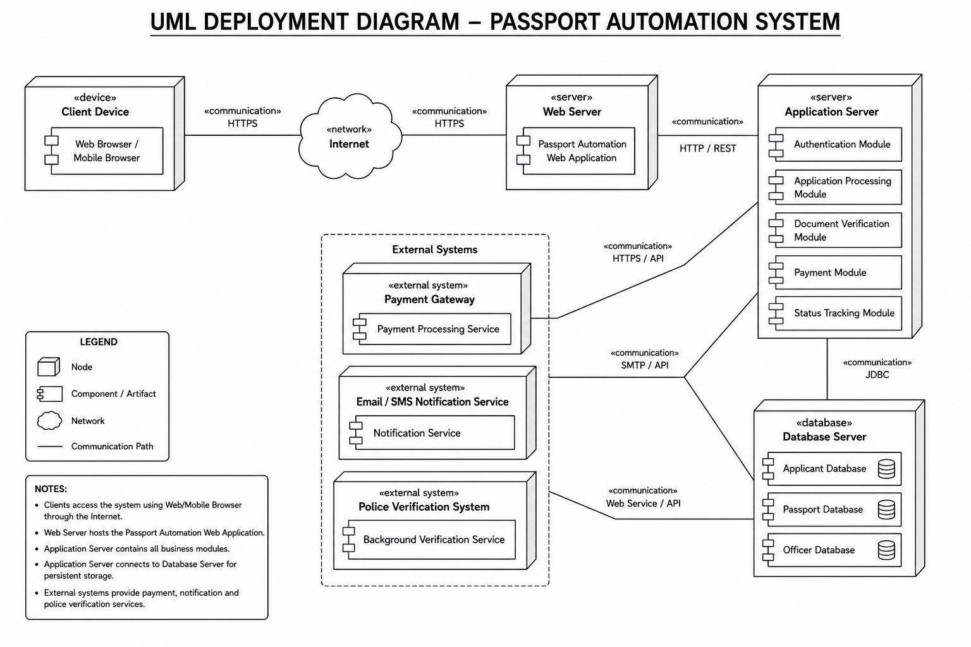

Fig 9. Deployment diagram for passport automation system

