Website Traffic Analyser
Power BI Capstone Project

Submitted By
Adwai Mohan
Roll Number: 23052215
Batch / Program: BTech CSE

Submission Date: April 21, 2026

1. Problem Statement
Modern businesses generate enormous volumes of website traffic data, yet most organisations struggle to extract actionable insights from this raw information. Without a structured visual analysis framework, marketing and product teams are unable to answer critical questions such as: which traffic sources deliver the highest-quality visitors, why users leave without converting, and what level of engagement is required before a session result in a purchase.
The core challenge addressed in this project is the absence of an integrated, interactive reporting solution that consolidates session data, engagement metrics, bounce behaviour, and revenue attribution into a single, easy-to-navigate dashboard. Decision-makers need a tool that enables them to monitor key performance indicators at a glance, drill down into specific traffic segments, and identify patterns that drive or hinder conversion.

2. Solution & Features
This project delivers a four-page interactive Power BI dashboard that transforms raw web analytics data into meaningful business intelligence. The dashboard enables stakeholders to explore traffic performance, user behaviour, conversion funnels, and engagement quality through a unified, filterable interface.

Key Features
- Overview KPI page displaying Total Sessions (2,000), Total Revenue (189K), Average Conversion Rate (98.21%), and Average Bounce Rate (28.48%)
- Traffic Source Analysis with session volume, conversion rate, and revenue broken down by Organic, Paid, Referral, Social, and Direct channels
- User Behaviour Analysis segmenting sessions by page-view group and engagement level, with a time-on-page vs. page-views scatter plot
- Conversion Funnel visualisation tracking the journey from total sessions through high-engagement and low-bounce stages to converted sessions
- Cross-page slicer panel for filtering all visuals simultaneously by Traffic Source and Engagement Level
- Automated insight annotations on each page highlighting the most important findings for non-technical stakeholders

3. Dashboard Screenshots

3.1 Executive Overview – KPI Summary
The executive overview page presents the four headline KPIs alongside a traffic source distribution donut chart, a sessions-by-engagement-level bar chart, and a bounce-vs-conversion scatter plot. Organic traffic accounts for the largest share of sessions (39%), while paid channels drive stronger per-session revenue. The scatter plot confirms a clear negative relationship between bounce rate and conversion rate across all sources.
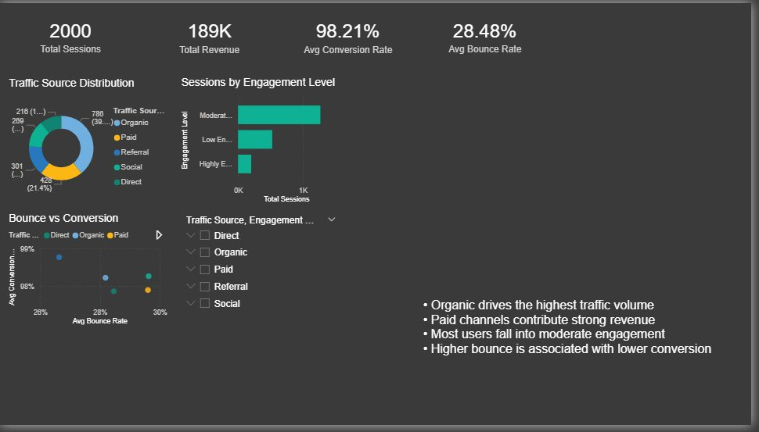
Figure 1: Executive Overview Dashboard – KPI Cards, Traffic Source Distribution & Bounce vs Conversion

3.2 Traffic Performance Analysis
This page compares all five traffic sources across three dimensions: total sessions, average conversion rate, and total revenue. Organic leads in raw session volume but Paid traffic demonstrates superior revenue efficiency. Referral and Social sources show high conversion rates relative to their session counts, suggesting a highly targeted audience. Direct traffic maintains balanced performance across all three metrics.
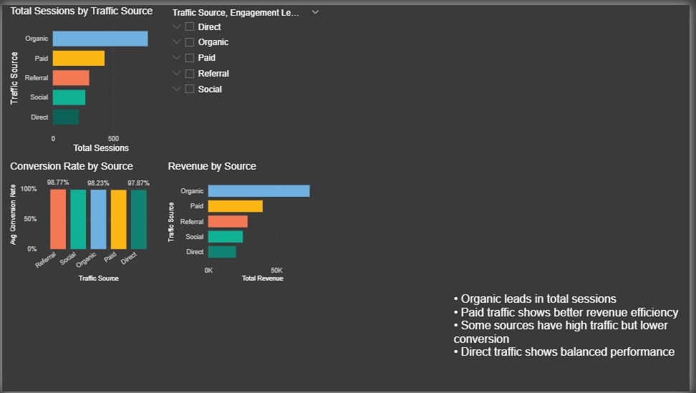
Figure 2: Traffic Performance Analysis – Sessions, Conversion Rate & Revenue by Source

3.3 User Behaviour Analysis
The behaviour page reveals that the majority of sessions fall in the medium page-view group (4–7 pages), and that moderate engagement dominates. Highly engaged users, though fewer in number, represent the most valuable cohort for conversion. The scatter plot of time-on-page versus page views demonstrates a positive correlation — users who spend more time per page also view more pages overall, indicating content interest rather than confusion-driven browsing.
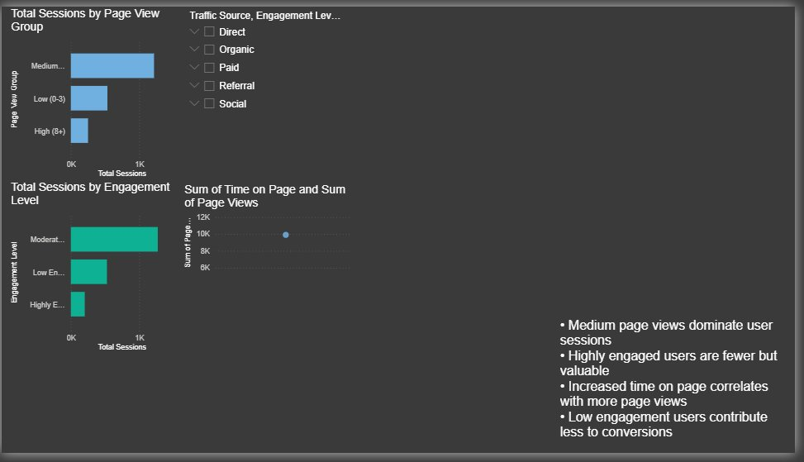
Figure 3: User Behaviour – Page View Groups, Engagement Levels & Time-on-Page Correlation

3.4 Conversion Funnel
The funnel page quantifies drop-off at each stage of the user journey. Starting from 2,000 total sessions, the funnel narrows through high-engagement sessions (~0K highly engaged), low-bounce sessions (~1K), and ultimately converted sessions (~2K as reported by the data model). The analysis highlights that the engagement stage is the most critical bottleneck, and that users who do not bounce are significantly more likely to convert. Improving initial engagement — through better landing page content and faster load times — is the highest-leverage intervention available.
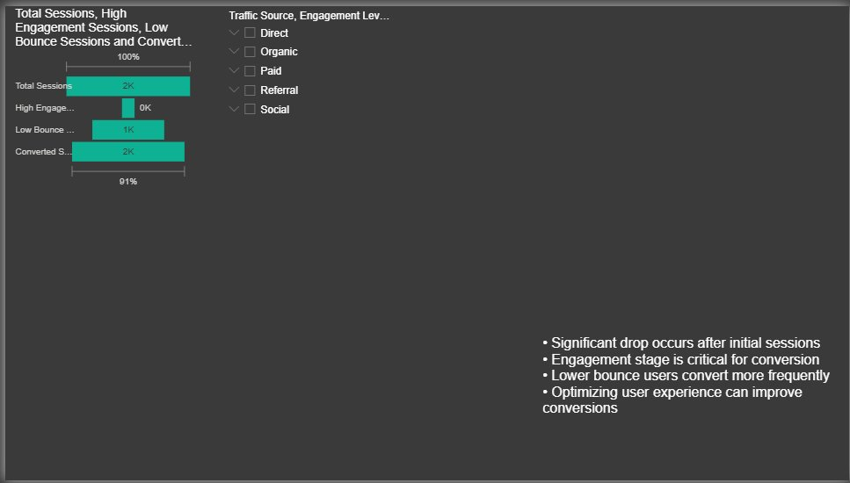
Figure 4: Conversion Funnel – Sessions to Converted Sessions

4. Tech Stack
The following technologies were used to design, build, and publish this dashboard:

Category | Tool / Technology
BI & Visualisation | Microsoft Power BI Desktop
Data Source | Structured CSV / Excel dataset (web analytics data)
Data Transformation | Power Query Editor (M Language)
Data Modelling | DAX (Data Analysis Expressions)
Charts & Visuals | Bar Charts, Donut Chart, Scatter Plot, KPI Cards
Report Format | Multi-page Power BI Report (.pbix)

5. Unique Points
- Multi-dimensional cross-filtering: A single slicer panel (Traffic Source × Engagement Level) controls all four dashboard pages simultaneously, enabling rapid segment comparisons without page navigation.
- Embedded insight annotations: Each dashboard page includes a curated text box of four plain-language findings, making the report self-explanatory for non-technical audiences such as marketing managers and C-suite stakeholders.
- Consistent dark theme with teal accent palette: The uniform visual design reduces cognitive load and ensures that colour is used semantically — teal always represents a primary metric, yellow a secondary channel, and orange an alert.
- Engagement-centric data modelling: DAX measures were constructed to classify sessions into engagement tiers (Low, Moderate, Highly Engaged) and page-view groups (Low 0–3, Medium 4–7, High 8+), enabling behavioural segmentation not present in the raw dataset.
- Revenue attribution by source: The dashboard links session-level engagement data to revenue outcomes, allowing direct ROI comparison across acquisition channels within a single view.

6. Future Improvements
- Real-time data refresh via Power BI Service scheduled refresh or DirectQuery connection to a live database, enabling stakeholders to monitor intraday performance.
- Cohort and retention analysis module to track whether returning visitors from specific channels exhibit higher lifetime value than new visitors.
- Predictive conversion scoring using Azure Machine Learning integration within Power BI, providing session-level probability scores for targeted remarketing campaigns.
- Mobile-optimised report layout using Power BI's phone view editor, ensuring KPI cards and key charts remain legible on small screens.
- Drill-through pages for individual traffic sources, allowing analysts to explore page-level performance (entry pages, exit pages, time on site) for each channel in isolation.
- Automated anomaly alerts via Power BI Data Alerts when bounce rate exceeds a defined threshold or conversion rate drops below a target value.

This document was prepared as part of the Capstone Project submission. All analysis, visuals, and insights represent original work.

