Assignment 7

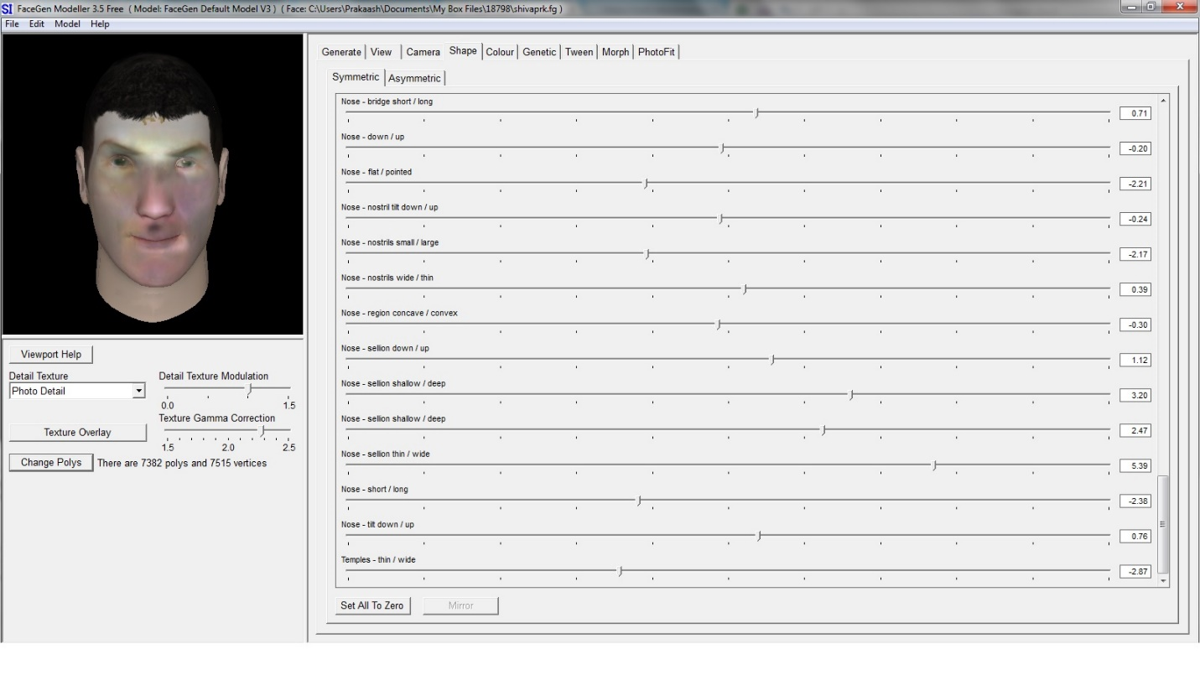Submitted by: Shivaprakaash Karthikeyan  
Andrew ID: shivaprk

# Summary:

The assignment involved using a face generation software called FaceGen to approximate the face of a criminal from a down-facing CCTV image.

# Steps involved:

1. The given image of the criminal was uploaded to FaceGen’s PhotoFit tab
2. The markers were adjusted to point the edges of the facial features so that FaceGen could approximate the facial features
3. Once the approximation was generated, the eyebrows, colour of the eyes hair, chin and jaw structure were changed in order to make it look like what the criminal might potentially look like.

