Using Different classifiers for Breast Cancer Analysis and Prediction

*Tintu P B

Research Scholar

Department of Computer Science,

Karpagam Academy of Higher Education Coimbatore,

Tamil Nadu, India

tintupadikkal@gmail.com

Dr. S Manju Priya

Professor

Department of Computer Science,

Karpagam Academy of Higher Education, Coimbatore, Tamil Nadu, India

smanjupr@gmail.com

Abstract – Breast cancer is one of the most common illnesses that cause the large number of female deaths each year. Despite the fact that cancer is treatable and curable at its early stages, many patients are screened for cancer only at a very late stage. Data mining processes and classifications are an efficient way to classify data. This is especially true in the medical field, where these approaches are widely used in diagnostic decision making.

Keywords : Breast Cancer, Data Mining, Wisconsin Breast Cancer (WDCO),Classification.

I INTRODUCTION TO BREAST CANCER

Breast cancer is considered as the second largest cause of death in women. There are two classification of cancer namely malignant and benign. If the cancer is benign and diagnosed at initial stage, the patient can be treated. It is considered to be one of the most frequent types of cancer in women, causing death of about 1.5 million people globally [1]. Presently , in the United States (USA), one in eight women are at the risk for breast cancer, with the highest proportion between the ages of 35 and 50. Examination of the latest data shows that the 6-year after discovery of disease the survival rate is 87.8% and after 12 years the survival rate is 80.3% [2]. Nations like Australia, the United States and Europe (Western countries) have confirmed a high proportion of breast cancer patients. In some countries, the proportion increased in the 20th century, leading to an increase in mammography and having a significant impact on general changes in reproductive patterns [3]. Information and Communication Technology plays an important role in cancer treatment. For example, data mining technologies are for reducing drug rates, generating real-time decisions in people's lives ,predicting outcomes, supporting patient health, , and performing well in developing customized quality of care. There are several methods for predicting and classifying breast cancer..

II. METHOD OF DATA COLLECTION

The data set is taken from WBDC (Wisconsin breast cancer Diagnostic) dataset from UCI repository [4]. The dataset contains 569 instances out of which 212 are Malignant and 357 are Benign . There are no missing attribute value. The information of the attribute in the dataset are as follows: ID number, Diagnosis which is classified as M or B .Ten real valued features were calculated for each available cell nucleus namelyradius,texture,perimeter,area,smoothness,compactness,concativity,concave points, symmetry and fractal dimensions. The mean, standard error, and "worst" or largest (mean of the three largest values) of these features were computed for each image, resulting in 30 features. For instance, field 3 is Mean Radius, field13 is Radius SE, field 23 is Worst Radius. All feature values are recoded with four significant digits.

III. Related work using classifiers

Medical Data Mining is a critical region of studies that is used to show styles from facts which became used to broaden predictive replicas. All fitness care organizations store information in digital order. The information comprise all information about sufferers and fitness care providers. By the usage of conventional methods, it's far tough to extract significant facts. Data mining is utilized in situations where a big series of healthcare information is used. Data Mining equipment assist us to find out facts from unknown styles. Techniques like classification, prediction, clustering and affiliation regulations are a few strategies that are used on scientific facts. This overview paper affords DataMining strategies within side the area of scientific region.

1.Zero R

Zero R classifier classifies the bulk of sophistication in education data it predicts imply for numeric fee and mode for nominal class[5][6].

2. Random forests

Random forests or random selection forests are an ensemble studying technique for type, and mak use of averaging to enhance the predictive accuracy and manage over-fitting. The random wooded area is a type set of rules together with many choices bushes. It makes use of bagging and characteristic randomness while constructing every character tree to attempt to create an uncorrelated wooded area of bushes whose prediction via way of means of committee is extra correct than that of any character tree [5]

4. REPTree

REPTree: set of rules is a quick selection tree learner it's also primarily based totally on C4. five set of rules and may produce type (discrete outcome) or regression bushes (non-stop outcome). It builds a regression/selection tree the usage of facts gain/variance and prunes it the usage of reduced-mistakes pruning (with back-fitting). [9]

5. Decision table

Decision tables are a concise seen example for specifying which actions to perform counting on given conditions. They are algorithms whose output is a set of actions. The statistics expressed in choice tables can also be represented as choice timber or in a programming language as a sequence of if-then-else and switch-case statements[10]

Table 1: Different Classifiers

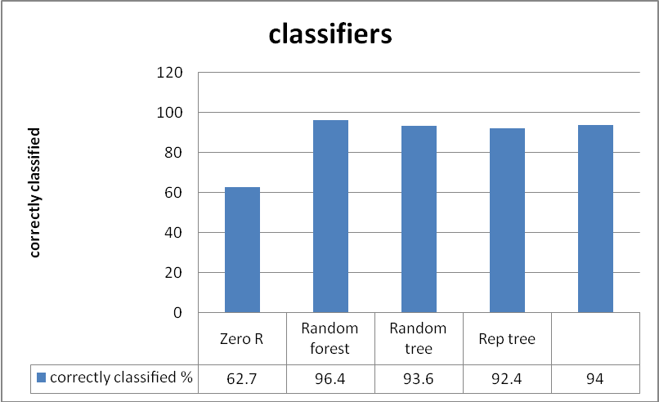

Table 2: Weighted Average

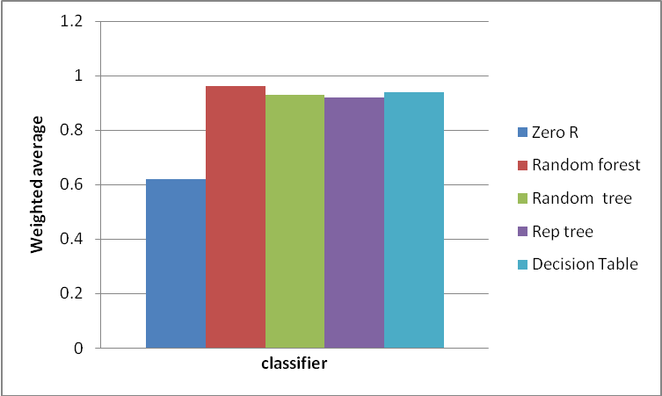

Table 3: Correctly and Uncorrectly classiﬁed

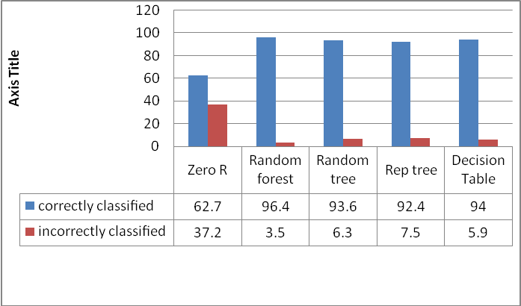

CONCLUSION

This paper aims to analyze different classifiers in medical data by using Data Mining for predicting Axiety. From the analysis, it is noted that answers may differ based on techniques and tools used. Good results are provided by Data Mining in diagnosing diseases.

References

[1] Lyon IAfRoC: World Cancer Report. International Agency for Research on Cancer Press 2003:188-193.

[2] American Cancer Society, 2007. Breast Cancer Facts & Figures. American Cancer Society

[3] Daniel F. Roses (2005). Clinical Assessment of Breast Cancer and Benign Breast Disease, In: Breast Cancer: Vol. 2, Ch. 14, M. N. Harris [editor], Churchill Livingstone, Philadelphia.

[4] UCI Machine Learning Repository and breast cancer site:archive.ics.uci.edu/ml site:ics.uci.edu..

[5] Prediction of Software Defects Using Zero R International Journal of Latest Engineering and Management Research (IJLEMR) ISSN: 2455-48471

[6] Sunita B. Aher1 and Lobo L.M.R.J COMPARATIVE STUDY OF CLASSIFICATION ALGORITHMS, International Journal of Information Technology and Knowledge Management July-December 2012, Volume 5, No. 2, pp. 239-243

[7] ]. Yu, K. ,Hand, D. J.; (2001). "Idiot's Bayes — not so stupid after all?". International

Statistical Review. 69 (3): 385–399. ISSN 0306-7734. doi:10.2307/1403452.

.

[8]http://chemeng.utoronto.ca/~datamining/dmc/m

[9] Rish, Irina (2001). An empirical study of the n naive Bayes classifier (PDF). IJCAI Workshop oEmpirical Methods in AI.,

[10] Rennie, J.; Shih, L.; Teevan, J.; Karger, D. (2003). Tackling the poor assumptions of Naive Bayes classifiers (PDF). ICML

