

MIT-World Peace University (MIT-WPU)

Faculty of Engineering, School of Computer Engineering & Technology

Synopsis

of

Trip Advisor with suitable companion using recommendation system

By Group B22:

Ameya Kulkarni

Tarak Kulkarni

Adwait Kulkarni

Vinayak Singh



Under The Guidance of

Chaitali Chandankhede

**Abstract:**

Travel planning can be a daunting task, especially when trying to find the right travel companion or destination. This paper presents a personalized travel planning website that uses content based filtering, collaborative filtering and social network analysis to provide recommendations for travel companions and destinations. The website allows users to create a profile and connect with friends to plan trips together. The recommendation system is based on the preferences and travel history of the user and their social network, as well as content-based analysis of travel destinations.

The website will be implemented using Node.js for the back-end and React for the front-end. We are also using MongoDB as the database along with Express.js library to build server side functions.

As for the recommendation algorithms, we are using python with the pandas library and scikit-learn

**Project Objectives:**

1. Recommend places to people who want to take a trip:

To recommend places to people, the travel recommendation system can use a combination of content-based recommendation and collaborative filtering.

1. Enable users to communicate and plan their trip:

The travel recommendation system can enable users to communicate and plan their trip by providing a platform where they can connect with other travelers.

1. Recommend people to travel with:

The travel recommendation system can recommend people to travel with based on shared interests, travel plans, and other factors.

1. Make trip planning more convenient than ever before:

To make trip planning more convenient, the travel recommendation system can offer a range of features and tools such as personalized recommendations etc.

## **Software (Tools)**

* **Jupyter Notebook:** Jupyter Notebook is an open-source web application that allows you to create and share documents that contain live code, equations, visualizations, and narrative text. The recommendation algorithms (content-based filtering, collaborative filtering, social network analysis) are going to be implemented in python.
* **React:** It is a very popular frontend library created by Facebook. We are going to use it to design the frontend of our website.
* **Node:** It is a JavaScript runtime environment that we are using to create the backend.
* **MongoDB:** It is a NoSQL database that we are going to use to store user data.
* **Express**: It is a popular backend library that we are going to use to create backend functions like CRUD operations.

**System Architecture**

**High level Diagram**

Activity Diagram

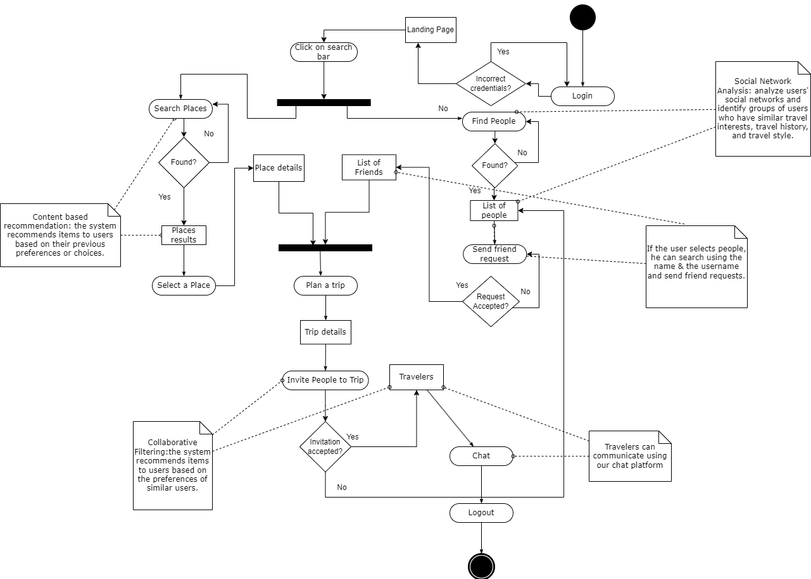

Use Case Diagram

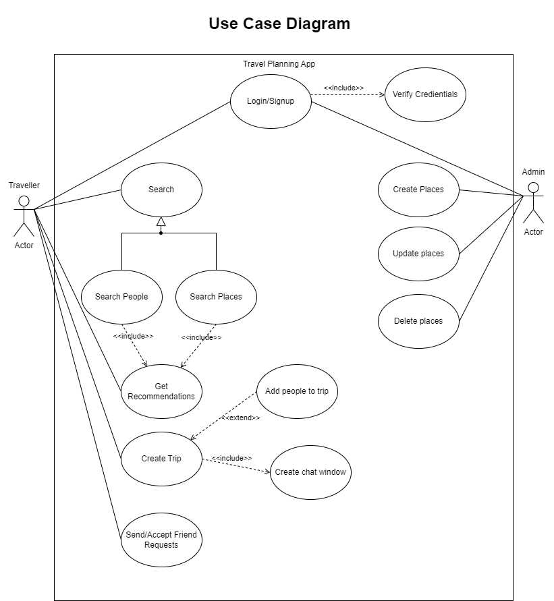

**Low level Diagram**

Module 1 & 2

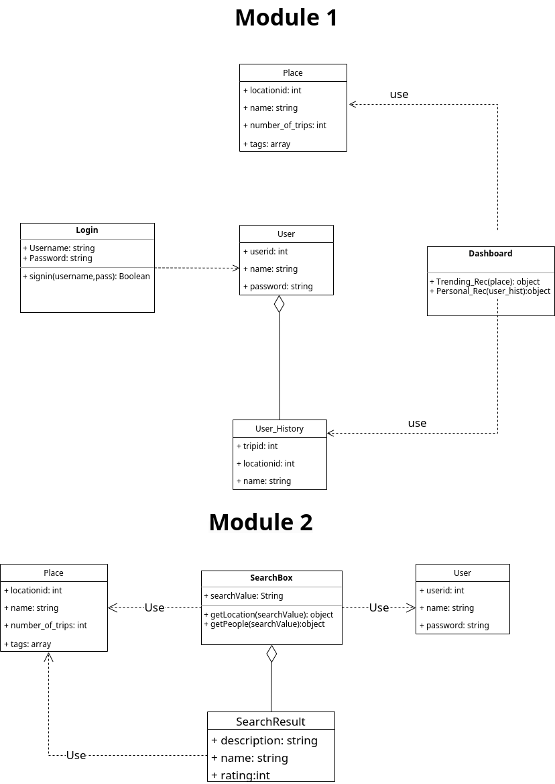

**Module 3**