**Junit**

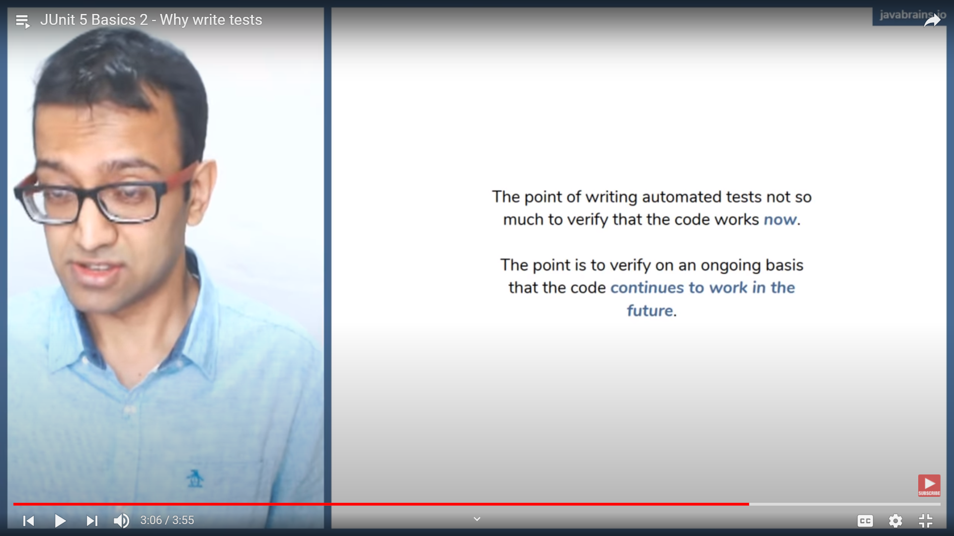

**Platform**: - Juint starts from platform meaning where we will be running our Juint Codes (Engine) and which Juint API we will be using depending on that we get the platform.

**Jupiter**: - Jupiter is the Juint API. Whenever we will be calling Juint for writing test cases we will be calling Jupiter not Junit from Juint 5.

**Vintage**: - Whenever we will be requiring Juint 4 run in our test class we will be using Vintage as Juint is not a backward compatible.

**External**: - We can use any third-party API to run our Juint tests. This API’s will be coming inside the external category.

@Test – Whenever we write Juint test cases we do not need any main method to run the same. Where in we use @Test to tell Junit platform (Jupiter for Juint 5) that this is a test class and we can run on Jupiter.

@AssertEquals – Juint tells whether the actual and expected are same.

@AssertArrayEquals – Verifies that each item in the array are equal in the right positions.

@AssertIterableEquals – Verifies that each in the Iterable are equal in the corresponding position.