
Symbiosis Institute of Technology, Pune
Faculty of Engineering
CSE- Academic Year 2025-26
Compiler Construction Lab Batch 2022-26
Lab Assignment No: - 10
Name of Student | Adyasha Subhadarsini
PRN No. | 22070122012
Batch | 22-26
Class | CC
Academic Year & Semester | 25-26
Date of Performance
Title of Assignment | Intermediate Code (IC) Generation
Practice Questions | 1. YACC program for IC generation for the expression involving parenthesis.  2. YACC program for IC generation for the expression involving programming constructs.

- YACC program for IC generation for the expression involving parenthesis.
ic_generation.y
%{
#include <stdio.h>
#include <stdlib.h>
#include <string.h>

int yylex();
void yyerror(const char *s);

int tempCount = 1;
void newTemp(char *buf) {
sprintf(buf, "t%d", tempCount++);
}
%}

%union {
char *str;
}

%token <str> ID NUM
%type <str> E

%left '+' '-'
%left '*' '/'
%left '(' ')'

%%
S : E '\n' { printf("\nIntermediate Code Generated Successfully.\n"); }
;

E : E '+' E
{
char temp[10];
newTemp(temp);
printf("%s = %s + %s\n", temp, $1, $3);
$$ = strdup(temp);
}
| E '-' E
{
char temp[10];
newTemp(temp);
printf("%s = %s - %s\n", temp, $1, $3);
$$ = strdup(temp);
}
| E '*' E
{
char temp[10];
newTemp(temp);
printf("%s = %s * %s\n", temp, $1, $3);
$$ = strdup(temp);
}
| E '/' E
{
char temp[10];
newTemp(temp);
printf("%s = %s / %s\n", temp, $1, $3);
$$ = strdup(temp);
}
| '(' E ')'
{ $$ = $2; }
| ID
{ $$ = strdup($1); }
| NUM
{ $$ = strdup($1); }
;

%%

void yyerror(const char *s) {
printf("Error: %s\n", s);
}

int main() {
printf("Enter an expression:\n");
yyparse();
return 0;
}

ic_generation.l
%{
#include "ic_generation.tab.h"
%}

%%
[a-zA-Z_][a-zA-Z0-9_]* { yylval.str = strdup(yytext); return ID; }
[0-9]+ { yylval.str = strdup(yytext); return NUM; }
"(" { return '('; }
")" { return ')'; }
"*" { return '*'; }
"/" { return '/'; }
"+" { return '+'; }
"-" { return '-'; }
\n { return '\n'; } /* <-- Added this */
[ \t\r]+ ;
. { printf("Invalid character: %s\n", yytext); }
%%

int yywrap() { return 1; }
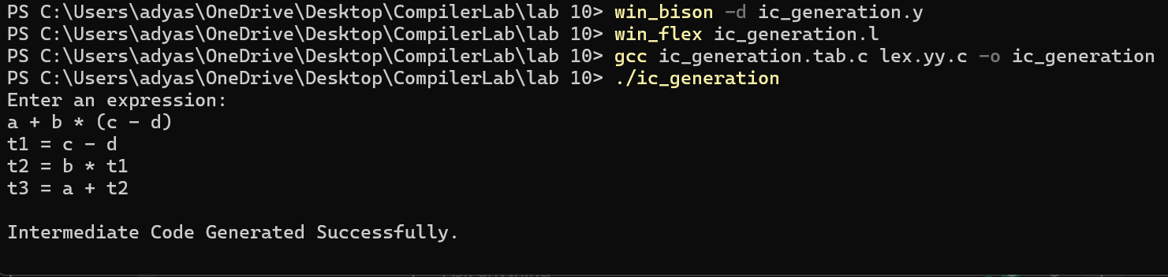
- YACC program for IC generation for the expression involving programming constructs.
ic_constructs.y
%{
#include <stdio.h>
#include <stdlib.h>
#include <string.h>

int yylex();
void yyerror(const char *s);

int tempCount = 1, labelCount = 1;

void newTemp(char *buf) {
sprintf(buf, "t%d", tempCount++);
}

void newLabel(char *buf) {
sprintf(buf, "L%d", labelCount++);
}
%}

/* Define union for string values */
%union {
char *str;
}

/* Tokens */
%token <str> ID NUM RELOP IF WHILE
%type <str> E CONDITION STMT

%left '+' '-'
%left '*' '/'
%left RELOP
%right '='

%%
S : STMT '\n'
{ printf("\nIntermediate Code Generated Successfully.\n"); }
;

STMT : ID '=' E
{
printf("%s = %s\n", $1, $3);
$$ = strdup($1);
}
| IF '(' CONDITION ')' STMT
{
char lbl1[10], lbl2[10];
newLabel(lbl1);
newLabel(lbl2);
printf("if %s goto %s\n", $3, lbl1);
printf("goto %s\n", lbl2);
printf("%s:\n", lbl1);
printf("%s\n", $5); // Body of if
printf("%s:\n", lbl2);
$$ = strdup("if_stmt");
}
| WHILE '(' CONDITION ')' STMT
{
char lbl1[10], lbl2[10], lbl3[10];
newLabel(lbl1);
newLabel(lbl2);
newLabel(lbl3);
printf("%s:\n", lbl1);
printf("if %s goto %s\n", $3, lbl2);
printf("goto %s\n", lbl3);
printf("%s:\n", lbl2);
printf("%s\n", $5); // Loop body
printf("goto %s\n", lbl1);
printf("%s:\n", lbl3);
$$ = strdup("while_stmt");
}
;

CONDITION : E RELOP E
{
char temp[40];
sprintf(temp, "%s %s %s", $1, $2, $3);
$$ = strdup(temp);
}
;

E : E '+' E
{
char temp[10];
newTemp(temp);
printf("%s = %s + %s\n", temp, $1, $3);
$$ = strdup(temp);
}
| E '-' E
{
char temp[10];
newTemp(temp);
printf("%s = %s - %s\n", temp, $1, $3);
$$ = strdup(temp);
}
| E '*' E
{
char temp[10];
newTemp(temp);
printf("%s = %s * %s\n", temp, $1, $3);
$$ = strdup(temp);
}
| E '/' E
{
char temp[10];
newTemp(temp);
printf("%s = %s / %s\n", temp, $1, $3);
$$ = strdup(temp);
}
| ID
{ $$ = strdup($1); }
| NUM
{ $$ = strdup($1); }
;

%%

void yyerror(const char *s) {
printf("Error: %s\n", s);
}

int main() {
printf("Enter a statement (e.g., if (a<b) c=a+b;):\n");
yyparse();
return 0;
}

ic_constructs.l
%{
#include "ic_constructs.tab.h"
%}

%%
"if" { return IF; }
"while" { return WHILE; }
"<"|">"|"=="|"!="|"<="|">=" { yylval.str = strdup(yytext); return RELOP; }
[a-zA-Z_][a-zA-Z0-9_]* { yylval.str = strdup(yytext); return ID; }
[0-9]+ { yylval.str = strdup(yytext); return NUM; }
"=" { return '='; }
"(" { return '('; }
")" { return ')'; }
";" { return '\n'; }
"*" { return '*'; }
"/" { return '/'; }
"+" { return '+'; }
"-" { return '-'; }
[ \t\r]+ ;
. { printf("Invalid character: %s\n", yytext); }
%%

int yywrap() { return 1; }
