**Lesson 05 Demo 06**

**Troubleshooting Container and Engine Logs**

**Objective:** To troubleshoot container and engine logs to resolve connectivity issues between containers

**Tools required:** Ubuntu OS

**Prerequisites:** None

Steps to be followed:

1. Set up Docker containers
2. Troubleshoot container and engine logs

**Step 1: Set up Docker containers**

1. Run the following command to switch to the root user:   
   **sudo su**  
     
   
2. Execute the following command to create and run a Docker container:  **docker run -dt --name containerA ubuntu /bin/bash**  
     
   
3. Execute the following command to create and run another Docker container:  
   **docker run -dt --name containerB ubuntu /bin/bash**  
     
   
4. Run the following command to list all the containers in the system:  
   **docker ps -a**  
     
   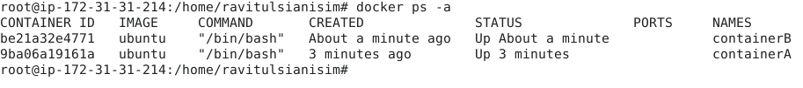

**Step 2: Troubleshoot container and engine logs**

1. Inspect the network configuration of containerA:   
   **docker inspect containerA**   
     
   A white screen with black text

   Description automatically generated
2. Inspect the network configuration of containerB:   
   **docker inspect containerB**  
     
   A close-up of a white background

   Description automatically generated
3. Run the following command to check the Docker daemon logs:  
   **journalctl -u docker.service**  
     
   A black and white text

   Description automatically generated
4. Retrieve the IP address assigned to the Docker containerB:  
   **docker inspect containerB | grep IPAddress**  
     
   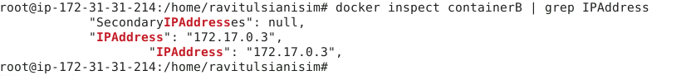
5. Run the following command to start an interactive bash shell session within the Docker containerA:  
   **docker exec -it containerA /bin/bash**  
     
   
6. Run the following command to update the package lists for repositories configured in the system:  
   **apt-get update**  
   **A screenshot of a computer

   Description automatically generated**
7. Run the following command to install the **iputils** package and test for network connectivity:  
   **apt-get install iputils-ping -y**  
   **A screenshot of a computer program

   Description automatically generated**

1. Check if the specified IP address is reachable over the network by sending echo requests and waiting for responses:  
   **ping 172.17.0.3**  
     
   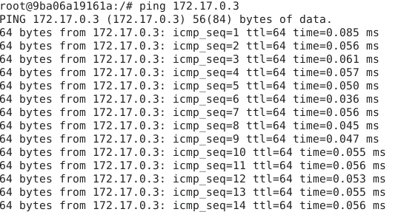 By following these steps, you have effectively troubleshooted the container and engine logs in Docker.