HOSPITAL MANAGEMENT SYSTEM
Python Programming Project Report

ADYA SINGH
Name: ______________________________
26BCE10804
__________________________________
INTRODUCTION TO PROBLEM SOLVING AND PROGRAMMING
__________________________________
AVR MAYURI
__________________________________
Institution
VIT Bhopal University
Academic Year
2026–2027

Introduction
The Hospital Management System is a menu-driven Python application designed to demonstrate basic patient and appointment management. It allows a user to register patients, view patient records, search for a patient, delete a patient record, book an appointment, and view appointments.

Problem Statement
Managing patient details manually can be time-consuming and may make it difficult to find or update information. This project demonstrates how a simple computer program can organize patient details and appointment information through a menu-based interface.

Objectives
- Create a simple menu-driven application using Python.
- Register patients using a unique patient ID.
- Display and search registered patient details.
- Delete a patient record when requested.
- Book appointments for registered patients.
- Display appointment information.
- Practise functions, dictionaries, lists, loops, conditionals, and user input.

Software and Requirements
- Programming language: Python 3
- Code editor: Visual Studio Code (VS Code)
- Interface: Terminal / command line
- Data structures: Dictionary for patients and list for appointments
- Optional text file: patients.txt (file saving must be verified separately)

System Features
- Register Patient: Collects a patient ID, name, age, and disease, then adds the record to the program's patient dictionary.
- View Patients: Displays the registered patient records when the view function is implemented and connected correctly.
- Search Patient: Searches for a patient using the entered patient ID.
- Delete Patient: Removes a patient record using its ID; the current program may also remove associated appointments.
- View Appointments: Displays appointments already booked.
- Book Appointment: Checks that the patient ID exists, then collects doctor, date, and time details.
- Exit: Ends the menu loop and closes the application.

Program Logic / Algorithm
- Start the program.
- Create the patient dictionary and appointment list.
- Display the main menu.
- Read the user's choice.
- Call the corresponding function for registration, viewing, searching, deletion, appointment booking, or appointment viewing.
- For appointment booking, check whether the entered patient ID exists.
- Display the result of the selected operation.
- Repeat the menu until the user selects Exit.
- Stop the program.

Sample Test Cases
Test | Action | Expected result
1 | Register a new patient | Success message and patient record added in memory
2 | View registered patients | Registered patient details displayed
3 | Search using a valid ID | Matching patient details displayed
4 | Delete using a valid ID | Patient removed and confirmation displayed
5 | View appointments when none exist | Message indicating no appointments
6 | Book appointment for registered ID | Appointment details collected and saved in memory
7 | Book appointment for unknown ID | Prompt to register the patient first
8 | Enter an invalid menu choice | Invalid-choice message displayed

Limitations
- In the current in-memory version, patient and appointment data are lost when the program exits.
- Text-file persistence should only be claimed after saving and reloading records has been tested.
- The application is an educational prototype and is not intended for real clinical use.
- Authentication, privacy controls, input validation, and robust date/time validation can be added in future versions.

Future Enhancements
- Save and reload patient and appointment records using a text file or SQLite database.
- Improve validation for IDs, ages, names, and appointment dates.
- Add appointment cancellation and rescheduling.
- Add a simple graphical user interface.
- Add login and access controls if required by the project specification.

Conclusion
The Hospital Management System demonstrates how Python functions, conditional statements, loops, dictionaries, and lists can be combined to create a basic management application. Testing each menu option helps verify that the functions work as expected. Persistent storage and additional validation are useful next steps before treating the project as complete.

Screenshots
The following screenshots were taken from the VS Code terminal and show the main menu and each tested menu option of the program.
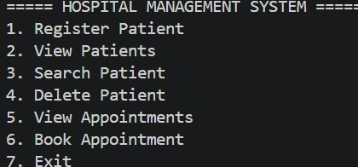
Figure 1: Main menu of the Hospital Management System.
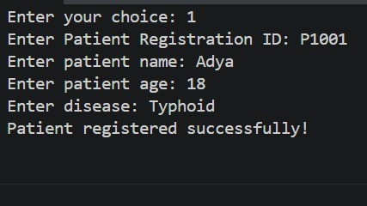
Figure 2: Successful registration of a new patient (ID P1001).
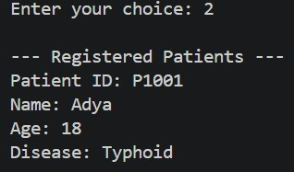
Figure 3: Viewing the registered patients.
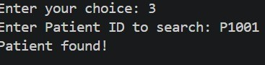
Figure 4: Searching for a patient using a valid Patient ID.
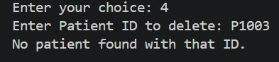
Figure 5: Delete option entered with an ID that is not registered (P1003), showing the "No patient found" message.
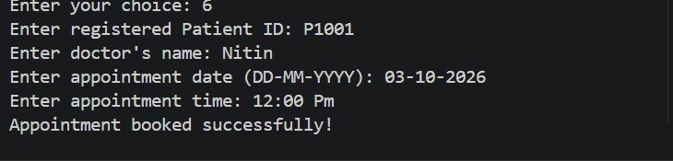
Figure 6: Successful appointment booking for a registered patient.
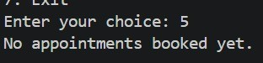
Figure 7: Viewing appointments when none have been booked yet.
Figure 8: Exiting the program.
Declaration: This report should be reviewed and edited to match the exact code, features, and requirements of the submitted project.

