Material related to RFID and Predictive analytics

RFID and RFID asset tracking/tagging has afforded industries with several advantages as its use continues to grow among everyday tracking. In Part One of a five part mini-series examining the advantages of RFID in various vertical industries, we take a look at five advantages of RFID in the Transportation & Logistics market.

RFID ARCHITECTURE
- With this vision, we developed Tracksphere, an RFID software infrastructure (compatible with other technologies), that connects RFID readers of all kinds (RFID Portal, Gates, Handhelds, Forklift mounted readers, etc.) and brands (Impinj, Zebra-Motorola, Honeywell-Intermec) to the Web and your applications like ERP, WMS or MES.
- To enable end to end solution, we also developed a critical piece of software (with the help of our device partners) that runs on the RFID reader, as an embedded middleware, communications agent and device manager.
- Tracksphere also includes an Asset Management (TrackAsset) and People tracking (PeopleCare) specific applications for customers that require more than just RFID reads, inventories and consolidated tag views. TrackAsset and PeopleCare are customer applications to solve operational problems without the need to buy or develop expensive stand alone software.
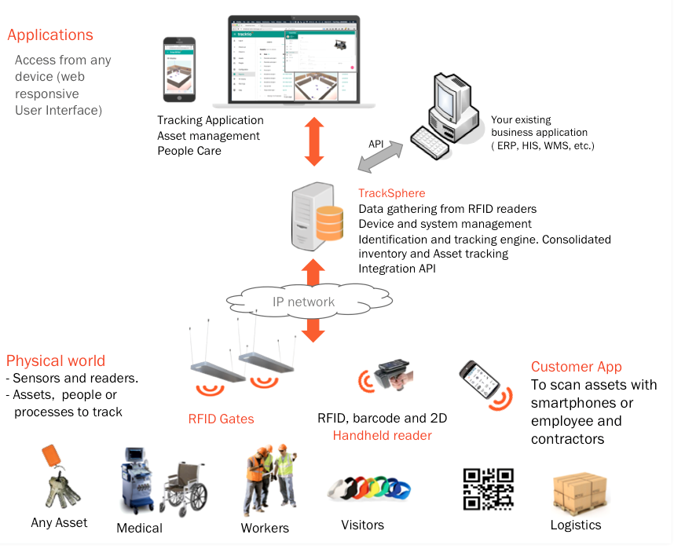

SIMPLIFYING TRACEABILITY FOR TRANSPORTATION AND LOGISTICS
Maintaining on-time and on-track freight management operations is essential for improving the accuracy and efficiency of asset utilization.
Lowry’S solutions for transportation and logistics automate the tracking of fleets and freight so you can be sure every vehicle is taking the right shipment to the right place at the right time.
Real-time data capture and reporting streamline inbound/outbound logistics, optimize stock levels for just-in-time/just-in-sequence manufacturing, reduce shipping errors, and lower costs. Automated processes replace time-consuming paper handling to improve dispatch efficiency, promote yard productivity, track and manage assets, and increase in-transit visibility.
Our comprehensive transportation and logistics solutions include pickup & delivery, cross dock logistics, fleet management, and field mobility solutions.

TRANSPORTATION AND LOGISTICS SOLUTIONS: FLEET MANAGEMENT
By increasing the quality, speed, and accuracy of information that accompanies each package, pallet or container, companies utilizing barcoding and RFID can improve responsiveness and efficiency as well as cut operating costs, giving them an advantage dock-to-dock and dock-to-door.
Lowry transportation and logistics barcode solutions offer a variety of transportation and logistics solutions to meet unique needs:
- Compliance – from CSA to electronic HOS logs
- Fleet management – from reduced fuel costs to real-time visibility
- Delivery management – from traceability reporting to “clean invoicing”
- Operating efficiency – from mobile routes to end-of-day settlement
With off-the-shelf and customizable packages of hardware and software ready to be deployed by our expert team, barcoding can bring rapid results to the supply chain while providing expert support and service.

TRANSPORTATION AND LOGISTICS BARCODE SOLUTIONS: FIELD MOBILITY
Field workers are one of the most important direct interactions your business has to your customers. How well and effectively they perform is crucial to a positive customer experience. Access to technical resources, customer data, stock availability and route scheduling can be the difference between a satisfied customer and a lost opportunity.
Rugged tablets allow mobile workers access to business-critical data in real time so they can complete tasks including mobile inspections, work orders, paperless forms/surveys, automated safety audits, maintenance, and repair capabilities.
Today’s enterprise mobility solutions mean that your mobile workers can be connected virtually anywhere.
Lowry’s transportation and logistics solutions include integrated management software and handheld computers that allow you to fully mobilize your workforce for greater productivity. Eliminate the gap between the network of resources your business has in the office and your workers out in the field.
A Field Mobility barcode solution can help improve any application with the benefits of:
- Accuracy – Eliminate errors in the field, have real-time access to data, service logs, and manuals
- Efficiency – Workers can do their jobs on-the-go, and provide a better customer experience
- Productivity – Reduce man hours, and visit more customers per day
- Optimization – Improve workforce management with visibility

Data Items of RFID for transportation

• location of roads,
• The status of roads (e.g., road quality or temporary construction on the roads)
• types of vehicles that can utilize the road
• limitations and congestion
• Real-time information eg. congestion, accident
• location of the freight through the transportation network between the actors:
• arrival of the freight
• loading and unloading information
• location of the freight in the warehouses, terminals, and ports
• physical attributes of the product during the transportation ( in warehouse or
through shipping)
• Real-time information regarding the temperature, pressure, impact, humidity
or the level of light in the vehicle during transportation
• placement and sequencing of the products when they are stored or being
shipped
• positioning of the products in warehouses presented in three axes of x, y and
z
• placement of the containers in the Ro-Ro ships
• number of items in the warehouses,
• customers’ orders for different items,
• loading and unloading times for different orders
• contents of different warehouses, types of items stored in the war

Content for the RFID website

what is RFID and its importance
For many organizations, the solution is the automation of visibility and management processes. Most transportation and logistics companies have been using barcodingsuccessfully for years now. A growing number are also adding Radio Frequency Identification (RFID) solutions. RFID is essentially a more automated way of knowing what youhave and where it is. There are substantial differences between barcoding and RFID. One of the most significant is the fact that barcodes need a clear line-of-sight to bar codescanners, making them difficult and slow to work with in many locations and situations. Another is the high numberof manhours it takes to count shipments, inventory andassets with barcodes. In addition, barcodes are able to identify only the type or class of goods, rather than individual items. RFID, on the other hand, identifies and locates every single item you want to track, from trucks to forklifts to returnable
transit items (RTIs) to containers to whatever is being
shipped in them. With RFID there are no line-of-sight
requirements, so you can read a great many tags
simultaneously. RFID lets you read, write and re-write to
flexible, low-cost tags that offer greater data capacity,
durability in harsh environments and the security of being
difficult to replicate. And you can read them at distances of
up to 30 feet.
An RFID system includes tags, or transponders, that include
a small antenna and a chip that can hold a significant
amount of data such as product number, manufacturer,
location and much more. It also includes three basic types
of RFID readers.
• Fixed readers have an external antenna and are often
located at entry points to facilities and yards.
• Handheld readers provide on-demand scanning and are
used by personnel moving through the space.
• Mobile readers can be located on moving equipment,
such as trucks and forklifts, for faster, more accurate
inventory and process tracking.

Components of RFID systems

Advantages of RFID in transportation:

RFID on a Fast Track
Today, RFID is proven technology providing far-reaching benefits for transportation and logistics organizations. While many of these businesses are successfully usingsystems for asset management, warehouse and yard management, the future of RFID goes far beyond internal closed loop solutions. Transportation and logistics companies are moving inexorably toward deploying open loop solutions in which every link in the supply chain is able to utilize the same RFID tags. The industry is already working to fast track the solutions that will get us there, including developing innovative new RFID tagging andreading technologiessuch as active and semi-active tags, initiatives to enable environmentally friendly green solutions and solutions to lower supply chain management costs. Equally important, RFID technology costs are steadilydecreasing as adoption continues to grow, thereby allowing faster return on investment for projects while at the same time allowing profitable RFID deployments across a wider set of materials and goods.

Retailers developing predictive analytics strategies need highly accurate visibility into their inventories to know which products will move in which channels to anticipate future trends.
Retailers that integrate RFID into their supply chains have true item-level data, allowing them to develop more sophisticated merchandising, planning, and allocation systems.
“Item level RFID is an essential component to enable the supply chain visibility and inventory accuracy needed to know what’s available, where it’s located, and how to best deliver it – helping meet consumer expectations anytime, anywhere,” the article notes.
Using predictive analytics, retailers can build clear pictures of product performance so they can effectively manage purchasing, planning, assortment, storing, optimization, and discounts.

