Learnings Week 1:

-- Whycon Markers

In Mobile robotics one the biggest problems is precise pose estimation which is where whycon markers come in. Autonomous robots not only need to pose estimation for themselves but also for other obstacles (which might be in motion), this is where whycon markers come in. They help in recognizing and doing pose estimation which is very useful. Due to its reliability, simplicity of use and availability as an open-source ROS it is now used in a number of robotics projects where fast and precise relative localization is required.

--Arucon Markers

Aruco markers are also the kind of markers that are used for camera pose estimation. The main advantage for these is that their detection is fast and simple. The Aruco module includes the detection of these types of markers and the tools to employ them for pose estimation and camera calibration. The difference between two of them is Whycon is a good alternative for all ranges while Aruco is only good at small distances.

-- Open loop vs Close loop

The main difference betweeen open and closed loop lies in the Feedback variable. While the open loop usually works in a fixed cycle, the closed loop has flexibility in terms of adjusting to the output, giving better results. Example for closed loop might be PID controller. Closed loop ones detect the error and try to minimize them.

--PID Controller:

PID controllers are named after the Proportional, Integral and Derivative control behviors they possess. They are used in most automatic process control applications in industry. PID controllers can be used to regulate flow, temperature, pressure level etc. They quickly minimize the error which is ultimately desirable.

P (proportional) accounts for present values of the error. For example, if the error is large and positive, the control output will also be large and positive.
- I (integral) accounts for all past values of the error. For example, if the current output is not sufficiently strong, the integral of the error will accumulate over time, and the controller will respond by applying a stronger action.
- D (differential) accounts for possible future trends of the error, based on its current rate of change.
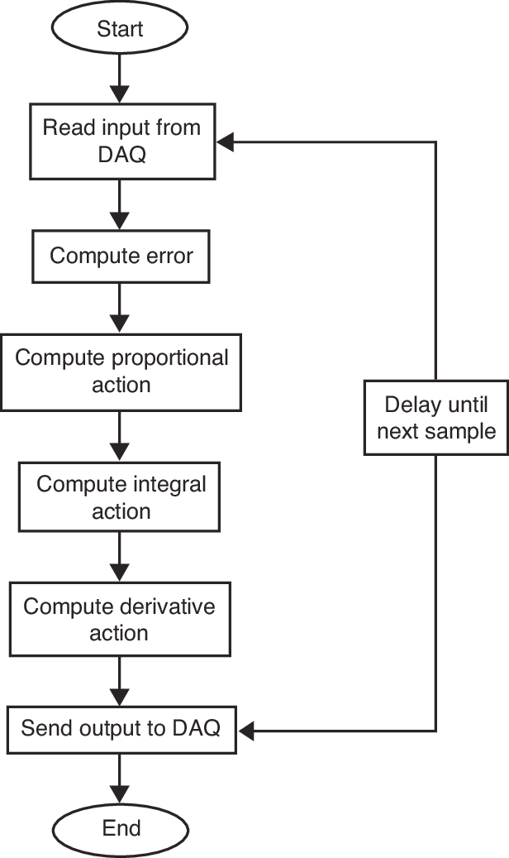

References:

Whycon Markers

https://github.com/gestom/whycon-orig

Aruco Markers

https://www.youtube.com/watch?v=aWmzhmfahh8

PID

https://blog.opticontrols.com/archives/344
https://www.controlglobal.com/blogs/controltalkblog/basics-of-pid-control-modes-tips/

Open loop-Closed loop

https://www.electronics-tutorials.ws/systems/closed-loop-system.html

