**CASE STUDY:**

**SMART HAND SANITIZER DISPENSER**

NAME: Aditya Sawant

ROLL NO: 31302

PRODUCT DESCRIPTION:

Smart Hand Sanitizer Dispenser is a device which aims to provide contactless hand disinfection in order to prevent spread of infectious diseases and improve hygiene. Additionally, it is economical and eco-friendly by decreasing waste emissions.

PURPOSE AND REQUIREMENT SPECIFICATION:

**Purpose**:

This product aims to build an Automatic Hand Sanitizer Dispenser. This project will use ESP32, Ultrasonic Sensor, 16x2 LCD Module and Water pump. An ultrasonic sensor is used to check the presence of hands below the outlet of the sanitizer machine. It will continuously calculate the distance between the sanitizer outlet and itself and tells the ESP32 to turn on the pump whenever the distance is less than 15cm to push the sanitizer out.

ESP32 is used as the main controller, it is a Wi-Fi module that can easily connect to the internet.

Besides that, automated hand sanitizer will make notification to the owner, if the liquid has run out to the smartphone

**Behaviour**: Has both manual mode to spray sanitizer and auto mode which sprays it.

**System Management Requirement**:

Interaction through app installed on user’s phone or through physical intervention.

**Data Analysis Requirement**:

It send data to the Arduino Nano to activate the pump. If the ultrasonic sensor detect the distance of water to the sensor 15 cm it will send data to node MCU that connect to Blynk server. It can transfer the data to the output devices such as smartphones or PC based on the Internet of Things (IoT).

**Application Deployment Requirement**:

It can be attached to the sanitizer bottle directly and can be accessed remotely using the app.

**Security Requirement:**

User authentication on app, password login after long period of inactivity.

DOMAIN MODEL SPECIFICATION

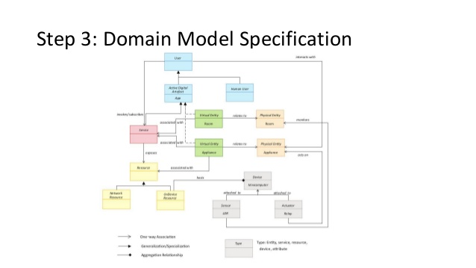

INFORMATION MODEL SPECIFICATION:

Level: High

Level: Low

Level: Low

Level: High

Attribute: Sanitizer

TYPE: Level

Attribute: Hygiene

TYPE: Level

Virtual entity: Sanitizer container

TYPE: Appliance

Virtual entity: Hand

TYPE: User

SERVICE SPECIFICATION:

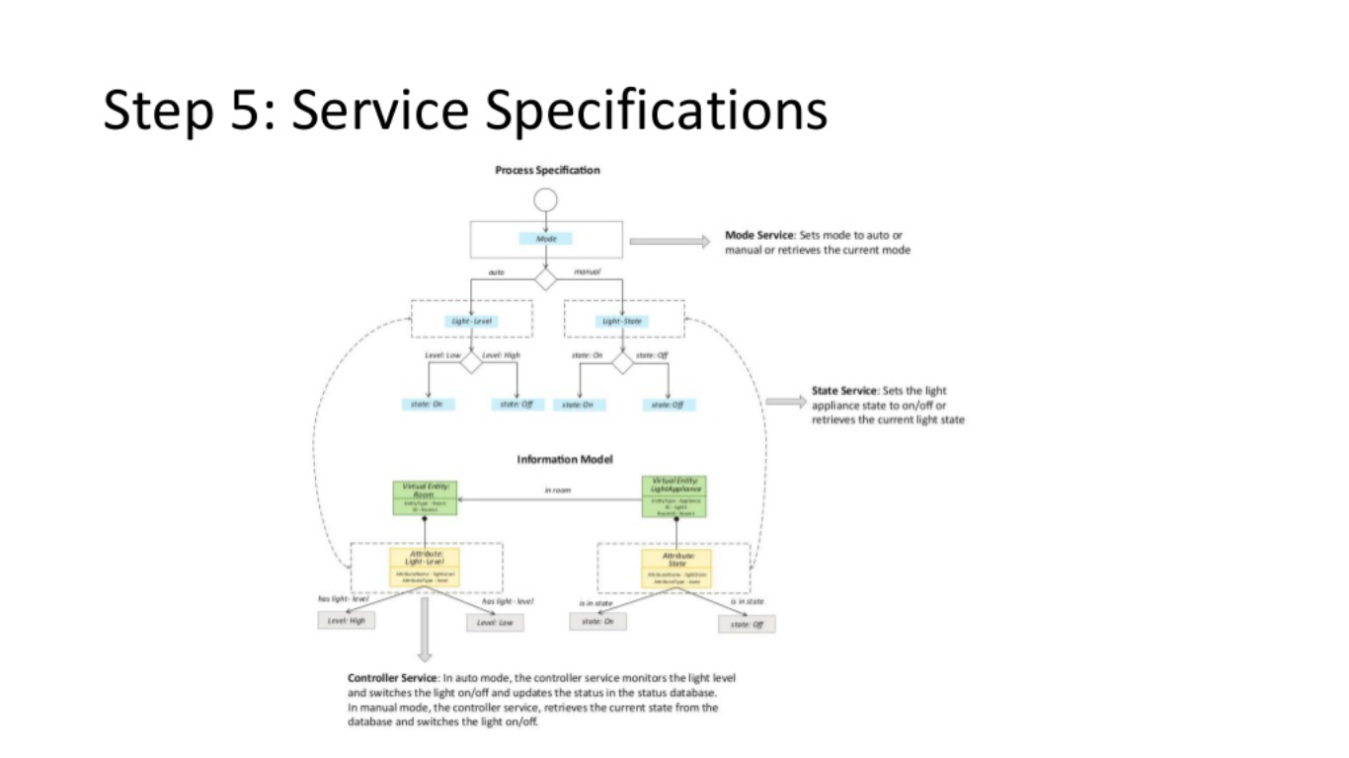

IOT LEVEL SPECIFICATION:

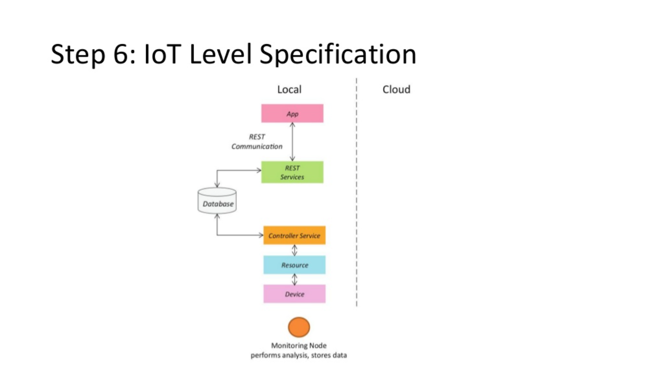

FUNCTIONAL VIEW SPECIFICATION:

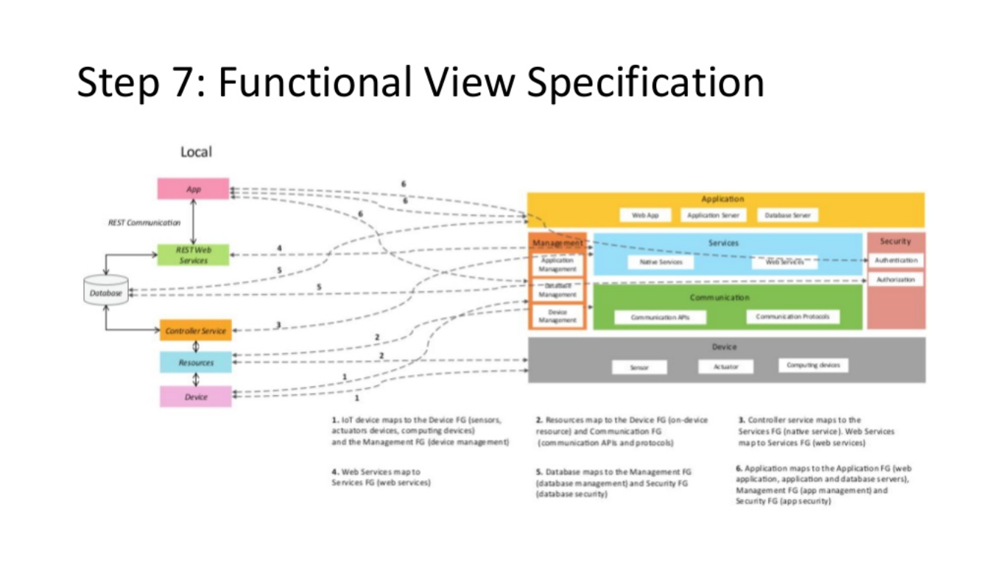

OPERATIONAL VIEW SPECIFICATION:

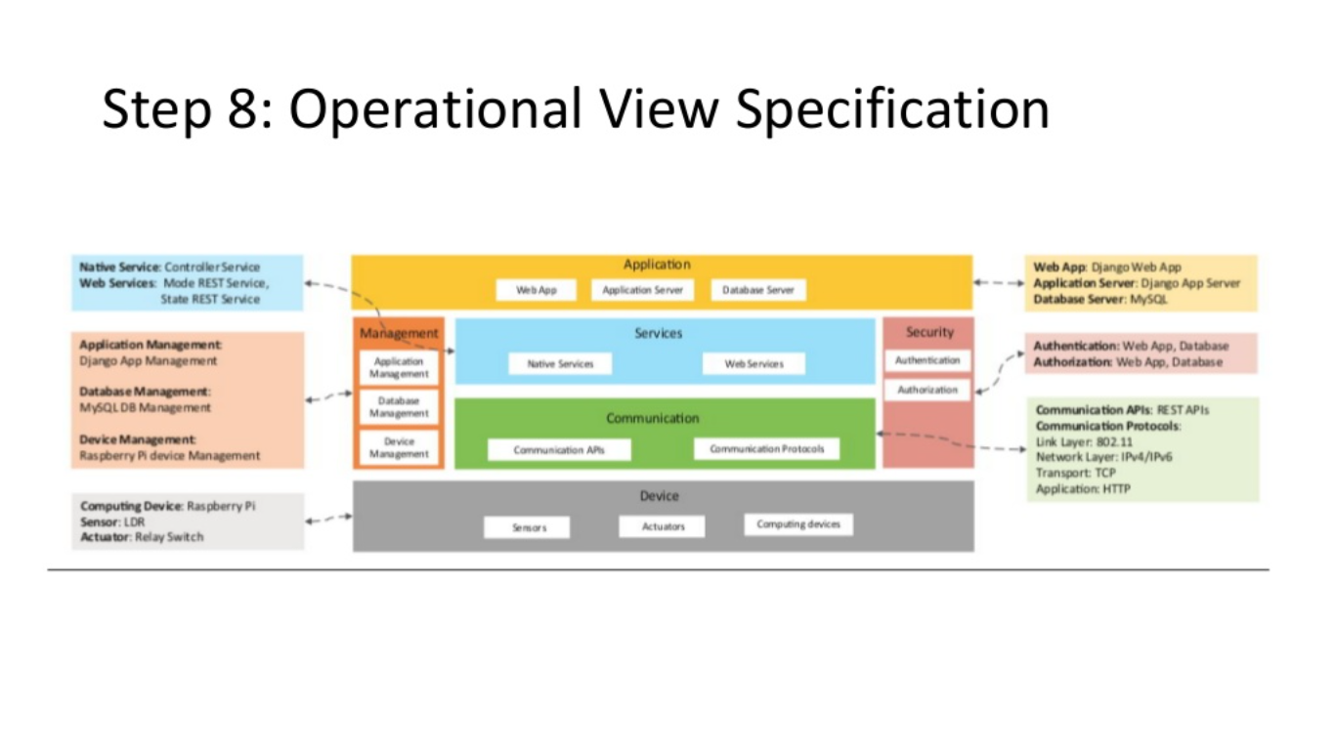

CONCLUSION

Thus, with the proposed device, it is possible to avoid many people coming into contact with the pump handle, thus preventing viral transmission of and making the use of hand sanitizer much more convenient and helps to control the spread of COVID-19 epidemic.