**TASK: implement possibility to remove values from the list.**

Removed values should be shown as crossed out.

Use Store and Dispatcher for these operations.

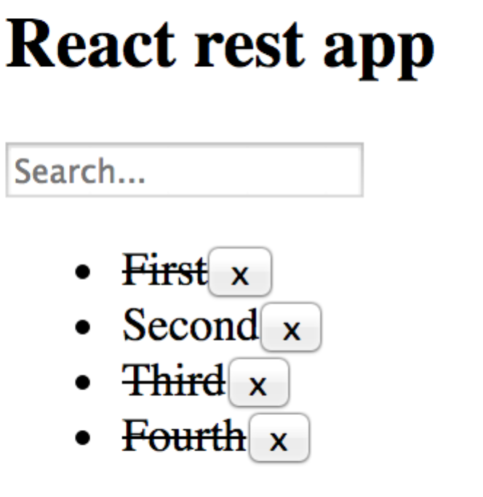

**Solution**

1) Create button x in MyList:

**const** *MyList* = ({items}) => (  
 <**ul**>  
 {items.map(i => (  
 <**li key=**{i}>{i} <**button onClick=**{()=>*remove*(i)}>x</**button**></**li**>  
 ))}  
 </**ul**>  
);

2) Implement method remove(val):

**function** *remove*(value) {  
 *removeFromList*(value);  
}

3) Implement removeFromList() in actions:

**export function** *removeFromList*( value ) {  
 **let** payload = {  
 **type**: **'REMOVE_FROM_LIST'**,  
 **value**: value,  
 }  
 appDispatcher.dispatch(payload);  
}

4) Add additional value to the initial Store in filteredList.js:

*setState*(*getState*().merge({  
 **placeholder**: **'Search...'**,  
 **items**: [**'First'**, **'Second'**, **'Third'**, **'Fourth'**],  
 **tempItems**: [],  
 **removedItems**: [],  
}));

5) Register dispatcher function to perform action on Store:

appDispatcher.register(**function**(payload) {  
  
 **switch**(payload.**type**) {  
  
 **case "REMOVE_FROM_LIST"**:  
 **let** state = *getState*();  
 **let** removedItems=state.get(**"removedItems"**);  
 *// Updates the state of the store.  
 setState*(state.merge({  
 **removedItems**: removedItems.push(payload.value)  
 }));  
 **break**;  
  
 **default**:  
 }  
});

6) Add style style.css:

.**removed** {  
 **text-decoration**: **line-through**;  
}

7) Attach style to MyList.js:

**import "./style.css"**;

8) Implement function getRemovedClass(value) which will return class «removed» in case if value was removed:

**function** *getRemovedClass*(value) {  
 **if** (*getState*().get(**"removedItems"**).find(e=>e==value)) {  
 **return "removed"**;  
 } **else return ""**;  
}

9) Use getRemovedClass in MyList component:

**const** *MyList* = ({items}) => (  
 <**ul**>  
 {items.map(i => (  
 <**li className=**{*getRemovedClass*(i)} **key=**{i}>{i}  
 <**button onClick=**{()=>*remove*(i)}>x</**button**></**li**>  
 ))}  
 </**ul**>  
);

10) Reload page and check the result.