Process: Customer Master Record
Country: UKI

Desk Procedure

Date reviewed | Reviewers | Content
May 2015 |  | Complete revisions

Author: Renata Skopkova, Jana Varholakova, Ivan Rolko

Table of Contents:
1. SOF UKI 3
2. Create a New Customer Number 5
Create a CN using EFORMS ….5
3. New Customer Request 6
4. Different Types of CustNRS 6
4.1 Brand New Customer 6
4.2 Existing Customers 6
4.3 Non VAT Registered CustNRS 6
4.4 Public Customers 7
4.5 Private Households 7
4.6 Foreign Customers 7
4.7 Internal CustNRS 8
4.8 CSI CustNRS 12
4.9 BP VRxxx/end user CustNRS 13
4.10 FSL (IGF) CustNRS 13
4.11 Melody CustNRS 14
4.12 Leasing Company 14
4.13 Lenovo / Infoprint 14
5. IRISH Customers 15
6. Manually creation of CustNRS 16
7. Changes to existing Customer Records 17
8. BDE1 19
9. Cancellation/Reactivation of customers and Embargo codes 26
10. T50 UKI 37
11. Non E-from tool 40
12. Transition errors 45
13. List of approvers 47

1. SOF UKI

SYSTEM IMSC, COUNTRY ID 866

TRANSACTIONS: SI1 CR1 BDE1 EC1

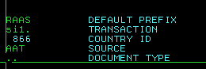

SI1: Shows customer records, doesn’t allow any changes

Option 1: Search by Customer Number
Option 51: Search by Customer Name

CR1: Allows the following changes

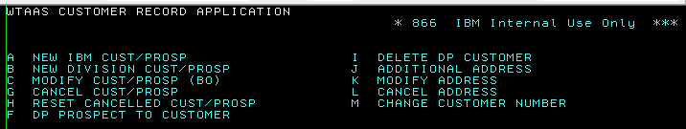

Option A: Create a new CN manually

Option C:
- Abbreviated name (max. 22 characters)
- Abbreviated location (max. 12 characters)
- ISIC, ISU, INAC
- VAT REGISTRATION NUMBER
- EMBARGO CODE, TYPE OF CUSTOMER
- D modification: SBO/MUBU, SALESMAN, COLLECTION CODE, ISU

Option H: Reset cancelled customer number – activation

Option G: Cancel customer number - inactivation

Option J: Add new addresses

Option K: Change the addresses

BDE1: When opening BDE1, always specify ‘Document Type’ CR
Allows the following changes:

- Line 104: tax code, enterprise number

EC1: Correction of errors

Transition errors from E-form to SOF: Source AAT, F90 or personal

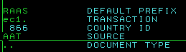

2. Create a New Customer Number
When reviewing an E-forms request, the CMR approvers team performs data accuracy validation (check of VAT, legal name and legal address), DPL check and duplicate search.

Create a CN using EFORMS

A: First of all do the DPL check.
The company name in the Mailing address (used for automatic DPL check)
If there is a DPL hit, send the E-form for review to ERC of requested country.

B: VIA FindCMR TOOL:
Check by name in the Find CMR tool (D&B database) if the company is already registered.
VAT, Legal Name and Legal Address validation is to be verified before creating a customer in the
Legacy Systems against Commercial Registry or Dun & Bradstreet website.
A letter from the customer, official web site, letterhead, invoice with the brand signature can also be
used as valid evidence.
Only requests from DSW team, can be created for exactly the same addresses. Maxim of 4 duplicates for DSW is allowed. All requests from LOB DSW must hold DSW in the abbreviated name!
Take the Duns number from the Find CMR tool (D&B tab) and put on eform.

ISIC code should be also verified via D&B database. If we cannot find ISIC in D&B in FindCMR we can take ISIC from existing number if customer is already registered. In case it is brand new customer we try to discover customer industry area from webpage or hoovers and pick most suitable ISIC from table. If we cannot identify ISIC we can send for review to client id team. !!!We must never use unassigned ISIC!!! Which means 8888, 8889 and all old ISICs which are not present in web site https://w3-01.ibm.com/standards/information/tmt/output/Approved/ibmww/ci/bds/Sales/Industry_Sector_UN_ISIC_Cross_Reference.html

D&B is considered as a trusted source – no need for additional check via local VAT registry.
If we already have a CN with the same address, we reject the request providing in comments the existing CN.

Cancelled CN can be reactivated again but all codes should be review by
UKI CMR Client ID Analyst Support/Slovakia/IBM.
Take the Duns number from the CMR search tool (Duns list tab) and put on eform.

C: Check VAT nr in the VIES
http://ec.europa.eu/taxation_customs/vies/vatRequest.html
In case VIES is not working vat id can be validated via http://www.vat-number-check.com/ however this tool validates just vat id. Name and address must be checked on separate source.

The VAT nr is needed for commercial customers of all European Community Countries

Format of VAT numbers: E-form and in SOF UK: GB999999999
IRELAND VAT: IE9999999X
Foreign and Irish addresses can be validated on this web: http://www.dnb.com/
UK addresses on https://www.gov.uk/government/organisations/companies-house

In case the address cannot be found anywhere, ask the requestor for a document of the company.

- Government customers and private households don’t have a VAT nr, fill the field with 99999 in E-form and make sure that in SOF on the field for VAT should be empty

D: Check the correct spelling of the name + address
Abbreviated name cannot exceed 22 characters
Each address line cannot exceed 30 characters

E: Check all the codes (ISIC, ISU, INAC, SBO/MUBU, Sales Team). In case requestor if is asking for special codes for brand new customer, eform must be approved by proper territory manager from coverage table. If it come directly from proper territory manager no approval needed. Please distinguish between requesting special coverage codes and random codes picked by requestor. Mostly requestors are filling random codes just to submit eform. We don’t send these eforms for approval. Just correct codes according our process.

F: When all data are correct, send the E-form to SOF (‘Send to SOF’). Once the number has been created in SOF (Master, all codes and mailing address), fill in the customer number on the E-form and send it back (‘Complete form’). Then all other addresses will be created in SOF.

CMR BP validation process - countries in scope All Europe
1) Prior registration of any new BP customer number or changing an end user to a BP => the CMR ops team in BA CoE will perform validation of BP authorization against C2S2 application or PPS web page.
2) In rare cases when the C2S2 application and PPS is not updated yet nor the BPCM team is aware of any details on the newly authorized BP the CMR ops team is to start investigation and interlock with local BPO/BPM to confirm whether the given customer is a potential BP ( to be appointed ) etc. as per below contact list.

3. New Customer Request

Check if there are no duplicates
- Copy VAT + address verification in comments field of the E-form
- ALWAYS CHECK CODES ON E-FORMS
- Verify also name and address
- Remember to add following codes in SOF after completing E-form:

In case of new creation request for hybrid CMR (VR, IGF,..), both customer names should be included into the short name field. Slash sign "/ "

4. Different Types of CustNRS

4.1 Brand New Customer

Codes according to the existing CMR or default. ISIC according DUNS.

4.2 Existing Customers

- Use same codes as the existing ones: INAC, ISIC, ISU, SBO/MUBU, SALESREP, ENTERPRISE NR, COLL CODE
- Never use codes of cancelled customer numbers or LENOVO nor Infoprint customer numbers

4.3 Non VAT Registered CustNRS/Governmental

Some entities don’t have a VAT – hospitals, insurance companies, charities, etc.

When a creation is needed for a customer without VAT, confirmation must be provided in the E-form. For vat exception of governmental customers proof from customer (possible web page but it must be clearly stated there) or approval from tax manager is required. Commercial customers need for vat exception always confirmation from tax manager

4.5 Private Households

Always coded as follows:

- IMG : Z
- IMS : ZZ
- ISIC : 9912
- ISU : 32B
- SBO/MUBU and SALESREP :
UK
457 - MMLSE1
958 – MMIRE1
458 – MMNTH1
758 – MMSN13

IRE
090 – MMIRE2

No VAT, full name needed for DPL check (no abbreviations).

4.6 Foreign Customers

ON EFORM
In the E-form the foreign address has to be put in the address field, with the corresponding VAT nr, except when outside EU no VAT needed. Postal code is default **** *** for foreign customers.

4.7 Internal CustNRS

Always start with 99xxxx (range will provided by CMR Helpdesk)

IMG = C
IMS = CB
ISIC = 7414
INAC = T933
MUBU/SALESREP = 100/ M01000
ISU = 217
Collection Code = 88 (45 for Ireland)

Ireland has coverage codes BAU

An internal nr. (Dept. nr) has to be provided by the requester.

Creation of internal CMR is manually via Task id

VAT nr field may also stay blank on internal customer numbers.

Internal numbers creation:

In order for us to create internal number it is needed from requestor to provide ODB number (UK) or Leru number (IRE) both of these numbers stands for department numbers upon which this new internal.

The number would be set up and charged. There is not possibility to create new internal number if no Dept. number provided. Important thing to have in mind is that there is only one internal number allowed to be created for each ODB, therefore no duplicates are allowed. Only exceptions are request on the ODB 777440.

Before anything is done it is important to make sure that in SOF there is not already internal number created for requested ODB. You can check it in si1.

Example: 940009/2 or IBM/940009/2 and if no match feel free to created new one.

Example: Creation of new customer numbers on ODB 777440:
.
1. NAME IBM/777440/UISL-RH13
(CSI19/RESOLUTION) - SO

1st check the SOF for duplicates IBM/777440/UISL-RH13/1

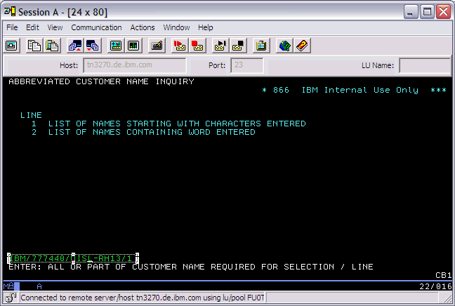

Or cut a bit if name too long...

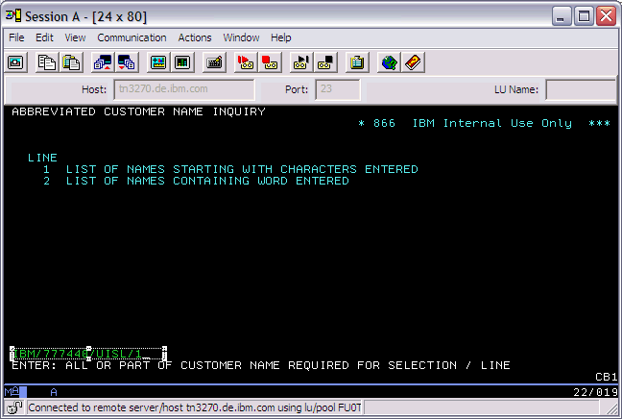

In request as you seen above there is already provided Abbreviated name and Location so no other database is needed in order to create such a number just process manual creation with details provided.

Also details of addresses that are needed to be set in the internal numbers should be provided:

Example: 1. the mailing and billing address

IBM UK Ltd
BIRMINGHAM ROAD
WARWICK
CV34 5JL

2. the installing address
IBM UK Ltd
Lennox Wood
Worthing Road
Southwater
HORSHAM
RH13 9JJ

Another type of request.

1. Check ODB in SOF if not exist...

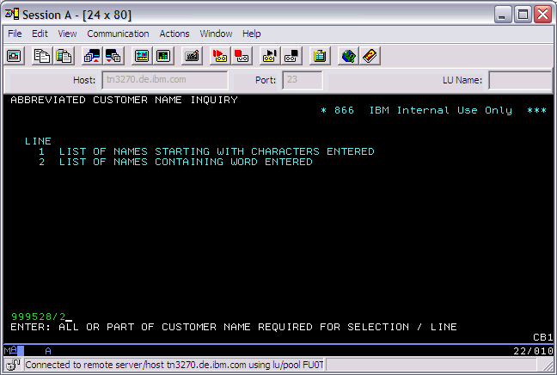

2. ODB number details can be extracts from Database called

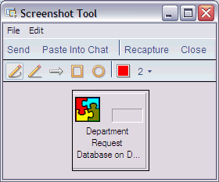

3. Once you enter into this database.... you should click on Dept Code on left hand side

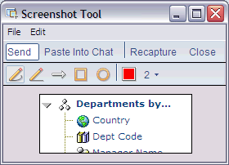

4. Then you should via ctrl F enter requested ODB (dept. number) example 999528 and once found enter in and you should have a such screen in front of you...
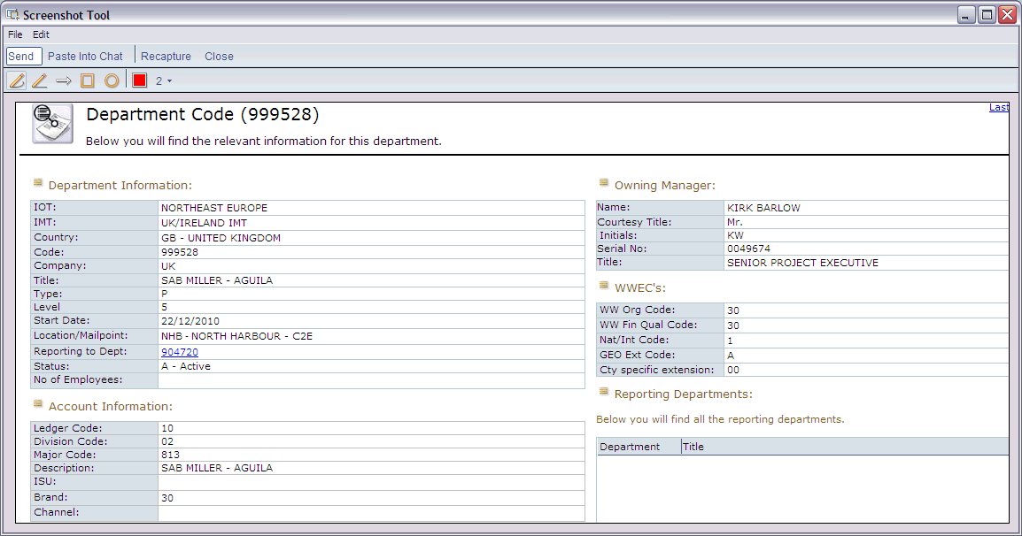

4.8 CSI CustNRS
- CSIxx/end user
- creation of new CMR or change of existing should be always approved by Sarah Lockwood
-VAT number is for customer on address (different as on abb.name)
- checking for duplicates according abb.name
- DUNS for customer name on address
- DPL for customer name on address and for name on abb. Name
- this type of customer is not currently in use for new creation

4.9 BP VRxxx/end user CustNRS

New BP number is requested via eForms application. DPL check is done for both customer names
IBM BP numbers are created according to this:
Abbreviated name: VRxxx/Name of End user
Abbreviated location: End user’s location
(xxx –number of Business Partner)
Mailing, billing, shipping, EPL address for BP:
BP name
VRxxx/End user name
BP address
Installing address for End user

VRxxx/end user name
End user address

Duns belong to end user
Coverage codes belong to end user

Special VR customer for Avnet VR012
- mailing billing belong to avnet located in Belgium, shipping and EPL belong to avnet located in UK, installing belong to end user
- Belgium vat id 0464298616 cannot be accepted by eform tool so it is usually used without zero. Vat must be corrected in SOF afterwards.
- Tax code always 32

Exertis

- similar like VRxxx.
- mailing and billing belong to Exertis and installing to enduser
- short name “exertis/end user

4.10 FSL (IGF) CustNRS

- are internal numbers
- on eform must be tick FSL
- VAT number is 99999
- must have customer class 33 in abbreviate name
- postal code of end use on abbreviate location
- tax code is always xx - tax exempted
- collection code is always 69
- Duns is on end user
- proof of address on end user

Format of addresses:

Requestors from UK:

FSL/end user customer nameZG33 = abbreviate name in SOF

mailing + billing address

IBM UK LTD
(customer name of end-user)
PO BOX 41, NORTH HARBOUR
PORTSMOUTH
HAMPSHIRE
PO6 3AU

installing + shipping + EPL mailing address = end-user address

Requestors from Hungary:

IBM UK LTD/end user customer nameZG33 = abbreviate name in SOF

mailing + billing address

IBM UK LTD/end-user customer name
NORTH HARBOUR
PORTSMOUTH
HANTS
PO6 3AU

installing + shipping + EPL mailing addresses = end-user address

4.11 Melody CustNRS

- requested via eForms application
- checking for duplicates according abb.name
- VAT validation + name & address verification
- special codes MUBU/SALESREP
UK : 070/MEL000
IRE: M90/MEL001
- DPL check
- all CMRs marked with abbreviation MEL in abbreviated location
- do not change default ISIC 8888 & 8889 in Melody eforms.
- for UKI isu code must be validated as BAU. Other IBM codes are irrelevant and doesn’t need validation
- all melody numbers should be updated with Lenovo dummy collection code MELOGB for UK and MELOIE for Ireland
- melody eform sources to EC1 are UK PCD and IE Y90

4.12 Leasing Company

When on Eform “Leasing Company” is ticked, the Leasing Company field will be set to “Y” in SOF and the Customer Classification field to 33 in RDC.

When the Customer Classification field needs to be permanently set to 33 in RDC, the Leasing Company field has to be set to Y. This can only be done by TFU update (CF Connect).

4.13 Lenovo / Infoprint

We cannot update or restore any LENOVO / INFOPRINT customer number
To be identified them with embargo codes:

J - Infoprint
U, V, W, Y – Lenovo

All Lenovo numbers exist only in SOF archive and they were deleted from RDC. CMR does not do any action with these numbers.

5. IRISH Customers
- the validation process is the same as for UK CustNRS
- VAT number IE9999999XX
- default postal code II1 1II
- source code F90
- eform must be properly marked as Irish.
- customer country: domestic

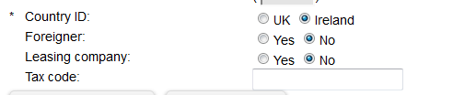

Tax codes for Ireland

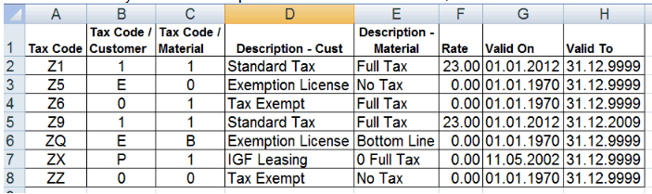

Ireland vat scenarios

STANDARD VAT CUSTOMERS

For ‘standard’ customers, VAT is chargeable on ALL purchases at the VAT rate in force at the time for that product or service.
The CMR is to be setup as TAXABLE - Tax Classification = 1

Cust Material
1 1 Standard Tax Full Tax 21,00 01.03.2002 31.12.9999 Z1
1 S Standard Tax Services 21,00 01.03.2002 31.12.9999 Z1

VAT EXEMPT CUSTOMERS (13B CERTIFICATE)

Customers must give a copy of the 13B VAT Exemption certificate to IBM. This entitles the customer to be provided with goods and service exempt from VAT.
The CMR is set up as TAX EXEMPT - Tax Classification = E

Cust Material
E 1 Exemption LicenFull Tax 0,000 10.03.2000 31.12.9999 Z5
E S Exemption LicenServices 0,000 10.03.2000 31.12.9999 Z5

SHANNON FREE ZONE

Customers that are located within Shannon Airport Free Zone (customer will advise) are privileged to special VAT treatment by the Irish government.
Goods are allowed to be purchased VAT free, whilst Services will be charged VAT at the prevailing standard rate.
Because VAT is dependant upon type of goods/service provided, and the physical location of the customer, the following rules have been setup in SAP

Goods Tax Classification = 1
Services Tax Classification = S (this applies to all service pac part
numbers in sales org 0066 Ireland)

Customer Tax Classification = 0
(CMR)

Cust Material
0 1 Tax Exempt No Tax 0,000 10.03.2000 31.12.9999 Z6
0 S Tax Exempt Services 21,00 01.03.2002 31.12.9999 Z1

6. MANUALLY CREATION OF CustNRS

- validation as usual (duplicates, VAT, name, address, DPL)
- under cr1

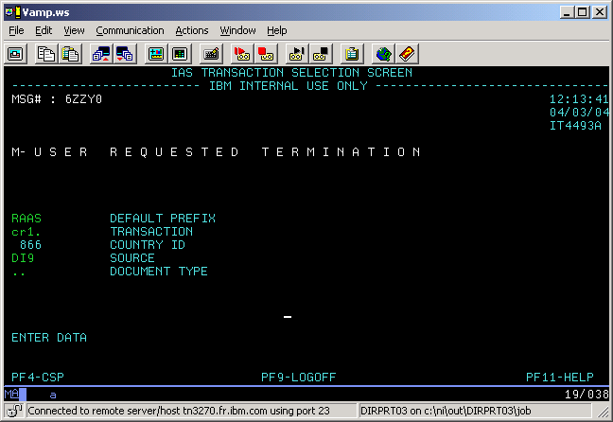

This takes you to the following screen where you type A (New IBM Cust) & press enter.

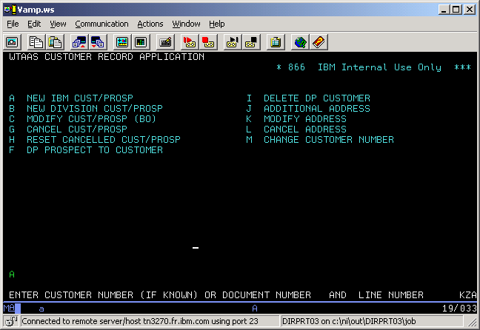
Now type D and press enter
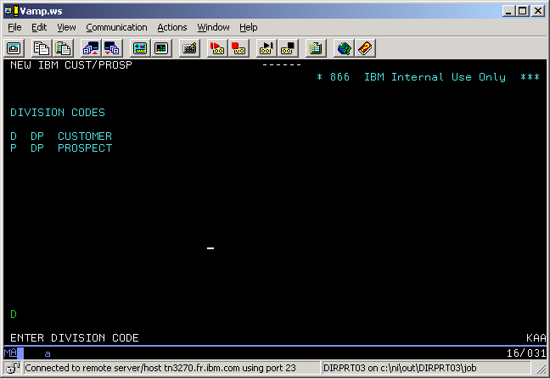

You will see the following screen

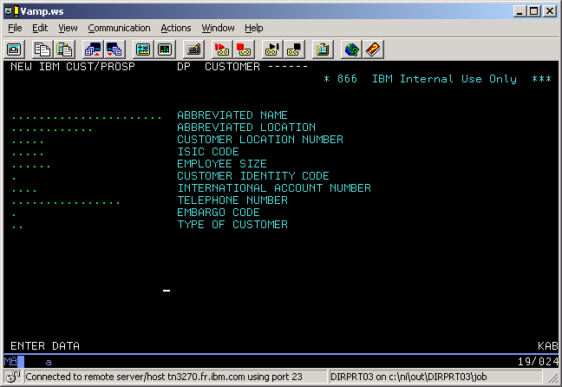
You now enter information in the following MANDATORY fields:

Abbreviated name and location
ISIC 8889 should be used from existing CustNRS, from DUNS or default 8889

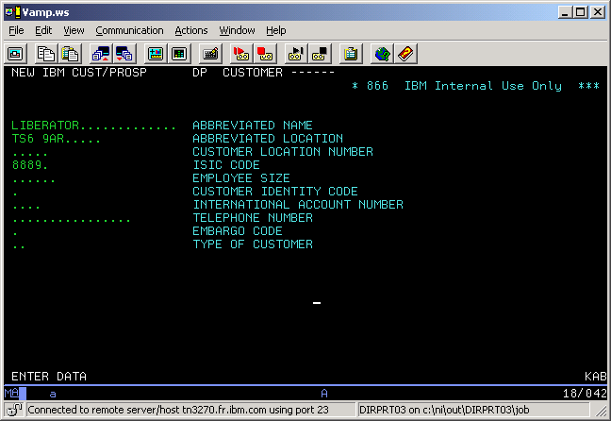

Now press enter
You will see the following screen which contains Sales data

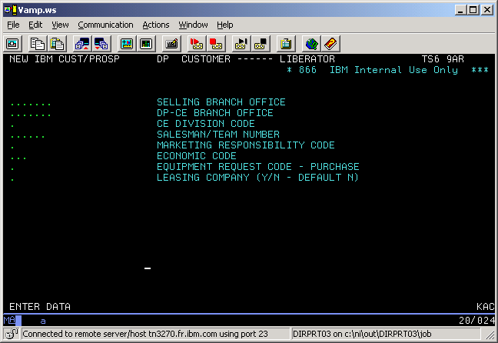

Use the information from your research to populate the following MANDATORY fields
DP-CE Branch (S22 – UK, W90 – IRE)
Selling Branch office and Salesman/Team Number from existing CMR, from E-form or default.
457 - MMLSE1
458 - MMNTH1
758 - MMSN11
958 - MMIRE1 – Northern Ireland
090 - MMIRE2 - Ireland
457 - MMLSE1 - European countries + world
ISIC 8889
ISIC Private Cust 9912
ISU 32B
CE Division code and Marketing Responsibility Code are always 2 for UK customer record, for IRE: CE Division code = 2 and Marketing Responsibility Code = 3
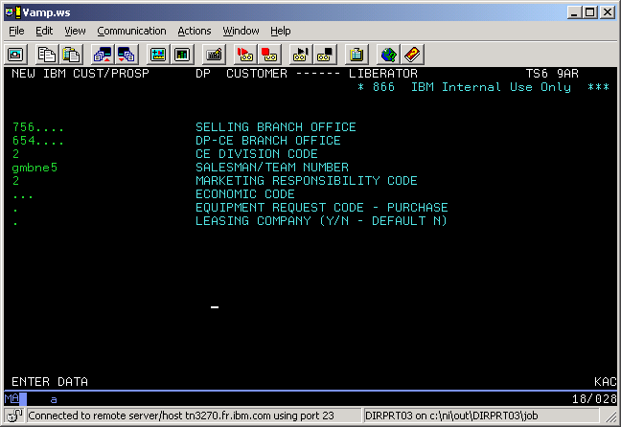

Press enter; you will see the following screen
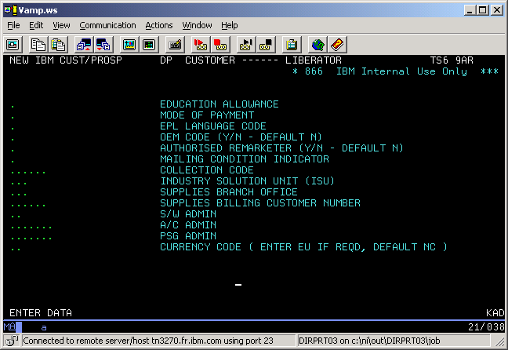
You must enter data in the following MANDATORY fields
EPL Language code is always 1
Collection code for all new GSMB customers is 17 (see exceptions sheet) ISU from existing CustNR or default
S/W admin from existing CustNR or 75 for UK and 00 for IRE
A/C admin from existing CustNR or AE for UK and 5N for IRE
Currency code NC for UK and EU for IRE

Press enter, the following screen will show the data you have entered in a different format
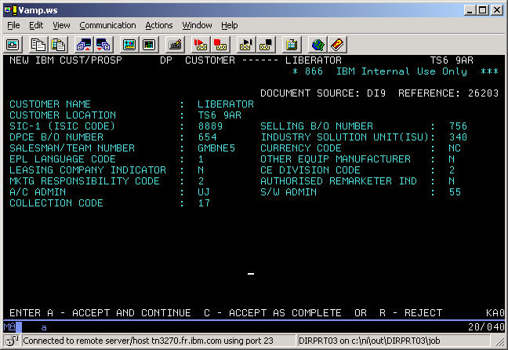

Check it is correct and type A and press enter to accept and continue. This will take you to the following address screen

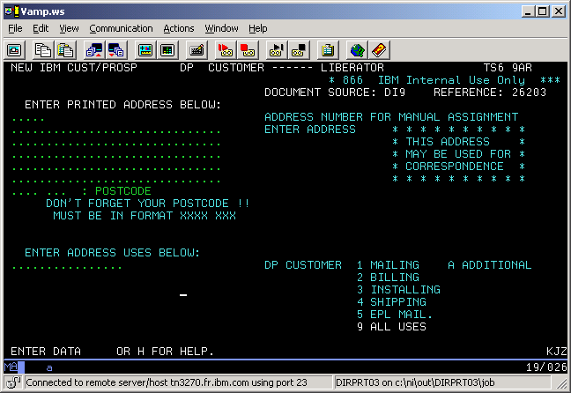

Enter the address given by the requestor. In this case we have one address for all uses. Sometimes there are different addresses for billing and installation, or mailing, shipping and EPL

Enter the postcode carefully in the given field; use the space bar to tab across if necessary:
A9_ _ _ 9AA
A99 _ _ 9AA
A9A _ _ 9AA
AA9 _ _ 9AA
AA99 _ 9AA
AA9A _ 9AA
Irish default postcode is II1 1II.
Crossboarder default postcode is **** ***.

In this example we are setting up Mailing and Billing together, so enter Address uses 1 and 2 only

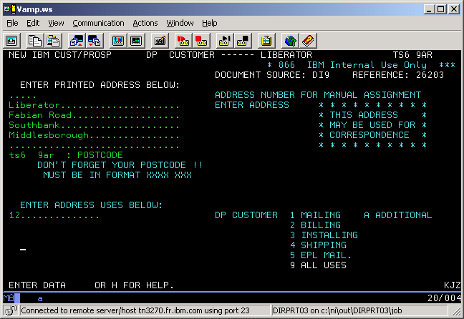

Press enter; you will see the following where X must be entered against Special Ref Cust NR
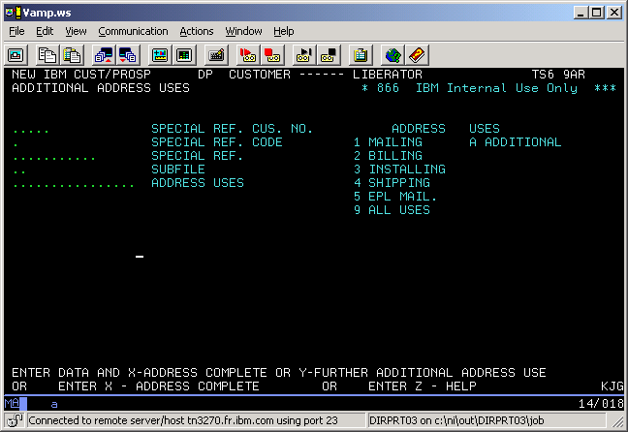
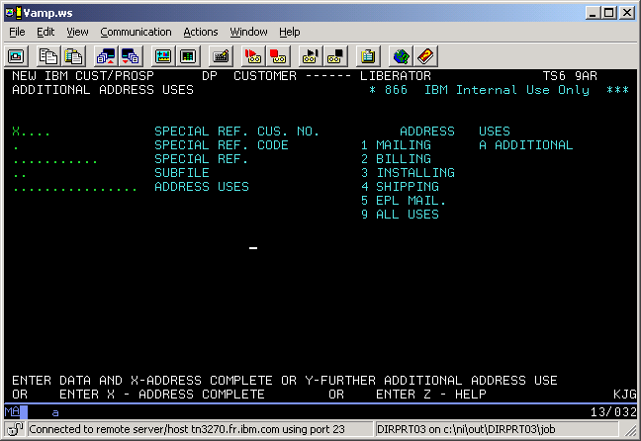

Press enter

The new number has been set up. You must now go to your Si1 search screen using the same search method to find a customer name, as described earlierThis is the new customer number - 219551
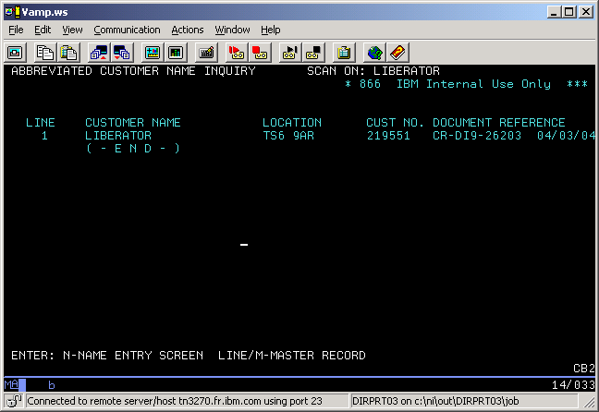

You should now return to your CR1 session to complete the rest of the addresses, using J (additional addresses)

7. Changes to existing Customer Records

COMPANY NAME

Company name can be change based on proof from customer or legal registry (for more viz trusted sources). Proof from customer must be always sent directly from customer. In case of proof from different company, their connection must be verified. Proof from BP is not accepted as well. In case of name change we update abbreviated name and name in all addresses. Exception are shipping address from different company. Before change of name new DPL check must be performed!

ADDRESS CHANGE

All address changes are requesting via Eform tool. Only exceptions are temporary troubles with tool. In this cases we can proceed via emails and store requests in non-eform tool. In email requests is still required to perform necessary validation and DPL if needed.

In address changes validation is mandatory for change of billing address. We can validate address via legal registries (D&B, VIES, Companies House, …) or proof directly from customer. Proof from BP or IBM internal communication is not accepted.

In case of sold to (billing), address can never change the country. If billing should be located in different country always new CN must be created
All addresses outside billing can be changed without proof.
Requests of address updates have to be always clear and requestor must specify which address should be updated (mailing, billing, all...)

Changes are performed in SOF, transaction Cr1 option K or J. Please always check if you using correct source. Ireland f90, foreigner aat, rest personal source.
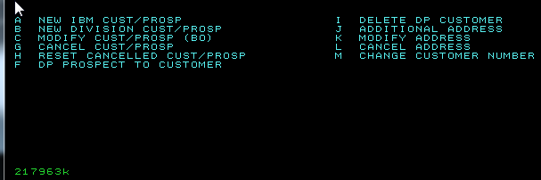
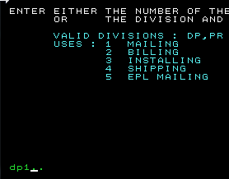
We can choose option DP 1,2,3... or direct sequence
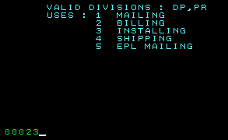

After address update is performed, we continue with conformation c. In case we are updating more address we can choose option n, which allow us continue with update

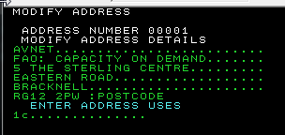
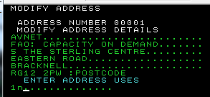

In case that on one sequence are multiple address and we need to update only one we need to unlink them via option CR1 – J. It can be performed only with mailing, installing and EPL. Billing can be never added via CR1 – J because it would create secondary sold to in RDC. So for example if we need update only billing which is on same sequence mailing, installing and EPL. We re-create via CR1 – J EPL, Install and Mailing and once billing is alone we update it. Shipping must be first removed and created via CR1 – J. Otherwise new shipping would be create and old will stay untouched.

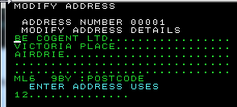

Option J in CR1

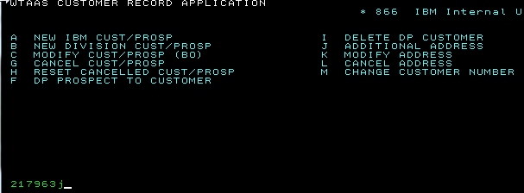
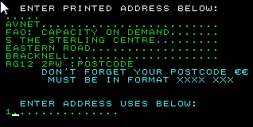
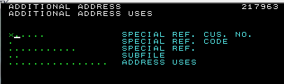
Shipping address (BPSO/CHW shipping)

These requests usually comes from order entry. All eform with LOB BPSO or CHW shipping should be consider as urgent and should be closed within 2 hours.
In addition of shipping address we should provide requestor sequence number.

In case name in added shipping is different from customer name we must perform DPL check!

In case requests which are updating name/address in all fields/addresses and there is multiple shipping, we add new one instead of changing. In case there is only one shipping identical with rest of address, we can update it along with rest.

CODES (ISIC, INAC,, MUBU, Sales Rep, ISU)

IBM code can be changed via email or eform. These request must always come from Client id team or coverage leader (currently Kerry Maskery). In case if these requests come from coverage leader always put client id team on copy or in case of eform let them know via email.

Change code requests which are not submitted by client id team or coverage leader, requests must be rejected and requester navigated to client id submitting tool.
https://cfweb.rochny.ibm.com/CWM_Project/index.jsp

All IBM codes are updated via CR1 option c

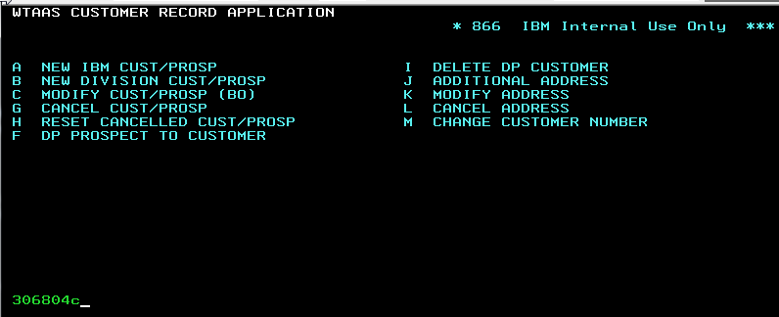

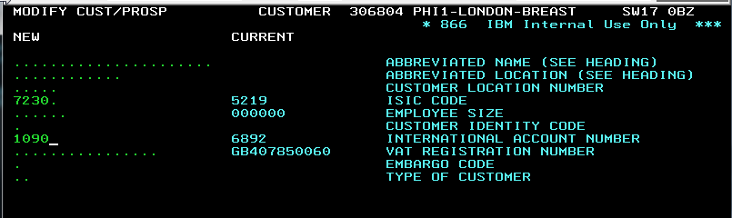

Continue with option D. If there is no option D (for example only option P), number is not active
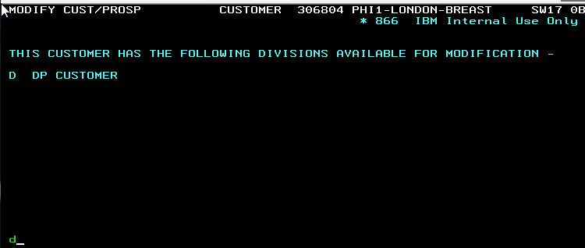

MUBU and Sales reps must be always updated together along with CE division, MRC, DP CE branch office which remains same as on screenshot below

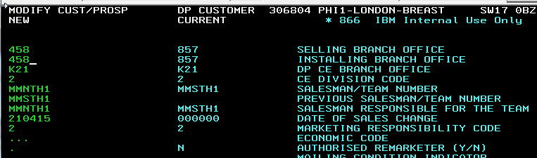
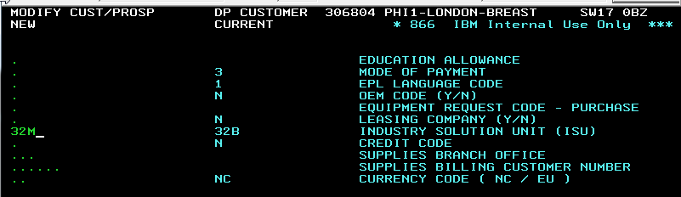

VAT ID

Vat ID can be changed if it reflects all data (name and address) in VIES. In case data in VIES are different we require proof directly from customer. In case we are changing invalid vat id to valid vat id it is enough if it belong to same company.

TAX CODE

We are updating tax code very rarely. Update is performed in BDE1 on line 104. These requests must be first always approved by tax manager. For current tax manager see list of all approvers in the end of document.

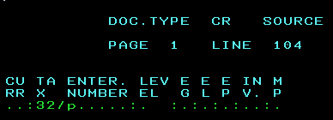

COLLIECTION CODE

Collection code can be received as mass updates via task id or separately via Eform tool. They are updating in transaction CR1 – C. They usually come from pre-legal or account receivable teams. All must be either approved or come from approver. For approver matrix see list of all approvers in the end of document. Collection code can be 6 or 2 digits.

EMBARGO C

Embargo C is used for credit control. All requests received via Eform or email must be forwarded to Jane Manners. She will update embargo code. This update is not performed by CMR.

8. BDE1

Some transactions cannot be done in CR1 so use for update BDE1. These values are: tax code, removal of customer type 5 and rare occasions enterprise number (same validation rules as for coverage data)

All transactions from CR1 can be performed in BDE1 as well.

How to proceed:

- document type is always CR

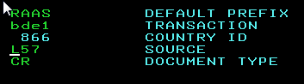

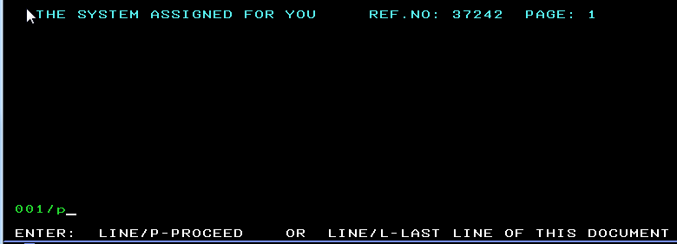
- open new document

customer number:modify:details/proceed

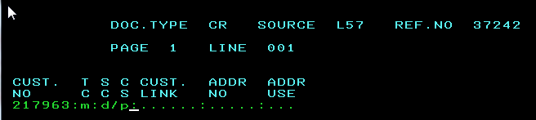

choose line and proceed



add value and proceed
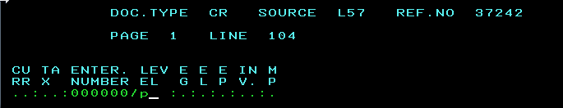

complete document or add new line for additional update



9. Cancellation/Reactivation of customers and Embargo codes

Cancellation

Requests for cancellation are usually coming twice per year in form of mass updates from BT/IT. We cancel customer by putting customer type 5 via transaction CR1 – G. There is also option to use embargo code S. We do not cancel customer outside mentioned runs (only in rare special cases with strong business justification). All cancelled customer number should have central block code 93 and mark for deletion YES in RDC. If these values are missing due to transition error we can add it without special approval.

Reactivation

Requests for reactivation are usually coming separately to task id. There are few types of reactivation.

1 - Customer Type = 5

- ask for business reason, check/offer duplicates

- DPL check, remove CT = 5
- perform the same validation as we do for new creations:

a) VAT & name, address validation
b) mandatory codes check (ISU, INAC, BO, SBO, MUBU, SR,...)

if you are not able to decide, set default values or send it for review to Client ID

2 - CMR in archive

1. ask for business reason, check/offer duplicates
2. send to Mercedes Munoz Echeandia/Spain/IBM@IBMES for approval
- DPL check

- submit CF connect for restoration (CMR helpdesk)

- perform the same validation as we do for new creation and update what needed:

a) VAT & name, address validation
b) mandatory codes check (ISU, INAC, BO, SBO, MUBU, SR,...)

- if you are not able to decide, set default values or send it for review to Client ID
- same approach as for new creation

3 - CMR is with embargo code S

- ask for business reason, check/offer duplicates
- perform the same validation as we do for new creation and update what
needed:
a) VAT & name, address validation
c) DPL check
d) mandatory codes check (ISU, INAC, BO, SBO, MUBU, SR,...)

- if you are not able to decide, set default values or send it for review to Client ID

- remove embargo code

4 - CMR is with embargo code - J, U, V, W
- J - Melody - TBC - discuss with your TC
- U, V, W - CMRs of old divestitures, can't be used anymore for any kind of business, can't be reactivated

Embargo codes

Embargo code E for DPL and embargo C legal issues are not part of reactivation/cancellation. They would have different rules explained in other part of DLP document

Current list of existing embargo codes for UK
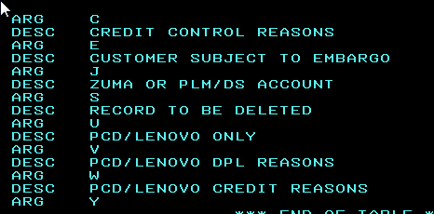
10. T50 UKI

T50 is transaction is SOF for updating legacy tables with current data. We are doing in UK T50 updates on regular basis. Most often updated fields are sales rep, mubu, inac.

How to use T50


Choose table

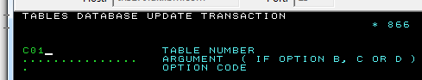

Options of action
A - ADD NEW ARGUMENTS
B - UPDATE FIELDS FOR SPECIFIED ARGUMENT
C - DELETE SPECIFIED ARGUMENT
D - DISPLAY ENTIRE TABLE or SPECIFIED ARGUMENT IF ENTERED

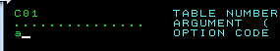
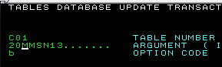

In case you are adding new argument, please make sure you are using correct setup. In case you are not sure, you can find regularly used value via option D and copy setup from it.

Sales rep setup

for each sales rep id must be present always three arguments in T50: 20+repid, 30+repid, 50+rep
function always contain 0+mubu seller name mubu. If we are not adding SR but updating it. We must always check all three (20...,30...,50...) arguments if they are correct. Each seller must be always align with correct mubu.

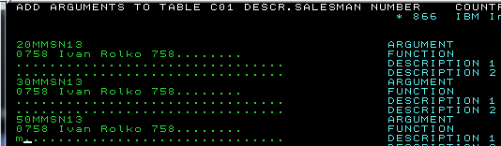

MUBU

Example mubu U14 with description Sytems Gibraltar
Mubu is in T50 in format: DE+U14 00, Di+U14 00 and DS+U14 00. Two zeros are always last characters of argument name (4 blank spaces). Function is always information + 2 (aligned MRC code, choose 2, if requested differently or need for synchronisation, also 3 and 5 possible) on last position of function. All three arguments must be present in table same as sales in sales rep case.

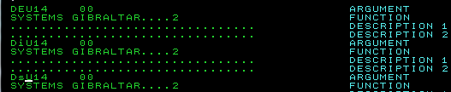

List of T50 tables
C01: Current Salesman/Team Number
C02: Location Code = Zip Code
C03: ISIC Code
C04: International Account Number = INAC
C05: Economic Code = IMS
C06: Competetive Equipment Code
C07: Local Currency Code
C08: Tax Code
C09: Language Code
C10: Mode of Payment
C11: Large Account Number
C12: Branch Office Number = MU
C13: Region Code = ISU
C14: Account Administrator Branch Office
C15: Subfile Code
C16: Account Administrator DSC
C17: Collection Code
C18: Credit Code
C19: Direct Debit Code
C20: Embargo Code
C21: Mailing Condition Indicator
C22: District Code

Some of the below tables doesn't have any data for chosen country. Or few values might be on different position from country to country

11. Non E-form tool

Non eform tool is an archive database, that is used to store history of changes that are done based on task ID inputs.

It is possible (now) only to have access to Bratislava countries, or Madrid countries, not both.
For UK, access to Bratislava countries is required.

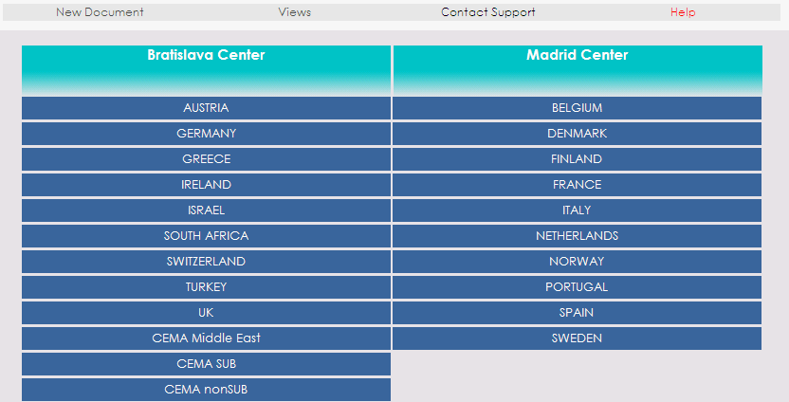

To archive a change, enter the respective country (always one by one, never open two countries at once).
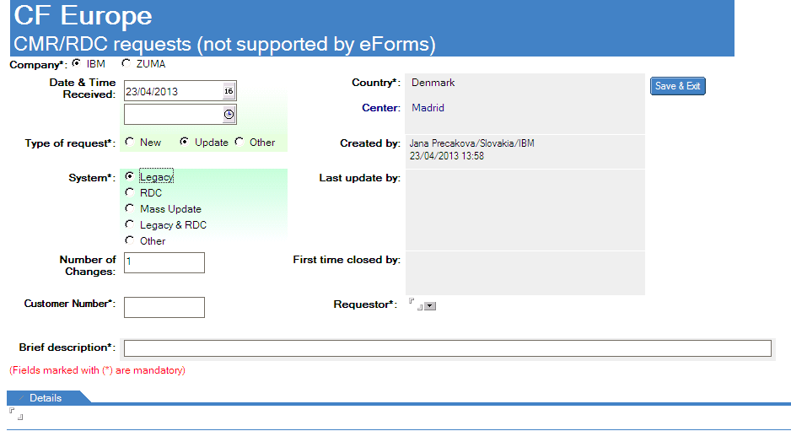

Fill in:
- Date and time
- type of requesters
- system – where the change was done
- number of changes – ex. 2 (if SR and ISU was changed
- Customer number – enter multiple in case there are several numbers changed
- Brief description - ex. Collection code update
- Copy-paste the request from task ID to DETAILS
- enter requester

SAVE and EXIT

In case of mass updates, do NOT use system “mass update”. Choose legacy and enter list of all updated number in field for customer number

Non eform tool can be used also for eform trouble solving: For example storage of additional DPL if it is not possible to attach it to eform. Or storing necessary updates which should be perform within eform but weren't and discovered later.

12. Transition errors

Transition errors are messages we receive to task ID, when a record does not flow correctly form SOF to RDC.

There are several errors that can occur and each of them has a specific text in the message.
Messages with child and parent are not to be taken care of.

In case CMR is not able to understand the error message, CI transition team is contacted:
CI TRANSITIONS SUPPORT EMEA/France/IBM,

Possible Transition errors text:

Multiple matches found for CMR customer.
Postal Code exact length should be 6
Postal Code max value length without gaps exceeded.
MISSING POSTAL CODE INFORMATION.
VAT ID invalid.
And other...
There are two kind of transition errors coming:
CONVERSION ERROR NOTICE – by the record entering to RDC
CMR Load Data IBM Error Log for loadfile. - when the record is leaving SOF

List of approvers and other CMR contacts
Names of approvers:

Client ID Team:
- Monika Pencakova
- Zuzana Lasakova
- Marcel Noga

Coverage leader:
- Kerry Maskery

Credit control:
- Jane Manners

ERC:
- UK – Naciera Ouaissa
- IRE – David Curran

Tax Manager:
- UK- Steve Browning (SBrownin@uk.ibm.com), assitant Adele Peel

- IRE: Ciaran S Kearney

CMR search tool
- Thomas Grey

Collection code approvers
- current approver matrix
- Additionally Pauline Harris

Reactivations

  - Mercedes Munoz Echeandia

List of useful task ids

Eforms helpdesk
STS Web Tools Helpdesk/Slovakia/IBM@IBMSK@IBMDE
SOF helpdesk
CF Legacy CMR System Support/Austria/IBM
CI transition team
CI TRANSITIONS SUPPORT EMEA/France/IBM
RDC support
CCM Worldwide Support/Raleigh/Contr/IBM@IBMUS
Client id team
UKI CMR Client ID Analyst Support/Slovakia/IBM
ERC/ERO task id
UK Export Regulations/UK/IBM but eforms send to 3EXPORT@uk.ibm.com

