Simple Introduction for GMSH

Produce the following input file

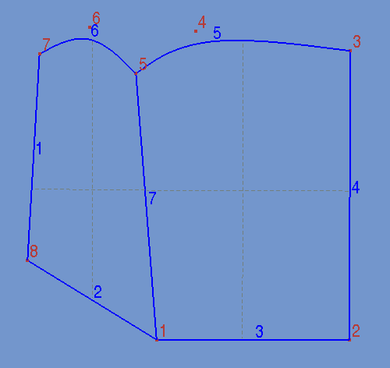Figure 1: model surface
cl1 = 1;
cl2 = 0.2;
Point(1) = {0, 0, 0, cl1};
Point(2) = {10, 0, 0, cl1};
Point(3) = {10, 15, 0, cl1};
Point(4) = {2, 16, 0, cl2};
Point(5) = {-1.1, 13.8, 0, cl2};
Point(6) = {-3.5, 16.2, 0, cl2};
Point(7) = {-6.1, 14.8, 0, 1.0};
Point(8) = {-6.7, 4.1, 0, 1.0};
Line(1) = {7, 8};
Line(2) = {8, 1};
Line(3) = {1, 2};
Line(4) = {2, 3};
BSpline(5) = {3, 4, 5};
BSpline(6) = {5, 6, 7};
Line(7) = {5, 1};
Line Loop(8) = {4, 5, 7, 3};
Plane Surface(9) = {8};
Line Loop(10) = {6, 1, 2, -7};
Plane Surface(11) = {10};
Physical Surface(1) = {9};
Physical Surface(2) = {11};
This input file creates the surface that is shown in Figure 1.
- 8 points: Among these, points 4, 5, and 6 have a different element size factor.
- 4 linear lines:
- 2 spline lines:
- 1 linear line:
- 2 line loops and an associated plane surface for each loop.
- 2 Physical surfaces for the created plane surface.

At this time we need to adjust the mesh options. Select gmsh -> Tools -> Options. A window should open. On the left hand side, select “Mesh” and click on the “General” tab.

For an introductory level, two parameters are important to us: First, the “Element size factor” affects the size of the elements to be generated. Second, the “Element order” decides on the order of the element – it can be a linear element, a quadratic one, or higher. See Figure 2 for the selected values. The Element size factor is selected as 2, and the element order is selected as 1 (meaning linear elements).
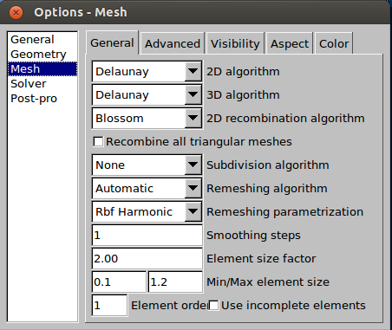Figure 2: Options window

Now, we will investigate what happens ones we mesh this plane surface, which is composed of two different surfaces. From the main Gmsh window select the Mesh option by selecting the pull down menu, or by pressing the “m” key. Then click on the 2D item. This will create a two dimensional mesh of second order triangular elements on the created surfaces. See Figure 3 for the output.

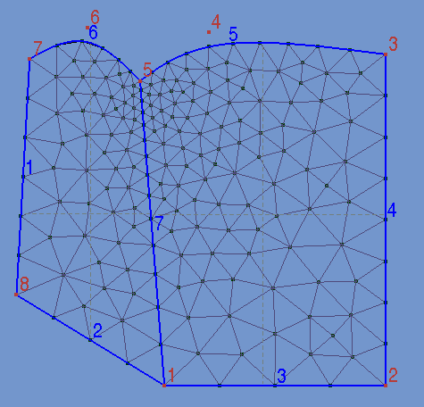Figure 3: CST mesh

Notice that the mesh is refined at nodes 4, 5, and 6. In other words, the element size is smaller at these nodes. This is the result of using a smaller element size factor for these points.

The Options → Mesh menu in the “General” tab has a feature that is called “Recombine all triangular meshes”. Click that box as shown in Figure 4, and remesh the surface by clicking on the “2D” buton in the Gmsh → Mesh window. The result consists of noded elements that are created by combining two triangles.

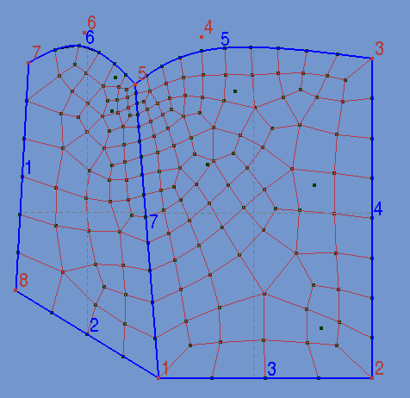Figure 5: combined triangles
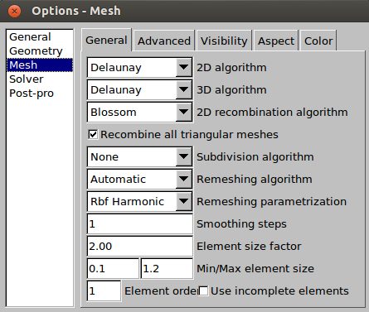Figure 4: Recombine triangles

The recombination of two triangles, obviously does not result in a perfect mesh. This method is still under development by the authors of Gmsh. It can be used for implementing 4, 8, 12 noded elements in a mesh.

At this stage, the mesh is created. Now it needs to be saved, so that it can be used by the FemLab solver. Go to the Gmsh window and select File → Save Mesh, or simply press Shift + Ctrl + S. This will save the mesh information next to the input file but with extension msh. The function load_gmsh is used to load this file. See additional notes, distributed in the class.

Node and Element Numbers
Note that the node and element numbers may be different in the created mesh file than those on the gmsh screen. In order to view the structure with the created mesh node numbers, simply load the mesh file into Gmsh (FILE → OPEN → filename.msh).

