1. GET SEND NO PARAMETER PASS IN : /post/getpost

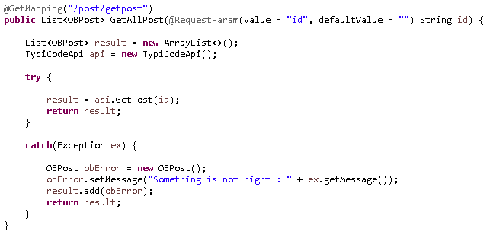

1. GET SEND WTH PARAMETER PASS IN : /post/getpost?id=1



1. POST: /post/sendpost

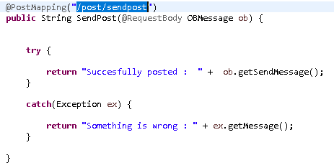

1. On Exception will always prompt to the caller something is wrong

