Basic Reinforcement Learning
Grid World (Agent Finding a Goal)
Imagine:
- A small grid (like a board)
- An agent starts at one position
- A goal is placed somewhere else
- The agent can move: Left, Right, Up, Down
- The agent gets:
  - +10 reward for reaching goal
  - -1 penalty for each step
The agent must learn the best path to reach the goal.
Visual Idea of Grid World
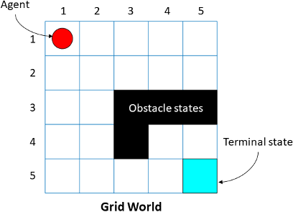

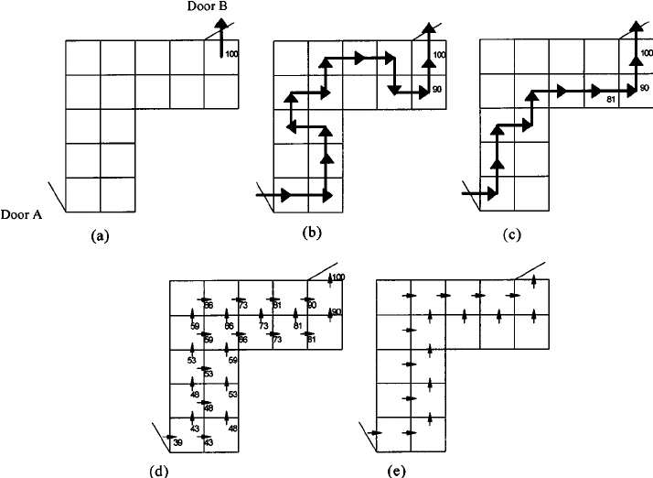
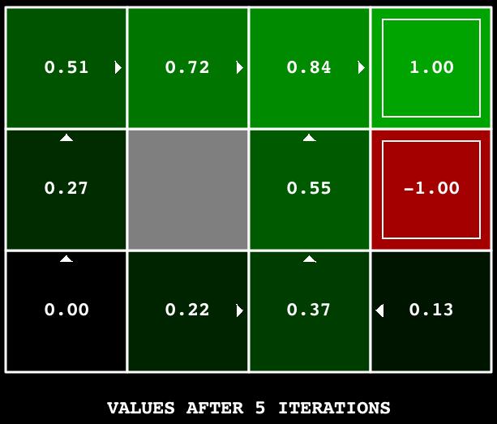

Why This is Reinforcement Learning?
✔ No labeled dataset
✔ Agent learns by trial and error
✔ Uses reward & punishment
✔ Goal: maximize total reward

Simple RL Flow
- Agent observes state
- Agent chooses action
- Environment gives reward
- Agent updates knowledge
- Repeat

OBJECTIVE:
Lets demonstrate a simple Reinforcement Learning example using Q-Learning in Python.
--------------------------------------------------
PROBLEM STATEMENT:
We have a simple 1D environment with 5 positions (0 to 4).
Agent starts at position 0.
Goal is at position 4.
Actions:
0 -> Move Left
1 -> Move Right
Rewards:
+10 for reaching goal
-1 for each step
Goal:
Learn best path to reach the goal.
STEP 1: Import Libraries
import numpy as np
import random
--------------------------------------------------
STEP 2: Create Environment
states = 5
actions = 2
Q = np.zeros((states, actions))

STEP 3: Set Parameters
episodes = 1000
learning_rate = 0.1
discount_factor = 0.9
epsilon = 0.2
--------------------------------------------------
STEP 4: Training Loop
for episode in range(episodes):
state = 0
while state != 4:
if random.uniform(0,1) < epsilon:
action = random.randint(0,1)
else:
action = np.argmax(Q[state])
if action == 1:
next_state = min(state + 1, 4)
else:
next_state = max(state - 1, 0)
if next_state == 4:
reward = 10
else:
reward = -1
Q[state, action] = Q[state, action] + learning_rate * (
reward + discount_factor * np.max(Q[next_state]) - Q[state, action]
)
state = next_state

--------------------------------------------------
STEP 5: Display Q-Table
print(Q)
--------------------------------------------------
STEP 6: Test Agent
state = 0
path = [state]
while state != 4:
action = np.argmax(Q[state])
if action == 1:
state += 1
else:
state -= 1
path.append(state)
print("Path to goal:", path)
--------------------------------------------------
EXPECTED OUTPUT:
Path to goal: [0, 1, 2, 3, 4]
--------------------------------------------------
INTERPRETATION:
Agent learns to always move RIGHT to reach goal quickly.

