Anna Phillips
Lab 6 Report: Diabetes Interventions
A clinical trial on pre-diabetic treatments (n = 699) was run to investigate differences between three interventions: metformin (Met), rosiglitazone (Rosi), and lifestyle adjustments (Lifestyle). To compare treatments, we must compare average treatment effects between the three interventions through bootstrapping to determine if there are any statistically significant differences.
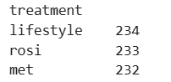
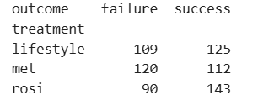

Figure 1. Overview of failure and success rates from each trial
When looking at each trial individually, both Lifestyle and Rosi interventions had an over 50% success rate in pre-diabetic treatment, with Rosi being highest at 61.4% success. Conversely, the Met intervention only resulted in a 48.3% success rate. When comparing means, Rosi appears to be the best intervention, as it outperforms both Met (Average Treatment Effect = 0.131) and Lifestyle interventions (Average Treatment Effect = 0.08). However, before drawing immediate conclusions, we need to bootstrap these outcomes to see how they perform in replication.

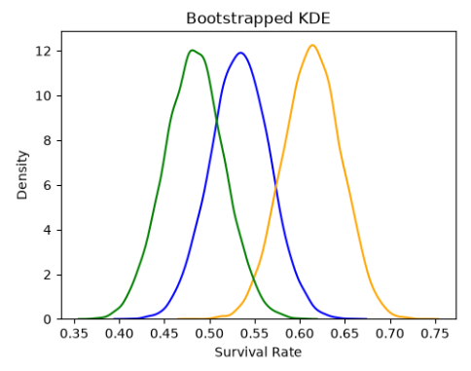

Figure 2. Bootstrapped estimates for each intervention.
When we bootstrap across samples and plot the KDE for mean outcome, we can see that there’s variation in success across all three treatments – in fact, all three overlap at some point. However, we can still see clear differences in where the frequencies of results lie for each intervention, with Rosi having higher frequencies around 60-65%, Lifestyle having higher frequencies around 50-55%, and Met having higher frequencies around 45-50%.
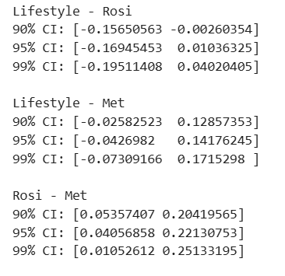
Figure 3. Confidence Intervals for pairwise comparisons.
After bootstrapping 10,000 times, confidence intervals for 90%, 95%, and 99% were also calculated (with significance level α at 0.10, 0.05, and 0.01 respectively) in order to better compare treatment effect results. For these confidence intervals, we can only reject the null hypothesis if the interval does not contain 0, because an interval with 0 means that, if we resample many times, no average treatment effect difference is possible in 90, 95, or 99% of samples. So within these confidence intervals specifically, Rosi outperforms Lifestyle at 90% CI but we fail to reject the null for 95% and 99%. For Rosi vs Met, Rosi outperforms Met at every confidence interval, so we successfully reject the null hypothesis that there is no difference between those groups (at all three significance levels). Finally, for Lifestyle – Met, all three CIs include 0, which means that we fail to reject the null hypothesis, because 0 is a possible treatment difference at all three levels.

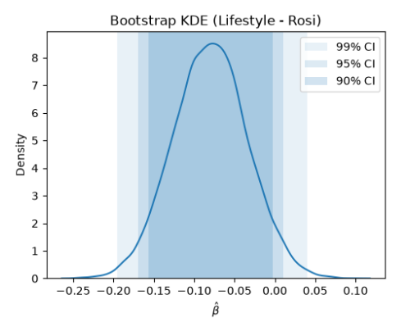
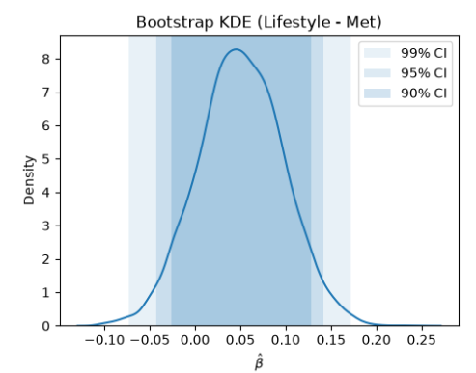
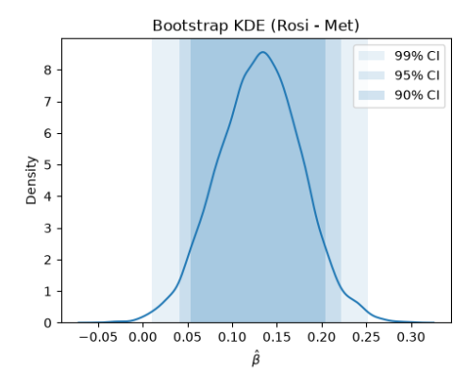
Figure 4. KDE plots of confidence intervals for pairwise comparisons.
The KDE plots above provide a visual comparison of confidence intervals for the three pairwise comparisons. As aforementioned, Rosi outperforms Met at all three Cis but Rosi only outperforms Lifestyle at 90%.

