**CP3402 Weekly Practical Student Learning Journal Record**

**Student’s name** : Cao Ziyu  
**ID** : 15014211

|  |  |
| --- | --- |
| 12/ Oct / 2025 | Week 4 - Website Optimization and Plugin Enhancement in WordPressLearning Activities & Resources This week, I focused on improving my WordPress-based website by optimizing layout design, enhancing content editing capabilities, and integrating video playback through plugins. I explored how the WordPress Block Editor interacts with custom themes and template files.  At first, I found that my homepage appeared blank when using a custom theme. After investigating, I discovered the issue was caused by the missing the_content() function in the front-page.php file, which prevented content from displaying. To address this, I tried two solutions:  Adding the the_content() loop directly in the template file.  Creating a new custom template (page-homeeditable.php) and linking it to the homepage in the dashboard.  The second approach worked best, allowing me to edit and preview the homepage content directly through the Block Editor.  In addition, I installed and configured the Faster YouTube Embed plugin to embed videos smoothly. This plugin offered a responsive layout and high compatibility with both Gutenberg and Elementor. I also used basic CSS styling to improve page symmetry, font consistency, and alignment. Estimated Hours 4 hours Content Insights By embedding videos and refining the layout, I gained a clearer understanding of how WordPress handles media, shortcodes, and plugin rendering. I also learned that custom CSS can enhance user experience even within the limitations of the default Block Editor.  Moreover, I realized that although the default WordPress visual design tools are limited, combining HTML, CSS, and plugin integration can significantly improve the website’s functionality and aesthetic consistency.  Career/Employability/Learning Insights This week’s experience improved my problem-solving skills in debugging template and plugin conflicts, which are essential for real-world web development. I also strengthened my understanding of how WordPress themes interact with backend PHP logic — a crucial skill for anyone pursuing a career in **web design, digital media, or content management systems (CMS)**.  Additionally, learning to apply third-party plugins effectively enhanced my ability to develop flexible and scalable web solutions, which is highly valuable for modern IT professionals. Next Steps In the coming week, I plan to **study WordPress operations in more depth** and **rebuild the Los Pollos Hermanos fried chicken website** within the platform. My goals are to:   1. Improve the site’s visual appeal and interactivity. 2. Enhance the storytelling and modern design sense. 3. Integrate more dynamic features using plugins. 4. Add a few “Easter Eggs” to make the browsing experience more engaging and immersive.  Summary This week, I learned to combine technical knowledge and design thinking to enhance my WordPress project. By addressing issues in templates, embedding media, and refining presentation through plugins and CSS, I’ve gained valuable experience in balancing usability with visual design. Next week, I’ll continue to refine my project to create a more professional, dynamic, and story-driven website inspired by Los Pollos Hermanos. |

**Appendix：**

**A:Blank homepage**

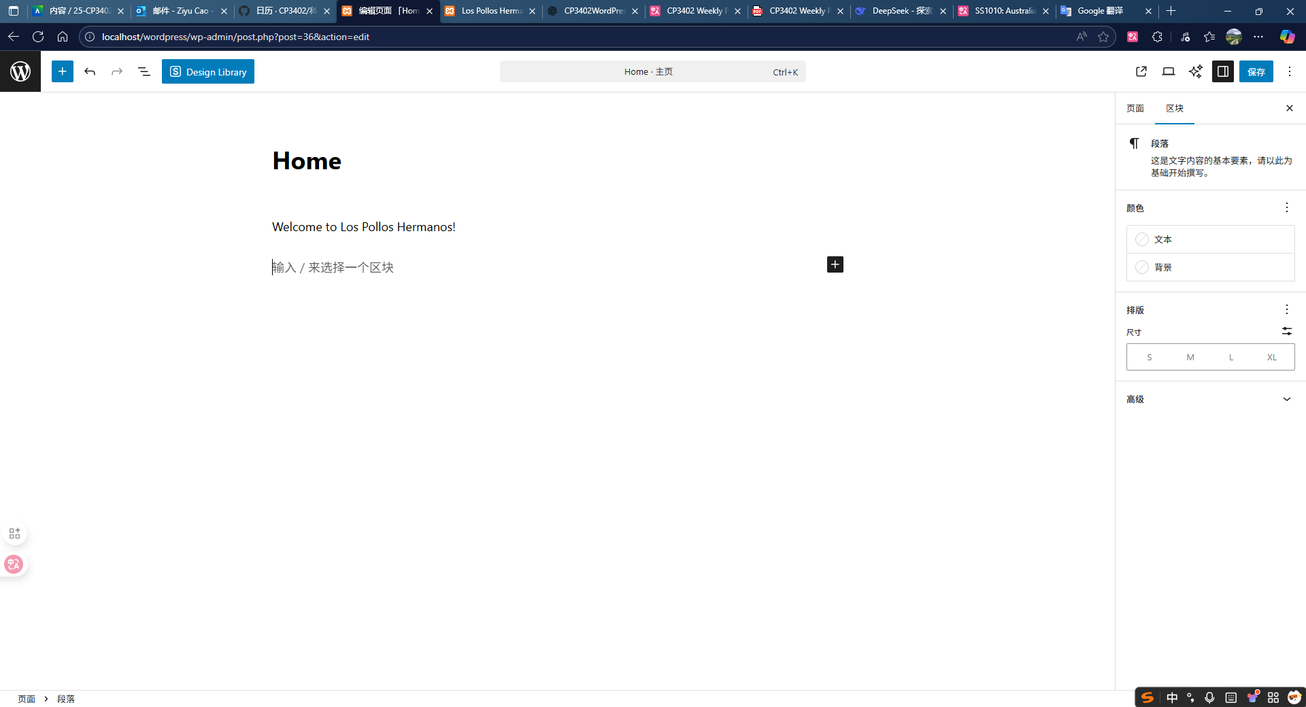

**B:Training Video page**

