CP3402 Weekly Practical Student Learning Journal Record
Student’s name : Cao Ziyu
ID : 15014211
16/ Nov / 2025 | Week 8 - Learning Experiment & Presentation Rehearsal  Learning Activities & Resources  This week, I completed the following activities:  • Reviewed the requirements for the Learning Experiment and Presentation Rehearsal.  • Conducted a small learning experiment to test whether the Pomodoro technique improves study efficiency.  • Recorded an early draft of my presentation rehearsal video.  • Reviewed my group’s development and deployment workflow to determine what to include in the final presentation.  Estimated Hours  4hours  Content Insights  This week, I focused on running a simple learning experiment and preparing for my presentation rehearsal.  Learning Experiment:  Hypothesis:  Using the Pomodoro technique (25 minutes focused study + 5 minutes break) helps me stay more focused and improves learning efficiency compared to normal study without structured breaks.  Test Method:  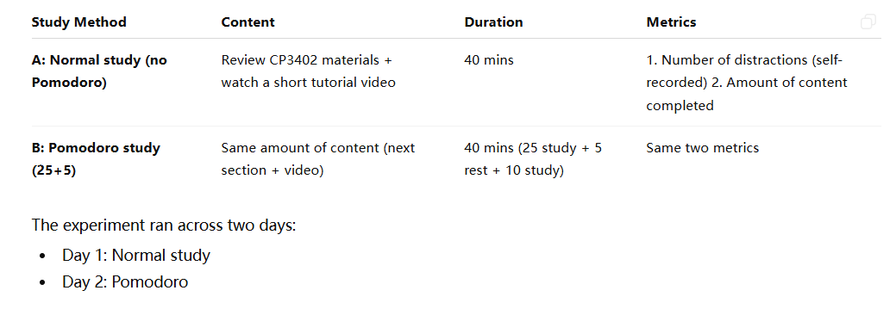  I conducted a simple two-day experiment on myself:  • Day 1 – Normal Study (40 minutes): Reviewed CP3402 content freely without breaks.  - Metrics: number of distractions and amount of content completed.  • Day 2 – Pomodoro Study (25+5+10 minutes): Same amount of content but using the Pomodoro structure.  - Metrics: same as Day 1.  Results:  • Normal Study: 6 distractions, ~1 section completed, felt tired in the second half.  • Pomodoro Study: 2 distractions, ~1.5 sections completed, more consistent pace and better energy.  Conclusion:  The experiment supports the hypothesis. The structured Pomodoro rhythm helped improve focus, reduced distractions, and increased the amount of content completed within the same time.  Presentation Rehearsal:  This week I recorded my first draft presentation. The rehearsal helped me identify areas for improvement:  • My introduction flow needs more structure.  • Workflow explanations were not detailed enough.  • Slide text appeared too small in the recording.  • Microphone had mild background noise.  • I forgot to demonstrate a complete Git commit-to-deployment workflow.  Next Steps:  • Improve slide readability and reorganize the script.  • Add a full workflow demonstration.  • Adjust microphone setup for cleaner audio.  • Slow down speaking pace for clarity.  Links to Teamwork Tools  • LearnJCU Weekly Materials: Learning Experiment & Presentation Guidelines  • Personal Rehearsal Video (YouTube Unlisted)  • Learning Journal Entry: (this document)  Next Steps  • Continue using the Pomodoro technique in future study sessions.  • Re-record the presentation with improved structure and clearer explanations.  • Strengthen the demonstration of deployment workflow during the final presentation.  • Improve audio and slide readability for the next rehearsal.  Summary  • Continue using the Pomodoro technique in future study sessions.  • Re-record the presentation with improved structure and clearer explanations.  • Strengthen the demonstration of deployment workflow during the final presentation.  • Improve audio and slide readability for the next rehearsal.

