CP3402 Weekly Practical Student Learning Journal Record
Student’s name : Cao Ziyu
ID : 15014211
23/ Nov / 2025 | Week 9 - Sass, Automated Workflow, and Website Styling  Learning Activities & Resources  This week, I focused on learning the fundamentals of Sass, understanding how to create an automated SCSS-to-CSS workflow, and applying these skills to build a simple custom website as required in the Week 9 practical task.  The main learning activities included:  - Installing Node.js and configuring Sass on Windows.  - Learning how to use the VS Code terminal to run Sass commands.  - Setting up a Sass watch workflow using  sass --watch scss:css  - Writing SCSS files using variables, nesting, mixins, and extend/inheritance.  - Structuring an SCSS folder with partials (_base.scss, _components.scss, etc.)  - Compiling SCSS into usable CSS for my website.  - Testing the site locally using a browser.  Estimated Hours  5hours  Content Insights  This week, I spent most of my time understanding how Sass works and how to implement a functional workflow for front-end development.  Understanding Sass  Before this week, I had zero experience with Sass. Through practice and debugging, I learned:  Variables: how to store reusable values such as colors and font sizes.  Nesting: to write cleaner and more readable CSS structures.  Mixins: to define reusable style patterns.  Extend/Inheritance: to share common styles between selectors.  Partials & imports: how to split styles into multiple SCSS files for better organization.  Using Sass helped me understand how modern front-end workflows improve efficiency and maintainability.  Workflow Challenges  I encountered several problems while setting up the environment:  PowerShell execution policy blocked npm commands.  I resolved this by switching execution policy temporarily.  Sass not recognized as a command.  This required installing Sass globally with npm install -g sass.  Deprecation warnings.  Sass warned me that @import and functions like lighten() will be removed in future versions.  Although my site still works, it reminded me that modern Sass uses @use and @forward, which I may learn later.  Folder structure confusion.  I initially struggled to understand why separate partials were needed, but later realized it improves scalability.  Website Development Notes  I successfully created a simple website styled with Sass.  However, due to time limitations, I was unable to translate all website text content into English.  The main structure and styles are complete, but I may polish the content later.  Links to Teamwork Tools  - Week 9 Practical Overview (LearnJCU)  - Sass Documentation  - VS Code Terminal Tools  Next Steps  - Learn the modern @use and @forward syntax to replace deprecated @import.  - Improve mixin usage and explore more advanced Sass features.  - Refactor the website text into English once time allows.  - Continue experimenting with automated workflows such as Gulp for future projects.  - Strengthen my understanding of component-based CSS structure.  Summary  This week, I gained practical experience with Sass and front-end workflow automation.  Although I faced several technical obstacles, I successfully set up Sass, created a structured SCSS environment, and completed a functioning website. This task helped improve both my technical confidence and my understanding of real development workflows.  Appendix：website screenshots  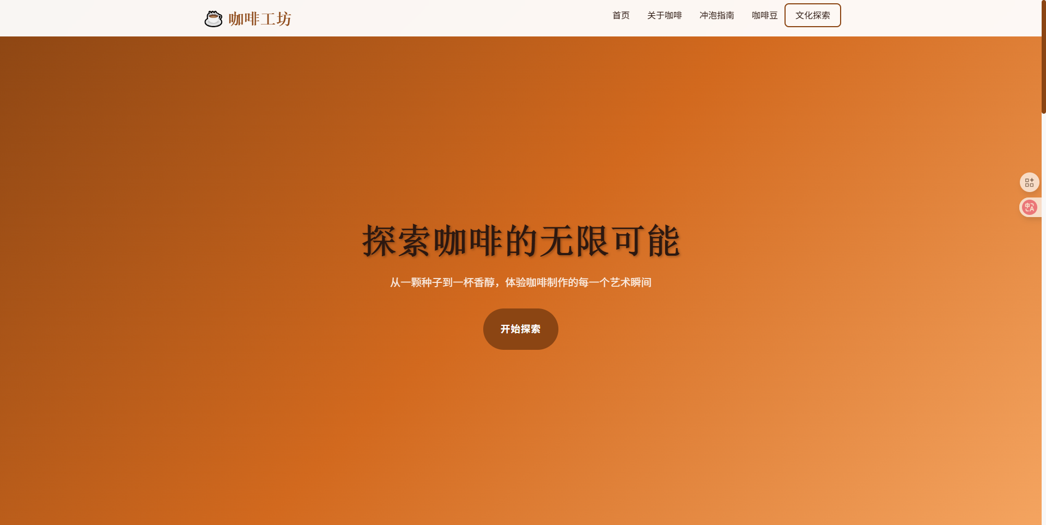
 | 
 | 