Shivam Desai

Asa Eckert-Erdheim

ENGR3199: Elecanisms

October 7, 2013

Mini-project 3: Ultrasonic Ranging System

All source code for this mini-project can be found on [Asa and Shivam’s Github repository called MiniProject3_Ultrasonic](https://github.com/ae2/MiniProject3_Ultrasonic).

Introduction

An ultrasonic ranging system measures distance to target objects by emitting brief pulses of ultrasound and measuring the time it takes for any echoes to be received. The speed of sound in the propagation medium and time for the sound to make the round trip to a target is used to compute the distance to a target.

In this lab, we constructed an ultrasonic ranging system using our 2 DOF mechanical pan-tilt system from Mini-project 2. We constructed an ultrasonic transducer PCB, designed an ultrasonic transmitter and receiver circuit, calibrated our system, and extended our PIC/Python software to map the distance to targets in the full field of view of our gimbal system. Our system has a maximum range of **MAXIMUM** with a resolution of **RESOLUTION**.

**INSERT PIC OF FINAL SYSTEM**

Figure 01: Fully assembled ultrasonic system with Elecanisms board

Electrical System

We soldered two Prowave 400SR160 ultrasonic transducers to a PCB and mounted them on the head of our gimbal system from Mini-project 2.

The 400SR160 ultrasonic transducers are tuned to send and receive ultrasound at 40 kHz, so our transmitter circuit drives the emitter at this frequency by sending a 40 kHz PWM signal with a duty cycle of **DUTYCYCLE** and a period of **PERIOD**.

Considering that the received signal is very small and noisy, we wanted to implement a third-order band-pass filter centered at 40 kHz with a high gain (excess of a few thousand). We chose the band-pass filter shown below in Figure 02.

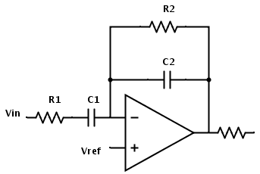

Figure 02: Band-pass filter used

With set at ground, we can use ohm’s law and Kirchoff’s current law to arrive at the equation below.

We can simplify to obtain the transfer function

And simplify further to obtain

Where the gain is given by , the high-pass component is given by , and the low-pass component is given by .

We selected , , , and so that our pass band would be between 26 kHz and 52 kHz as seen below.

At each stage our gain was . Considering that we wanted to amplify our signal substantially with a third-order roll-off, we stacked three of these filters in series for a total gain of -123762 as seen in Figure 03.

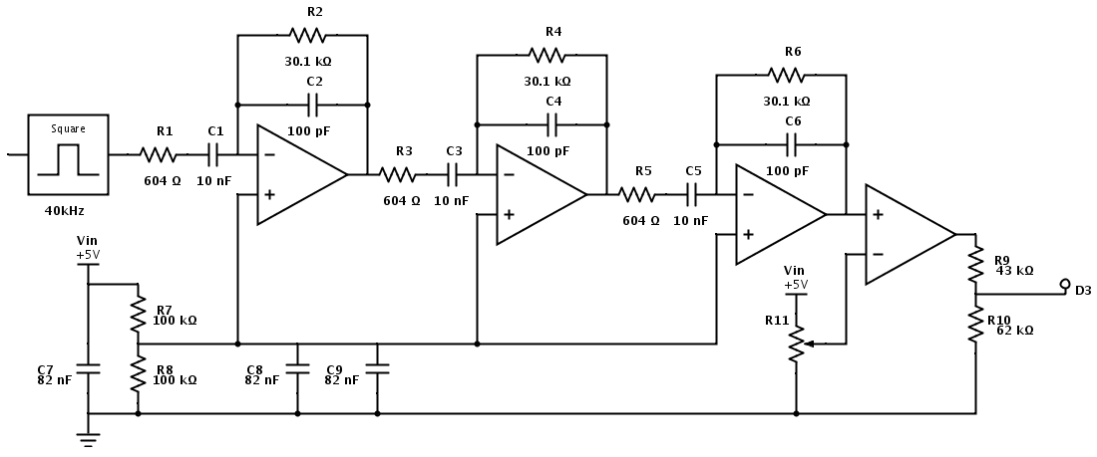

Figure 03: Schematic for Ultrasonic Receiver

After the filter chain, we threshold the final signal and use a comparator to provide a nice digital signal for the PIC. In order for the digital signal to wire directly into the PIC, we scale down the input voltage with a voltage divider. We also used multiple bypass capacitors to remove noise from the system.

We implemented our design on the protoshield from Mini-project 2 with a combination of through-hole components and surface-mount (SMT) components as seen in Figure 04.

**INSERT PIC OF PROTOBOARD**

Figure 04: Implementation of ultrasonic circuitry on Elecanisms protoboard

Software