| **Team Number** | 08 | **Section** | 61 |
| --- | --- | --- | --- |
| **Team Members** | 1. Josh Medina 2. Aden Mengistie 3. Anh Nguyen 4. Steve Rubin | | |
| **Software Name** | Reflection | | |

# Introduction

## Objective

This document is intended to describe the functionality of the Reflection software, which allows users to keep a recorder of their journal entry electronically. It will present some of the features that are available such as: login, creating a journal entry, and searching for a journal entry. It also shows the respective mock-ups for those features. This will give the designer and the client a better understanding of the final deliverable of the software.

## References

Scene Builder - Gluon

[www.pexels.com/@jessbaileydesign/](http://www.pexels.com/@jessbaileydesign/) - Images

## Acronyms, and Abbreviations

N/A

# Software Overview

## Problem Statement

The current option for personal journals like notebooks or web-based applications are filled with ads, and could present several limitations and security risks to the user. Paper journals can be damaged by the elements and web based applications can be susceptible to lack of privacy and cyberattacks. The Reflection software system will aim to overcome these challenges by providing an ad-free environment for users to write and review their personal journals.

## Scope

The target audience for this type of application will be individuals with basic knowledge of computers, and who wish to maintain a personal journal in a secure and digital environment. This software is intended for any user who wants privacy and wants to preserve their reflections for the future.

## Functional Requirements

**Authentication**

1. The First time logging in the user will be prompted to enter the default password.
2. First time user will be prompted to change password
   1. Provide default
   2. Enter new password
   3. Confirm password
   4. Enter security question
   5. Enter answer to security question
3. The user can enter password to login to application
4. The user shall be able to reset their password
   1. Answer the security question initially set up.
   2. Enter the new password
   3. Confirm the new password
5. Password shall be stored in a file as plain text
6. The user shall be able to logout and be directed to the home page.

**Application’s Features**

1. User shall be able to create new journal entries
2. The user will be able to enter the following information to their entry:
   1. An **optional** title
   2. Current date-time (date-picker that picks the current date-time by default, but it shall be editable)
   3. The context (main text area for writing the journal)
3. The user shall be able to save the journal entry
4. The user shall be able to cancel any entry to return to the homepage
5. The user shall be able to search for a journal entry based on a substring in the context or in the title.
6. The user shall be able to edit an old journal entry **after searching for it.**
7. The user shall be able to delete an old journal entry **after searching for it.**

# Use Cases

**3.1 Login to System**

| **Use Case Name** | | UC-01: Login to System for the first time | |
| --- | --- | --- | --- |
| Goal | | | |
| A description of how the user can login into the system for the first time | | | |
| Participating Actors | | | |
| User, System | | | |
| Glossary | | | |
| N/A | | | |
| Primary Flow of Events | | | |
| Trigger | | | |
| User launches this desktop application | | | |
| **Steps** | **Action** | | **System Response** |
| 1 | Enters default password | |  |
| 2 | Clicks “Login” button | | Flags user as first time user (based on default password) |
| 3 |  | | Verifies no password stored in the database (ensure first time user) |
| 4 |  | | Shows change password page |
| 5 | Enters old password (default password), new password, and re-enter new password | |  |
| 6 | Selects a security question and provides the answer | |  |
| 7 | Clicks “Change Password” button | | Stores user’s password, security question, and the answer into the database |
| 8 |  | | Shows login page |
| Alternative Flow of Events | | | |
| **Alternative Trigger** | | | |
| Not a first time user | | | |
| **Steps** | **Action** | | **System Response** |
| 1 | Enters default password | |  |
| 2 | Clicks “Login” button | | Flags user as first time user (based on default password) |
| 3 |  | | Verifies no password stored in the database (ensure first time user) |
| 4 |  | | Sees there is already a password stored in the database |
| *4* |  | | Displays an error message: “Invalid password, please retry” |
| *5* |  | | Stays on the login page |
| **Alternative Trigger** | | | |
| A first time user enters an invalid password default | | | |
| **Steps** | **Action** | | **System Response** |
| 1 | Enters invalid default password | |  |
| 2 | Clicks “Login” button | | Attempts to verify the user’s password |
| *3* |  | | Unable able to locate a password in database |
| *4* |  | | Displays an error message: “Invalid password, please retry” |
| *5* |  | | Stays on the login page |

| **Use Case Name** | | UC-02: Login to System | |
| --- | --- | --- | --- |
| Goal | | | |
| A description of how the user can login into the system | | | |
| Participating Actors | | | |
| User, System | | | |
| Glossary | | | |
| N/A | | | |
| Primary Flow of Events | | | |
| Trigger | | | |
| User launches this desktop application | | | |
| **Steps** | **Action** | | **System Response** |
| 1 | Enters password | |  |
| 2 | Clicks “Login” button | | Verifies and confirms the validity of the user’s password |
| 3 |  | | Shows the home page |
| Alternative Flow of Events | | | |
| **Alternative Trigger** | | | |
| The user enters an invalid password | | | |
| **Steps** | **Action** | | **System Response** |
| 1 | Enters invalid password | |  |
| 2 | Clicks “Login” button | | Attempts to verify the user’s password |
|  |  | | Displays an error message: “Invalid password, please retry” |
| 3 |  | | Stays on the login page |
| **Alternative Trigger** | | | |
| The user does not enters any value for the password | | | |
| **Steps** | **Action** | | **System Response** |
| 1 | Clicks “Login” button | | Displays an error message: “Please enter a password” |
| 2 |  | | Stays on the login page |

**3.2 Create a Journal Entry**

| **Use Case Name** | | UC-03: Create a Journal Entry | |
| --- | --- | --- | --- |
| Goal | | | |
| A description of how the user can create a journal entry using the system | | | |
| Participating Actors | | | |
| User, System | | | |
| Glossary | | | |
| N/A | | | |
| Primary Flow of Events | | | |
| Trigger | | | |
| User clicks on "New Entry" button located on the home page | | | |
| **Steps** | **Action** | | **System Response** |
| 1 | Clicks "Create Journal Entry" button | | Shows the create journal entry page |
| 2 | Enters title (optional), journal entry text, and selects the date | |  |
| 3 | Clicks “Save” button | | Stores user’s inputted data into the database |
| 4 |  | | Shows the home page |
| Alternative Flow of Events | | | |
| **Alternative Trigger** | | | |
| User clicks on "Cancel" button | | | |
| **Steps** | **Action** | | **System Response** |
| 1 | Clicks "New Entry" button | | Shows the create journal entry page |
| 2 | Clicks “Cancel” button | | Shows the home page |
| **Alternative Trigger** | | | |
| User clicks on "Cancel" button | | | |
| **Steps** | **Action** | | **System Response** |
| 1 | Clicks "New Entry" button | | Shows the create journal entry page |
| 2 | Enters title (optional), journal entry text, and selects the date | |  |
| *3* | Clicks “Cancel” button | | Discards user’s inputted data |
| *4* |  | | Shows the home page |
| **Alternative Trigger** | | | |
| User does not input journal entry text (required/mandatory field) | | | |
| **Steps** | **Action** | | **System Response** |
| 1 | Clicks "New Entry" button | | Shows the create journal entry page |
| 2 | Enters title (optional) and selects the date | |  |
| *3* | Clicks “Save” button | |  |
| *4* |  | | Shows a message: “Please input a journal entry text.” |
| *5* |  | | Stays on create journal entry page |

**3.3 Search for Journal Entry**

| **Use Case Name** | | UC-04: Search | |
| --- | --- | --- | --- |
| Goal | | | |
| The goal of this use case is to describe the process of searching for journal entries based on a substring | | | |
| Participating Actors | | | |
| User, System | | | |
| Glossary | | | |
| N/A | | | |
| Primary Flow of Events | | | |
| Trigger | | | |
| User clicks on "Search Entry" button located on the home page | | | |
| **Steps** | **Action** | | **System Response** |
| 1 | Clicks “Search Entry” button | | Shows search page |
| 2 | Enters a substring into text field or date | |  |
| 3 | Clicks “Search” button | | Searches database for entries that contain the substring in the title or entry, specified date range, or both |
| 4 |  | | Display entries matching search parameters |
| 5 |  | | Stays on search page |
| Alternative Flow of Events | | | |
| **Alternative Trigger** | | | |
| User does not input a search parameter (date or substring) | | | |
| **Steps** | **Action** | | **System Response** |
| 1 | Clicks “Search Entry” button | |  |
| 2 | Does not enter any search parameter | |  |
| *3* | Clicks “Search” button | | Shows a message: “Please enter a valid search parameter” |
| *4* |  | | Stays on search page |

# Mockups

# UC-01 - Login

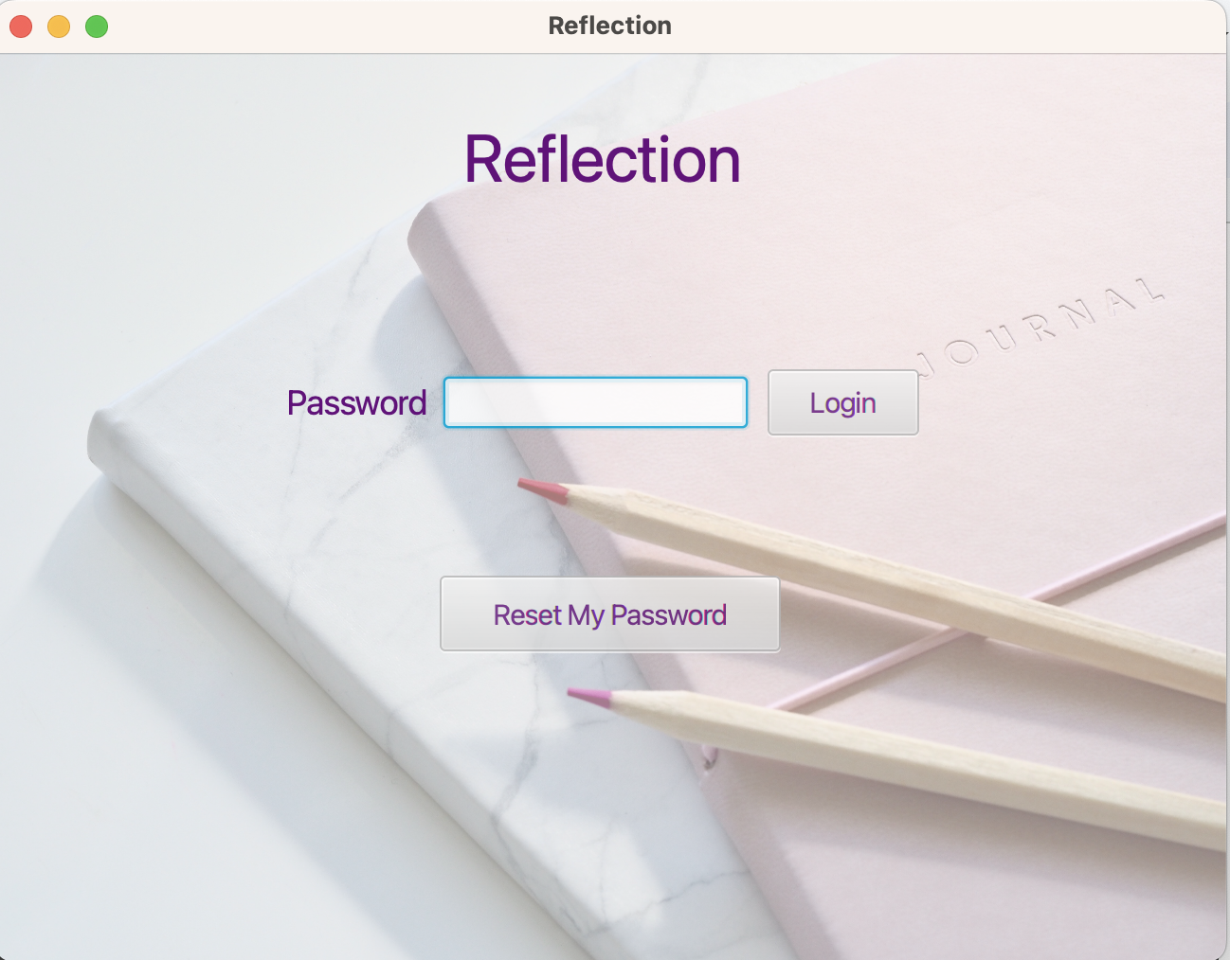

# UC-01 - Change Password

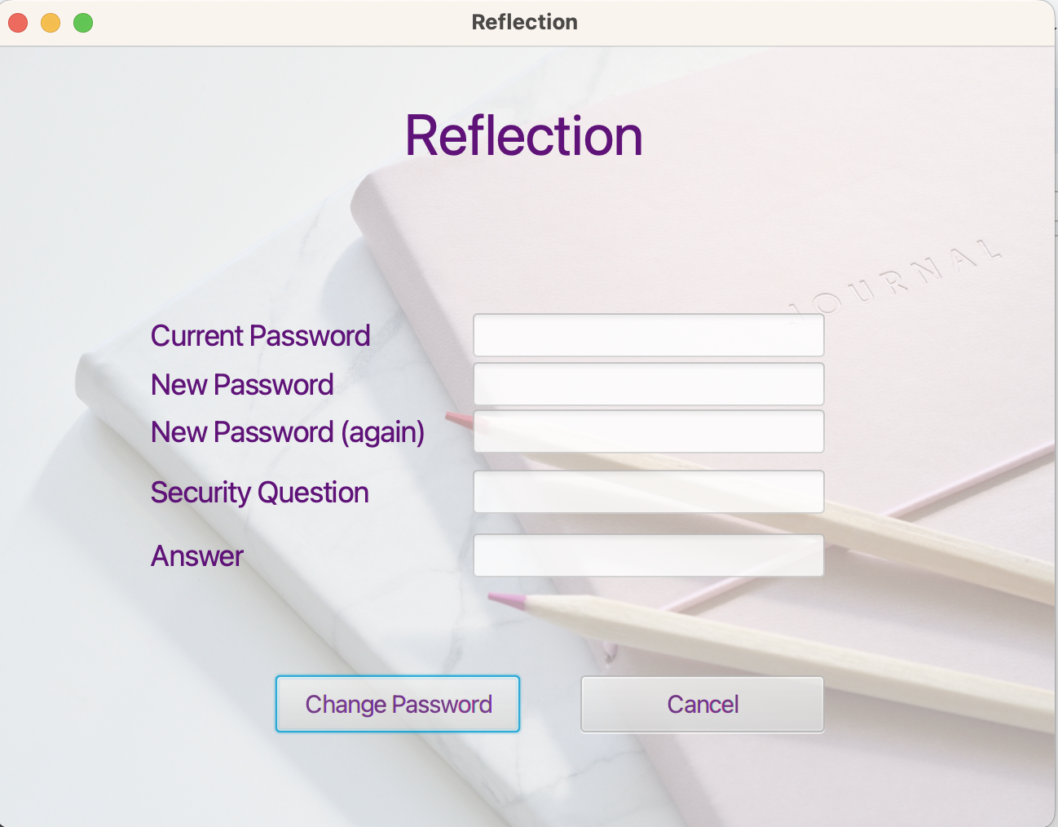

# UC-02 - Journal Entry

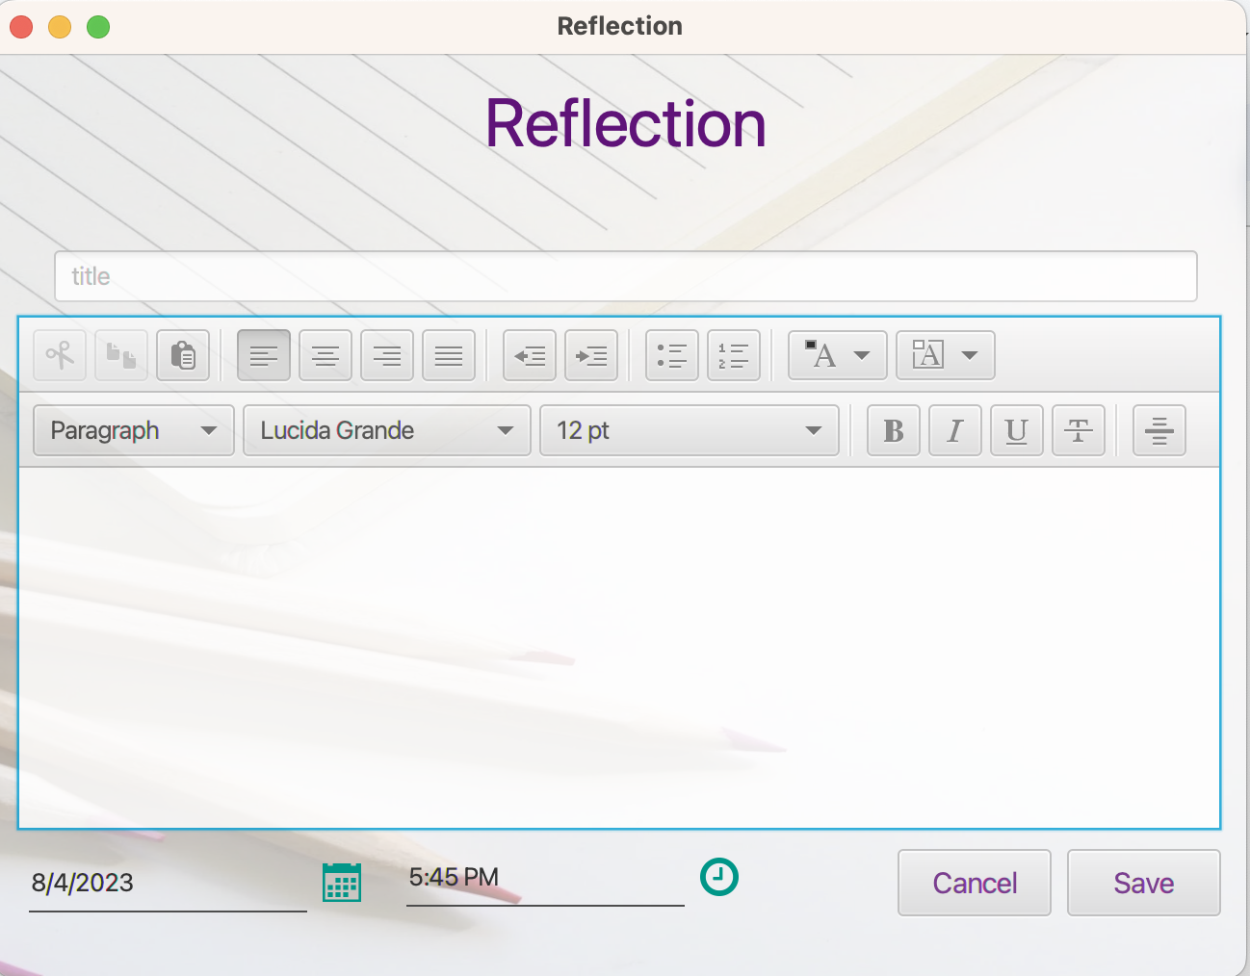

# 

# UC-03 - Search

