1.Introduction

Credit default swaps (CDS) and corporate bonds both price credit risk, and in principle, their spreads should be related through an arbitrage relationship. The difference between them — the CDS–bond basis —, is therefore often seen as a temporary deviation from parity.

Although it has been shown that CDS premia and bond spreads are strongly related in normal times, the financial crisis has highlighted that the basis can become large and persistent. The question that arises in this context is therefore the following: if an arbitrage relationship exists, why do such deviations not disappear?

This paper will review the empirical evidence on the CDS-bond basis, identify its main economic drivers, and discuss whether it can be predicted and exploited through trading strategies. We will argue that the basis is related to time-varying limits to arbitrage, especially in periods of funding stress and capital constraints.

Section 4

4.1 Theoretical Arbitrage Relation and Predictability

A central implication of the evidence in Sections 2 and 3 is that the CDS–bond basis represents deviations from a long-run equilibrium between CDS premia and bond spreads. De Wit (2006) finds a high degree of co-movement and cointegration in the pre-crisis period, which indicates that, under normal circumstances, the two markets are connected by an arbitrage relationship. In this sense, the basis can be viewed as a transitory departure from parity that, in principle, should display mean reversion properties under the action of arbitrage forces.

Nonetheless, the evidence on the crisis provided by Bai and Collin-Dufresne (2011) indicates that such departures are not necessarily corrected. Although cointegration implies the existence of a long-run relationship, the process can be very gradual or even non-existent when funding constraints, counterparty risk, and capital scarcity are taken into account. The predictability of the basis thus appears to be conditional on the funding markets' state.

4.2 The Negative Basis Trade: Mechanics
If the basis indicates an arbitrage discrepancy, the obvious question is whether the basis can be arbitraged away. When the basis becomes negative, investors can engage in a “negative basis trade,” which involves purchasing the bond, funding it in the repo market, and buying CDS protection on the same reference entity.

In theory, this trade is a hedge against credit risk. The investor earns the bond coupon income while paying the CDS premium. If the CDS spread is sufficiently lower than the bond’s credit spread, a positive carry is realised. In the absence of default, the return on investment equals the bond-CDS spread differential minus funding costs. If default occurs, the CDS payment compensates the bond loss, assuming the hedge is correct.

From a textbook solution, the trade looks very close to an arbitrage opportunity. When the basis approaches zero, investors earn both carry and capital gains. However, as the financial crisis has shown, this trade is much more complicated in reality.

4.3 Why Predictability Does Not Imply Risk-Free Arbitrage
Despite the attractive nature of the negative basis trade, several risks make it impossible for the trade to be considered as pure arbitrage.
First, there is the risk of mark-to-market. Even if the default risk is properly hedged, the basis may continue to widen before eventually converging. During the 2007-2009 crisis, the widening of credit spreads caused significant losses for investors who engaged in negative basis trades. If the trades are subject to margin requirements or internal risk limits, investors may be forced to close their positions before the basis converges.
Second, the trade is dependent on short-term funding. Bonds are normally funded in the repo market, where funding costs and haircuts can increase significantly in times of stress. Bai & Collin-Dufresne (2011) show that an increase in the LIBOR-OIS spread is related to a more negative basis, suggesting that funding stress limits arbitrage. Haircuts increase, requiring more capital and reducing leverage, making the trade less desirable.
Third, counterparty risk in the CDS market can impair the hedge. During the crisis, the credit quality of the major CDS market participants deteriorated. If the protection seller becomes risky, the hedge becomes less credible, further widening the negative basis.
Finally, capital constraints make it difficult for arbitrageurs to scale up their positions. Balance sheet constraints, regulatory capital requirements, and internal risk limits can make it impossible for investors to fully capitalise on apparent mispricing. As a result, mispricing can persist for a long time.
In light of these observations, it appears that the negative basis trade is more similar to a leveraged carry trade than a risk-free arbitrage. The trade is profitable not only when spreads converge, but also when funding conditions are stable, and risk-bearing capacity is sufficient. The mechanism is summarised in Figure X.
Figure X. Conceptual Framework of the CDS–Bond Basis and Limits to Arbitrage
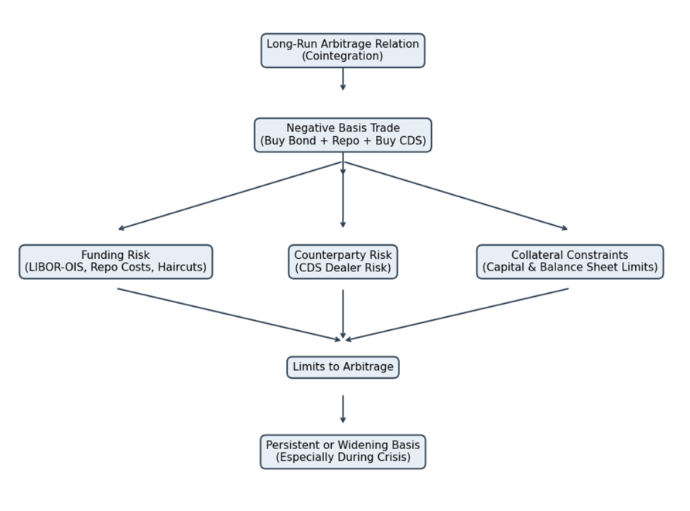

4.4 Risk Premium Interpretation

The above discussion indicates that, although the CDS-bond basis could be mean-reverting under normal circumstances, its predictability is conditional. Under stable funding and low counterparty risk, forces of arbitrage are more likely to be at work, allowing deviations to close and basis trades to earn returns.

But under systemic stress, deviations could persist or even widen. The evidence from the crisis period indicates that the basis could turn deeply negative when funding markets are under stress and the balance sheets of intermediaries are squeezed. In such circumstances, convergence may not necessarily happen within the investment horizon.

The basis should not be considered a mere mispricing. Rather, it represents a premium for compensating liquidity and funding risks. Its profitability is contingent upon macro-financial conditions, especially the availability of leverage and stable funding. In this regard, the CDS-bond basis could be statistically predictable, but economically risky.

5. Conclusion

This paper has analysed the CDS-bond basis through its empirical pattern, economic drivers, and trading implications. The results show that while there is a long-run relationship between CDS and bond spreads, the deviations from parity can become large during times of financial distress.

The financial crisis illustrates that deviations from parity are more than just market inefficiencies. Rather, the lack of funding, counterparty risk, and collateral constraints make it difficult for arbitrageurs to close the basis. Consequently, the negative basis trade is more than just a risk-free opportunity, as it entails significant risks of funding and liquidity.

In conclusion, the CDS-bond basis is more than just a manifestation of arbitrage relationships. Rather, it is a reflection of the complex relationship between credit pricing and intermediary balance sheet conditions.

