|  |  |  |  |  |  |  |  |
| --- | --- | --- | --- | --- | --- | --- | --- |
|  | |  |  | | --- | --- | | 503-697-8986 |  | | mccalawa@gmail.com |  | |  |  |   LinkedIn QR Code |

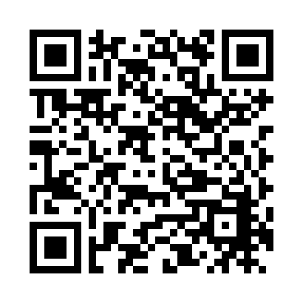

**Melissa**

**Calawa**

# Education

### expected June 2018

## Bachelor of Science in Computer Science

## Western Oregon University, Monmouth, OR

### August 2016

## Bachelor of Arts in English

## Portland State University, Portland, OR

# Experience

### March 2012 – Present

## Technology and Textbook Sales Associate

## Portland Community College Bookstore, Portland, OR

* Provided personalized solutions for customers by asking questions to identify needs
* Resolved consumer and coworker conflicts with active listening and problem solving
* Utilized databases to look up product inventory and inform buyers of reorder needs

# Skills

|  |  |
| --- | --- |
| * Strong programming skills in Java, C++, C, Haskell, SQL, Python, POV-Ray, Visual Basic, HTML, CSS, and JavaScript, and C++ * Knows basic written and spoken Japanese * Brings a unique and innovative perspective to problem solving with critical thinking skills honed by a liberal arts background | * Works with many types of software and operating systems such as Office 365, SQL Server, MySQL, Azure, Eclipse, IntelliJ IDEA, BlueJ, Acrobat, Photoshop, Fireworks, Dreamweaver, Director, Vim, Windows, Mac OS, and Linux |

# Activities

### Sept 2016 – Present

## English Tutor

## Portland Community College Student Learning Center, Portland, OR

* Communicated with students from diverse and international backgrounds
* Responded to native and non-native speakers by tailoring instruction to individuals
* Adapted when presented with unexpected situations and fast-paced student rotation