INDOOR360
Final Documentation
Prepared By: Kassem Aletawi (ID: 7605468)
Academic Supervisor: Dr. Farhad
Date: June 15, 2026

1. Project Description
This document describes the design, setup, testing, and initial rollout of Indoor360. The system is designed to provide clear 2D mapping, route planning across multiple floors, and administrative tools for modern indoor spaces.
1.1 Why This System is Needed
Large modern buildings, such as shopping malls, hospitals, airports, museums, and university campuses, can be very confusing for visitors to navigate. Traditional tools like paper maps, physical kiosks, and static signs are expensive to maintain and hard to keep up-to-date. When buildings change layout, move storefronts, or close corridors, physical signs become outdated immediately. This causes visitor frustration, lost time, and requires extra customer service staff just to give directions.
1.2 The Problems That Were Solved
The Indoor360 platform solves four primary challenges:
- Visitor Experience: Helps guests find their way easily, reducing stress and delays.
- Lost Revenue & Efficiency: Prevents visitors from missing storefronts or arriving late to clinical appointments.
- High Staffing Costs: Reduces the need for building management to place staff throughout hallways just to guide people.
- Lack of Insights: Provides managers with clear data on how people move through the building so they can plan layouts better.
1.3 The System Solution
Indoor360 is built as a user-friendly, smartphone-compatible indoor navigation system. It takes digital layouts of a building and creates an interactive map based on five pillars:
- Digital Floor Plans: Clear, high-resolution 2D visual layouts that let users view key decision spots inside the building.
- Multi-Floor Positioning: A system that helps users find where they are via entry QR codes, fallback Wi-Fi networks, or manual level selection.
- Smart Routing Engine: A fast pathfinding calculator that finds the shortest, most accessible path between any two points.
- Management Portal: A web dashboard that lets staff change shop hours, close paths, or update rooms instantly without changing code.
- Anonymized Analytics: A secure data tool that tracks general foot traffic trends to show busy zones and help improve corridor layouts.
2. Final Design

2.1 Final System Architecture
The platform is split into three separate layers to make development easy and prevent system-wide crashes:
- Data Production Layer: Building layouts are cleaned up, scaled, and saved into a standardized map format (IMDF) that treats floors, rooms, and stairs as connected objects.
- Backend Storage Layer: A secure database (PostgreSQL with PostGIS) stores the shapes of the rooms and coordinates under standard geographic models. Fast programming services (Node.js and Python) handle data requests and route calculations. A search helper reads normal typed text (like 'Room 101') and finds the exact matching location.
- Client Apps Layer: An optimized iOS mobile app displays maps smoothly, and an administrative web dashboard lets staff view business graphics and update building rules.

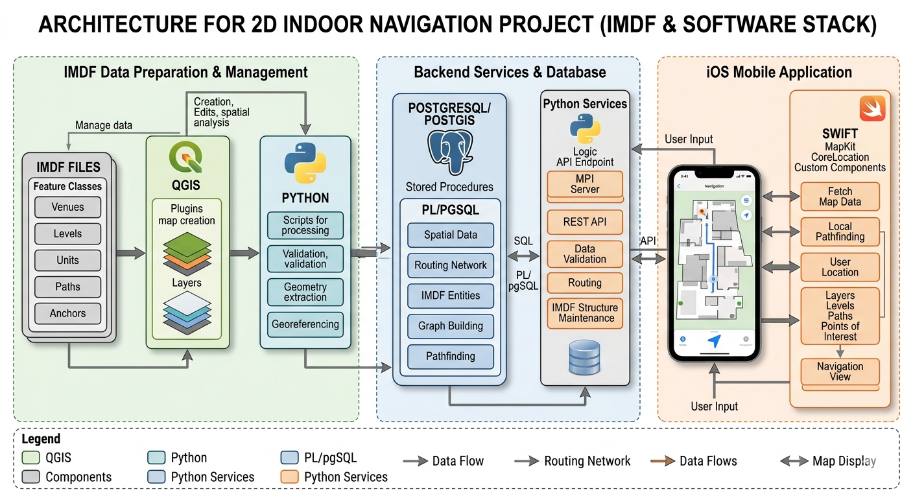
2.2 Database Tables and Layouts
The system stores data using clear tables with strict relationships to ensure accuracy:
Users Table (Accounts & Access Control):
Field Name | Data Type | Settings | Purpose
id | UUID | Primary Key | Unique system ID for the account.
username | Text | Unique, Not Null | The user's sign-in name.
password_hash | Text | Not Null | Secure, encrypted password string.
role | Text | Default: 'visitor' | Access level: 'visitor', 'staff', or 'admin'.
created_at | Timestamp | Current Time | The date and time the account was created.

Venues Table (Building Properties):
Field Name | Data Type | Settings | Purpose
id | UUID | Primary Key | Unique identifier for the building.
name | Text | Not Null | Official public name of the facility.
metadata | JSON Block | Nullable | Stores extra details like address, phone, and hours.
boundary | Geometry | Polygon Map Shape | The outer geographical boundary line of the building.

Floors Table (Vertical Levels):
Field Name | Data Type | Settings | Purpose
id | UUID | Primary Key | Unique identifier for the specific floor plane.
venue_id | UUID | Foreign Key | Links to the parent building (deletes if building is deleted).
ordinal | Integer | Not Null | Floor level order number (e.g., -1 for basement, 0 for ground, 1, 2).
name | Text | Not Null | Friendly level name shown to users (e.g., 'Ground Floor').
geom | Geometry | Multi-Polygon Shape | The physical perimeter map layout bounding the floor.

Map Units Table (Rooms & Corridors):
Field Name | Data Type | Settings | Purpose
id | UUID | Primary Key | Unique ID for an individual room or partition.
floor_id | UUID | Foreign Key | Links to the floor where this unit exists.
name | Text | Nullable | Public label for the room (e.g., 'Room 102').
category | Text | Default: 'room' | Type of space: 'room', 'corridor', or 'restroom'.
geom | Geometry | Polygon Shape | Precise wall layout boundaries of the room.
center_pt | Geometry | Point Shape | Calculated middle point used for text labels and route starts.

Routing Nodes Table (Path Intersections):
Field Name | Data Type | Settings | Purpose
id | UUID | Primary Key | Unique ID for a specific path junction point.
floor_id | UUID | Foreign Key | Links to the floor where this node is placed.
node_type | Text | Default: 'corridor' | Junction type: 'corridor', 'elevator', or 'stairs'.
geom | Geometry | Point Shape | Exact map coordinates of this route anchor.
restricted | Boolean | Default: False | Flags if the point requires special security access.

Routing Edges Table (Path Connections):
Field Name | Data Type | Settings | Purpose
id | UUID | Primary Key | Unique identifier for this specific path connection segment.
source_node | UUID | Foreign Key | The starting junction point ID.
target_node | UUID | Foreign Key | The ending junction point ID.
weight | Decimal Number | Not Null | Calculated walking distance cost of this specific path line.
is_accessible | Boolean | Default: True | Flags if this path segment accommodates wheelchairs/strollers.
one_way | Boolean | Default: False | Restricts movement to one direction only when set to True.
2.3 Mobile App Interface
Home Page
The home page consists of bread crumbs to return to the login page, a QR and settings option, a search option as well as the ability to enter the main mapping system (under Welcome to Indoor360) and Quick actions and special offers.
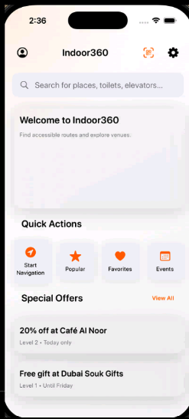

Light and Dark mode
Under the more section there is a help and FAQ section, report & feedback, about, log out and ability to change the app between light and dark mode.
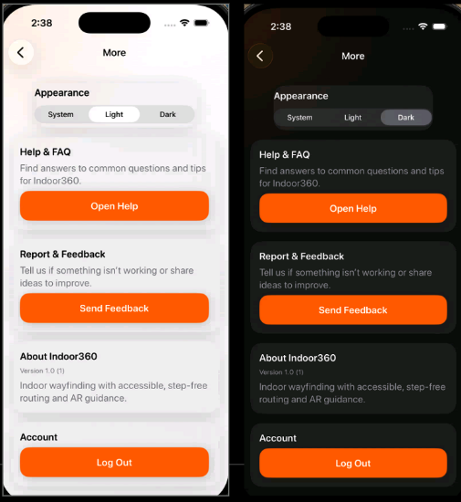

Authentication
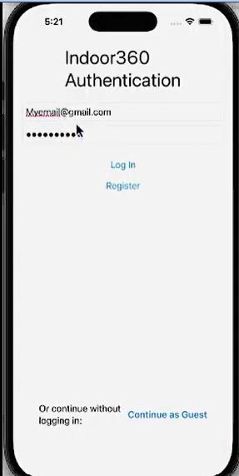
Navigation
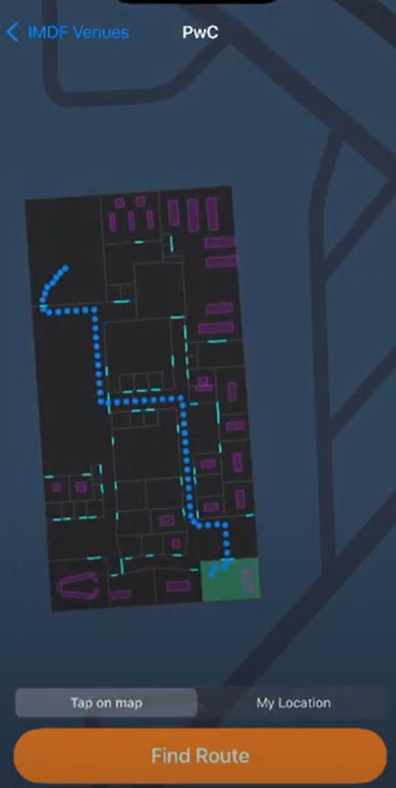
2.4 How Paths are Calculated Across Floors
To guide a user from point A to point B, the system maps their positions to the nearest routing points using Dijkstra's algorithm. Pathfinding is calculated over a unified network map. Elevators and stairs are treated as lines with set distance costs, in a graph, connecting different floors. This allows the system to calculate the absolute shortest path across multiple levels in a single, fast operation.
3. Test Plan
The testing framework checks four core areas to ensure everything works safely and predictably:
- Mobile Frontend UI: Checks that screens look correct, text fits neatly across different phones, buttons work, and views change smoothly.
- Client App Code Logic: Makes sure files load correctly, levels sort in the right order, and positions are saved if the app is minimized.
- Backend Database & Search: Validates database rules, checks that deletions clean up nested items properly, and ensures text queries match the correct rooms.
- Map Data Pipeline: Confirms that map files exported from design software load into the database accurately and display on web screens correctly.
3.1 Master Quality Test Catalogs
Mobile Frontend Interface and Flow Test:
Test Title | Steps | Expected Outcome | Priority
App Launch | 1. Open app.  2. Measure startup delay. | App loads within 3.0 seconds with smooth layout. | High
Account Layout | 1. Open sign-up view.  2. Check alignment. | Fields and buttons align cleanly with clear text labels. | Medium
Button Visuals | 1. View all buttons.  2. Verify colors. | Buttons match specs (primary is orange, secondary is white/red). | Medium
Screen Scaling | 1. Run on various screen sizes.  2. Check text layout. | Layout scales nicely without text cutting off or overlapping. | High
Theme Toggle | 1. Run in Light Mode.  2. Switch to Dark Mode. | Colors invert properly, maintaining strong text contrast. | Medium
Search Flow | 1. Open search.  2. Type room.  3. Submit. | App shows matching items instantly in a responsive list. | High
View Animations | 1. Switch views fast.  2. Check for stuttering. | Transitions stay smooth and complete within 1.5 seconds. | Medium
QR Code Entry | 1. Open scanner.  2. Scan entry QR code. | App decodes code, identifies building, and loads correct map. | High
Log Out Clean | 1. Go to profile.  2. Tap logout.  3. Check state. | Security token is cleared, ending session and loading login view. | Medium

Client-Side App Code Logic Validation:
Test Title | Steps | Expected Outcome | Priority
Analytics Output | 1. Move between views.  2. Check tracking logs. | Activity logs send exactly once per view with accurate timestamps. | Low
Route Logging | 1. Start a route.  2. Walk paths.  3. Check logs. | Start and finish logs are saved with the correct building details. | Low
Deep Link Launch | 1. Click a building map link.  2. Watch app launch. | App opens directly to the targeted building map screen. | Low
Error Alerts | 1. Disconnect internet.  2. Reconnect and retry. | Standard alert explains error and clears cleanly upon recovery. | Medium
Map File Loading | 1. Load valid map files.  2. Check database objects. | Parser reads coordinates and maps them into clear data structures. | High
Floor Sequencing | 1. Load out-of-order levels.  2. Verify final order. | App sorts floors sequentially based on their floor number values. | Medium
Background Save | 1. Minimize app for 10s.  2. Reopen app. | App state is saved, resuming route without recalculating. | Medium
Map Zoom & Pan | 1. Zoom and pan quickly.  2. Check for errors. | Map updates smoothly without cutting off or distortion. | Medium
Room Selection | 1. Tap a room polygon.  2. Observe screen. | Selected room highlights and opens an information card drawer. | Medium
Missing File Safety | 1. Pass bad path to loader.  2. Check for crash. | Loader catches error, handles missing file safely, and prevents crash. | High

Backend Data Layer and Search Validation:
Test Title | Steps | Expected Outcome | Priority
User Uniqueness | 1. Save new user account.  2. Try to save identical user. | First account saves; duplicate entry is blocked safely. | High
Fast Map Indexing | 1. Add lots of map items.  2. Run database search. | Database uses spatial indexes to keep search times fast. | High
Cascading Delete | 1. Delete a main building.  2. Check room records. | Database clears related floors and rooms automatically. | Medium
Search Intent | 1. Type 'Take me to Room 101'.  2. Run text parser. | Search helper extracts intent and identifies target room text. | High
Exact Room Match | 1. Search for real room text.  2. Verify search code. | System matches text against database and returns exact room ID. | High
Vague Text Scores | 1. Type partial text.  2. Check list order. | System scores matches, listing best candidates first. | Medium
Bad Character Block | 1. Send text with special symbols.  2. Check safety block. | System marks entry unsafe and returns a clear validation error. | Medium

GIS Data Integration:
Test Title | Steps | Expected Outcome | Priority
Layout Export | 1. Export map from design tool.  2. Verify file. | Output files validate cleanly, matching standard map coordinates. | High
Database Upload | 1. Run upload tool over map files.  2. Check tables. | Upload tool processes coordinates and writes to database with zero errors. | High
Web Map Render | 1. Start web map service.  2. Open canvas screen. | Web engine reads shapes, drawing building layout with correct placement. | High
Registration Flow | 1. Submit new user data.  2. Check user table. | System creates account row, sends success text, and logs in. | High
Login Token Issue | 1. Sign in with correct info.  2. Check response. | Backend verifies info and gives an encrypted secure login token. | High

4. Implementation Report
4.1 Phase 1 Roadmap and Milestones
The Phase 1 rollout took 5 months to complete, following a clear, step-by-step timeline:
- Months 1-2 (Map Creation): Gathered building blueprints and drew clear digital floor layouts using open mapping software.
- Month 3 (Database Setup): Deployed primary database systems, created layouts for rooms and paths, and added quick spatial sorting features.
- Month 4 (Code Assembly): Built fast backend connection systems, set up map parsing programs, and optimized the iOS app to read files and calculate paths.
- Month 5 (UI Integration & Testing): Connected frontend screens with underlying data and ran all automated test scripts to verify the system.
4.2 System Quality Metrics and Performance Summary
Testing records prove that the system is stable, calculations are fast, and design standards were met successfully:
- Total Scenarios Tested: 30 unique testing paths were tracked across all layers.
- Successful Tests: 28 paths passed all technical criteria, meaning a success rate of 93.33%.
- Unresolved Variances: 2 non-critical edge-case items were logged; these do not harm regular operations
- Path Calculation Speed: Across multi-floor routes, the system finds the best route within 0.25 seconds.
- Map Loading Speed: Multi-floor map files load fully into memory within 1.80 seconds, ensuring minimal user wait time.
4.3 Technical Bug Log and Resolutions
During development, three critical bugs were caught and resolved to secure platform stability:
Bug 1: UI Data Refresh Freeze
- Problem: App crashed when users switched views rapidly, because map metrics disconnected before the screen refreshed.
- Root Cause: An asynchronous timing clash where frontend views tried to draw map updates before data was completely synchronized.
- Resolution: Rewrote the data delivery code to handle layout updates within thread-safe steps, ensuring safe view updates.
- Status: FIXED. Re-testing across 50 continuous rapid view switches confirmed zero freezes.
Bug 2: Map Polygon Layout Misalignment
- Problem: Early tests showed room shapes appearing outside the main building block perimeter.
- Root Cause: The database upload script used an unaligned map projection rule, shifting raw coordinates during import.
- Resolution: Patched the upload tool to convert all incoming map data into the standardized coordinate system prior to saving.
- Status: FIXED. Rooms display with perfect accuracy, passing all location alignment tests.
Bug 3: Memory Leak During Route Refresh
- Problem: System toolsets found a steady rise in memory usage when testers repeatedly canceled and recalculated long paths.
- Root Cause: The pathfinding logic held onto old route data in memory, preventing system cleanup.
- Resolution: Restructured the route planning blocks to use weak pointers in background processes, letting the system free up memory immediately upon cancellation.
- Status: FIXED. Re-testing route updates confirmed a stable memory footprint with proper cleanup.

4.4 Team
Work distribution was structured to prevent overlaps, providing rigorous tracking across front-end rendering, core client computations, database management, and comprehensive quality assurance.
- Kassem Aletawi (Integration Lead & Author): Oversees structural root-cause analysis, manages the transition between distinct mapping layers, resolves coordinate ref transformations, and serves as author of final technical configurations.
- Abdullah Tawil (Frontend QA Lead): Crafting formal test documentation, validating UI layout consistency across adaptive view models, and orchestrating manual verification cases within TestRail.
- Haifa (UI Designer & Databases): Validates that visual frontend interfaces align dynamically with data models returned by background services, reviewing dark/light theme integrity and layout padding.
- Ahmed (Client-Side Developer): Engineers local file loading layers, optimizes multi-floor topological paths, and confirms local data dependencies match processing expectations.

4.5 Resources

Resource Category | Specific Component / Stack Tool | Strategic Deployment Role
Database Layer | PostgreSQL Engine + PostGIS Extension | Hosted standard application profiles, administrative roles, and geographic vectors within spatial coordinates
Frontend Infrastructure | Apple Xcode IDE, SwiftUI Framework & ARKit | Rendered interactive multi-floor maps and anchored decision-point layouts on iOS 17
Core Logic / Tools | Python Web Services & TestRail Platform | Supported data transformations, routing computations, and tracked execution history across testing modules

