Installation Guide
Enterprise Server Deployment and Operating System Installation — ITEP 414, Week 3

1. Project Overview
Operating systems are the foundation of enterprise IT infrastructure. This guide documents the deployment of a new Ubuntu Server for ABC Startup Solutions, performed in the role of Junior System Administrator, covering installation, configuration, verification, and supporting research on boot technologies.

2. Objectives
- Deploy a clean Ubuntu Server virtual machine using enterprise installation practices.
- Configure hostname, user account, disk partitioning, and SSH access.
- Verify server functionality (login, hostname, IP, connectivity, updates, SSH service).
- Compare BIOS and UEFI firmware and document the Ubuntu boot process.
- Produce professional documentation for future administrators.

3. Software Requirements
- Oracle VirtualBox or VMware Workstation
- Ubuntu Server LTS ISO (latest stable version)
- Windows Server Evaluation ISO (for the bring-home activity)

4. Virtual Machine Specifications
Component | Minimum Requirement
Name | Ubuntu-Server-Week03
RAM | 4 GB
CPU | 2 Virtual Processors
Storage | 40 GB (VDI/VMDK)
Network | NAT (or Bridged if instructed)
Optical Drive | Ubuntu Server ISO

5. Step-by-Step Installation Procedure
Language: Select English.
Keyboard Layout: Select the appropriate layout (e.g., English (US)).
Network Configuration: Accept DHCP unless instructed otherwise; record the assigned IP address.
Hostname: server01
User Account: Create a non-root administrative user with a strong password.
Disk Partition: Use Guided — Use Entire Disk. Record the partition scheme, file system, and disk size below.
SSH Server: Enable and install OpenSSH Server.
Additional Packages: Do not install extra packages unless instructed.
Complete Installation: Restart the VM and remove the installation ISO if prompted.

6. Configuration Details
Partition scheme used: [ FILL IN — e.g., GPT, single LVM volume group ]
File system used: [ FILL IN — e.g., ext4 ]
Disk size allocated: [ FILL IN — e.g., 40 GB ]
Assigned IP address: [ FILL IN ]

7. Verification Commands
The following commands were used to verify the deployed server:
- hostname — confirms the configured hostname
- ip addr — confirms the assigned IP address
- ping -c 4 google.com — confirms internet connectivity
- sudo apt update && sudo apt upgrade -y — applies system updates
- systemctl status ssh — confirms the SSH service is active (running)

8. BIOS vs UEFI Comparison
See the accompanying BIOS_vs_UEFI.docx / BIOS_vs_UEFI.pdf document for the full comparison table and one-page explanation of why UEFI has largely replaced BIOS in modern computers.

9. Boot Process Flowchart
The Ubuntu boot process proceeds through the following stages, from power-on to login prompt:
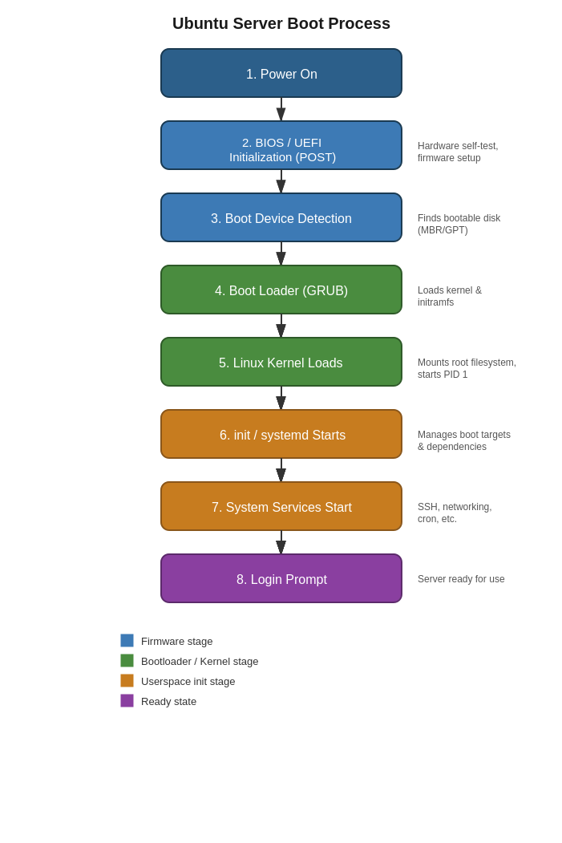

10. Windows Server Installation Summary
Summarize the bring-home Windows Server Evaluation installation here: computer name assigned, administrator account created, and successful login confirmed.
[ INSERT SCREENSHOT HERE: Windows Server installation / login screenshot ]

11. OS Comparison Table
See the accompanying OS_Comparison_Report.docx / .pdf document for the full Windows Server vs Ubuntu Server vs Rocky Linux comparison table and discussion.

12. Problems Encountered
[ FILL IN — document any issues encountered during installation or configuration, e.g., network adapter not detected, disk space warnings, SSH not starting automatically, etc. ]

13. Solutions Implemented
[ FILL IN — describe how each problem above was resolved. ]

14. Lessons Learned
[ FILL IN — reflect on what this project taught you about enterprise OS deployment, boot technologies, and documentation practices. ]

15. References
[ FILL IN — cite the sources used for research, e.g., official Ubuntu Server documentation, Microsoft Docs, Rocky Linux documentation. ]

