Professional Installation Manual
Ubuntu Server Deployment for Enterprise Environments

ABC Startup Solutions
Prepared by: KURT ANDREW C. RAMOS
Role: Junior System Administrator
ITEP 414 – System Administration and Maintenance | Week 3
AUGUST 14, 2026

Table of Contents
Table of Contents 1
1. Introduction 1
2. Ubuntu Server Installation Guide 1
3. Initial Server Configuration 1
4. Server Verification Procedures 1
5. Boot Process Reference 1
6. Troubleshooting Guide 1
Issue: VM fails to boot from the ISO 1
Issue: No IP address assigned / no network connectivity 1
Issue: Cannot SSH into the server 1
Issue: apt update/upgrade fails 1
7. Best Practices 1
8. References 1

1. Introduction
This manual documents the deployment of Ubuntu Server for ABC Startup Solutions' first Linux server, which will support file sharing, remote administration, database hosting, web hosting, and internal services. It is written so that another system administrator can reproduce the installation and initial configuration without additional guidance.

2. Ubuntu Server Installation Guide
Virtual machine specifications: Name Ubuntu-Server-Week03, 4 GB RAM, 2 virtual CPUs, 40 GB storage (VDI/VMDK), NAT networking, Ubuntu Server ISO mounted as the optical drive.
Installation steps: select English as the language and an appropriate keyboard layout, accept DHCP networking (recording the assigned IP address), set the hostname to server01, create a non-root administrative user account, choose Guided – Use Entire Disk for partitioning, enable the OpenSSH Server package, decline additional packages unless instructed, then restart and remove the installation media.

3. Initial Server Configuration
Partition scheme: [ FILL IN ] File system: [ FILL IN ] Disk size: [ FILL IN ]
Assigned IP address: [ FILL IN ] Hostname: server01
User account created: [ FILL IN — username ]

4. Server Verification Procedures
Run the following commands after first login to confirm the server is functioning correctly:
- hostname — confirms the hostname is set to server01
- ip addr — confirms the network interface received an IP address
- ping -c 4 google.com — confirms outbound internet connectivity
- sudo apt update && sudo apt upgrade -y — applies the latest security and package updates
- systemctl status ssh — confirms the SSH service shows active (running)

5. Boot Process Reference
For context, the Ubuntu Server boot sequence proceeds as follows:
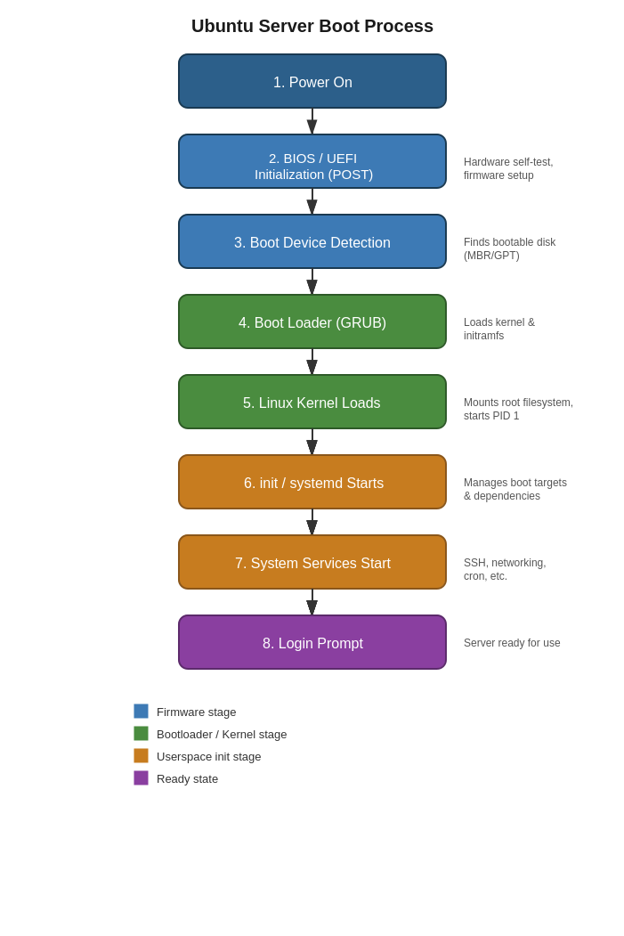

6. Troubleshooting Guide

Issue: VM fails to boot from the ISO
Confirm the ISO is correctly mounted to the virtual optical drive and that the VM's boot order places the optical drive before the hard disk.

Issue: No IP address assigned / no network connectivity
Confirm the VM's network adapter is set to NAT or Bridged as required, and that the virtual network adapter is enabled in the hypervisor's VM settings. Run sudo dhclient or restart networking with sudo systemctl restart systemd-networkd if DHCP does not assign an address automatically.

Issue: Cannot SSH into the server
Verify the SSH service is active with systemctl status ssh, confirm the server's firewall (ufw) allows port 22, and confirm you are using the correct IP address obtained from ip addr.

Issue: apt update/upgrade fails
Confirm internet connectivity with a ping test first; if connectivity is fine, check /etc/apt/sources.list for corrupted repository entries or try sudo apt update again after a few minutes in case of a temporary mirror outage.

7. Best Practices
- Always create a non-root administrative user and disable direct root SSH login.
- Enable a firewall (ufw) and only open the ports required for the server's role.
- Apply system updates immediately after installation and on a regular patching schedule thereafter.
- Use key-based SSH authentication instead of passwords where possible.
- Document the exact configuration (hostname, IP, partitioning) at the time of deployment for future reference.
- Take a snapshot of the VM immediately after a clean, verified installation before making further changes.

8. References
Canonical AppArmor documentation, Microsoft Windows Server documentation, Rocky Linux documentation.

