1. Write a program that displays “Hello” in one line, and “World” in another line using exactly two (2) COUT statements.
   1. Code and Sample Output

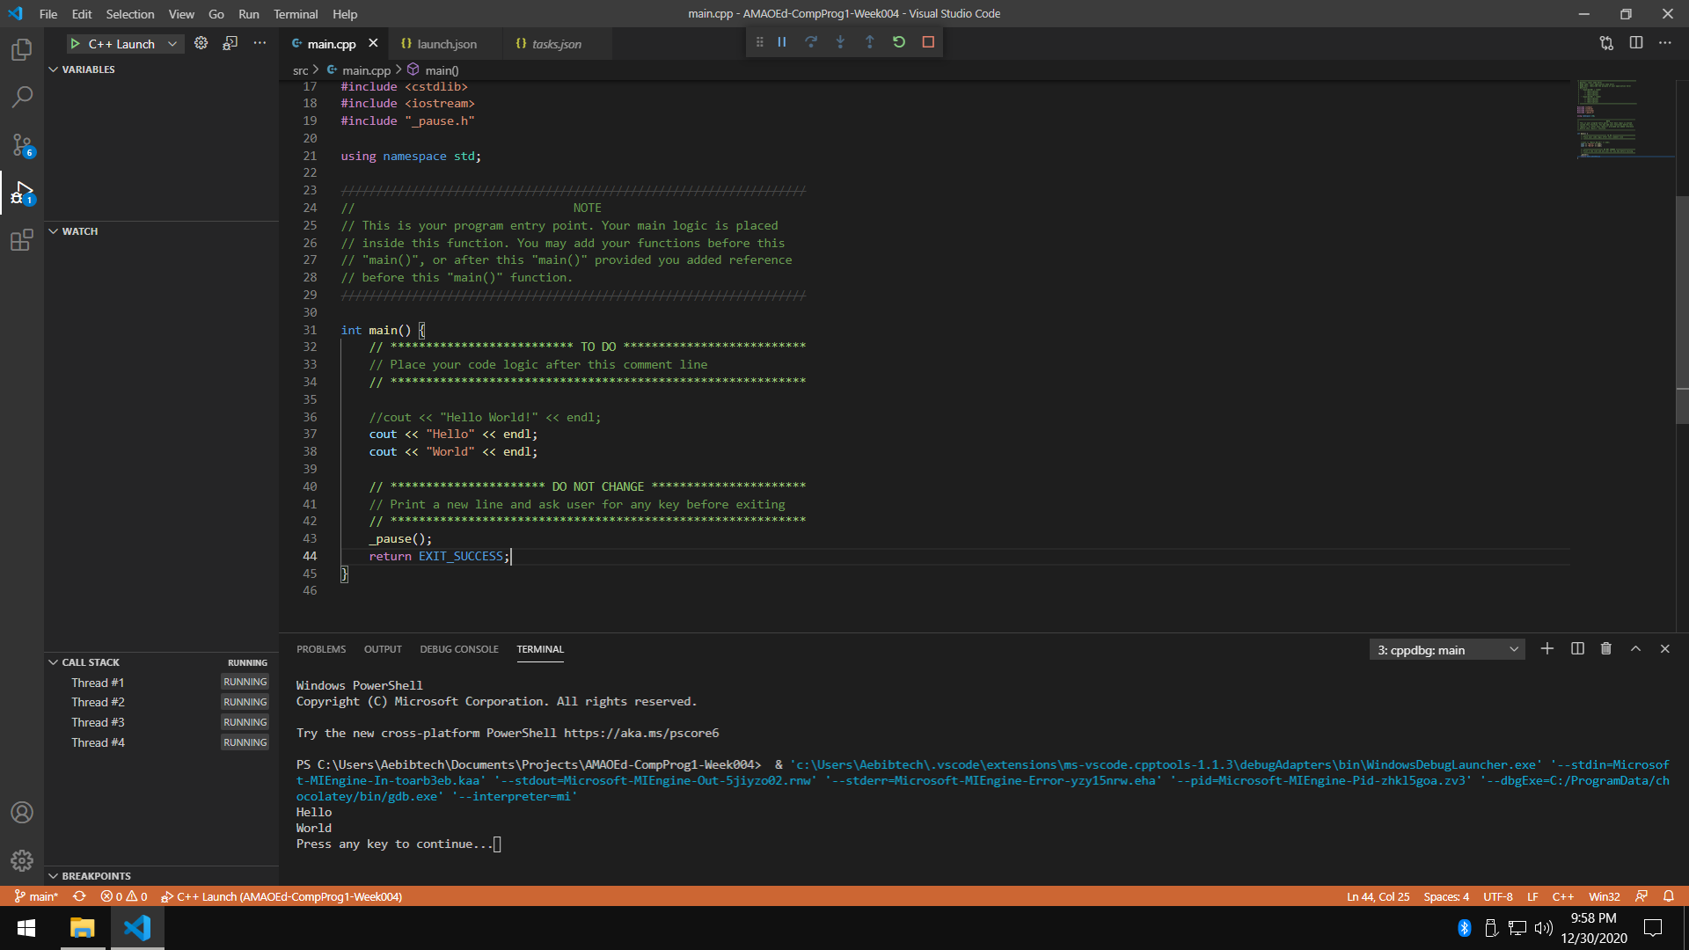

* 1. Flowchart
  2. Pseudocode

1. Write a program that displays “Hello” in one line, and “World” in another line using exactly ten (10) COUT statements.

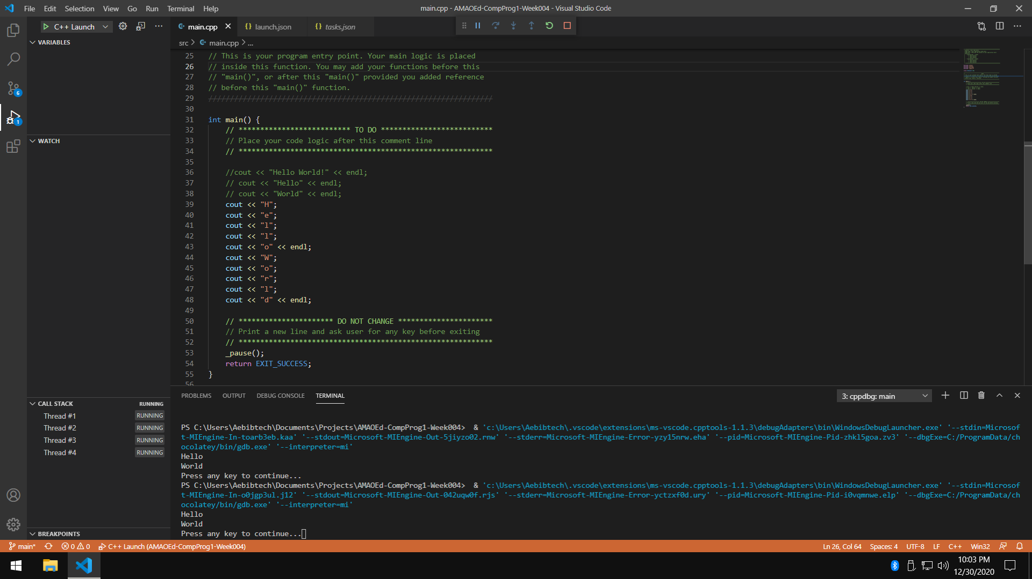

1. Write a program that displays “Hello” in one line, and “World” in another line using exactly one (1) for the “Hello” and exactly five (5) COUT statements for the “World”.

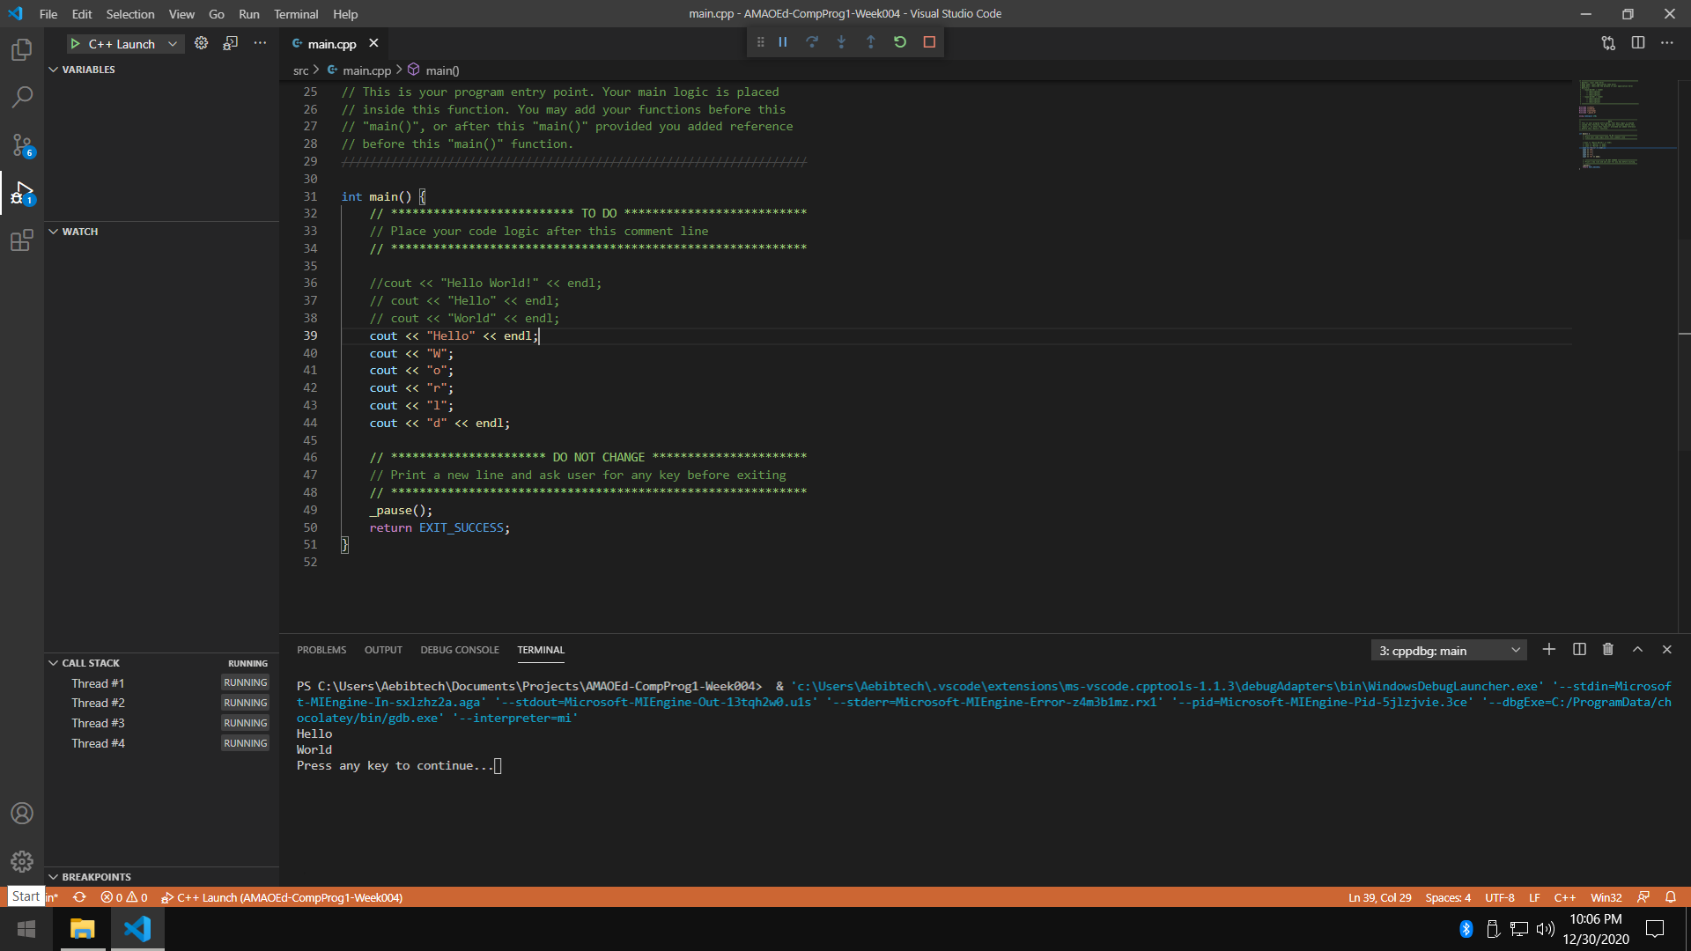

1. What can you conclude from this activity?

I can conclude from this activity that an Integrated Development Environment is the main tool that a programmer uses in order to code a program and compile it to an executable that can be run by the operating system to show output to the user.

Also, cout << “String”; is the statement that is used to display output to the console.