1. Write a program that accepts user’s section, and display them back with the format “\*\*\* Section: *user’s section* \*\*\*”.

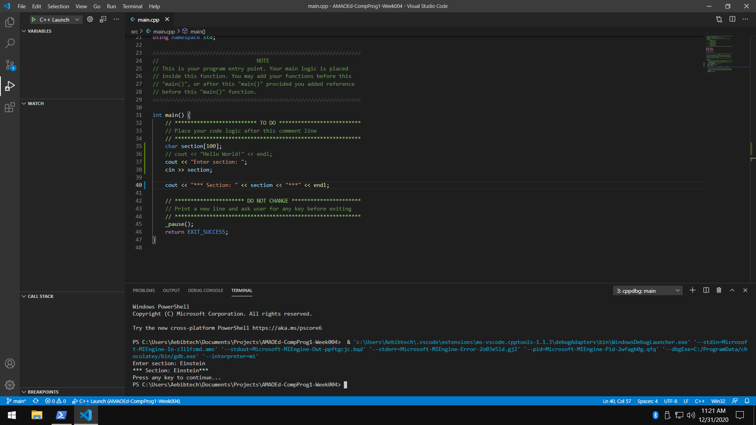

1. Write a program that accepts user’s daily budget and display the product of the daily budget and itself.

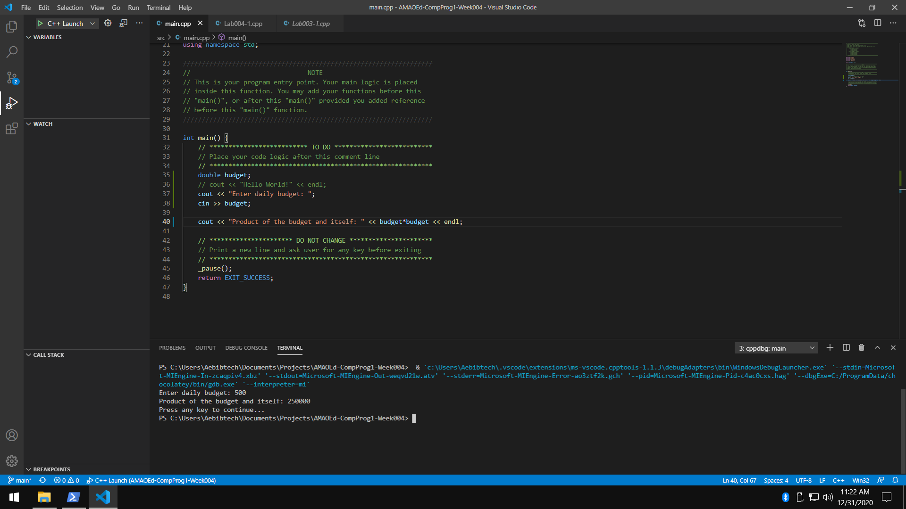

1. Write a program that accepts user’s name, password and address and display them back using the format “Hi, I am *user’s name*. I live at *user’s address*.”.

Restrictions:

* + Use only three variables.
  + Make sure you support spaces.

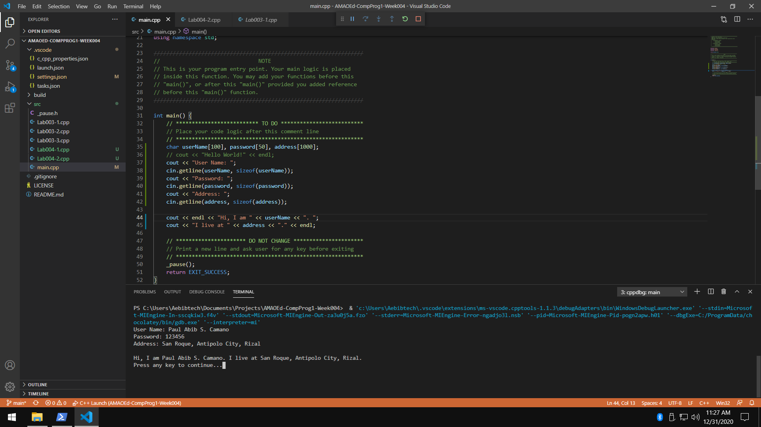

1. What can you conclude from this activity?

I can conclude from this activity that cin >> *variable* ; is the statement that is used to store user input values to variables. Also, cin.getline(*variable,* sizeof(*variable*)); is the statement that is used to store an array of characters with spaces.