1. Write a program that will accept an integer and execute one of the following based on the input using IF statements:
   1. If 0, display only “Hello World”.

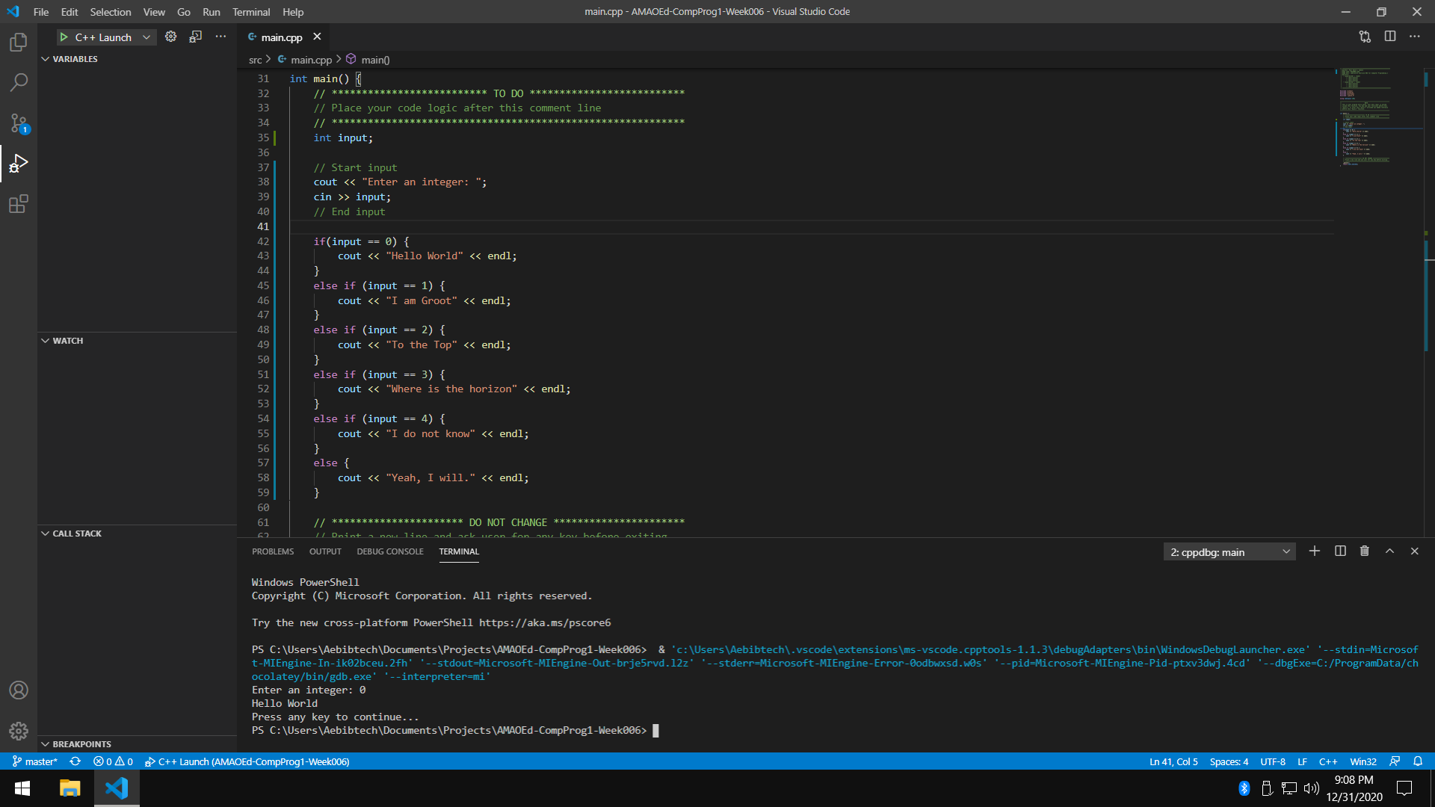

* 1. If 1, display only “I am Groot”.

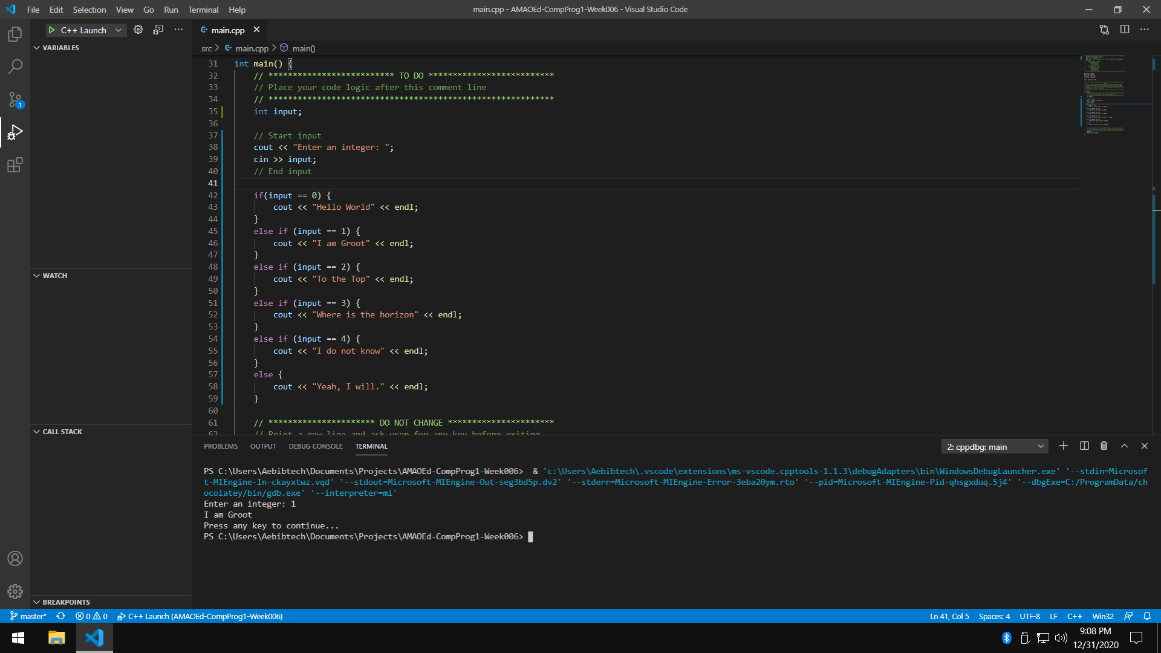

* 1. If 2, display only “To the Top”.

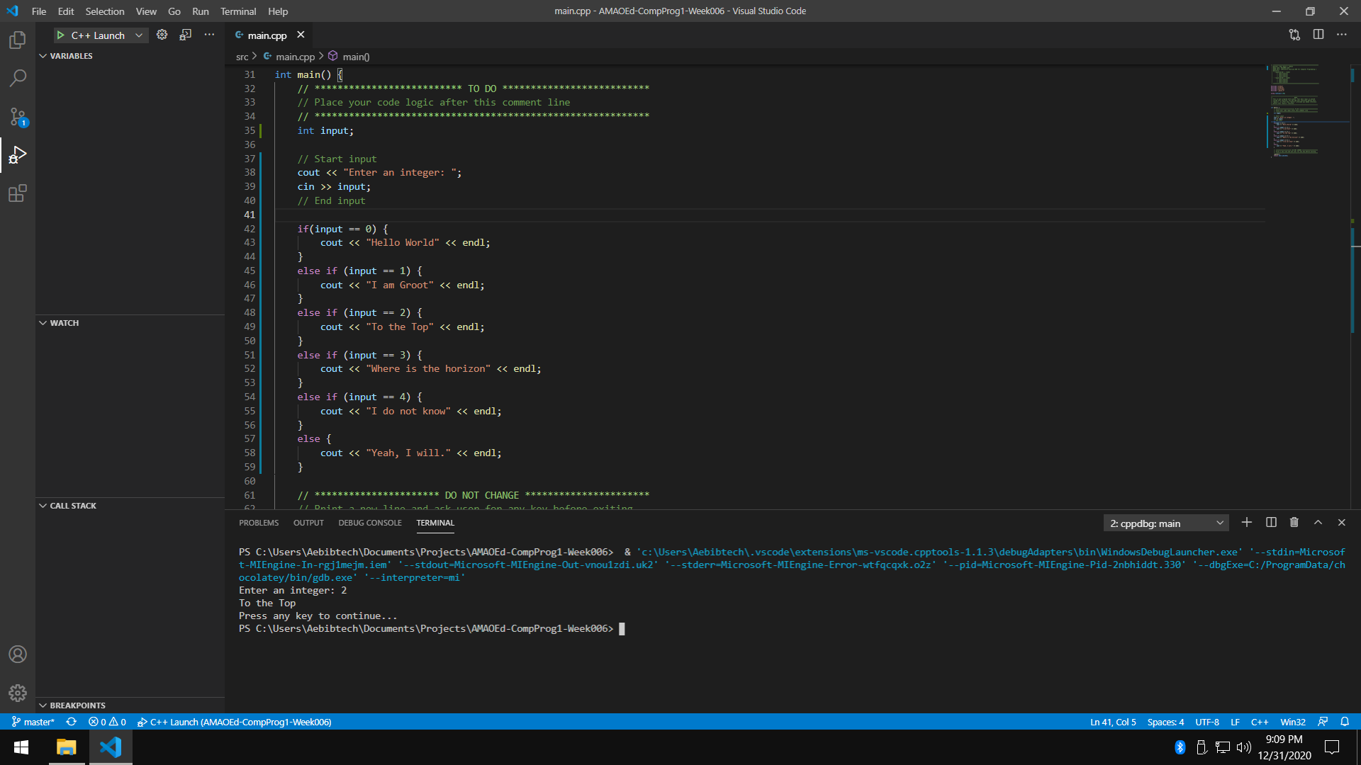

* 1. If 3, display only “Where is the horizon”.

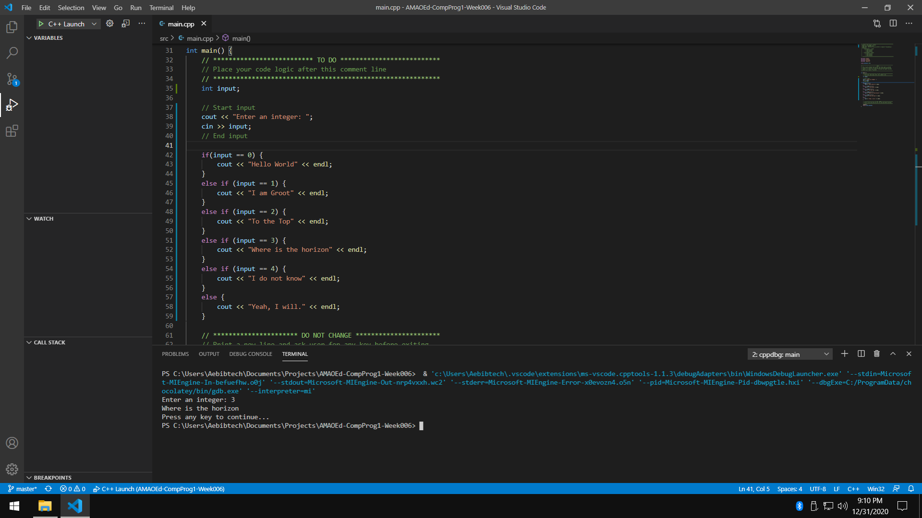

* 1. If 4, display only “I do not know”.

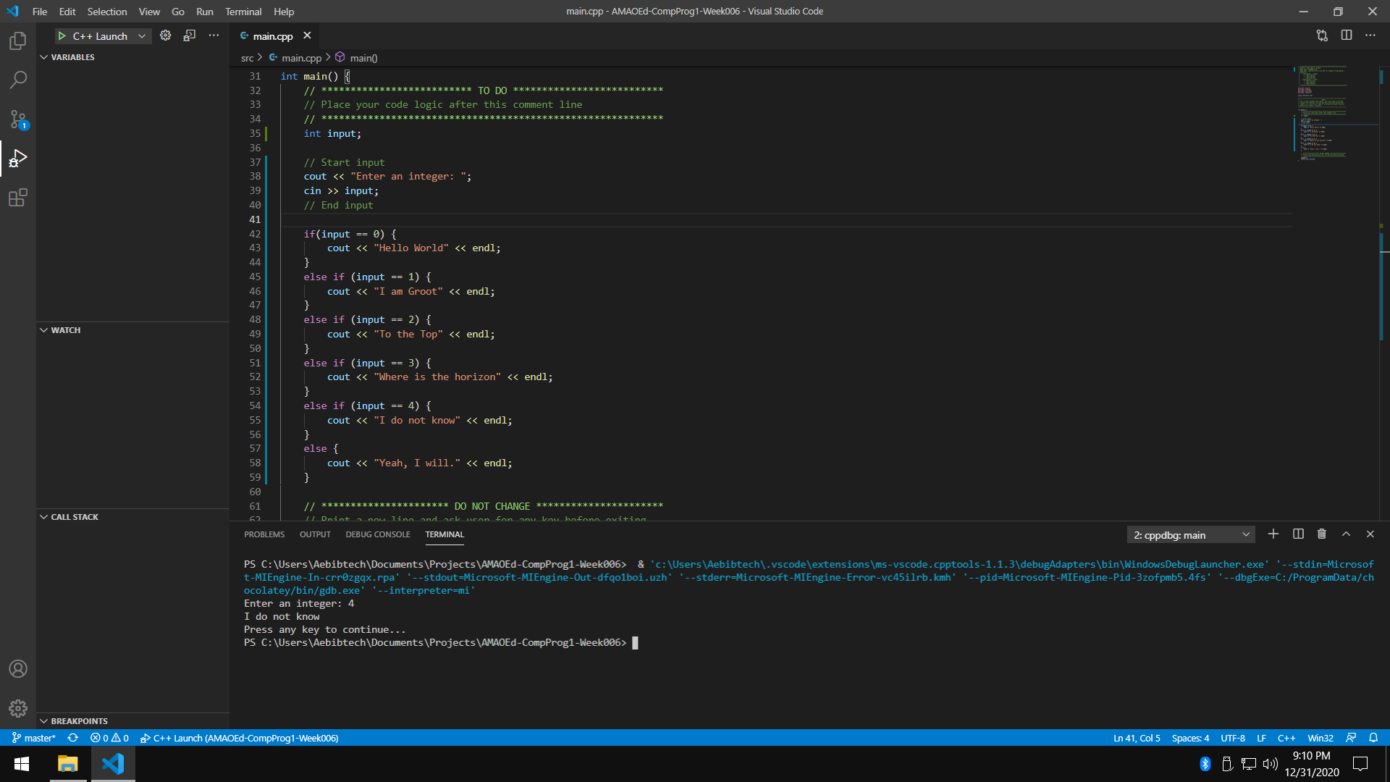

* 1. If none of the above, display only “Yeah, I will.”.

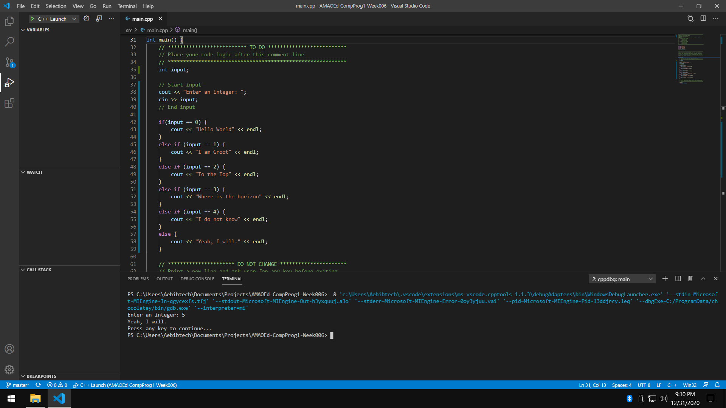

1. Write a program that will accept an integer and execute one of the following based on the input using SWITCH statements:
   1. If 0, display only “Hello World”.

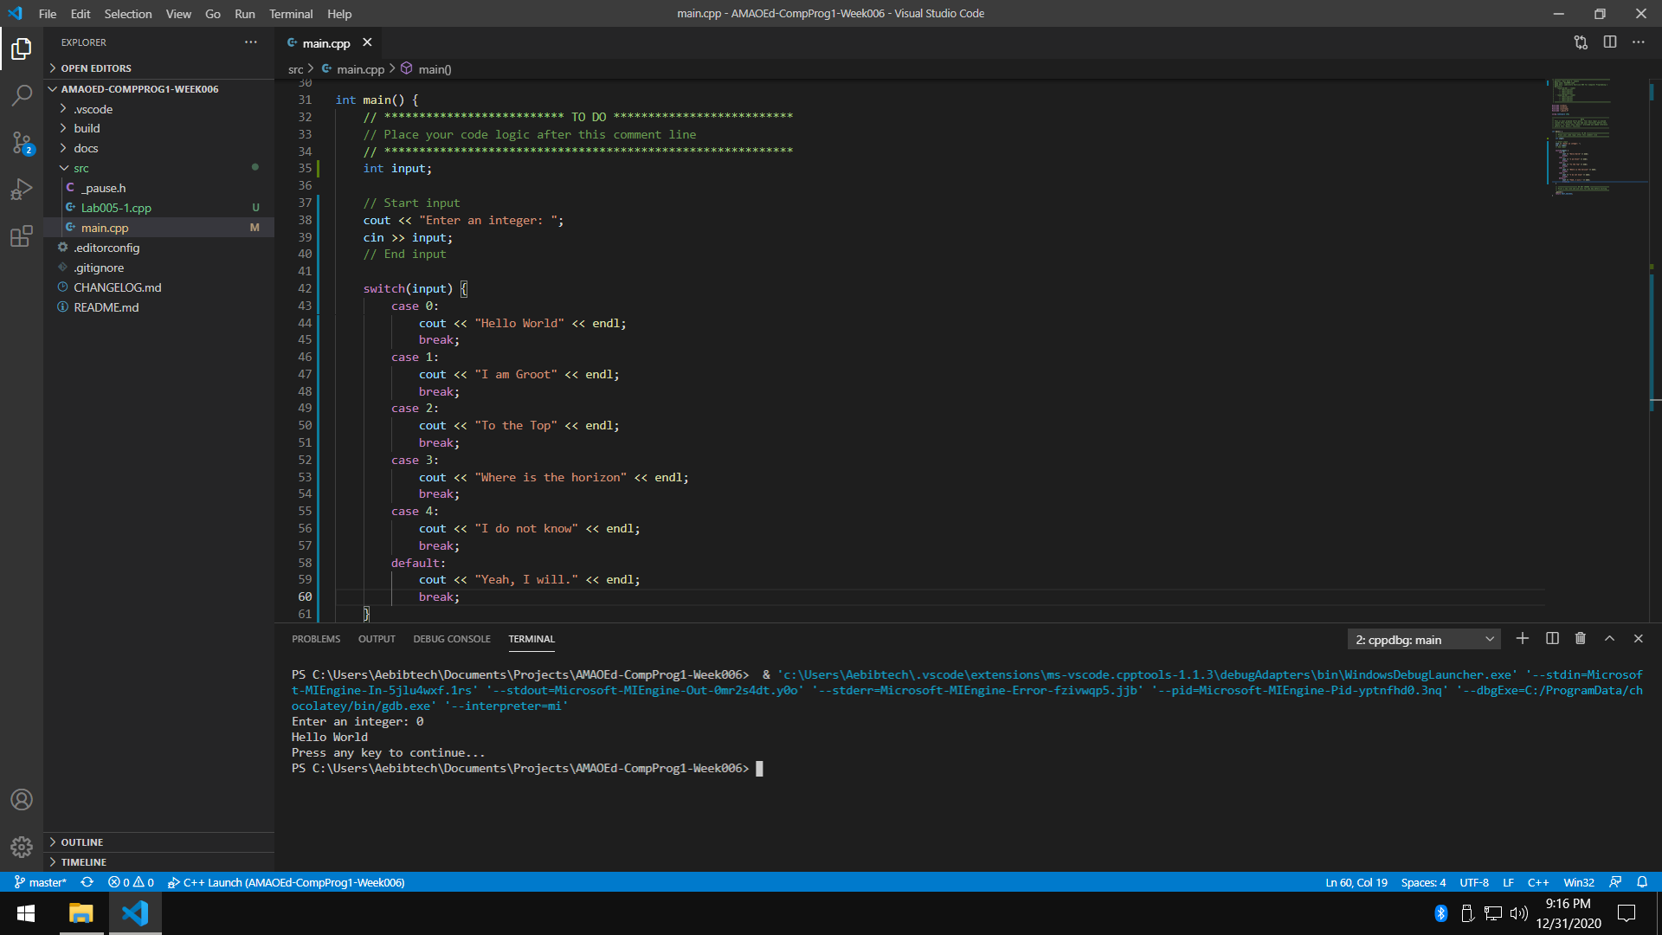

* 1. If 1, display only “I am Groot”.

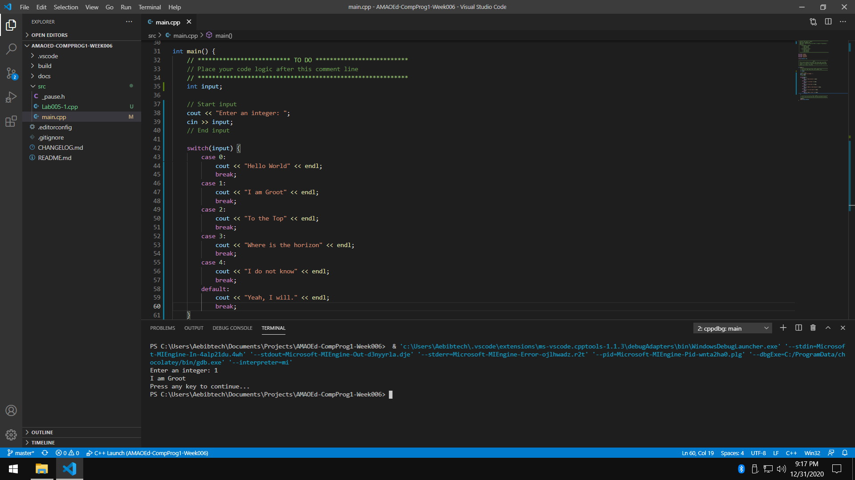

* 1. If 2, display only “To the Top”.

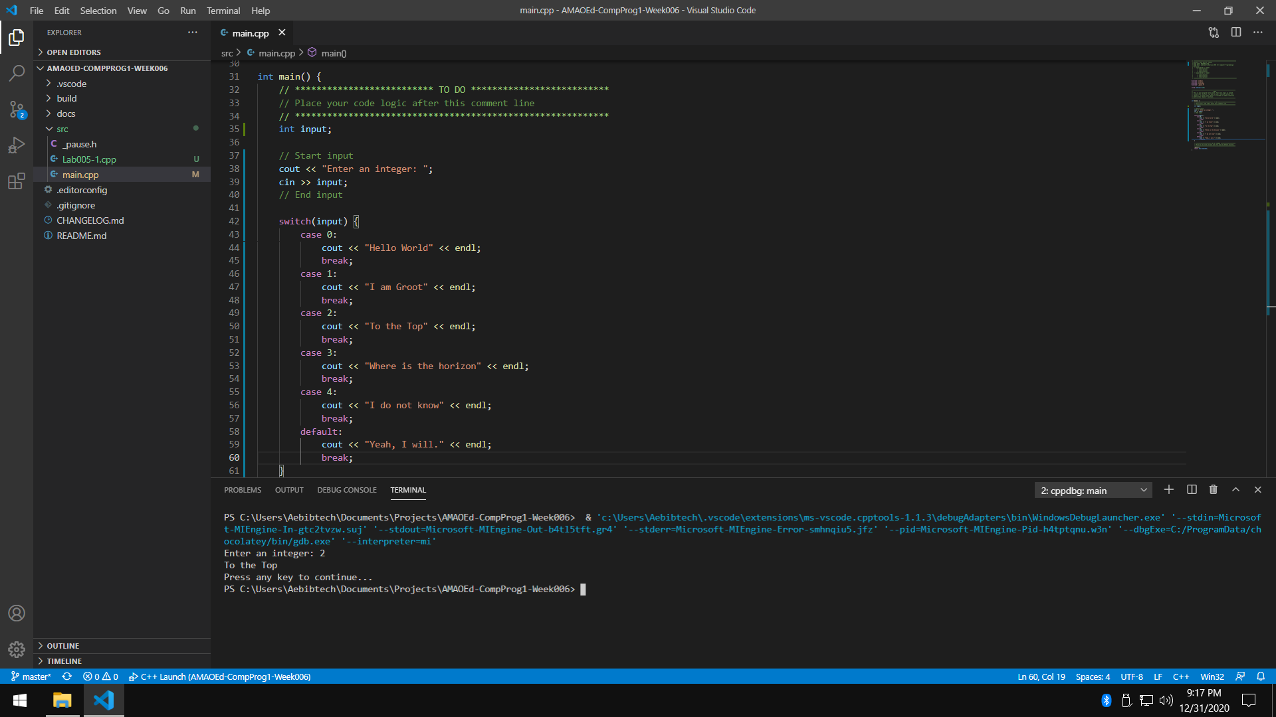

* 1. If 3, display only “Where is the horizon”.

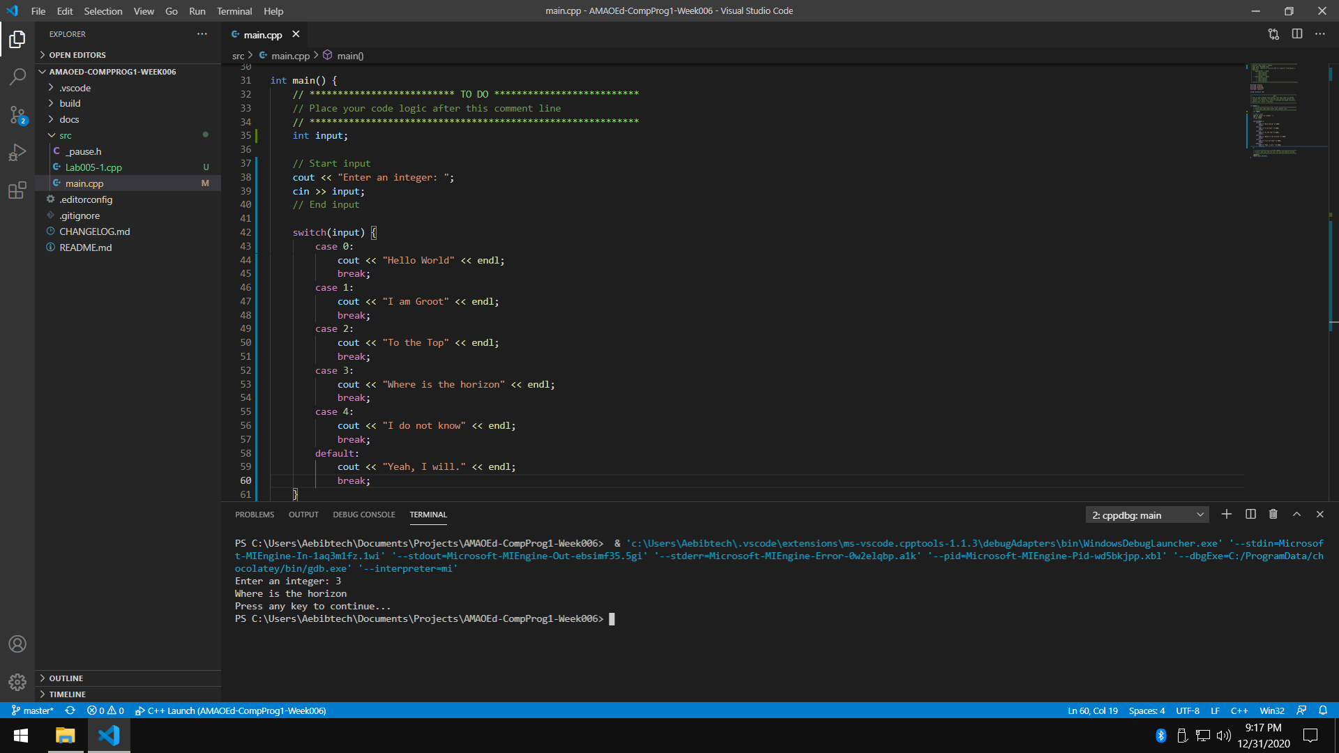

* 1. If 4, display only “I do not know”.

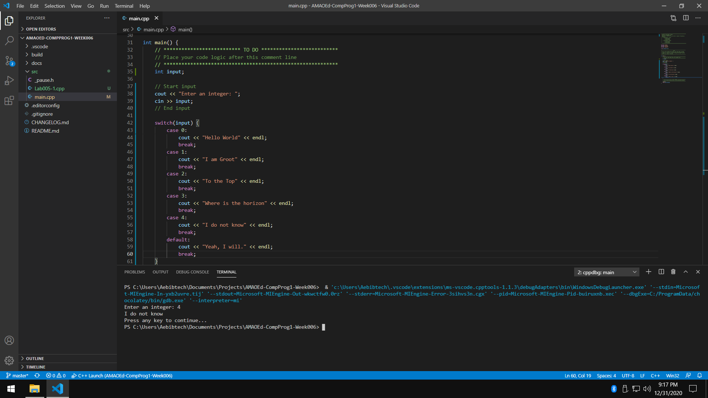

* 1. If none of the above, display only “Yeah, I will.”.

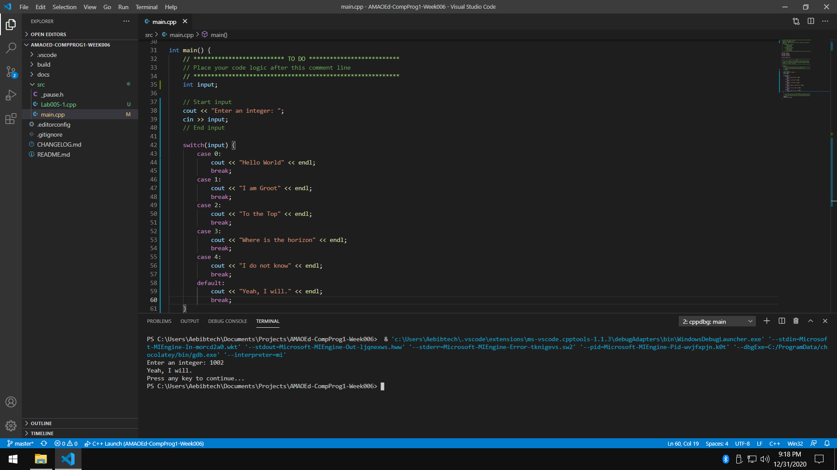

1. Write a program that will divide the two floating points entered by the user (first number entered divided by the second number entered). Make sure your application handles all possible scenarios with floating points.
   1. Both inputs are valid.

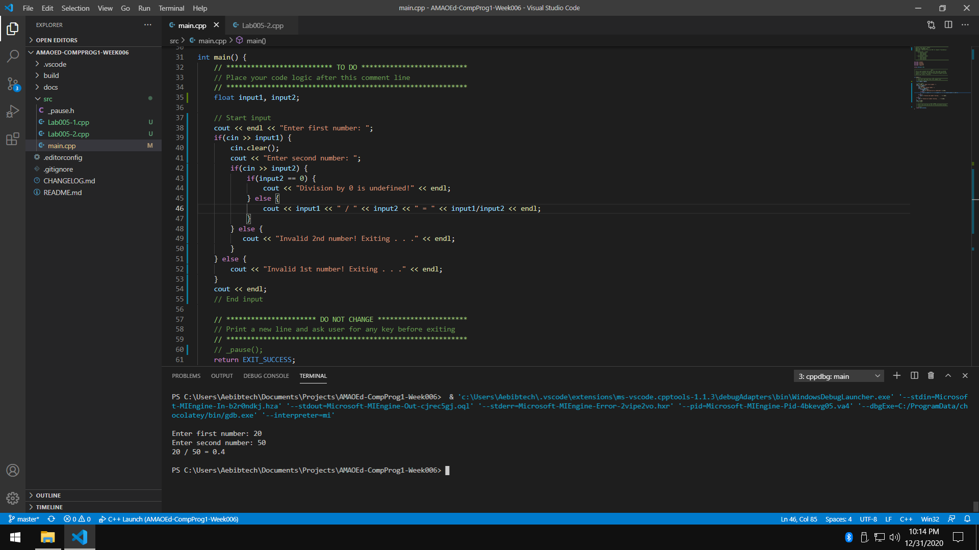

* 1. First number is invalid.

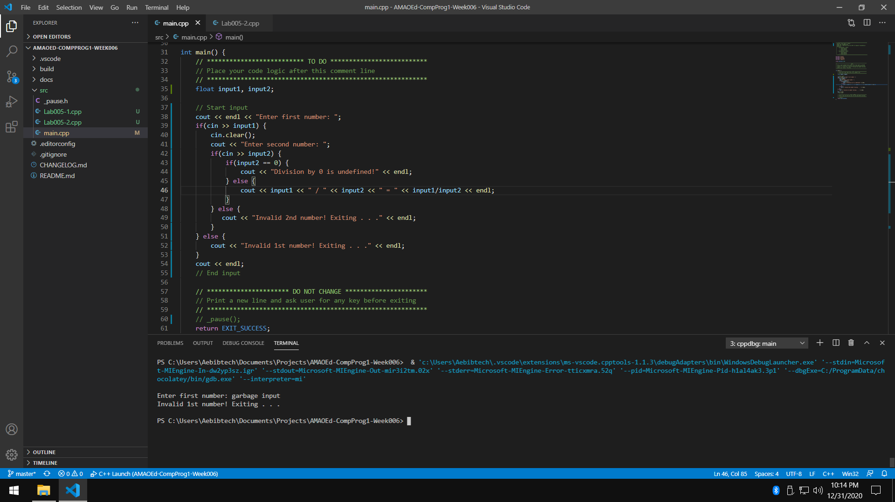

* 1. Second number is invalid.

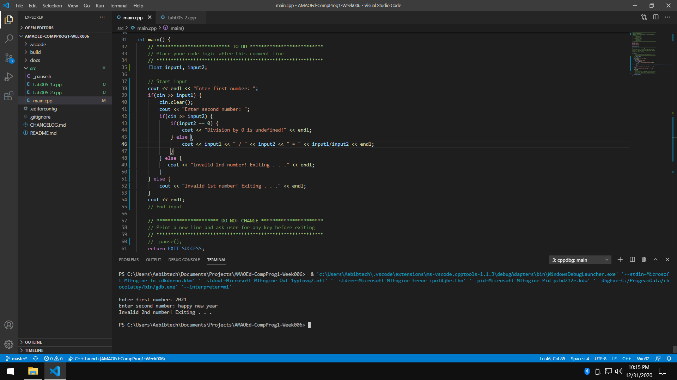

* 1. Second number is zero. This should be invalid since n/0 = undefined.

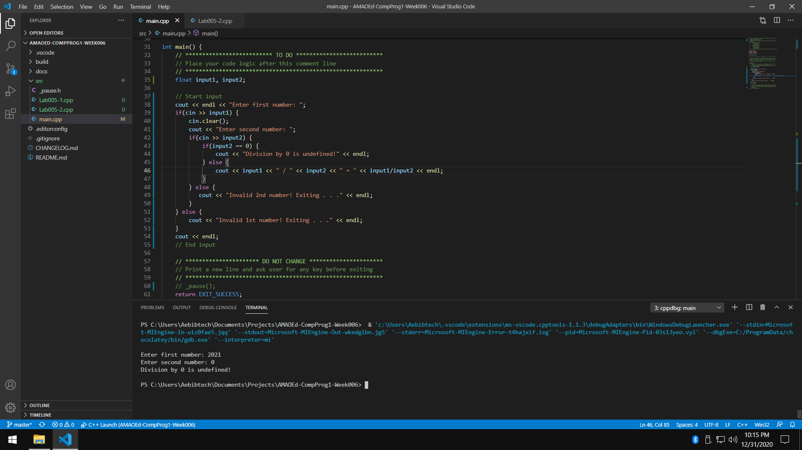

1. What can you conclude from this activity?

I can conclude from this activity that conditional statements (if and switch) enable programmers to set conditions to programs, to act based on user input and to prevent errors. Also, conditional statements can be used in order to validate user input.