1. Write a program using WHILE statement that displays a right triangle using asterisks where the height is at the left corner of the application. The height will depend on the user input.

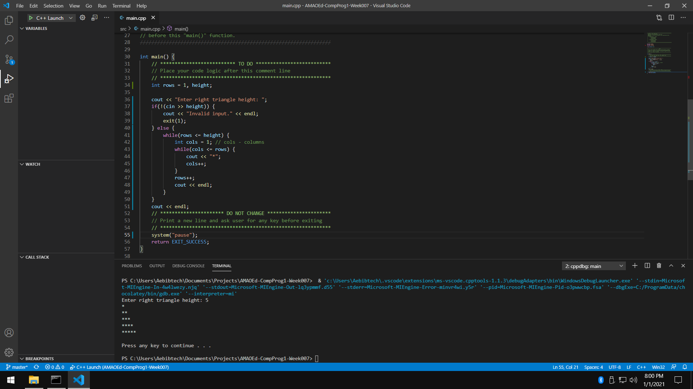

1. Write a program using FOR statement that displays a right triangle using asterisks where the height is at the right corner of the application. The height will depend on the user input.

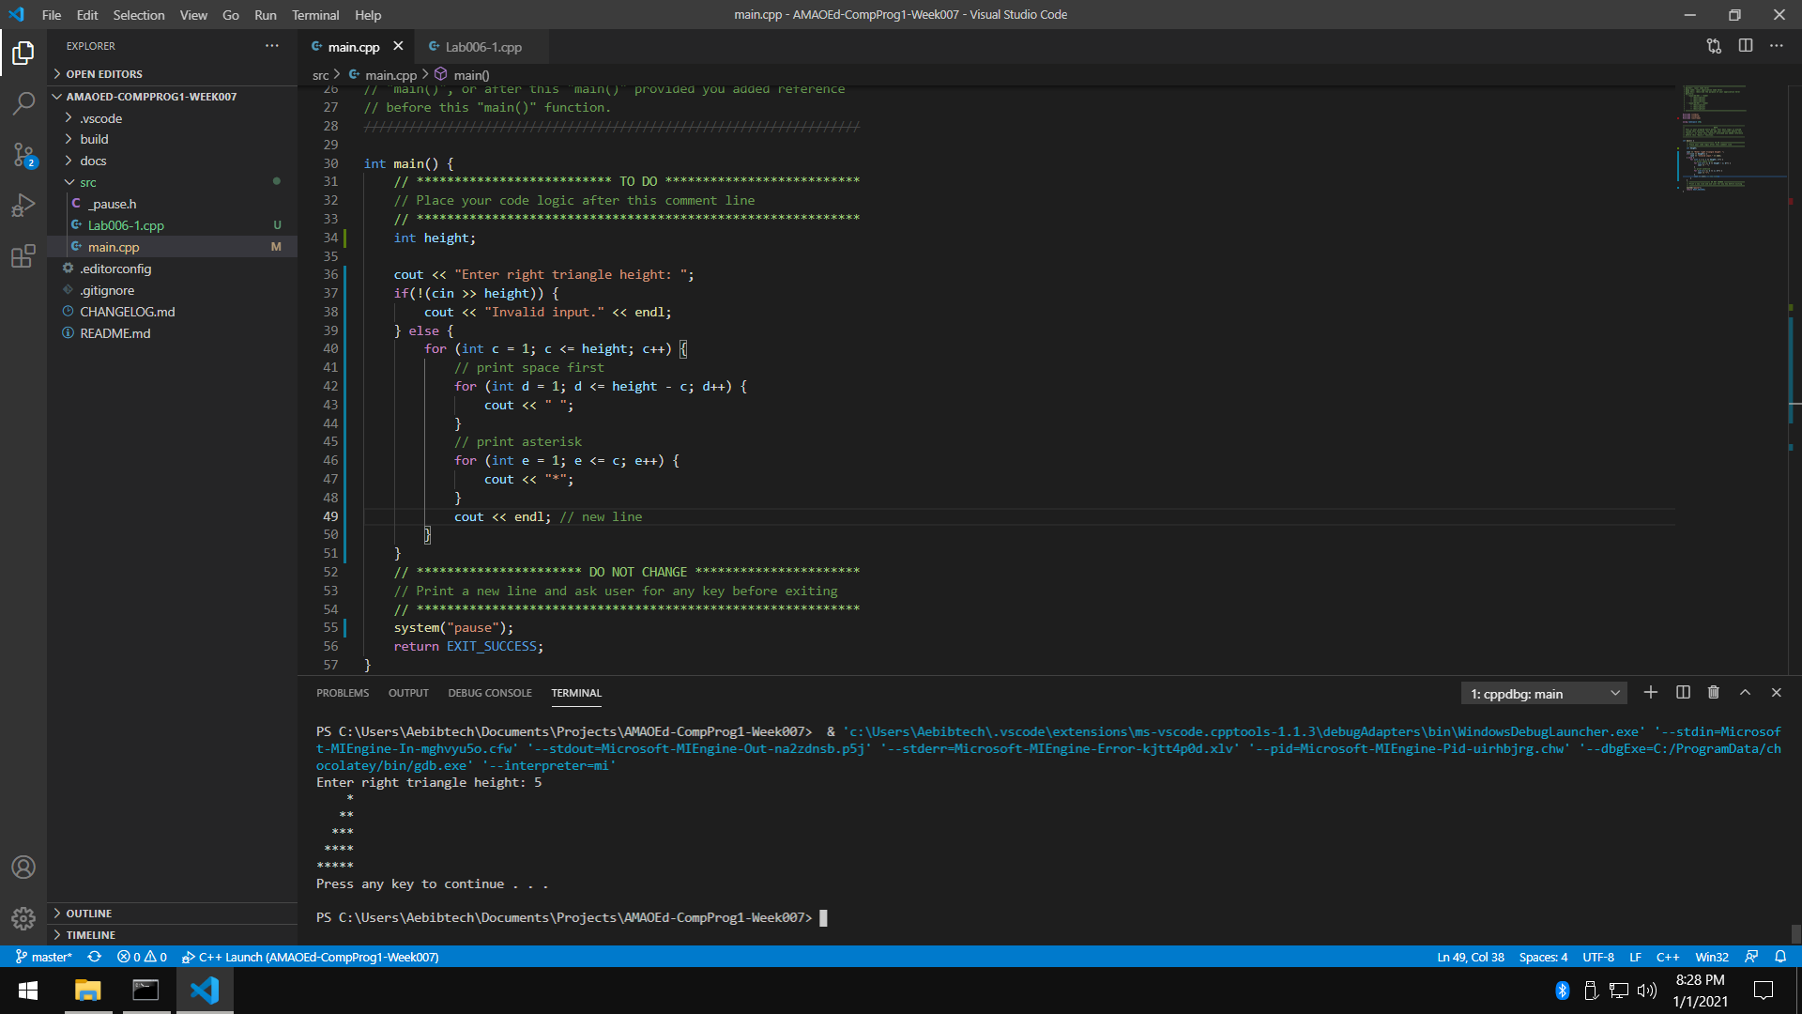

1. Write a program using DO WHILE statement that displays an inverted equilateral triangle using asterisks. No asterisk should be adjacent to one another. The height will depend on the user input.

[Hint]

* You can use an IF statement to eliminate the initial space for the first row.

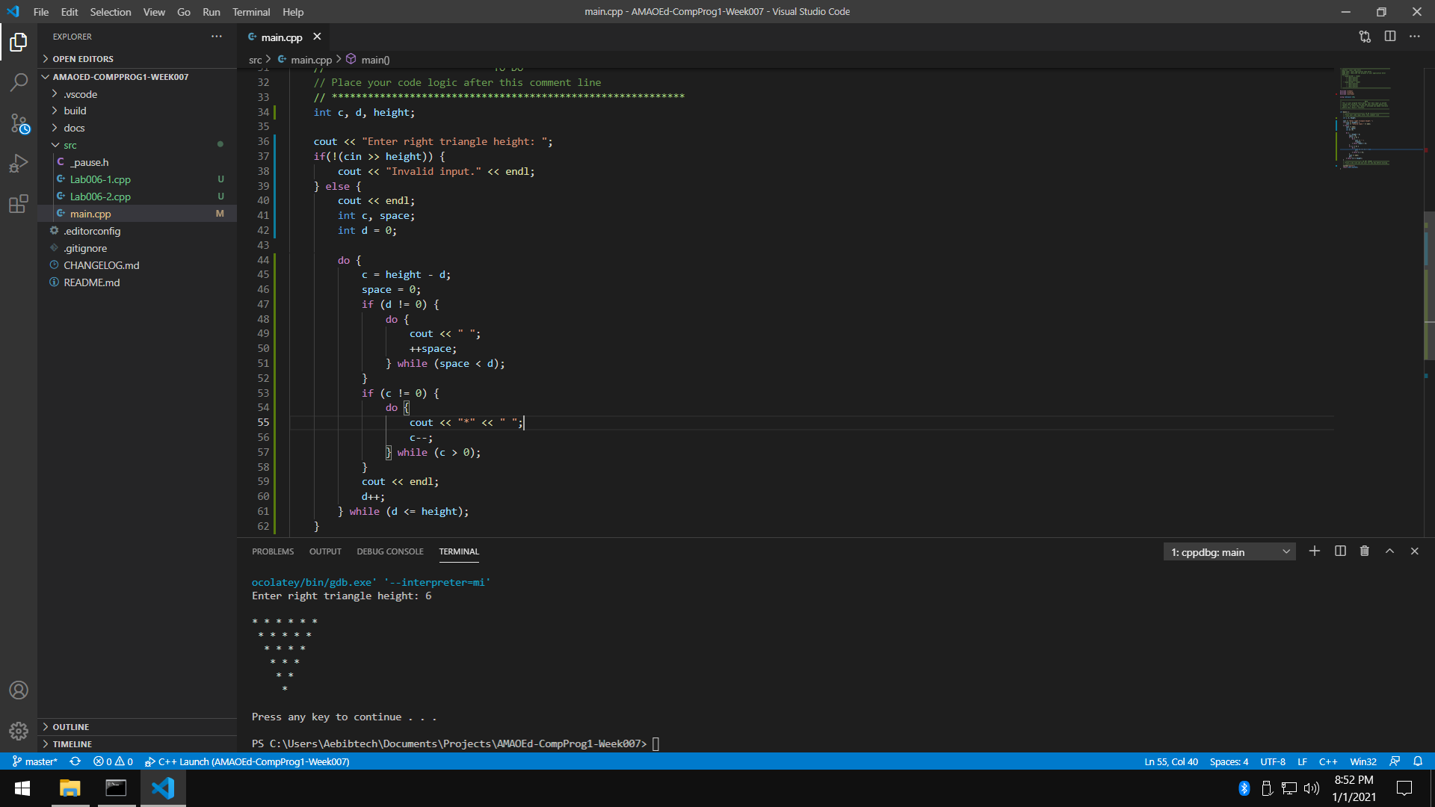

1. What can you conclude from this activity?

I can conclude from this activity that looping statements are tools that help programmers repeat tasks. It’s hard to understand loops at first. The programmer must use loops carefully. Mistakes in initialization and conditions can give unpredictable behavior in loops.