1. Write a class that will represent a LeggedMammal. Consider the number of legs, kind of fur, presence of tail.

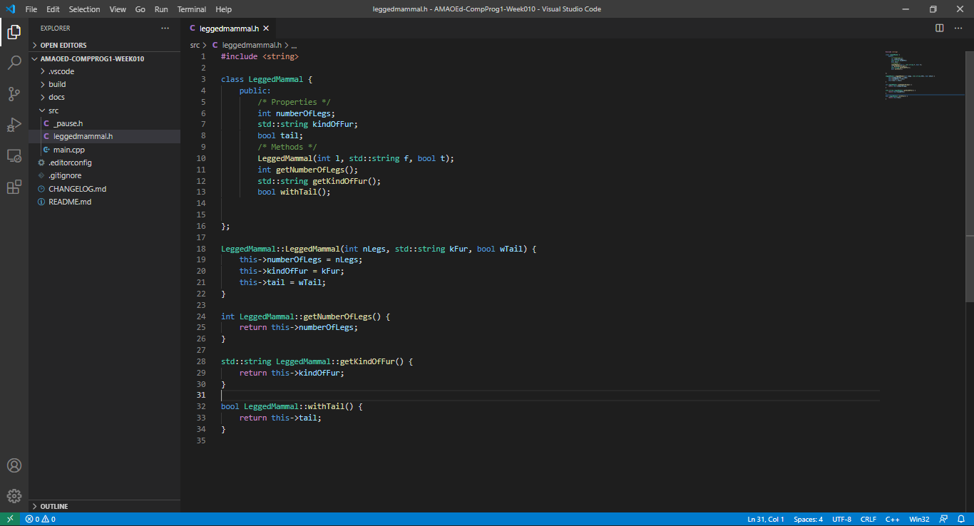

1. Write a class that will represent a Person. Consider the name, address, gender, age and occupation.

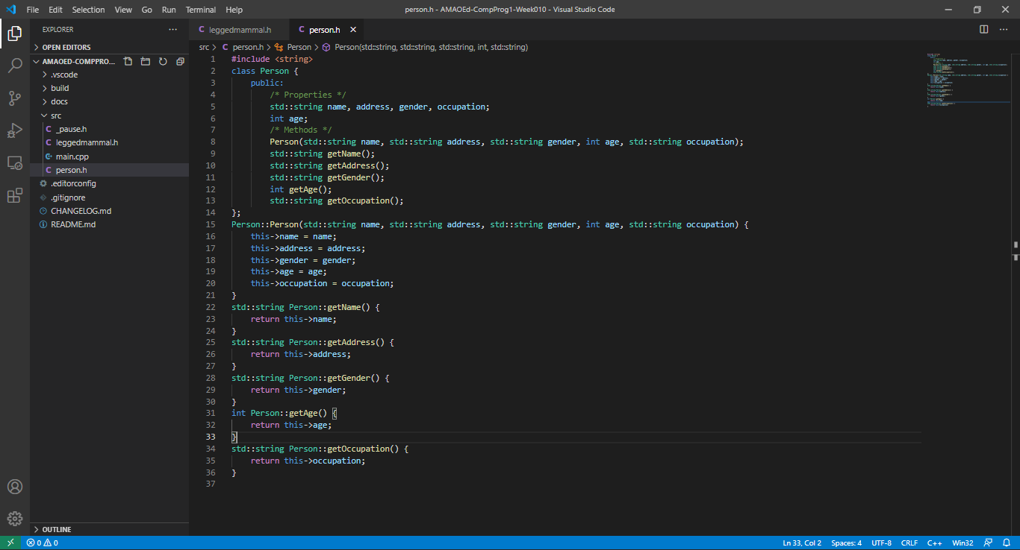

1. Write a class that will represent Polygon. Consider the name, number of sides and color.

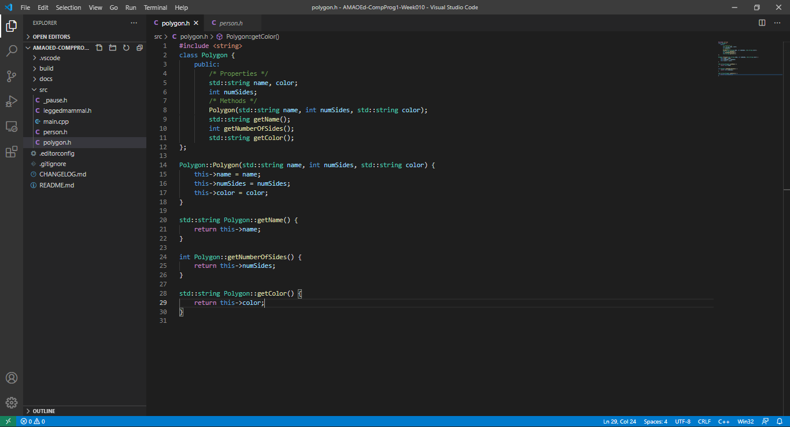

1. What can you conclude from this activity?

I can conclude from this activity that Object-Oriented programming promotes code readability and reusability. Objects have properties and methods (what the object can or will do).