1. Write a program that will display the value and logical address of an integer variable with an initial value of 900.
   1. Code

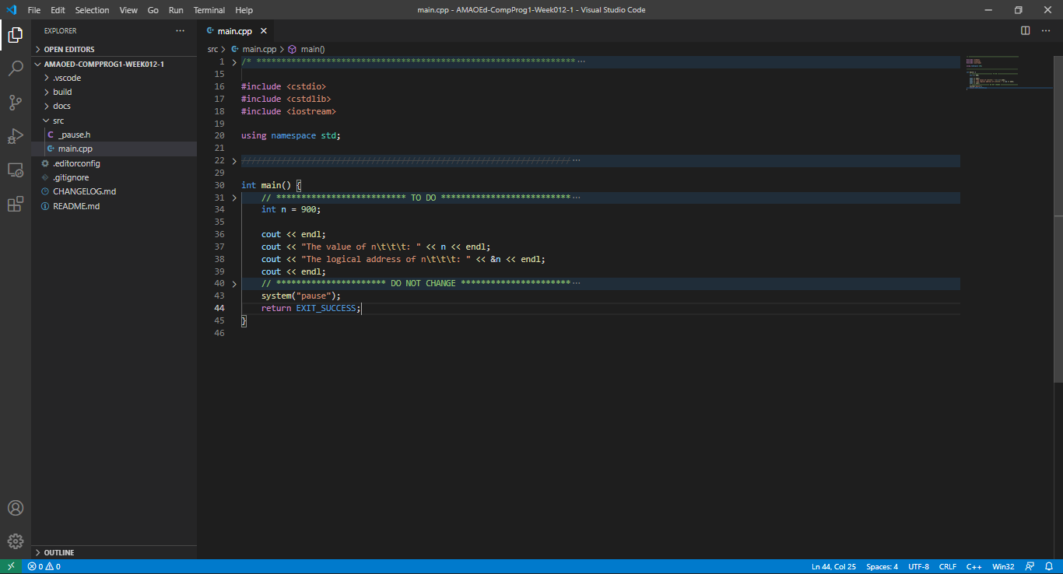

* 1. Output

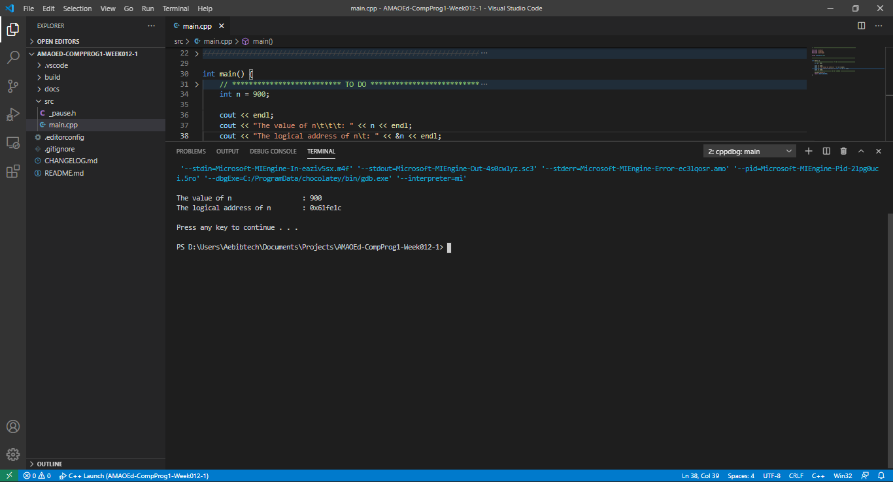

1. Write a program that will display the value and logical address of an uninitialized character array with size ten (10) and a pointer pointing to the array. (Hint: you may need to perform some casting.)
   1. Code

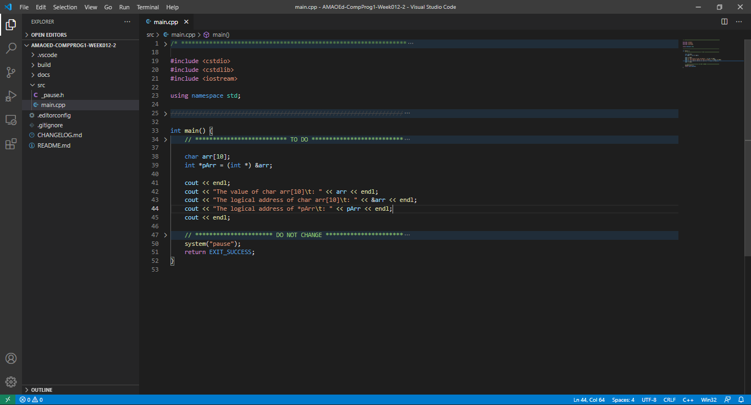

* 1. Output

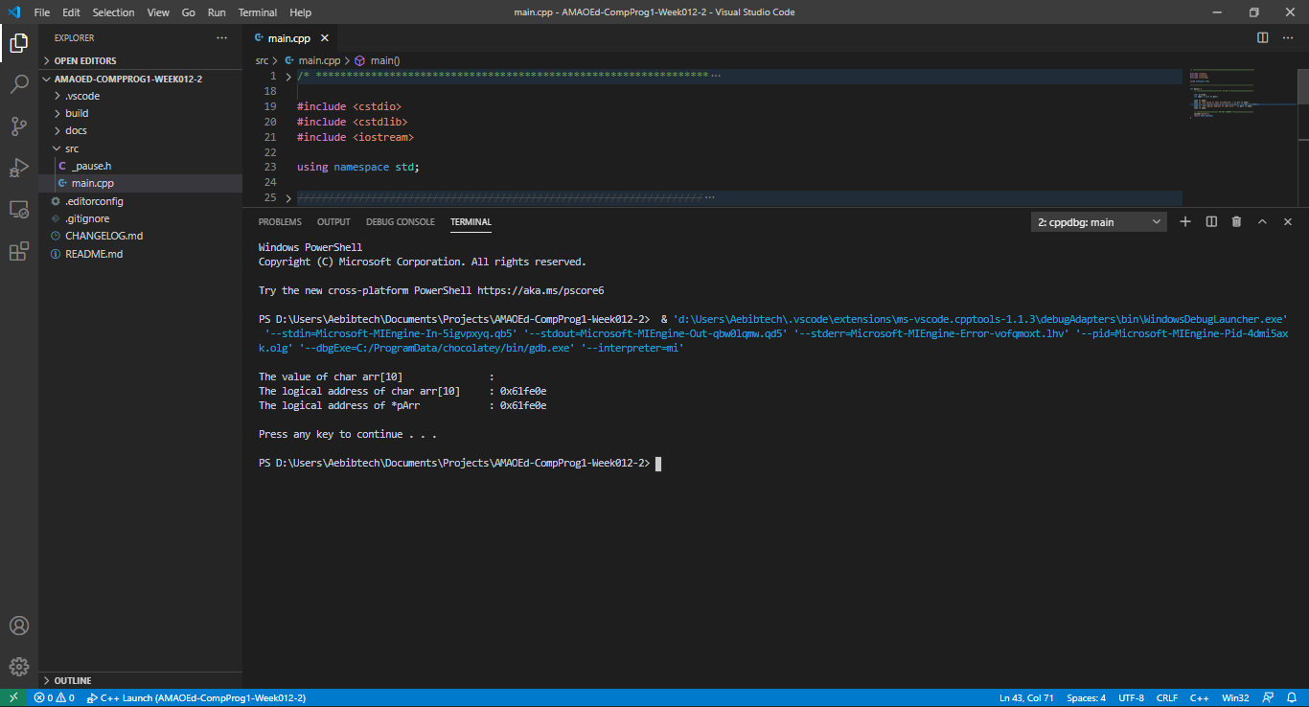

1. Write a program that will display the value and logical address of an uninitialized float array with size twenty (20) and a reference pointing to the array.
   1. Code

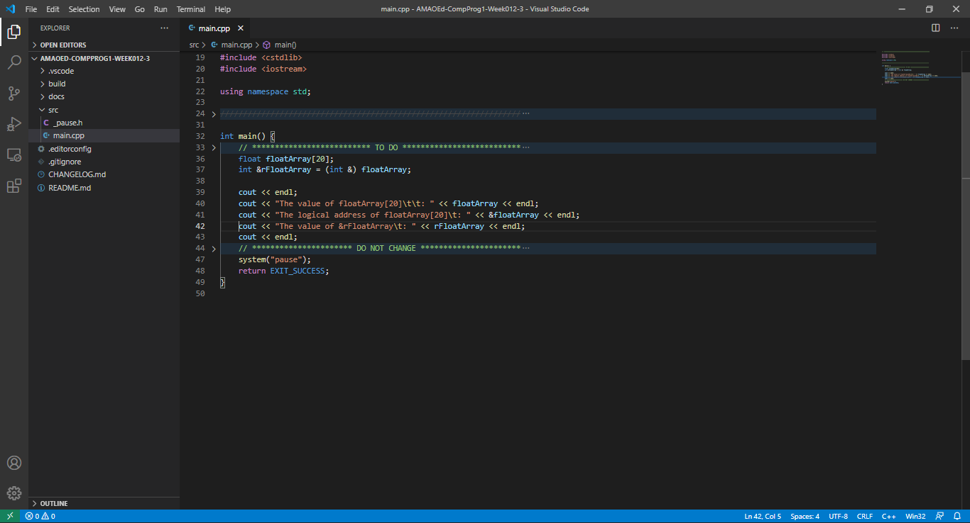

* 1. Output

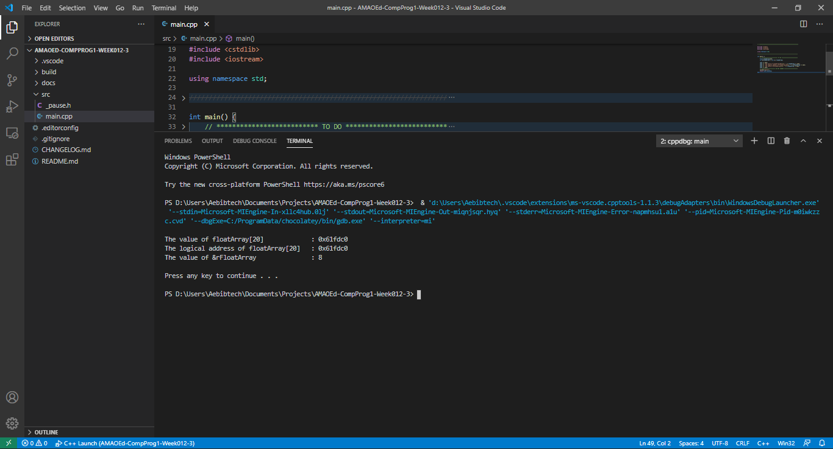

1. What can you conclude from this activity?

I can conclude from this activity that a pointer is a variable that holds memory address of another variable while a reference is an alias or alternate name for another variable.